Physical Workgroup Meeting Summary
March 2, 2020
Trinity County RCD office, Weaverville
Coordinator: Conor Shea

Participants, in-person: Conor Shea (USFWS), Smokey Pittman (McBain Associates), Dave Gaeuman (YTFP), James Lee (TRRP), Todd Buxton (TRRP), Mark Smelser (CDFW), Brandt Gutermuth (TRRP), Eric Peterson (TRRP / note taker)

Participants, on phone: Aaron Martin (YTFP), Scott Kennedy (CDWR), Justin Alvarez (HVTFD)

Introductions, Agenda discussion

No changes made to the agenda, participants launched quickly into the day’s topics.

Discussion of 2019 Monitoring Results

This topic intergraded with other topics for the morning. The note taker has organized these by topic, so they may not follow the chronological order of discussion.

Bathymetry data are not quite delivered yet, so “monitoring results” are not really available. Discussion focused on casual observations and prior years (Gaeuman topics later in Agenda).
- “looks” like the objective of reducing prior augmentation materials at Sawmill Burner Hole worked, but need to validate with bathymetry. These prior augmentation materials came from injections around 2008 and 2009, when a contractor used material larger than specified. In 2019 TRRP stacked piles on river left (3 times during flows) to help focus hydraulic energy on the hole to clear materials out.
- Area below Sawmill appears to have more gravel, but very wide opinions on how the area is changing with regards to river function and fish habitat.
- Lowden (upper) – did not augment in 2019 due to Dave’s recommendations. 2016 and 2017 studies indicated the area is becoming plane-bedded and efficient for gravel transport.
- Lowden (lower) – now has a “pile of lag”. Road ramp area still exists with coarse materials; otherwise about 10-20 ft of bank erosion.

There was a brief side discussion about remnant infrastructure at the old USGS Lewiston Site (Diversion Pool). There are old bent pipes that should be removed. There should be coordination with USGS (it is their property) and USFWS (as they may be locating a temperature monitoring station there).

Aaron raised questions about a long track of fine materials in the center of the bed from Chapman down to the Sky Ranch area. One question is if these were from the Channel Rehabilitation at Chapman, but Justin Alvarez noted that the track exists in the river immediately above Chapman so must be from some other source.

Aaron also mentioned a gravel bar formed from augmentation gravels downstream of Deadwood creek on river right, that is on floodplain where it rarely interacts with water. There could be a possible objective to mobilize this back into the river.

Todd has some results of studies on a bar in the Douglas City area. These suggest that even in the Douglas City area where prior gravel budgets assume sufficient supply, there actually may be a deficiency.

2020 Augmentation Proposals

Even with Critically Dry hydrograph, the proposal goes to about 4,000 cfs and has a second notable peak (long period in between for fish study).
Conor and others noted that there are no sites currently permitted where we ought to place gravel this year. Group consensus was that it doesn’t make sense to add gravels where we can because:
- This year is dry or critically dry so there will be a lack of significant transport
- There is no clear advantage to habitat objectives from augmenting where we currently are permitted.

Discussion: if we make it to Dry, does that change our recommendation? Peak flow would be in the mid-6000 cfs range. Dave suggested the same concerns apply.

Dave suggested the one possible place he might suggest for augmentation would be at cableway, river left, with the objective of raising the water surface into vegetation on river right for better habitat. This led to discussion of the value of augmentation for transitory purposes that would only be in place until the augmentation mobilized.

Consensus: the workgroup’s recommendation is for no augmentation in 2020 with either Critically Dry or Dry water year types.

Revised Gravel Augmentation Concepts and Objectives

Geologic Controls on Tributary Gravel Supply

Mark gave a fascinating presentation on the geologic history of the upper Trinity River area, including some preliminary analyses of watershed potential for mobile rock supplies and topographic relief metrics.

The presentation was placed in the context of the River Corridor Management Strategy prepared in 2016. The presentation explored a recommendation from that strategy outline to consider bed material fluxes and sediment supplies including an analysis of sediment sources and sinks. Each subwatershed in the upper river has different patches of underlying geology, and old faults in the region exert some control the course of the Trinity River and the deposition of alluvial sediments, which collectively leads to areas that are either sources or sinks for sediment. Rush Creek appears to have both the best materials for forming mobile sediments and the greatest relief metrics (see StreamStats, but also Mark added some calculations of his own, particularly relief vs. watershed area).

Conclusions:
- Investigating supply and transport in tributaries is worthwhile. Tributaries of particular interest include Indian Creek, McIntyre Gulch, Trinity House Gulch, Ton Lange Gulch, and Grass Valley Creek.
- Relief metrics are useful and relevant to tributary deltas, river sediment inputs
- A proposal for a synchronized tributary and high mainstem flow event should be developed.

Mark will send out his presentation and a paper on extensional faulting in the southern Klamath (Schweickert & Irwin 1989).

Out-year Gravel Augmentation Sites and Site Screening
The group quickly noted that there are two major aspects that need to be considered:
- Objectives/Methods – the what and how of sediment augmentation
- Locations – the where, with all its complexities due to the private/political landscape.

Toward objectives/methods, the group circled back to the basics: is there a gravel deficit? The conveyor belt ideas are no longer considered valid on the Trinity. Dave suggested that ‘deficit’ is a localized issue due to local source/sink conditions and the area where it is greatest is immediately below the dam. Tributaries, on the other hand, continue to deliver and could be described as overloaded (sediment sources).

Conor focused the group on TRRP immediate needs: Brandt needs to get permitting started, which requires statements of where, why, how, and what are the impacts (e.g. water surface elevation for flooding). See Figure 1 (whiteboard diagram developed by Conor).

Objectives discussed included increasing aquatic habitat and restoring dynamics to the river system, in the context of the Program’s Goal Statement.

Recognizing the growing awareness that the upper river is somewhat lacking in fine sediments, there was also discussion of changing the TMDL. Todd’s fine sediment report will be making some clear statements toward a need to augment fine sediments. Todd noted that in the upper river fine sediment increased due to supply from the Carr Fire via Deadwood Creek, yet still had only 18% fines – the low end of the ideal 15-30%). The group had general consensus that there is a need to augment a broad range of sediment sizes, not just ‘fish rock’.

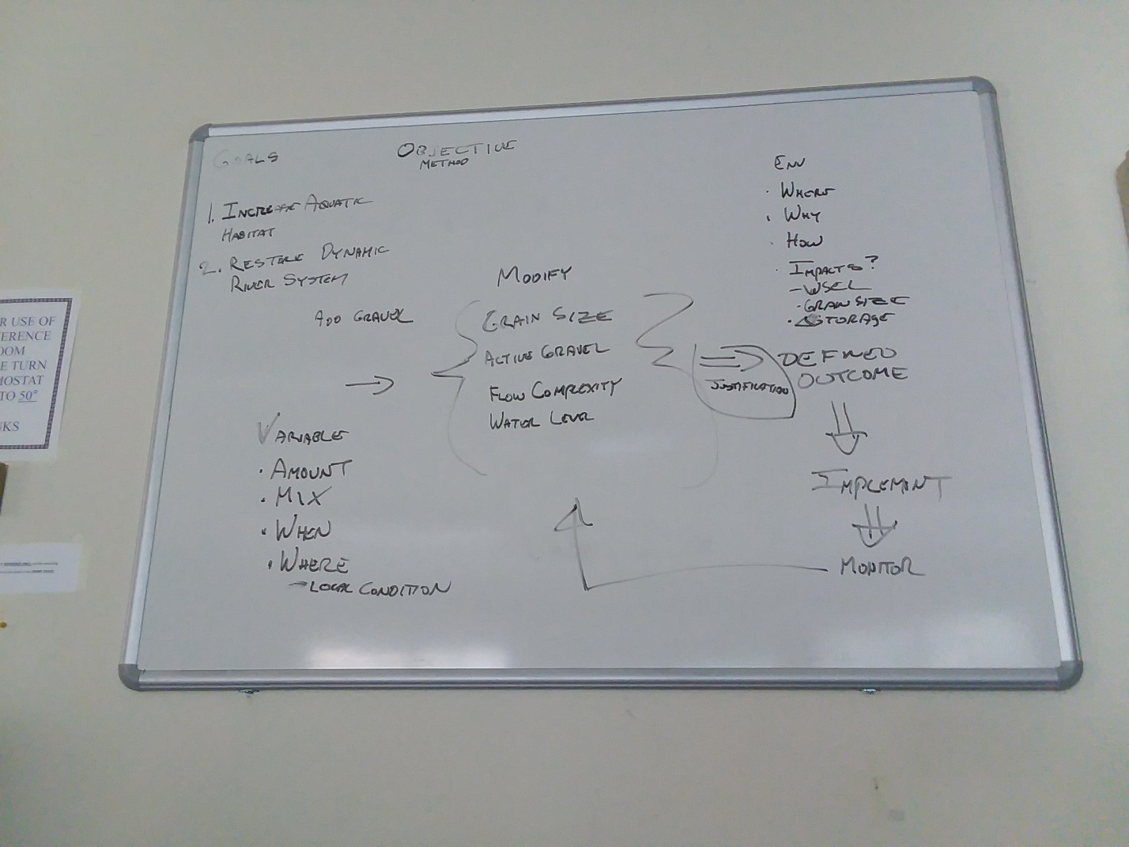
Figure 1: needs for augmentation permitting
After breaking for lunch the group focused on a list of 5 new sites to include in the coming augmentation permit effort. Conor had requested that a few group members complete a spreadsheet to help organize this discussion. All who completed these acknowledged that some of theirs had complications of land ownership or road access.

Todd’s included Bucktail (problematic due to houses), Steelbridge Island (has a good storage area), and fine sediment at the Hatchery.

Dave added Poker Bar on river left above the bridge, a ‘landslide’ across from Diversion Pool, and another ‘landslide’ at Vitzthum Gulch across from the notches.

Smokey focused on the area from Grass Valley Creek to Steelbridge including locations around Poker Bar and China Gulch.

The existing sites are:
- Hatchery
- Diversion Pool
- Cableway/Old Bridge
- Sawmill
- Lowden (both up and downstream)
Group consensus was to try adding:
- Steelbridge Day Use Area
- Vitzthum Gulch (‘landslide’)
- Trinity House Gulch
- China Gulch (access needs to be worked out – currently thinking river right)
- Gold Bar (river right)

Plus there was group consensus on pushing toward adding fine sediments at the hatchery.

Scheduling of Future Work

Whiteboard provides outline of how to construct proposals for new augmentation sites. Proposals should be 1 page briefs (~1/2 text and ½ map). The following assignments were made:
- Conor will provide a template within 2 weeks of the meeting.
- Todd to propose fines at Hatchery and general augmentation at Gold Bar
- Dave to propose Steelbridge and Vitzthum
- Smokey to propose Trinity House Gulch and China Gulch.

Additional action items:
- Conor to check with Brandt on permitting structure (is this to be a programmatic EA?)
- Mark to send powerpoint and referenced paper (completed).

