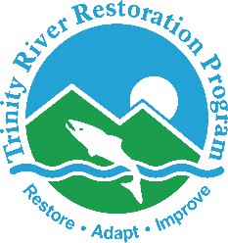

Trinity River Restoration Program

28 July 2022

VIA ELECTRONIC MAIL ONLY

Memorandum

To: TRRP Design Team

From: Brad Nissen, Coordinator, TRRP Riparian and Aquatic Ecology Workgroup;
James Lee; TRRP Implementation Branch Chief

Subject: Restoration potential reviews of two U.S. Government-owned parcels on the Trinity River

The purpose of this memorandum is to update the Design Team on the Riparian and Aquatic Ecology Workgroup’s (RAE) assessment of the restoration potential of two parcels on the Trinity River and begin a dialogue between the workgroups on processes for designing projects on these sites.
Since the 2000 ROD was signed, the U.S. Bureau of Reclamation has purchased two parcels of formerly private property along the Trinity River because these parcels were vulnerable to damage from ROD flows. One parcel, informally called ‘the little yellow house’ or ‘Chancellors’ is located on river-left, just upstream of the HWY 3/299 bridge at Douglas City (40° 39' 14.97" N 122° 55' 54.67" W). The other parcel, informally called “River Acres” is located on river left between the Wheel Gulch and Valdor Gulch channel rehabilitation projects, downstream of Junction City (40° 45' 50.31" N 123° 4' 49.88" W). We assumed that these parcels will remain the responsibility of Reclamation indefinitely, and also assumed that if there was any potential for increasing their ecological or educational value, TRRP should provide recommendations to do so.
In June 2025, RAE members visited both sites and discussed ideas for how to increase the ecological or educational value of these parcels. We present relevant information on each site below:

Yellow House site
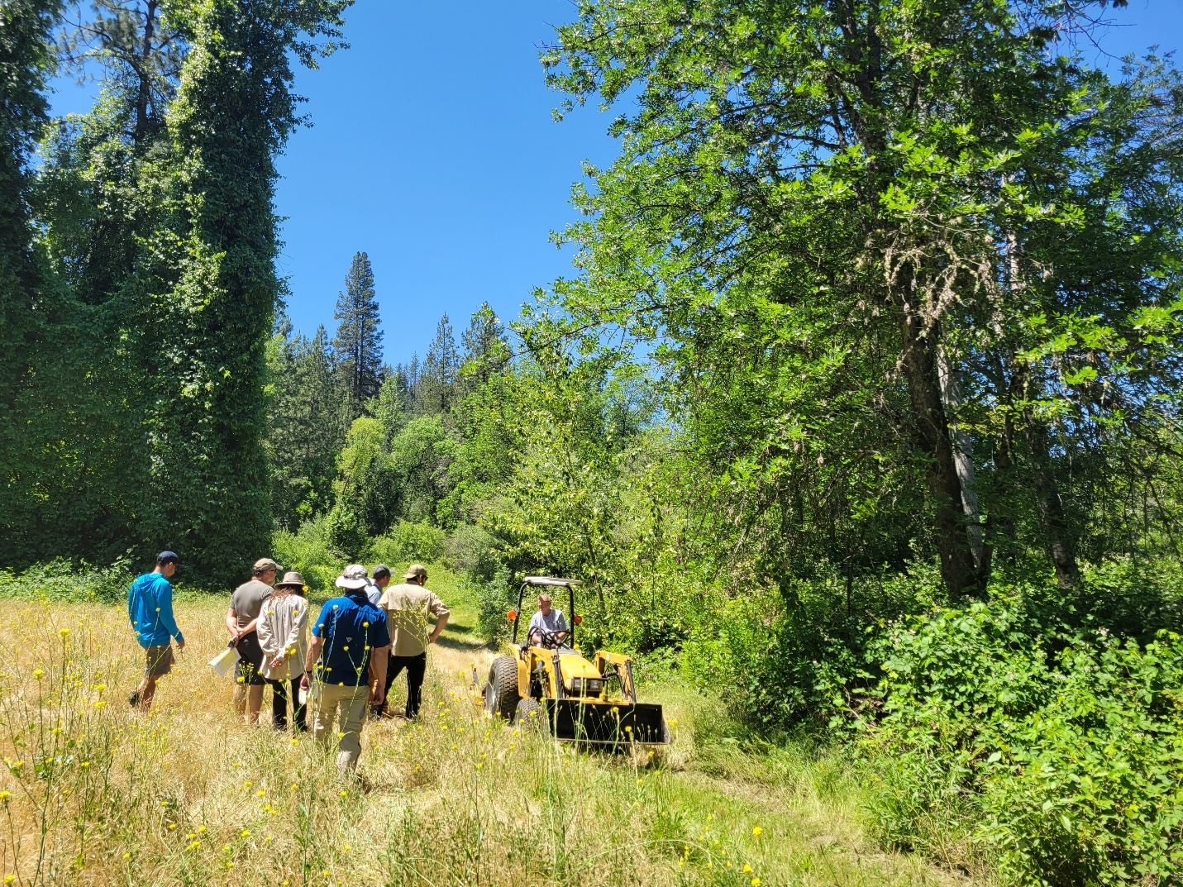
Figure 1. River-left area of the Yellow House site, facing downstream.
This site (see attached map) once had a small yellow house within the area inundated by ROD maximum fisheries flows. The house was moved off the parcel to a safe location, and the parcel was purchased by the U.S. Government. The parcel is approximately 5 acres and includes both sides of the Trinity River. The right bank area is very difficult to access, requiring either new road construction and a crossing over Weaver Creek, or the use of a seasonally-restricted private road from Union Hill Road. The right bank contains a side channel that was part of the Indian Creek and Upper Douglas City projects (last constructed in 2015). The left bank side is easily accessed via a short road off of HWY 299. A locked gate prevents the public from driving on to the site; however, it is a short walk from HWY 299. TRRP’s Restoration Action Database shows a high-flow channel through this parcel, possibly constructed around 2005, but no evidence of this feature was obvious during the RAE field trip. The area was used previously as an algae sampling site and for sampling turbidity during high flow events. The owner of the lot that shares the eastern boundary is very supportive of TRRP; the remaining boundaries are shared with the Bureau of Land Management.
Because of the difficult access and fairly recent TRRP work on the right bank portion of the lot, we dismissed that area and focused on the left bank portion. Some of the observations that we made include: The presence of diverse and healthy riparian and wetland vegetation, but with thick patches of invasive Himalaya blackberry (Rubus armeniacus) and a non-native wild rose (Rosa sp.); strong Oregon ash (Fraxinus oregana) recruitment; and the presence of an armored bank.
The RAE determined that the vegetation on the site should receive some attention. Partly because the site is so accessible and visible, a possible future use of this site would be for public outreach activities, where people can volunteer to treat the invasive blackberry and rose, and monitor its progress over the years. It could also serve as a small demonstration area for prescribed riparian fire. However, and of most potential interest to the Design Team, the RAE recommended considering this site as a place for implementing accelerated wood recruitment. Both sides of the river contain trees, particularly white alder (Alnus latifolia) and Oregon ash that could be cable-yarded from the banks and deposited into the channel. There is also an opportunity to construct a wood-racking feature on the left bank.
River Acres Site
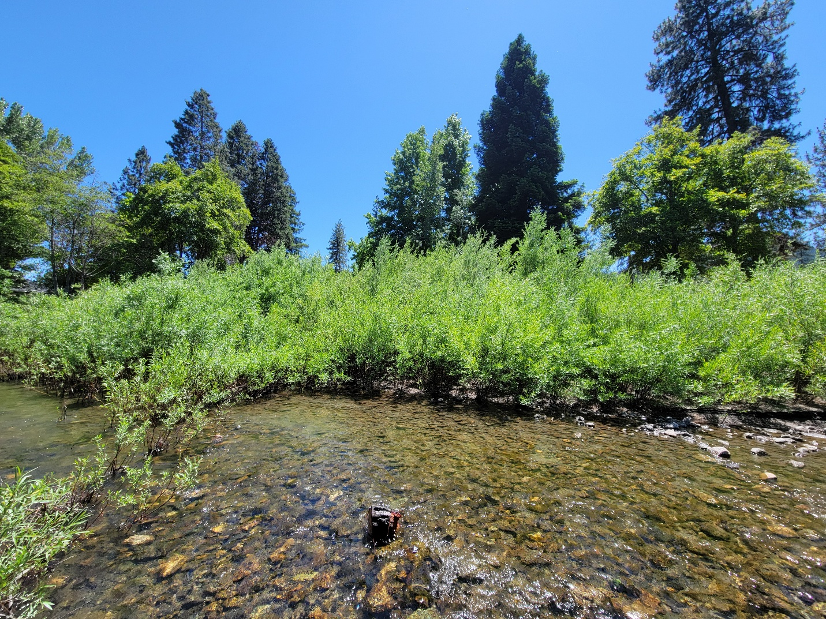
Figure 2. The River Acres property viewed from the Trinity River.
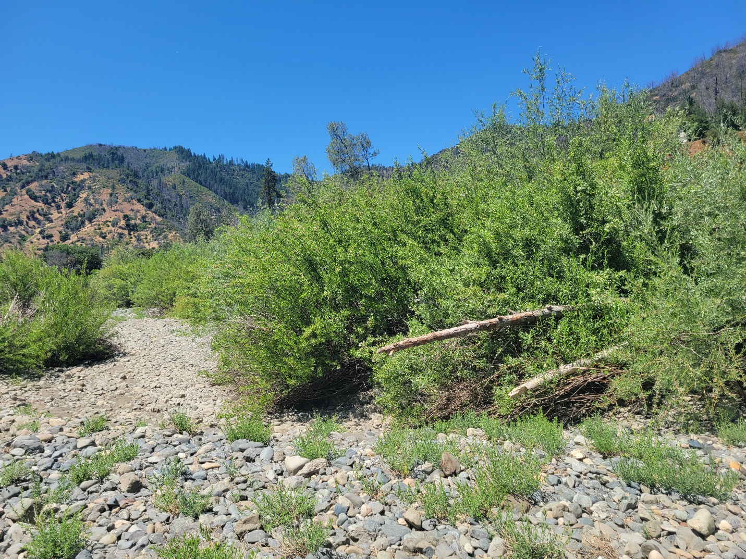
Figure 3. Portions of a large bar in the Trinity River on the River Acres parcel.
This site, located at 391 River Acres Road (hence the nickname) near Junction City, was the location of a house that was forecast to be inundated by the ROD Maximum Fisheries Flow, and so was purchased by the U.S. Government and the house removed (formerly known as the ‘Green House’) (see attached map). This parcel is approximately 3.25 acres and is mostly on the river-left side, with only very minor portions extending across the river to the river-right side. The parcel is bordered on all sides by private property, severely limiting the scope and scale of any bank and floodplain excavation or fill that might otherwise be considered here.
The most notable feature of this parcel is a large bar that begins in the middle of the parcel and extends downstream through adjacent parcels for about 300 m. The bar extends from the left bank to the middle of the channel, and creates an island during flows of ~ 2,000 cfs or greater, and a high-flow scour channel along the left bank. Numerous fish, likely speckled dace (Rhinichthys osculus) and three-spined stickleback (Gasterosteus aculeatus) were observed in the alcove at the top of the bar during the site visit, and one foothill yellow-legged frog (Rana boylii) egg mass was also found. The bar also had large wood that was naturally deposited on it. The main flow follows the right bank and appears to be down-cutting threatening to reduce connectively of the flood plain with in the parcel.
The 2017 Helena Fire burned through this area, however most of the trees on the parcel survived. Among the trees present, several large coast redwood (Sequoia sempervirens) and other non-native ornamentals could be used as a source of large wood for channel rehabilitation projects in the future. Too, the parcel is fairly well suited for revegetation with native species such as black cottonwood (Populus trichocarpa); however the consensus of the RAE was that the shade from the existing trees should be utilized to promote the establishment of native trees, therefore the large wood harvest of non-native trees should follow the establishment of a native substory.
The RAE group recognizes the potential for the site to improve through the planting of riparian hardwood trees and upland meadow species (ex. Equisetum, Carex barbarae). It also recognizes the potential of the bar area to provide good habitat for breeding and rearing of foothill yellow-legged frog, western toad (Anaxyrus boreas), Sierran treefrog (Pseudacris sierra) and salmonid species. Greater inundation of the flood plain on river left could be achieved by adding course substrates to the main flow channel along the right bank aggrade the channel or at least slow the down-cutting of the channel. This could enhance the ecological function of the bar and flood plain on river left. The site’s ease of access coupled with the nearby supply of large wood suggests that site could have additional potential that the Design Team may recognize as worth taking advantage of. Because the shade from the existing trees (that could be used as a future source for large wood) has value in helping the native species become established, any work on the bar that includes the use of this large wood, or the removal of large wood for off-site use, should be timed accordingly.
Conclusion
The RAE reviewed two government-owned parcels on the Trinity River and assessed them for restoration potential. Both parcels would benefit from revegetation work, and potentially from large wood placement. The RAE seeks the Design Team’s input on these sites pending a formal recommendation to TRRP for implementing future projects on these sites.

