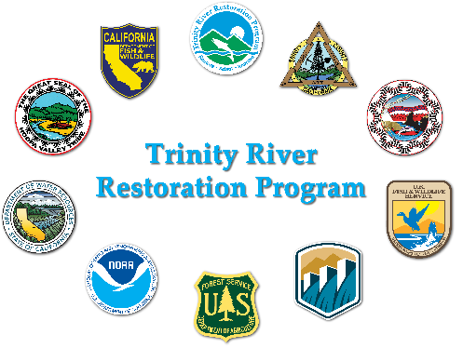
Physical Workgroup Meeting Summary

2026-04-17 (Friday) 0900 – 1600
Location (Teams)
Meeting Coordinator: Smokey Pittman (there was no designated note taker, Smokey combined his notes and the results of his Power Point discussion to create this summary)
Desired Outcomes:
  - Develop a proposal for sediment monitoring to support gravel augmentation recommendations
  - Bedload sampling – need to make a recommendation to TRRP regarding whether to collect additional bedload data, primarily to calibrate hydrophones
  - PWG recommendation for bathy LiDAR 2027 data collection
Attendees:
DWR: Radley Ott
HVT/ARS: Smokey Pittman
TRRP: James Lee, Eric Petersen, Kiana Abel
USBR: Oliver Rogers
USFWS: Josh Boyce, Reuben Smit
Trinity County: Patrick Flynn
Yurok Tribe: Kyle De Juilio, Dave Gaeuman, Ben Hocker, Cort Pryor, DJ Bandrowski
Time | Topic | Person
0900 | Meeting organization and introductions | Pittman
0915 | Progress on the Steel Bridge augmentation project to date | James Lee
1000 | Gravel augmentation monitoring | Pittman
1200 | Lunch
1230 | Gravel augmentation monitoring | Pittman
1300 | Trinity Bathy/topo, green LiDAR discussion | C. Pryor
1400 | Wrap up Gravel Augmentation Monitoring | Pittman
1500 | Bedload transport monitoring – do we need it? | All
1600 | Adjourn

Steel Bridge Gravel and Wood Augmentation (James Lee)
2k yards of gravel added
13 trees, can be monitored by attached black tags
First new site, first time placing wood like it is gravel
This was an expensive project
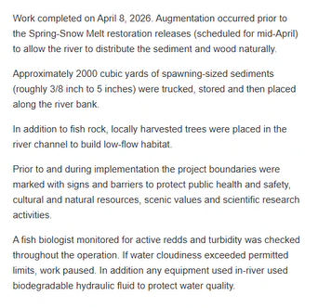
Eliot Sarnacki got drone images all the way down to the Treadwell bridge
Eric P installed hydrophones to detect when this thing begins to move
- Hydro Moth $150, goes in a PVC case on a T post
- Also have one at the TRLG gage to compare to the USGS hydrophone at the gage
- Objective is to try and compare onset of augmentation mobility with background transport
  - Pittman – these signals may not be comparable, they are site specific
Kiana will do an interview with Aaron and Smokey
- Also have public outreach to ask for hazard trees to be donated
  - Need project partners to actually take the trees down
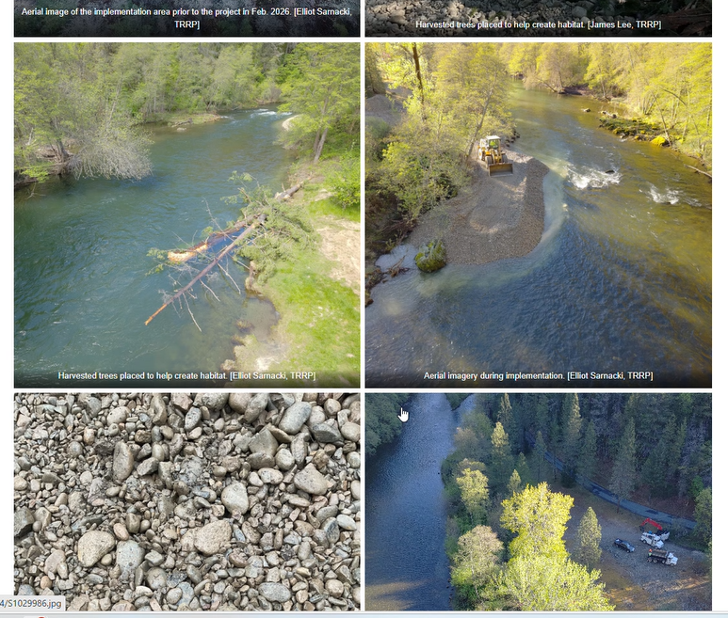
Gravel Augmentation Monitoring
EP: If need addtl funding, need to get this through the TMC if we want it in WY27
OR – could hold off until 2028
We have a lot in FY27 already. IDT meets May 4 to prioritize these things.
- FY Science covers one off-type studies – this is an ongoing need
- This is an implementation project, maybe that could cover it
Pittman – delivered presentation on elements of a monitoring plan which included:
- Reviewed TRRP sediment augmentation goals
- Problem statement:
  - Each year, the PWG is required to provide gravel augmentation recommendations to TRRP, however
    - In recent years, the PWG has been developing those recommendations with less information, as most of us are not in the field as frequently as we used to be.
    - To do the best job at making recommendations, we need to:
    - Have a better understanding of existing conditions in the river annually
    - Evaluate the performance of each site, based on site specific gravel augmentation objectives
- Pittman led a brainstorming session which included:
  - Review what data streams currently exist for gravel augmentation monitoring
  - Identify data gaps
  - Identify the key elements for:
    - Conducting routine gravel augmentation monitoring
    - Developing site specific objectives for existing sites
    - To the degree possible, provide provisions to include monitoring for fine sediment and wood. This is a lower priority; we have little experience here so maybe leave out for now?
- The group reviewed and commented on the elements of a monitoring plan:
  - field observations,
  - topography,
  - repeat photography,
  - grain size assessments,
  - mobility and scour experiments,
  - sediment sampling,
  - bedload monitoring,
  - hydrophones,
  - turbidity,
  - spawning habitat mapping.
- Existing data streams:
  - 5-year topo/bathymetry
  - 5-year topo differencing
  - 5-year updated SRH2D
  - ~5 -year grain size mapping (2014 and 2024)
  - 5-year bar area mapping
  - Annual aerial photography
  - Annual spawning use mapping
- TRRP objectives related to gravel monitoring:
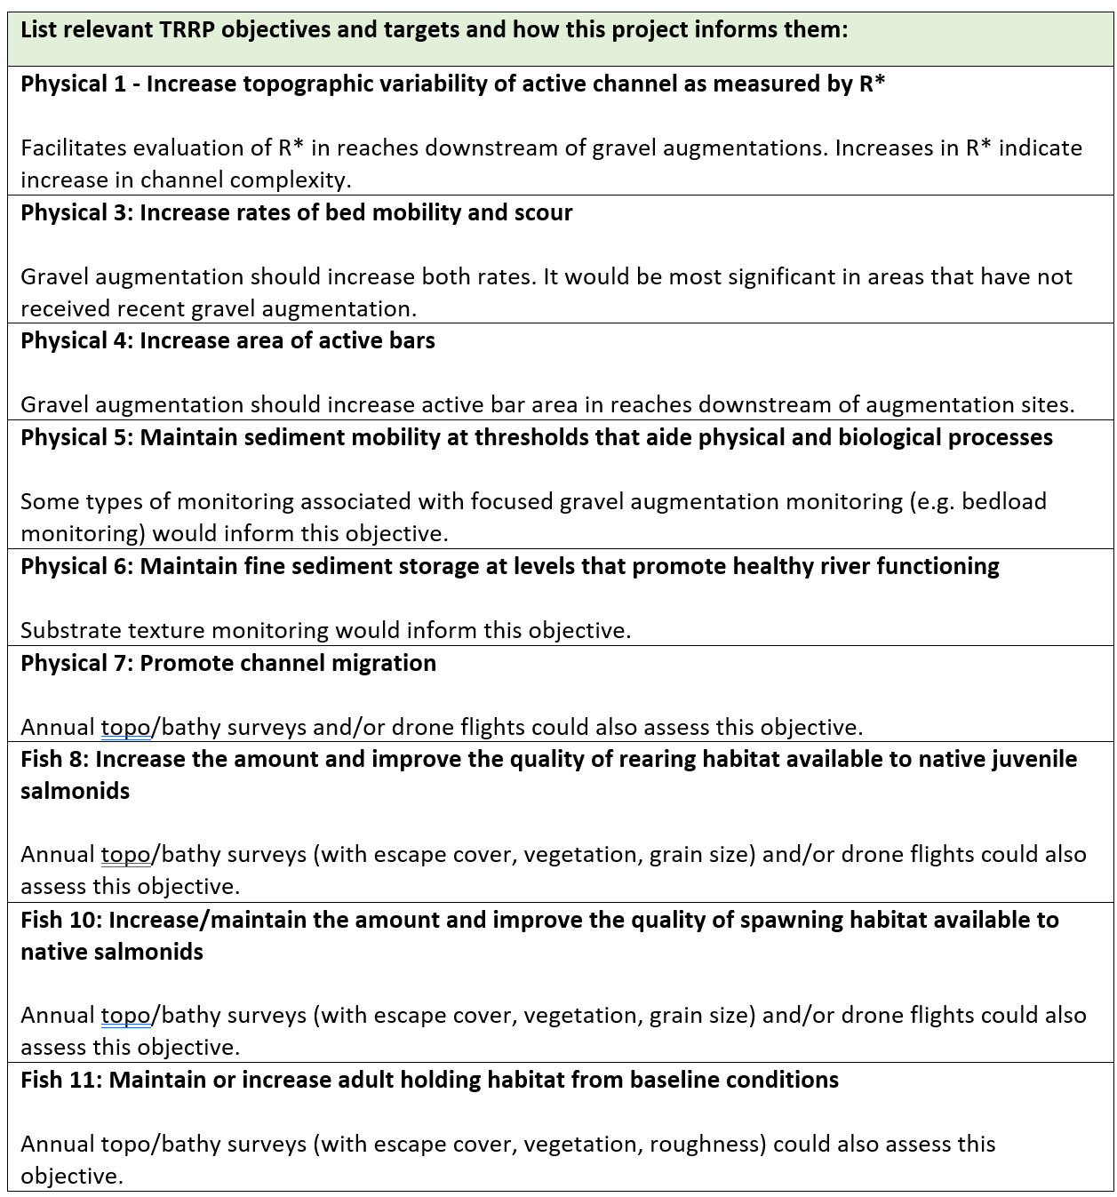
- The group decided that the preferred approach would be for TRRP to set aside ~$50k per year for monitoring and the scope would be dictated by the PWG each year. Pittman went through each element and will bring the results of the discussion into a 2-page brief for TRRP to consider.

2027 Topo-Bathy – Cort Pryor and Ben Hocker
EP:
Last survey was 2022
WVF monitoring provides additional incentive for full topo bathy – we will have findsihed 3 years by then
Cort:
Yurok Tribe successfully used Green LiDAR (GL) and Upper Conner Creek with great success
This is now a mature methodology – can penetrate to 2 Secchi depths
Got up to 19 ft of penetration on the Trinity River, would still require some areas of bathy infill. Trinity is so clear, it is ideal for GL
GL gets up to 40 pts/m² (a lot less than multi beam [MB] and nowhere near enough to do Scott’s grain size mapping method)
The last survey spanned 8 months, so not a true snapshot of static geomorphic state
GL would take ~3 weeks, done from a helicopter at 500-1,500 ft, much safer than doing the 5-method traditional method (multibeam, terrestrial LiDAR, sweep sonar, single beam single sonar, wading RTK). Note that the historic methodology is no good for grain size either
Radley Ott concurs that GL is ideal for Trinity River
GL provides a much cleaner dataset (no anomalies from overlapping MB lines)
The PWG endorses the Green LiDAR approach for Trinity River data acquisition 2027.
Bedload Sampling on Trinity River
This topic was postponed for a future meeting

