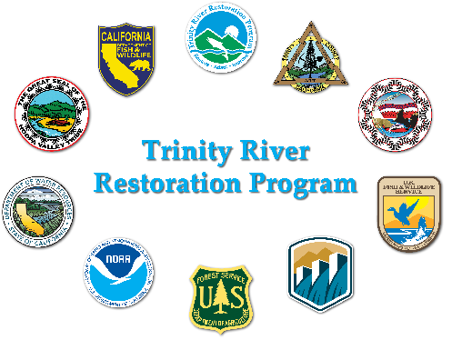
Physical Workgroup Meeting

2026-04-17 (Friday) 0900 – 1600
Location (Teams)
Join: https://teams.microsoft.com/meet/21656567571530?p=94u12xgszh3eaVwV94
Meeting ID: 216 565 675 715 30
Passcode: 2zE34YL9
Meeting Coordinator: Smokey Pittman
Desired Outcomes:
  - Develop a proposal for sediment monitoring to support gravel augmentation recommendations
  - Bedload sampling – need to make a recommendation to TRRP regarding whether to collect additional bedload data, primarily to calibrate hydrophones
  - PWG recommendation for bathy LiDAR 2027 data collection
Please review:
- M&M Review: Additional Sediment Monitoring Needs
Prior Action Items:
- NA
Time | Topic | Person
0900 | Meeting organization and introductions | Pittman
0915 | Progress on the Steel bridge augmentation project to date | James Lee
1000 | Gravel augmentation monitoring | Pittman
1200 | Lunch
1230 | Gravel augmentation monitoring | Pittman
1300 | Trinity Bathy/topo, green LiDAR discussion | C. Pryor
1400 | Wrap up Gravel Augmentation Monitoring | Pittman
1500 | Bedload transport monitoring – do we need it? | All
1600 | Adjourn

