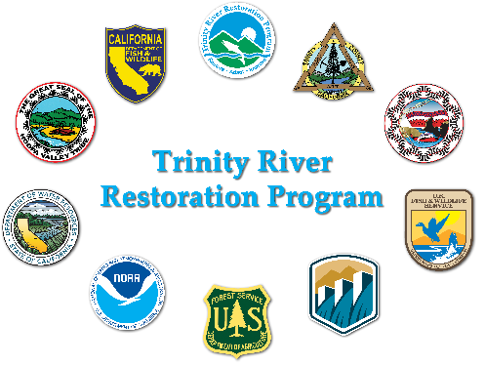
Joint RAEWG and Physical Workgroup Meeting

2026-03-11 (Tuesday) 0900 – 1300
Location (Teams)
Join: https://teams.microsoft.com/meet/2435988794644?p=IZOPrCTiUjqiGcR6Sn
Meeting ID: 243 598 879 464 4
Passcode: VY37mN3e
Meeting Coordinator(s): Smokey Pittman and Bradley Nissen
Desired Outcomes:
- First half of meeting (0900-1100, both WGs)
  - Discuss and provide recommendation to TRRP for large wood and sediment augmentation at Steel Bridge Day Use Site for 2026 Implementation
  - How to place the gravel?
  - How much wood?
  - How to place wood?
  - Review TRRP concerns for downstream bridge
- Second half of meeting (PWG only, 1100-1300)
  - Presentation from former USGS researcher Scott Wright: Novel techniques for assessing grain size distributions on the bed of a large river
Please review:
- James Lee’s original email request
- Sediment and wood augmentation EA
- Link to TRRP bridge elevations file
- Hydrograph recommendations (peak flow magnitude)
Prior Action Items:
- NA
Time | Topic | Person
0900 | Meeting organization and introductions | Nissen
0915 | Progress on the project to date, outstanding TRRP questions/issues, approximate timeline | James Lee
0930 | Augmentation Recommendations Discussion (all) | Pittman
1100 | PWG Updates | Pittman
1115 | Scott Wright Presentation | Wright
1215 | Open discussion: Recommendation for GSD mapping to TRRP? | All
1300 | Adjourn

