Trinity River Restoration Program
P.O. Box 1300, 1313 South Main Street, Weaverville, California 96093
Telephone: 530-623-1800, Fax: 530-623-5944

NC-152

MEMORANDUM

To: Trinity Management Council (TMC)
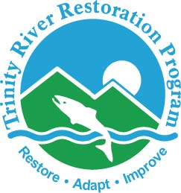

From: Mike Dixon, Executive Director
Trinity River Restoration Program (TRRP)

Subject: Director’s Report

Date: December 5, 2025

Major TRRP activities between September 2025 and December 2025 include:
A significant portion of the program were furloughed for Upper Conner Creek is essentially complete and equipment has been removed, though there will be further revegetation next year. TRRP Office and partner staff continue to work toward a draft of the Trinity River Division (TRD) Supplemental Environmental Impact Statement (SEIS).

Organizational Updates
At present, the TRRP Office has the following vacancies: Physical Scientist (x2), Natural Resources Specialist (Data steward), Natural Resources Specialist (Compliance). We do not anticipate being able to fill any of these vacancies during this fiscal year.
Kiana Abel continues to serve as the TRRP public affairs specialist despite being reassigned to the Department of the Interior Office of Communications as part of a broader consolidation of mission support/business services functions in the Department. We should know more in early 2026 about her future level of involvement with TRRP.
Mike Dixon remains in an unofficial detail as acting Deputy Area Manager for NCAO in addition to his duties as TRRP ED.

Budget Updates/Adjustments:
Because DOI Acquisitions staff were furloughed and have an incredible backlog to start working through once this funding logjam breaks, they have unfortunately requested the full 90 day budget, policy, and legal review period before processing Annual Funding Agreements (AFAs), so our hope of funding them in January is probably dashed. However, considering that both are nearly cut-and-paste exercises from last year, there could still be hope of these getting through sooner than they are saying. The Hoopa Valley Tribe initial AFA package was submitted for review on November 21. We are still waiting on a budget for the Yurok Tribe initial AFA to complete the package before it can be submitted for review.
We have received 33% of our FY25 appropriation level for FY26 operations through the expiration of the current CR on January 30, 2026. We have the green light to fund agreements proportionally to our available funding, so it is likely that agreements, including AFAs, that are funded before Jan 30 will be funded at 33% and additional funds will be added as they become available.

Implementation Updates
Channel Rehabilitation Projects
- Sawmill Gravel Processing Site: Gravel processing resumed in late September and is ongoing. The channel rehabilitation and remediation project at the site is partially funded now and will occur in 2026. TRRP intends to fully fund the remaining channel rehabilitation work and revegetation in the CY 2026 AFAs.
- Evans Bar Channel Rehabilitation Site: The State/Yurok Design Group submitted a 30% design last quarter. The Reclamation Value study that was previously scheduled for October 2025 was cancelled because of the federal furlough and was rescheduled for the week of January 26, 2026 . Permitting is underway this project should be ready for implementation starting in 2026.
- Upper Conner Creek Channel Rehabilitation Site: The civil portion of the project, including the river access portion, is complete. Revegetation is also largely completed and no equipment currently remains on-site, but some additional plants are scheduled for deliver in Spring 2026 and there will be some additional work at that time. A post-implementation walk-through is scheduled for December 11.
- Rush Creek Confluence: TRRP intends to fund 60% designs for this project in the CY 2026 AFA.
- Sky Ranch Channel Rehabilitation Site: The design for this site remains at the 60% stage. This site remains a high priority for implementation; however, moving forward with NEPA and finalization of the design requires the finalization of the land transfer to USFS, which continues to see delays. It is unlikely that this project will be implemented in the near future.
Watershed Programmatic Environmental Assessment
FONSIs were signed by all cooperating federal agencies in summer 2025. The BA/BO is underway and is expected to be completed soon. A Determination of NEPA Adequacy is being fine-tuned to streamline implementation.
Sediment and Wood Augmentation
The Implementation Branch submitted a conceptual plan for sediment and wood augmentation in the hatchery reach to the Physical Workgroup as a starting point for a 2026 augmentation project plan, and the PWG continues to refine this plan, but no formal sediment or wood augmentation plan for 2026 is complete at this time.
Watershed projects:
- Deadwood Creek: (5 Cs) This project includes accelerated wood recruitment and rolling dips on roads. NEPA should be fast and BLM is heading NHPA portion. BLM has several projects ahead of it, but we are expecting permitting to be completed in the next several months, and implementation in 2026. Will be tiered to the Watershed Restoration EA.
- Salt Creek: (WRTC) awaiting implementer’s cultural resources report as part of the NEPA process. Will be tiered to Watershed Restoration EA.
- East Branch of East Weaver Creek fish passage: (5Cs/Trinity County) NEPA is completed. Scheduled for implementation in June of 2026.
- Brown’s Creek Water Resiliency Phase II: (WRTC) Two landowners recently requested participation in this project and implementation is anticipated in Spring 2026.
Other
Smith Pit (HVT) TRRP committed to providing environmental compliance support to a project planned there, but there currently is a lack of funding to implement a project.
The TRRP Federal Design Group (which was more than decimated by the Federal Deferred Resignation Program) has cued up the McIntyre Gulch project for an existing conditions report and subsequent conceptual design.

Public Outreach Update

Publications and Education Materials:

The TRRP Facebook Page is up 665 followers since the last report (in September). We are currently at 1869 followers. We had four “viral” posts in October/November that brought in tens of thousands of views to our page.
October 7, October 10
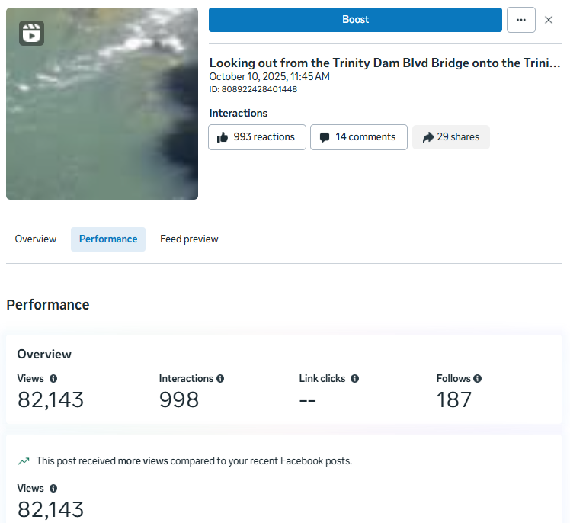
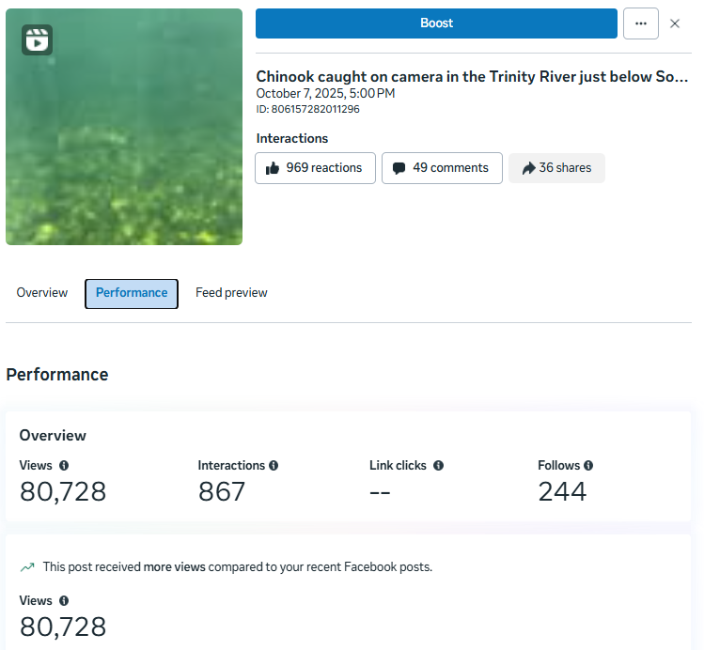

October 20, November 5
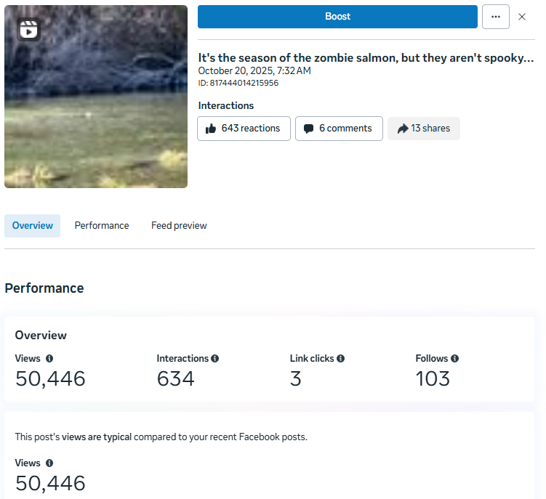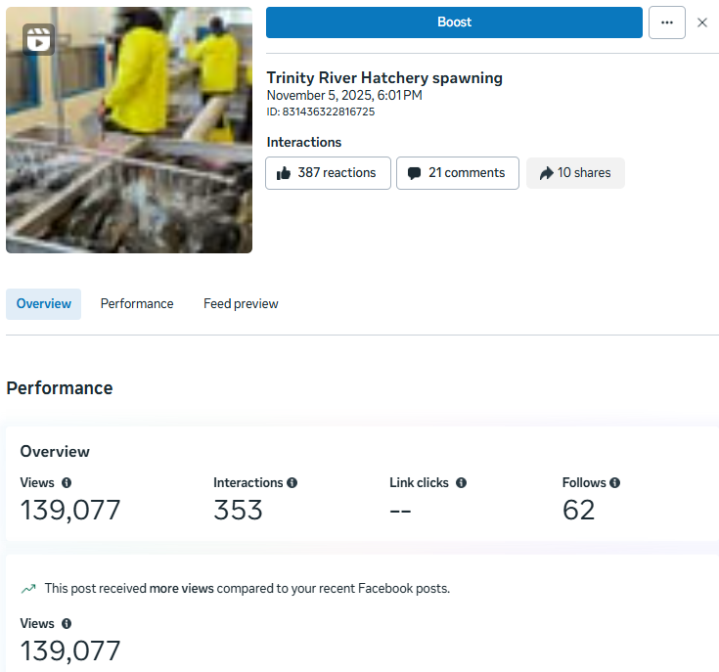

2024 Annual Report Story Map – complete but waiting approval from Reclamation Public Affairs to publicly publish.

Upper Conner Creek Interpretive Sign – hope to install in January.

Public Events and Environmental Education
October 1: Salmon Harvest Fest
October 15: Riparian Ecology Lesson for Junction City Elementary 6-8th grade. Simone & James – keeping the heart pumping!
October 21: Science on Tap, Michael Kauffmann – Author, ecologist and founder of the Big Foot Trail Alliance spoke about the Big Foot Trail and Conifer Diversity in the Klamath Mountains
October 23: Quarterly HWY 3 roadside trash pick-up. Thanks to Elizabeth for joining us and we had our first ever volunteer.
No events scheduled for November/December
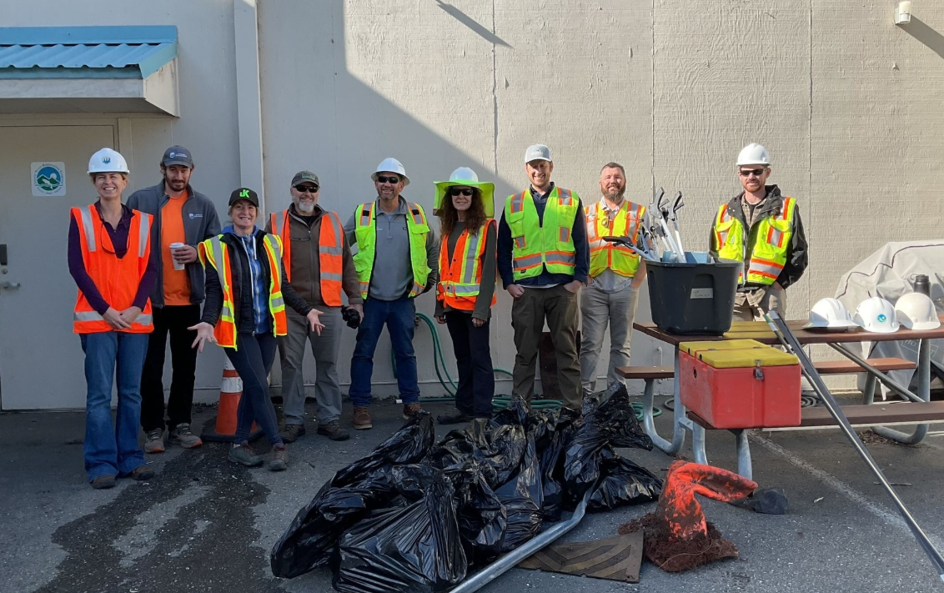

Landowner and Stakeholder Notifications
Upper Conner Creek Neighborhood – project “wrap”.
Notifications Environmental flow schedule for WY 2026
- River Front Landowner Mailing (sent 12/5)
- Press Release (for print in the 12/10 publication of the Trinity Journal)
- Forest Service Board Notification at Holiday Market (deployed 12/8)
- River Access point flyers (posted 12/8 & 9)

Science Update
- Limiting Factors Analysis (LFA). Phase 2 (implementing the study plan) contract spans Aug. 2024 – Aug. 2026 with Cramer Fish Sciences (CFS). The interaction between CFS and IDT has picked up while a life cycle model is rapidly developing, so the IDT and SAB met with CFS on November 5th and December 3rd. The IDT and SAB also met without CFS on November 21st to discuss parameters and possible scenarios so that we can better advise CFS on what must be accommodated in the life cycle model. Other recent topics of discussion have included how to address hatchery influences and how to spatially segment portions of the river.
- FY26 Science Priorities. The IDT brought two project proposals to the TMC’s June meeting with requests for funding: $126,614 for a thermal heterogeneity study using turtles for biological response, and $336,266 for adding variability of consumption into the S3 model inclusive of collecting calibration data. Given uncertainty over the FY26 budget, the TMC was reluctant to approve funding until more is known. These remain outstanding. However, the Science Coordinator has adapted one of the proposals (S3 Consumption; $336,266) to Reclamation’s Science and Technology RFP. Results of this attempt for external funding are pending.
- FY27 Science Priorities. The Science Plan provides a standard process for the IDT to develop Science Priorities and request funding from the TMC. Following that process, the IDT met in July to initiate discussion of FY27 priorities. While many ideas were discussed, the group recognized that the Environmental Flow Evaluation (below) may identify data needs and would be a top priority. Secondarily, we have recognized that the Monitoring and Modeling Review (below) may also result in priorities for FY27. There has been further discussion of unfunded FY26 proposals being forwarded to FY27. Lastly, our typical 5-year cycle for topography models will come around again in FY27. Therefore, we appear to have abundant needs for FY27 science planning and we will not have an RFP like we did for FY26.
- Monitoring and Modeling Reviews. Following the Science Plan’s requirement of a review of long-term monitoring projects, combined with a request from the Flow Workgroup to review our DSS, the IDT and workgroups have been developing reviews of TRRP monitoring and modeling projects. Thirteen of the 28 have been distributed within the IDT for an internal review and a deadline has been set for completing the remaining 15. Internal review by the IDT will be followed by external review from the SAB. The IDT has scheduled the process with the hope of providing an Action Plan for adjustments to the science plan to the TMC in time for the June budget meeting.
- Environmental Flow Evaluation. Following AEAM concepts, the IDT has called for a study plan for an Environmental Flow Evaluation (aka winter flow evaluation). This was also included in the HVT stipulations for recommending winter flows in WY25-27. The IDT identified a subgroup to complete a draft study plan. This group is currently working through a process to prioritize hypotheses. Methods to assess these hypotheses will be developed with a draft study plan available for review in winter or spring. Although most involved feel that the breadth of data from our existing monitoring projects should cover most needs of this study, the challenge will be the short time period of study (currently presumed as 3 years of environmental flows).
In Review or Final Edits
- Lindke, K. T., Video monitoring of fish passage at Willow Creek weir: feasibility of validating mark-recapture run size estimates. [Final edits]
- Bridegum, J., D. Goodman, T. Daley, R. Smit, J. Boyce, O. Black, J. Alvarez, and K. De Juilio. The Effects of Restoration Actions on Juvenile Salmonid Rearing Habitat in the Trinity River Restoration Reach at an Index Streamflow, 2009 to 2017. [Final edits]
- Martel, C. J. Alvare, Z. Reinstein, and K. T. Lindke, Fall Chinook Redd Environmental Conditions and Egg Survival to Emergence in the Trinity River. [Peer Review]
- Gaeuman, D., K. De Juilio, and C. Laskodi. Efficacy of two-dimensional modeling for assessing spatial variability in stream temperatures. [Peer Review]
Final Publications and Reports
- No new reports.
Remaining Synthesis Reports:
- Cohort Reconstruction – last substantive adjustments to the new model are being completed.
- Large Wood Management – in draft, engaged group between McBain Associates (ARS) and the Riparian Aquatic Ecology Workgroup
- Flow Synthesis – draft in process, eta near the end of the calendar year
- Channel Complexity – draft in process

Post-Implementation Reports

Final Data Packages
- 2025 Aerial Photography received, but not yet posted.

Appendix I: Technical Workgroup Briefings
September 2025

Updates have been prepared for the Trinity Management Council by the Trinity River Restoration Program Technical Workgroup (WG) Coordinators.
Workgroup: Fish Coordinator: Chris Laskodi
Pending.
Workgroup: Communications Coordinator: Kiana Abel
The Communications workgroup fall meeting was scheduled one day before the shutdown ended. Kiana is working on rescheduling discuss Workgroup initiatives and the 2026 Communications Calendar.

Workgroup: Design Coordinator: Oliver Rogers
The Design Team did not meet for a quarterly meeting primarily due to the protracted federal
government shutdown. The State of California-Yurok Tribe Design Team submitted the Draft
30% design of the Evans Bar Channel Rehabilitation project in time for Design Team’s review
and to provide comments and feedback ahead of the Value Study, but the shutdown forced
rescheduling of the study to January 2026. At the next quarterly meeting, the Design Team will
review the Memo from the Riparian and Aquatic Ecology Work Group regarding U.S.B.R.-
owned parcels along the Trinity River and solicit proposals and/or recommendations to utilize
these parcels in a way that is consistent with Program goals. The Design Team will also continue
to progress the Monitoring and Modeling Review task in accordance with the Design Team’s
Annual Work Plan

Workgroup: Flow Coordinator: Patrick Flynn
The streamgaging modeling and monitoring review has been completed.
On Dec 2, the Flow WG met to talk through any last-minute details for planning the synchronization flow event, and to begin thinking about spring flow planning for WY2026.
During the meeting, the workgroup expressed interest in reviewing the utility of the Decision Support System (DSS) used for flow planning. Many of the model outputs that are part of the DSS have not shown significant contrast between hydrographs in recent years. The workgroup talked about organizing our thoughts into a peer-reviewed white paper that will be transmitted to the IDT, then the TMC for review. At the IDT meeting the following day (Dec 3), the group continued the conversation and thought about ways to continue using the DSS, but also doing sensitivity testing on the existing models we have, which would hopefully result in better outputs from the models. The Flow WG will continue talking about these topics during our January and February meetings.
The Flow WG also talked about continuing to plan for diurnal flows during the spring flows. We talked about who might do that for us, since Todd Buxton is no longer with the program.

Workgroup: Physical Coordinator: Smokey Pittman
Pending.
Workgroup: Riparian and Aquatic Ecology Coordinator: Brad Nissen
The Riparian and Aquatic Ecology Workgroup (RAEWG) met on Sept 9 and Nov 17, 2025. At these meetings the group worked to:
- Revise and finalize a proposed temperature target for turtles, which was submitted for discussion at the Dec 3rd IDT meeting.
- Helped Simone Groves to chart a path forward for forming a sub-committee to work on the Wood Management Strategy document
- Drafted a memo on our summer field trip to two BOR-owned parcels with suggested uses for these properties that was submitted to the design team for their consideration in Sept.
- Discussed potential recommendations to the Flow work-group for possible flow modifications in the spring to assist with riparian vegetation management.

Workgroup: Watershed Coordinator: Justin Alvarez
No meetings.

Workgroup: Interdisciplinary Team Coordinator: Eric Peterson

The IDT met with Cramer Fish Sciences (CFS), along with several SAB members, on November 5th, to discuss the development of the life cycle model that forms the basis of the Limiting Factors Analysis. CFS is now deep into the crux of model development and requested feedback from the IDT on several details, including hatchery influences, segmentation of the river, and accommodation of scenarios of interest to TRRP. These topics and others as the model comes to fruition will require more frequent interaction between CFS and the IDT, so monthly meetings are expected for the near future. The IDT held an internal meeting to further discuss scenarios on the 21st of November.

On December 3rd, the IDT again met with CFS, plus held a regular quarterly meeting. The primary topic for this meeting was the ongoing Monitoring and Modeling Reviews being developed by the various workgroups. The IDT scheduled-out a plan that is expected to result in an Action Plan for adjustments to our monitoring and modeling that we hope will inform the TMC budget in June.

Appendix II: Report and Data Tracker
This indicates the most recent reports data received for active long-term projects, or their ETA for short-term projects. When submitting final reports and data, please include the Science Coordinator or Implementation Branch Chief, with cc to the Data Steward. See TRRP 2012 for details, with particular note to Appendix C.

Long-Term Monitoring
Topic | Frequency | Last Report For | Last Data For
Streamgaging (discharge, temperature at gages) | Continual | Not applicable | Realtime online
Reservoir Ops | Annual | Not applicable | WY2015 online  WY2022 @TRRP
Flow Report | Annual | WY2024 | [see above]
Aerial Photography (64 km) | Annual | WY2024 | WY2024
Topography (64 km) | ~5 year | WY2022 | WY2022
Hydrology (64 km SRH2D)  and Juvenile Capacity | ~5 year, new in process | WY2022 | WY2022
Height Above River and Wetted Areas | ~5 year, new in process | Not applicable | WY2022v
Grain Size Facies | ~5 year, new in process | Not applicable | WY2023 @ TRRP
Active Bar Monitoring (5yr) | ~5 year | WY2023 | WY2023
Riparian Vegetation | ~5 year, new in process | WY2019 | WY2019
Aerial Photography (as-built) | ~Annual | 2024 OG | 2024 OG
Topography (as-built) | ~Annual | 2024 OG | 2024 OG
Post Implementation Report | ~Annual | Oregon Gulch | -
LWD Surveys | Annual | WY2016 | WY2016
Temperature Monitoring (USFWS) | Annual | WY2021 | WY2009 @TRRP
Sediment Transport (Hydrophones) | Annual | WY2017
Sediment Transport (bedload) | Not active | WY2019 | WY2019
Outmigrant (Willow Ck) – separate report not required | Annual | - | -
Outmigrant (Pear Tree) – separate report not required | Annual | WY2023 | -
Outmigrant (Population) | Annual | WY2018 | WY2009 @TRRP
Redd/Carcass Distribution | Annual | WY2019 | WY2024
Chinook Run Size Estimate | Annual | Run 2022 | -
Fall Run Scale Age | Annual | ? PFMC? | ? PFMC?
YT Harvest (Lower Klamath) | Annual | 2022 | 2022
HVT Harvest (Lower Trinity) | Annual | 2023 | 2013
Lower Klamath Creel Survey | Annual | 2024 | -
Sport Harvest / Trinity Creel | Annual | 2004 | 2013

Short-Term Projects
Items will be retained for at least one TMC meeting after completion.
Initiated | Topic | ETA Report | ETA Data/Model
FY18 | Synth: Cohort Reconstruction | 2025 (Spring?) | 2025 (Winter?)
FY18 | Synth: Adult Salmonid Spawning | Pending 508 | overdue
FY18 | Synth: Channel Complexity | overdue | overdue
FY18 | Synth: Large Wood Management | Late 2025? | overdue
FY18 | Video Weir | In peer review
FY19 | Synth: Flows | overdue | overdue
2020 | Periphyton (single-year) | Posted: 2022
2020 | Periphyton (multi-year) | 2025 | 2025
 | Pool Stratification (analysis 2 pools) | Posted: 2022 | tbd
 | Pool Stratification (model) | Posted: 2022 | -
 | Pool Stratification (numerous pools, 3d flows and HECRAS 1d temp) | 1D temp: 2025, more in future | tbd
 | Hyporheic Flow | 2025? | 2025?
 | Lewiston Reservoir Temperatures | 2026? | 2026?
 | Updated RBM10 (merging Trinity with Klamath) | Trinity: _ | tbd
FY24 | Limiting Factors Analysis | 2026 (August) | 2026 (August)
FY25 | Inundation/Scour Model | 2025 (Spring) | 2025 (Winter)
FY25 | BMI sampling | 2026 (Dec) | tbd
FY25 | Riparian Response | 2026 (June) | 2026 (June)

