Manual for implementing variable winter flows and elevated
winter baseflows on the Trinity River, California
November 22, 2024
Updated November 13, 2025
The purpose of this document is to outline procedures for implementing elevated ROD water releases from Lewiston Dam prior to the annual spring flow release. The flow management action to shift Record of Decision (ROD) water to the winter/early spring period is described and analyzed in the Trinity River Winter Flow Variability (WFV) Project Environmental Assessment (EA) (CGB-ED-2024-047). The EA was drafted by an interagency team of Trinity River Restoration Program (TRRP) partners following the Trinity Management Council (TMC) directive in September 2020 to develop a winter flow action and Central Valley Operation (CVO) approval of the framework and water volumes to be analyzed in March 2021. For a variety of reasons, WFV was only partially enacted in Water Year 2023, then fully enacted in Water Year 2025. This document provides steps for implementation of the flow management action as described in the EA, adopted by the TMC, and approved by U.S. Department of Interior’s regional directors for the Bureau of Reclamation and the Fish and Wildlife Service. Updates to this document are expected as the procedures are applied and adapted.
Development & Approval of Winter Flow Components
The Flow Workgroup should complete a water year strategy by mid-August prior to the water year in which the winter flow schedule would occur. This will allow the Interdisciplinary Team (IDT) time to review and elevate Flow Workgroup recommendations for approval by TMC at their September quarterly meeting. The winter flow process is different than spring hydrograph development in that it doesn’t include a suite of modeling to advance the recommended flow components. The modeling is not feasible because roughly fifty different winter flow scenarios could possibly be implemented each year. As such, ROD flow releases in winter rely on analysis already performed in the EA, and evaluation of the winter flow action will occur within the framework of the Adaptive Environmental Assessment described in the EIS and the TRRP Science Plan.
Flow components in the hydrographs include a) an additional flow release above winter baseflow of 60-thousand-acre feet (taf) that could be triggered by a storm event from December 15 through February 15 during the Flow Synchronization Period, and b) elevated releases added to the 300 cfs ROD winter baseflow, based on the February and March B120 90% exceedance forecast of water year type. The Elevated Baseflow Period is February 16 through April 15.
To enact the EA as previously analyzed and in support of an environmental flow evaluation study, hydrographs for a storm synchronization event and for baseflow elevations were pre-developed based on temperature modeling spreadsheets from EA development and shall remain consistent for the first 3 years of full implementation. The storm synchronization hydrograph was developed to sub-daily (2-hour) increments that meet ramping rate requirements and the total volume of 60,000 acre-feet, which will be adjusted temporally to maximize match between the peak release and the peak of the forecast flow at the Trinity River above North Fork streamgage. The baseflow elevation hydrographs are pre-developed only to daily average values; as the likely volume scenarios become more clear, the Flow Workgroup of the TRRP will develop sub-daily elevated baseflow hydrographs for implementation under this plan. Some minor adjustments to daily averages may be required in order to meet ramping rates for some combinations of baseflow elevations.
Flow components developed for the elevated baseflow period (EBP) are required to account for water volumes described in the EA (Table 1) for the range of winter flow options based on the forecast of the five water year types (i.e., Critically Dry, Dry, Normal, Wet and Extremely Wet) and whether or not a pulse flow occurred in the Flow Synchronization Period (FSP). It is possible that if a synchronization flow occurs late in the FSP, the hydrograph may overlap with the EBP and should be considered additive. Figure 1 describes when elevated baseflow releases occur during winter and accounts for a release during the FSP and to include the full ROD volume shifted to the Dec 15 – April 14 period under the range of scenarios for a particular water year. All periods begin on the 15th of the relevant month and proceed through the 14th of a subsequent month.
Table 1. Water volumes shifted in acre feet (af) to winter period for each forecasted water year type (from Table 2-2 of EA).
Water Year Type | ROD Water Volume (af) | ROD Volume Shifted to Winter Period under Proposed Action (af) | Percent ROD Volume Shifted from Summer to Winter under Proposed Action
Critically Dry | 369,000 | 60,000 | 16%
Dry | 453,000 | 80,000 | 18%
Normal | 647,000 | 120,000 | 19%
Wet | 701,000 | 180,000 | 26%
Extremely Wet | 815,000 | 220,000 | 27%

TRRP Post-Approval Responsibilities
After TMC approval of flow components at the September quarterly meeting, and in advance of December 15, the TRRP office shall communicate with CVO regarding the approved water year flow strategy. This communication shall include the 2-hr release schedule from the daily average hydrograph developed for the FSP that conforms to EIS ramping rates and other rule sets. Note that the flow schedule will not change, but dates and times of the release will be adjusted to approximately match the scheduled peak to an anticipated stormflow peak. TRRP shall delegate individuals to track weather forecasts, identify triggering events, and communicate with CVO as detailed below (with minimum 72 hours notice).
The TRRP office shall communicate the EBP strategy to CVO prior to December 15 as well; the EBP flow components are largely informational at that time to give CVO a sense of what flow actions may occur. TRRP shall develop and communicate the likely sub-daily EBP flow components to CVO a minimum of 3 days in advance of the February 15 EBP onset, and again in advance of the March 15 EBP adjustment. The delegate serves as a point of contact between TRRP and CVO on any other matters that need to be communicated for flow actions during the winter period.
Implementation of Flow Synchronization Period
Beginning on December 10, a TRRP delegate and alternate will monitor the CNRFC’s forecasts at CNRFC - Ensemble Products - TRNC1 for TRNF (https://waterdata.usgs.gov/ca) to identify if and when a trigger storm event of 4,500 to 12,000 cfs is forecasted. The responsible individual is advised to check the forecast twice daily when weather patterns warrant elevated awareness. This responsibility includes weekends and holidays and, if the primary delegate is sick or on scheduled leave, authority shall be delegated to the alternate. The delegate and alternate should be able to receive email notification from CNRFC of forecasted flows reaching the range of triggering discharges but shouldn’t solely rely on the notification system. A CVO responsible individual should likewise be able to receive these notifications by email from CNRFC and phone by the TRRP delegate and alternate. Approval of the schedule by CVO may come in the form of the official Change Order.
When CNRFC forecasts a trigger event, the delegate will inform CVO that the synchronization trigger has been met to implement the previously approved hydrograph as a change order. The delegate will then immediately adjust the pulse hydrograph to meet the forecast peak, then communicate the schedule to CVO in order to initiate the formal notice. This hydrograph should have the first flow change a minimum of 72 hours after initiating formal notice. Note that it may not be possible to perfectly match the peak release to the peak of the trigger flow as forecasted, as following the 72 hour notice, 30 hours are required to increase to following EIS ramp rates. Additionally, to synchronize spatially as well, an additional ~15 hours is needed for the peak to travel to TRNF (although storm surges may not require travel time consideration). However, even if the peaks are not in perfect alignment, significant efficiencies for geomorphology will be realized due to the additive nature of accretions and the flow release. For Water Year 2025, the Flow Workgroup determined that once an event on the 5th day of the forecast triggers activity toward a release, that action will continue even if subsequent forecasts indicate a smaller storm event. This should be maintained for the duration of the environmental flow evaluation study.
A series of public notifications shall occur once a trigger event has occurred. An initial notice released as quickly as practical will state that a trigger has occurred, and planning has commenced, but the schedule for the elevated release is uncertain until a change order is released by CVO. The TRRP Public Outreach Specialist shall develop the plan for public notification, which will include initial notification through the Trinity flow listserv and the TRRP Facebook page as a pre-announcement to CVO’s posting of the change order to that listserv. The delegate shall then provide the same notice and hydrograph to TRRP’s Outreach Specialist and Data Steward for posting to the TRRP website. Notification on social media shall occur to the extent allowable by DOI policy. Prior to the beginning of the winter flow period, a seasonal notice should be posted at all boat ramps from Pigeon Point upstream to Lewiston by TRRP staff.
If the actual weather event results in a flow less than 4,500 cfs at TRNF, or if the forecast is lowered under the trigger value after the 4-day notice is provided to CVO, the flow action will still occur. Therefore, the delegate should be certain of the triggering event before initiating planning and public notice. At any time during this process if the flow event is predicted to exceed 12,000 cfs at TRNF, notice to the public will still occur, but the timing and/or magnitude of the release will be delayed or decreased until the forecast predicts the river will be less than 12,000 cfs, with consideration for flow travel time and ramping rates and at CVO’s discretion to mitigate risk of downstream flooding. If the ramp up to a pulse flow has commenced and observed flows at TRNF exceed 12,000 cfs and show no signs of decreasing before the dam release travels to TRNF, the TRRP delegate will work closely with CVO to reduce the flow release from Lewiston Dam to avoid the combination of winter flow releases and flows from tributaries does not exceed the Maximum Fisheries Flow (MFF). In consideration of flood risk, it should be noted that the MFF is 23,854 cfs at TRNF (DWR 2007). Since the maximum in-river flow contemplated during this period is 18,500 cfs (12,000 max natural accretion + 6,500 cfs release), the risk of exceeding the MFF is somewhat unlikely.
Operational Limitations at Trinity Dam during Flow Synchronization Period
The two turbines at Trinity Dam can each pass 1,500 cfs and are remotely operated. Another source of water is the auxiliary outlet. The auxiliary flows at 2,500 cfs (on position) or 0 (off position) and can also be operated remotely by CVO without an operator present at the dam. Ramping rates can be accommodated even with the all or nothing operation of the auxiliary outlet by passing water through Carr tunnel when it is operational, so only the scheduled Trinity River flow passes Lewiston Dam. The third option for releasing water from Trinity Dam is the hollow jet valves. These can release variable amounts up to a maximum of 9,000-10,000 cfs, but the valves require a person to be onsite to manually operate. Thus, at full operation, the maximum flow that can be remotely released from the dam is 5,500 cfs, which is less than the 6,500 cfs daily average peak prescribed in the FSP.
The normal operation for getting a person to Trinity Dam to adjust the hollow jet valves involves CVO notifying Shasta Dam operators of the TRRP 72-hour notice so an operator can be sent to make the valve adjustments. In consideration of worker safety, the NCAO Area Manager could decide that road conditions are too hazardous fir travel to adjust the hollow jet valves. In this case, as close to the maximum scheduled flow will be implemented, and the water volume that is unspent in this scenario will be made up in the elevated baseflow period.
There is a possibility that forward power scheduling could impact the timing of release during the FSP. Under most circumstances during the December 15 to February 15 period, power generation is scheduled two days ahead during weekdays and three days ahead on weekends, meaning up to a 72-hour notice can be incorporated into the schedule. Exceptions arise during major holidays when power generation is scheduled up to five days in advance. If flows within the operational capacity of the dam are not power scheduled, the release is considered an undisclosed impact to the power customer. Therefore, flows up to the operational capacity of the dam need to be placed on the look-ahead power schedule or, alternatively, TRRP could request an exemption from the Regional Director on a case-by-case basis. In troubleshooting this issue, CVO encouraged the Program to provide the schedule for increasing flow to 3,000 cfs as soon as a synchronized release is being ordered so they can attempt to get it on the power schedule or decrease power generation at another facility to accommodate Trinity Dam’s increased generation.
Regarding operational limitations, flood operations could also impact FSP release timing should safety of dam releases hamper the ability to implement the TRRP-developed hydrograph. If any of these operational limitations impact the TRRP-developed hydrograph after the 72-hour notice, determination that the synchronization event occurred will be based on whether 60,000 af above base flow had been released (i.e., volume is determining factor).
Implementation of Elevated Baseflow Period
The California Department of Water Resources typically posts the B120 forecast between the 8th and 10th of each month beginning in February. After a B120 forecast is posted in February, the delegate will use the 90% exceedance forecast and the decision tree in Figure 1 to determine if an elevated baseflow release should occur and at what volume. It is the delegate’s responsibility to develop the TMC-approved elevated baseflow hydrograph to generate a flow schedule into a change order with two-hour changes in discharge that conforms to EIS ramping rates and other rule sets. It’s suggested the delegate has the alternate or a colleague check their work. The delegate then provides the change order to CVO for implementation. Note that CVO requires 72 hours notice prior to the onset of release changes for EBP schedules as well. Should B120 forecasts be delayed, the delegate should be prepared with sub-daily schedules for the most likely possibilities reviewed ahead of time. The same protocol for public notice and posting will occur for elevated baseflow events as described for FSPs.
Spring Hydrograph Considerations
The customary process of development and approval of the spring hydrograph will not change, but the spring volumes available for release on April 16 will be less, reflecting the water year specific volume when synchronized flows and/or elevated winter baseflows are released (Table 1). There is a concern about possible discontinuity between winter and spring releases since the EBP releases only extends through April 14, thus it’s paramount that the spring hydrograph approval process occur and be implemented by April 15 each year to avoid a return to the 300 cfs winter baseflow, which could compromise ecological investment in inundated areas and greatly diminish benefits of the Winter Flow Variability project.
Annual Coordination Meeting
The TRRP delegates will schedule an annual coordination meeting with CVO prior to the winter flow action. The purpose of the meeting will be to exchange contact information and discuss the forthcoming possible winter flows and elevated baseflow releases.
CVO Contacts
Primary Contacts before 3p on workdays:
Tom Patton, Hydrologic Engineer, northern CVP, tpatton@usbr.gov 916/979.2196 (o) 916/279.0446 (c)
Randi Field, Water Operations Chief, rfield@usbr.gov 916/979.2066 (o) 916/866.2684 (c)
Cary Fox, Power Scheduler, cfox@usbr.gov 916/979.3005 (o), 916/212.8146 (c)
Secondary Contacts after 3p on workdays, weekends, and holidays:
Reclamation Control Center 916/979.3002
On-call Water Engineer 916/798.1892
TRRP Contacts
General Primary Contacts:
Mike Dixon, Executive Director, mdixon@usbr.gov, 530/351.4760 (c),
Eric Peterson, Science Coordinator, ebpeterson@usbr.gov, 530/739.9993 (c), 530/623/6459 (c alt)
Additional TRRP participants:
James Lee, Implementation Branch Chief, jclee@usbr.gov, 530/739.3662 (c)
Patrick Flynn, Trinity County + Flow Workgroup Coordinator, pflynn@trinitycounty.org, 530/739.5126
Oliver Rogers, Civil Engineer, orogers@usbr.gov, 530/784.1086 (c)
Chris Laskodi, Yurok Tribe, claskodi@yuroktribe.nsn.us, 530/351.4912 (c)
Kiana Abel, Outreach Coordinator, jabel@usbr.gov, 530/739.9761 (c)

References
California Department of Water Resources. 2007. Trinity River hydraulic flow study: North Fork Trinity to Lewiston Dam. Report by DWR for TRRP.

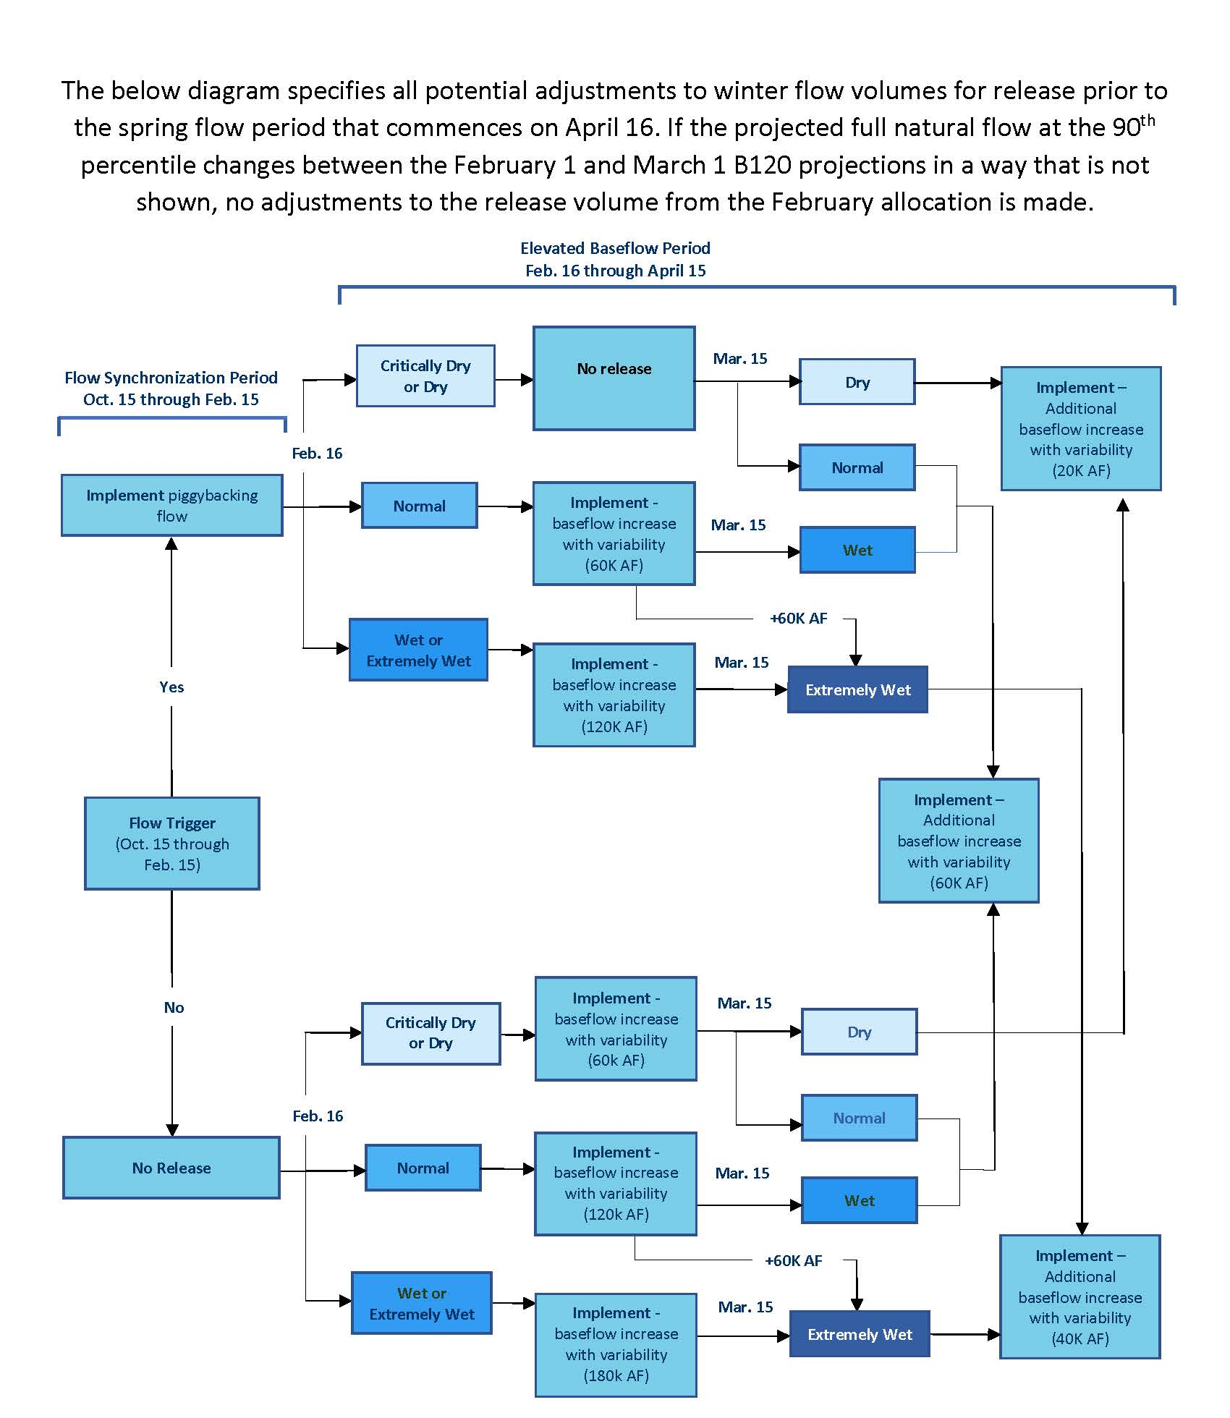Figure 1. Decision tree for implementing winter flow action.

CVO contact numbers are listed at the end of this document. In the event the primary contact cannot be reached, the delegate should attempt to contact the on-call Water Engineer, followed by the 24hr. Control Center if contact with Water Engineer is likewise unsuccessful.

