December Quarterly Meeting Notes

TRINITY MANAGEMENT COUNCIL

December 4th–5th, 2024

9 a.m. – 4:45 p.m. PST

Caltrans District 2 Office. 1015 Butte St.

Redding, CA 96001

MS Teams Video Conference

Trinity Management Council (TMC) Members in Attendance (12/04/2024 and 12/05/2024)
Name | Representative Seat
Justin Ly | National Marine Fisheries Service (NMFS) Core and Chair
Mike Dixon | Trinity River Restoration Program (TRRP) Executive Director
Liam Gogan | Trinity County (TC) Core
Tim Hayden | Yurok Tribe (YTFD) Core
Elizabeth Hadley | U.S. Bureau of Reclamation (USBR) Core
Mike Orcutt | Hoopa Valley Tribe (HVTFD) Core⁴
Radley Ott | California Natural Resources Agency Department of Water Resources (CNRA-DWR) Core
Bobbie Miller | U.S. Forest Service (USFS) Alternate
Bill Pinnix | U.S. Fish and Wildlife Service (USFWS) Core
Others in Attendance (in-person):
Kelli McElroy, (USFS), Eric Peterson (TRRP), James Lee (TRRP), Shane Quinn (YTFD), Ken Lindke (CDFW), Tyler Wallin (USFWS), Justin Alvarez (HVTFD), Chris Laskodi (Yurok Tribe), Andrew Carhart ( )
Others in Attendance (Microsoft Teams):
Emelia Barnum (USBR), Vicky Ryan (USFWS), Kiana Abel (TRRP), Simone Groves (HVT), Emily Van Seeters (USBR), Zac Reinstein (Yurok), Patrick Flynn (TC), Eric Peterson (TRRP-USBR), Deanna Jackson (USBR) Brett Kormos (CNRA-DFW), Morgan Knechtle (CNRA-DFW), Elliot Sarnacki (TRRP), Francisco Martinezcuello (Trinity Journal), Oliver Rodgers (TRRP), Seth Naman (NMFS), George Kautsky (HVT), Karl Seitz (HVT)
Notes: Brad Stumph (Chloeta)

Wednesday, December 4th, 2024

(Scheduled from 9 a.m. – 4:45 p.m. PST)

Introductions (Mike Dixon)
Welcome and Introductions
Seth Naman will be serving as the NMFS representative until Justin Ly’s arrival for the afternoon session.
MD: There is not a presiding officer until the Vice Chair arrives. The bylaws do not define this situation, so we will proceed with informational topics until the vice chair’s arrival, anticipated to be after lunch [note: it was clarified later in the meeting that, per the bylaws, Justin Ly was actually Chair, not Vice Chair].
MO: TMC should have provided notification. There is an item that was removed from the agenda that was requested in September about PFMC work group process. I just sent a copy to you and the regional directors.
MD: I will need to refer to meeting notes but thought that we left it that the Tribe was going to request USBR involvement in the PFMC outside of the TMC, and that’s what I read in the letter as well.
MO: That was not my impression after the quarterly meeting in September and the last coordination meeting.
MD: That is something we can raise once the Vice Chair arrives. He is the only one who can call a motion right now. I apologize for the late notice. I sent something out last week letting everyone know that Justin would be absent for the first part of the day.
MO: We are getting loose on communication, but fair enough.
SN: Requests clarification on the letter being discussed.
MD: The letter was not to the TMC, it was addressed to Karl Stock of USBR requesting that USBR participate in PFMC including the Klamath subgroup to become more engaged in fisheries management discussions in the broader Klamath basin. There was probably a misunderstanding about whether that was being taken up outside of TMC or as an agenda item by the TMC. It wasn’t captured in the agenda. Once Justin arrives, we can discuss adding it to the agenda when we approve the agenda. We are now on to the second item on the agenda as originally planned, “comments on non-agenda items”.

Comments on Non-Agenda Items (Mike Dixon)

MD asks if any members of the public who have joined online would like to comment.

Public Comments
No public comments received.
Reports and comments of TRRP entities
MO: TMC is an advisory body. Communication exchange can be tightened up, finding information on the website and changes in monthly call numbers cited. In this case substantive issues were raised in September and discussed thoroughly at the last meeting. TMC has linkages directly to the processes I’m talking about, and we’ll take it up as we quote, unquote have the authority to do so.
MD asks for any other comments. There are none.

TMC Discussion and Comments

Program Updates (Mike Dixon)

Director’s Report
Mike Dixon reviewed Executive Director’s Report and shared it on-screen for all meeting participants. Comments and questions received during the report are recorded immediately below followed by the written report in its entirety.

TMC Discussion and Comments

Budgets
MO: What limitations does the new administration’s proposed budget have on FY25 budget?
MD: Because of the Antideficiency Act, we can’t spend money that we don’t have. If congress has not authorized funding, we cannot spend that funding. Agreements may be put on hold unless USBR has enough surplus funds in other budgets to cover existing agreements.
EH: If we get 3 months CR, we only get 3 months of funding. The CR expires on December 22nd so we hope to know more then.
MD: We discussed with Kevin Clancy and our financial assistance folks in Sacramento that we could finalize and approve an initial calendar year annual funding agreement for the tribes. But funding may be proportional to what is available with funding mods to push the full funding out.
Implementation
MD: Next year will be very busy with three quarters of the work scheduled for UCC and additional work at Sawmill Ck. It is worth noting that Deadwood Ck. produces a lot of sediment after the Carr Fire. In the last storm event, less sediment produced than in similar sized storms. There were no major slope failures. We expect to lose redds to siltation after storms. Hopefully this was much less of an issue with the most recent storm.
MO: The Watershed EA, how long has it been going on? I’m interested in the utilization of artificial propagation techniques to recolonize streams. What is the scope of it? Who is the regulatory authority that signs it?
JLee: It’s been going on for a few years and includes remote-site incubators.
MD: It includes the whole suite of non-main stem and main-stem activities (flow enhancement, riparian restoration, fish passage, etc.).
MO: Including delta formation? Watersheds are contributing to delta formation in some cases.
JLee: I suppose indirectly through soil stabilization and sediment retention in tributaries junctions will be addressed but it is not taken on directly but indirectly.
MO: A lot of it is on USFS land. The scope is broad.
MD: And BLM and USBR, and USFWS joined late. We were trying to be as broad as possible to include each federal agency that could have a federal action associated with a restoration project to have programmatic coverage to streamline the permitting process for site-specific work. The broad inclusivity has made it a very slow process.
KM: What is permitted in BLM is different than what is permitted in USFS as far as programmatic processes. Threading that needle has made this a very slow process.
MD: An activity I forgot to mention, carcass augmentation is thought to be valuable in streams that don’t see the salmon runs that they should in terms of returning marine derived nutrients into the systems. Hopefully a public draft early in 2025.
Emily VanSeeters: I’ve been working with Lauren on the programmatic EA. As new sites are implemented a supplemental document will be attached for remote stream incubators.
Public Outreach
MD: RISE academy is a public school whose students are not on track to graduate without intervention. So, this is a unique program and unique opportunity for outreach for a group of students that probably doesn’t get many opportunities like this.
KA: Elliot had a presentation about using the drone to map the area, and the kids were really engaged. They helped in the launch process. The photos of the restoration work allow everyone to witness the change over time.
MD: A link will be shared for Darren Mireau’s SOT presentation about the removal of the 2 dams on the Eel River, probably through a River Riffle. Having a dedicated public affairs specialist, Kiana, has helped us provide a lot of information in ED memos as well as get information to public user groups.
MO: Public relations has been controversial throughout the life of this program. The program needs to reflect all the membership here. There is a strong tendency to amplify things. Information and how it is expressed in the public is important. I work for leadership representing 3,600 people on the Hoopa Valley Reservation. Sometimes the messages get skewed. My last question would be you had an article about the redd surveys. I’m not sure you did a retraction or updated that. Often a lot of times these things HVT when there was no money in funding went after these monitoring things over time historically. When you say something and there is this that one or this one, it gets spun certain ways. I know it’s a hard job to do. I’m open to suggestions on an advisory committee. You guys have all the federal regulations nailed down. However this body gets involved in that actively and positively, I’ll just leave it there. Suggestion for a future discussion if nothing else.
MD: Kiana and TC RCD who we collaborate with on a lot of this work develop annual program of work where there are topics we are intending to highlight. There is this multi-pronged approach to how we hit those topics throughout the year. One of the things that has been discussed is the possibility of standing up an annual ad-hoc work group so that TMC partners can participate in the development of an outreach plan. That is something we could consider and something the TMC may want to push forward because only the TMC can establish technical work groups. That may want to be a TMC topic for March to inform the group similar to design and flow work groups routing proposals up. We could conceivably convene a body that meets annually to contribute thoughts on topics that we should be highlighting. I’m spit balling.
MO: I appreciate that. There are other things this body is not even involved in, hatcheries for example. The report talked about those. Those are major things that are out there.
LG: We have been talking about having a stakeholder's group similar to TAMWG for the last year or so? Where are we at with that?
TW: That’s my position’s responsibility. Establishing a federal advisory committee is a minimum of an 18-month process. It all goes through the executive branch from the Secretary of the Interior up to the White House. We were not going to be able to complete the process before the election and potential change of administration. We will be able to pursue it now.
LG: What is your timeline now?
TW: Timeline is uncertain and dependent on the new secretary and their stance on those advisory committees.
LG: If I remember correctly, last time Pres. Trump nixed the TAMWG.
TW: Yes, it failed to be renewed.
LG: Do you feel that is a possibility again?
TW: I don’t think there has been any communication about advisory committees.
BP: That was part of the hesitation of moving forward, the fear of it being dismantled given the effort it takes to set up. Ty has been researching other large programs with advisory committees that don’t meet the level of a federal advisory committee. We are trying to scope what that looks like and how it can be implemented in Trinity River as an alternative to federal advisory. We are waiting for direction from the incoming administration. But we are taking steps to come up with an alternative structure that allows input from affected businesses, landowners, power generators, etc.
LG: What are the steps? I would expect a similar result to first Trump administration. Without having a schedule advisory board, what does that look like and what is the timeframe on it?
BP: That is essentially bringing proposals to this body. I feel like we can have some proposals by the March meeting. I think that is the appropriate way to do it; have the TMC decide that this is the type of group that could work and facilitate the appropriate input. There are some fine lines about how the information comes to the group. At some point it might cross the line into the federal advisory committee. We need to lay it out in a way that we can receive the input without crossing the legal threshold.
LG: Understandable. If we are in agreement, can we have this on the next agenda, so that we can start working on it and find out how we circumvent the federal part of it and just get a stakeholders group that is not a federal.
BP: I suggest that we frame this up for the January call. At that point we will know how ready we will be for our next in-person meeting. I can’t commit to that right now. We’ve done quite a bit of investigating, but we want to pull together a package that is actionable.
LG: Given those other groups that have a non-federal committee, TAMWG, is it based purely on people of the public and no federal or state employees? Is that where we cross the barrier?
TW: If any members are recommending a government entity to take action that are not a government entity themselves. For example, county, state and federal government or representatives that are hired to act on behalf of a government agency sit on the TMC. If there is anyone that is not a government representative or contracted to be a government representative, then it becomes a federal advisory committee. Then the government is concerned about who is providing recommendations for government actions. If there is a single voice that is not a government representative, then process needs to be equitable for all voices interested in those actions.
LG: And we would open it up to everyone that could possibly participate?
TW: That would be where it would start. If we go the advisory committee route, the groups represented on that committee would have to be approved by the Secretary of the Interior.
LG: And if we don’t?
TW: We could not expect to receive any consensus advice. It’s more informal feedback sessions. We can’t use any kind of standardized forms, because that is the alternative to advisory committees and then you have the paperwork reduction act. Those are the two things that we have to shoot the alley between and maintain compliance with both.
MD: A key point that you hit on Ty, and we’ve run into this in other contexts and had to get solicitor input on our science advisory board was triggering a federal advisory committee obligation. If a body is making a recommendation to the federal government that is one of the triggers. Individuals can discuss things and make statements and recommendations. But once a body is making recommendations that holds non-federal employees as part of that body, then it does trigger FACA. That's one of the important discriminators. When can send out, there's policy write-ups on what the FACA Federal Advisory Committee Act is and what the limitations are if it helps understand how we might work around those to still get that sort of feedback.
RO: I think that'll be good, so we know what our sideboards are as we go down the path. I agree with Liam. I think we're doing the program document. I think this is something the state really wanted to advocate for, and so I think as much as we can learn to help facilitate this process (indecipherable).

LG: I'm just using it more as a public outreach tool than TAMWG was. It’s more communication, more people, more local stakeholders, whether gas station or restaurant, to be involved. And then you get, for me for instance. Going in the store I see hundreds of people a day, people who own restaurants, gas stations. There's a lot of public outreach that gets done just simply by being where you are. We communicate with a lot of people.

RO: One of the things included in that program document, which I think is really important, and I don't know if is a pocket trigger or not, is to provide education to that group so they are able to hear from our science teams, and they're able to understand all the nuts and bolts. Because for them to give informal, or, if it's a thought group, formal recommendations that they understand all the nuts and bolts so they make an informed decision. I think that was one of the things that's really important in that program document. I think we can do that without triggering FACA.

LG: I think it’s more of an informational tool. I think you have 90% of the general public not really understanding what's going on. They see a closed fishery and (undecipherable) not doing their job. That's how that comes out. So, I think to get as many people in the general public as knowledgeable as possible, right. This is why we're doing things. This is how long it takes to do things. You know, the general public is not that knowledgeable about what we do and what restoration does and all the limitations that they have.
MD: I think one other thing that becomes challenging, though, is what Ty raised. The key word is that we need to provide equitable opportunity because the program serves 340 million Americans. How do we make sure that commercial fishing interests, water interests, power interests, and general environmental nonprofits that have a similar overlapping interest in what we do in a way that's structured enough to reach those people, rather than just open hearings, without triggering FACA. So that's where it's going to take some thinking about, how do we frame this in a way where we're really reaching all of the interested parties and not just specific parties? Otherwise, it's not equitable and we're not meeting our obligations to all Americans.

LG: Are those lines not clearly drawn, on who we can have and who we can't if it's a non-federal advisory group?

BP: I think it more speaks to the structure of the group, and how you can find the group, and whether it's got members. If it's just a regular, occurring informational and feedback gathering, I think that's okay. It's how we receive that input and how it gets incorporated is where there's trickiness. We can tee up more of an in-depth discussion. When is the next in-person meeting?

MD: We haven't set our dates yet. That's one of the agenda items, but it will be March in Weaverville.

LG: I think that'd be a good idea to start that way. Obviously, anybody that would have any federal connection like that would not be included in this group. If Ty wants to go down the FACA road that's fine also. But in the interim, because I know that's going to take a long time, we're back to day one, I guess, with the administration. So, we're 18 months out or so there. That's a long time to wait to see if it works or it doesn't work. In the interim, I think just having a general stakeholder's group, are just people from the public that are in the scope of influence of TRRP/TMC would be very beneficial.

MD: I should raise that maybe we're looking at it from a backwards lens. The issue that triggers FACA is when there are non-government employees involved. So there's nothing that would prevent other government entities from also participating in this group in the way that we have other government entities that don't participate in the TMC, but we probably want to participate in those sorts of discussions like education, like Bureau of Land Management, the Western Area Power Administration, and groups like that that aren't actually on the teams, possibly in other state agencies. So, I think we can still loop them in. That doesn't trigger FACA. It’s the opposite. It's including non-government that triggers FACA.

LG: Yeah, that's fine. My goal is to not trigger FACA, knowing that it will probably be non-starter in the next four years.

MD: We should talk before the January meeting. One of the things that comes to mind as maybe an imperfect model, but certainly a model that could be used for something like this is what the quarterly WIIN act meetings that Reclamation does. Anybody can attend them, anybody from the public. They are widely attended by different stakeholder groups, agencies, general members of the public, and it's an opportunity to present and take questions and comments. It's not great because they're largely virtual because of the breadth of the audience. But maybe we could do a hybrid meeting sort of thing, where we would have in-person meetings and virtual comment for non-local entities. It’s something to think about. We can talk at the January meeting.

LG: For the public outlook on this, I would try to keep away from entities that aren't included in the scope of Trinity River and what we do here. Having participation from the general public, their input is their input. It's not going to be taken under advisement, but it's not going to be like TAMWG was. But it certainly is a tool that restoration should use to solidify their thinking and let the public know how this whole thing actually works. The general public doesn't have a good understanding of the complexities of what goes on here, and then what goes on trying to implement some of the projects, what the follow-ups are, the roadblocks that you run into. I think those things are lost on the general public. Having a stakeholder's group, or just people you know from, say Trinity County, would be good, or people in the range of the scope, would be good for the time being. I think that with the new administration coming on board, and I think you see some of what we saw last time, that's not going to be prop up the FACA group, I would imagine.

KM: I look at the Trinity County collaborative as being another example of a non-FACA entity of stakeholders that helps inform the Forest Service, land management agencies, but it seems like it's a similar function.

MD: It'd be worth talking to Kelly Sheen to see how they're threading the needle on FACA, because I've looked at the collaborative before and am like how is this not a FACA committee?

KA: I think it's led by the RCD. That's primarily why, right? And then they ask agencies to come in and present.

LG: So, I guess what I'm trying to do away with is the haphazardness of the people that show up. And to get those 14 or 20 people, or whatever it might be, you are the ones, not just who shows up this random week. Then you get what we got. Now, some people show up some don’t, and the message gets mixed in the middle. So, I think that you want to pick out, you know, whatever the number is going to be, a dozen, 18 people, whatever it might be. Like, we are held accountable to show up to these meetings to hear and see what goes on, instead of it just being random people who might have that day off. You know, set time, set dates. 18 people, 12, whatever it might be, you should show up because you're on this group advisory to listen and hear what we do and to extend the public outreach that is lacking.

KA: I love that you're talking about this, Liam. This is the nexus of why I thought having a work group would be important for the program. I think there's a lot of challenges in making it relevant and worthwhile, and then also figuring out who it's directed at. There's a component like having it be for the public, like a pre-FACA committee, like everyone's discussing. Then there's a component where having local entities involved in restoration work, and also a lot of other community outreach work. And then also there's the agencies that we work with within the program itself. These last few months I've been thinking about how to make it the most worthwhile for everyone involved. Eric’s and my plan is, I mentioned Eric because I think the plan is to have a discussion at the IDT level in the next couple of months at the next meeting. It’s still really messy in my head. If there are folks who are willing to sit down with me to discuss, what this really means for the program, and how best my time is served, because I'm already really busy. That's where I'm at with it right now, but I think that it is moving forward in a positive direction. When I'm coming at it from a public outreach side, I really want to involve the public. I want them to come, and I want them to be engaged, and I want it to be the right people like you're saying. But I also want the TMC and all the partners that are sitting around that table to be also engaged. At the last TMC meeting I was asked, “what does that mean for our agencies?”, and I didn't have a really good answer. I didn't know how it would be effective for all of you guys. Maybe it's a different answer for each of you, for each of the agencies, and I just don't have all those answers yet.

LG: The effectiveness of it is not really with us. We kind of know what we're doing. We are in this box of things that we're going to do. The effectiveness of it is to get people to see that what we are doing. Nobody from the general public that I know of is going to sit down at this meeting and understand everything we're talking about. They probably understand very little that we're talking about.

KA: Yeah, it took me a year to really figure it all out. I mean, being here five days a week. It took me a long time. It's not easy stuff, for sure.

MD: So, at the risk of derailing what has become a pretty productive conversation, I would like to move on because we're over our agenda time for this topic, I'm going to refer TMC to the notes for science updates, with the disclosure that there's not a whole lot of new developments on the science front. Eric has to drop off, and we're over our agenda topic time. I apologize. Eric's out dealing with a family issue. I was hoping he was going to be able to call in, but this went longer than the time that he had available this morning.

LG: So let me just throw one more thing in there. The county would like to be involved in this, having five supervisors, five different districts, I think that we can probably come up with a decent, somewhat informed group of people to be on that group.

MD: It's something we should discuss in March. There's nuance to how we can pick and choose and who gets to participate. With that, let's move on, Elizabeth, you're up on the CV Central Valley operations update.

Reports and comments of TRRP entities

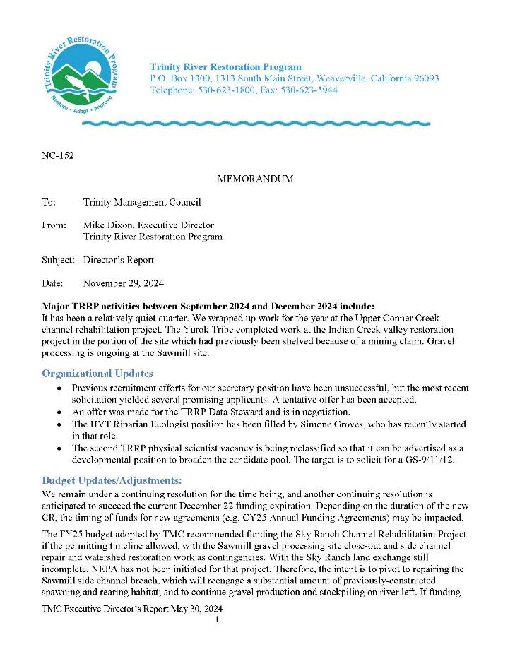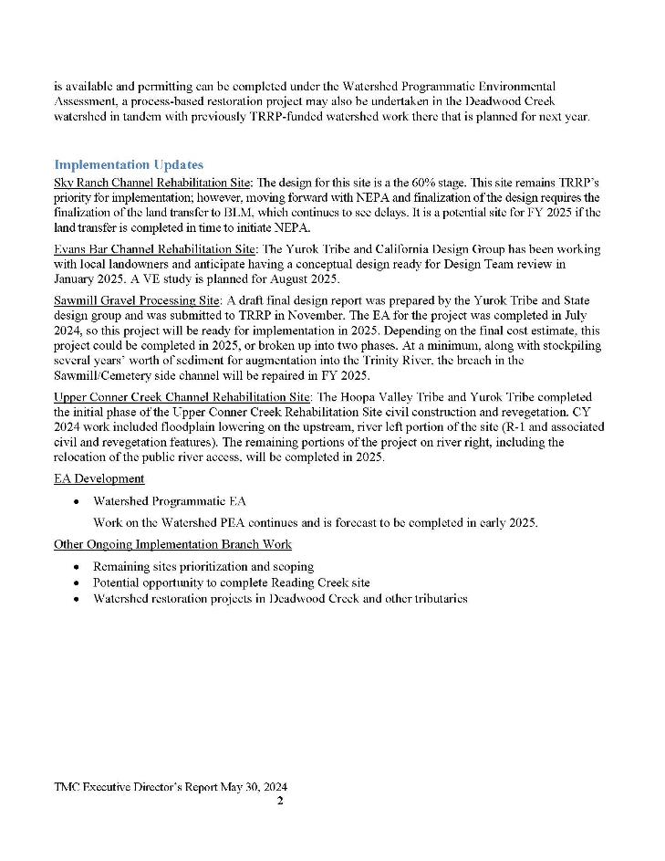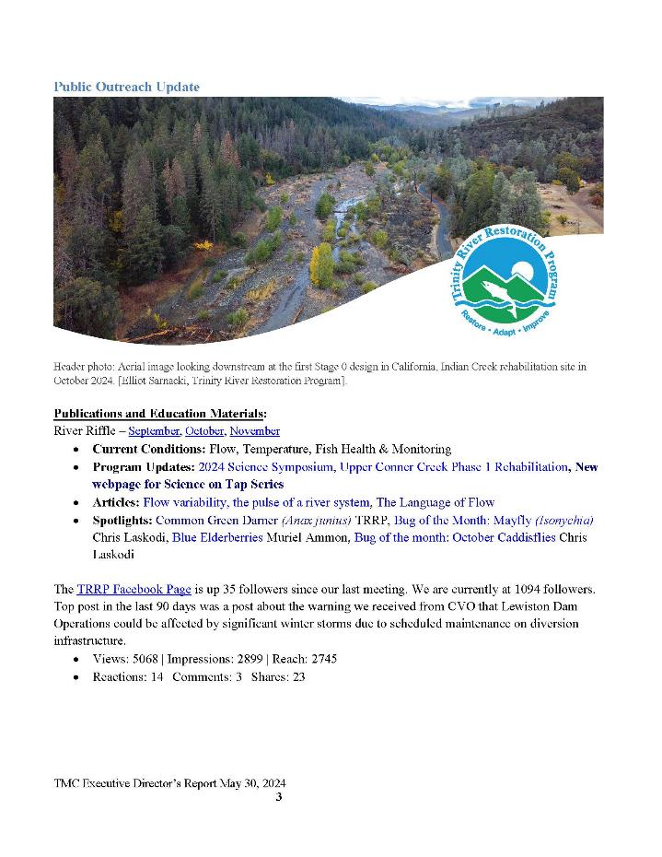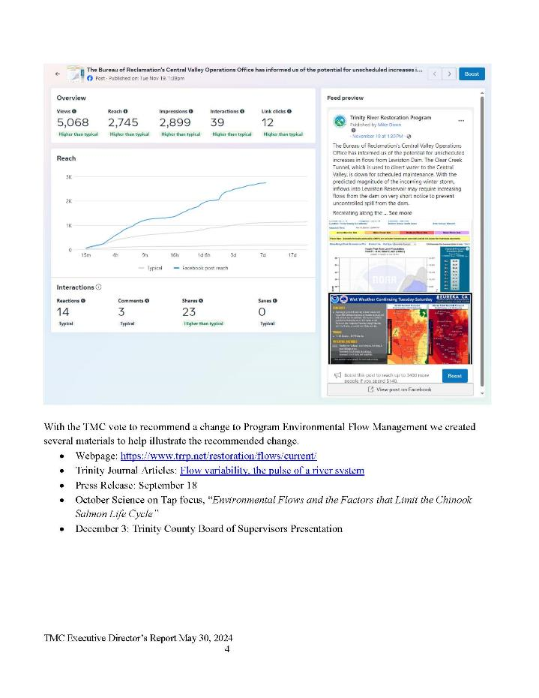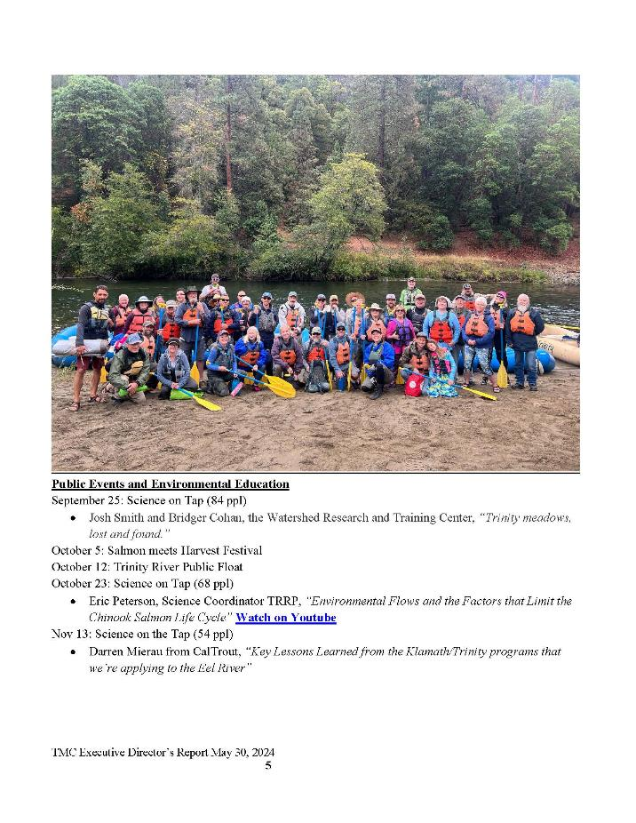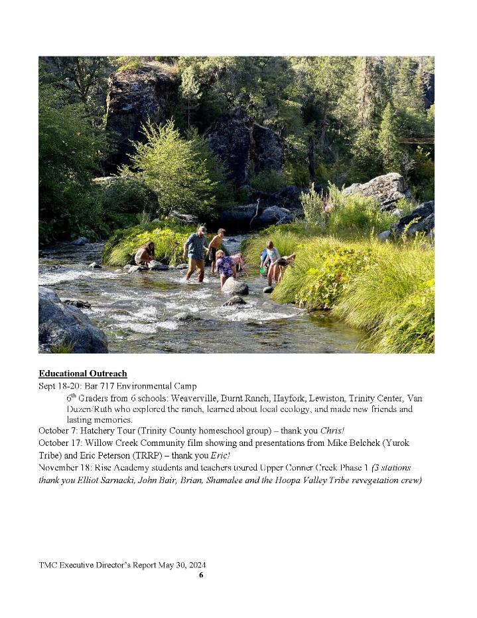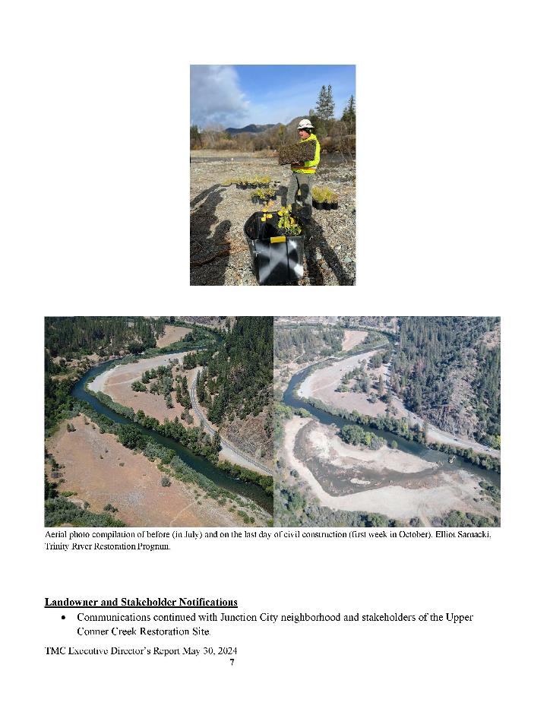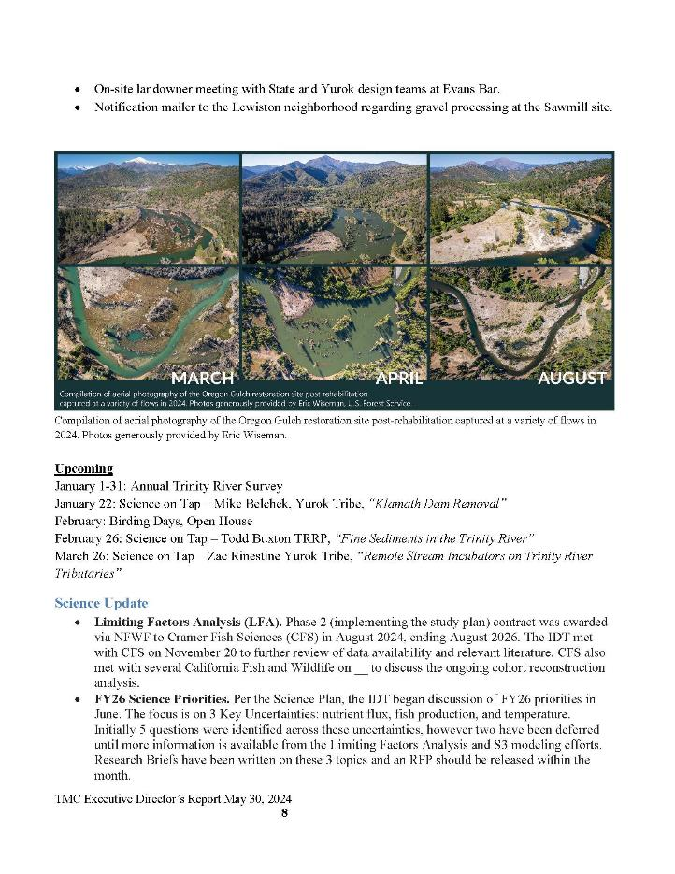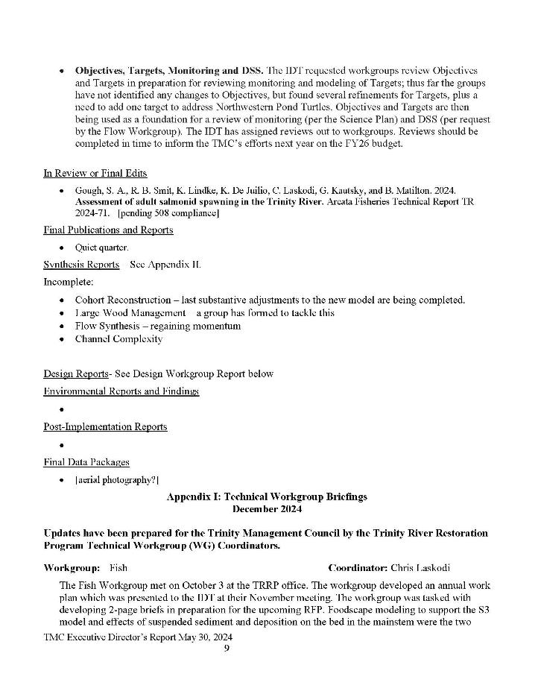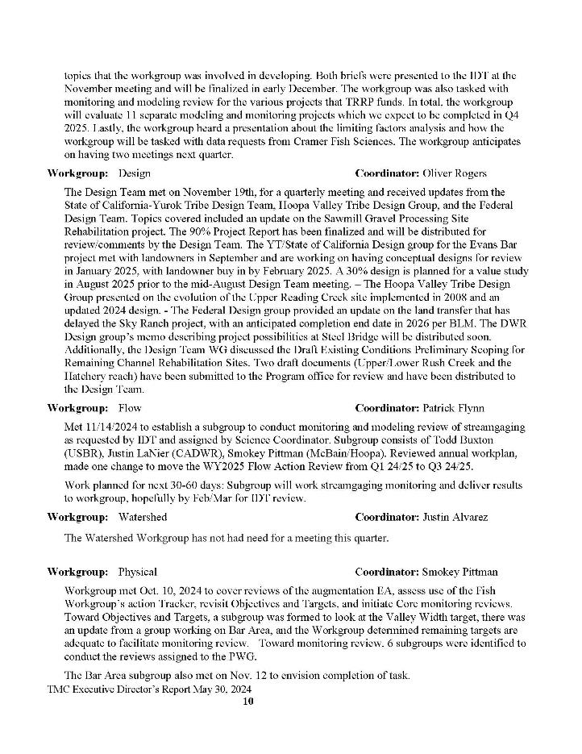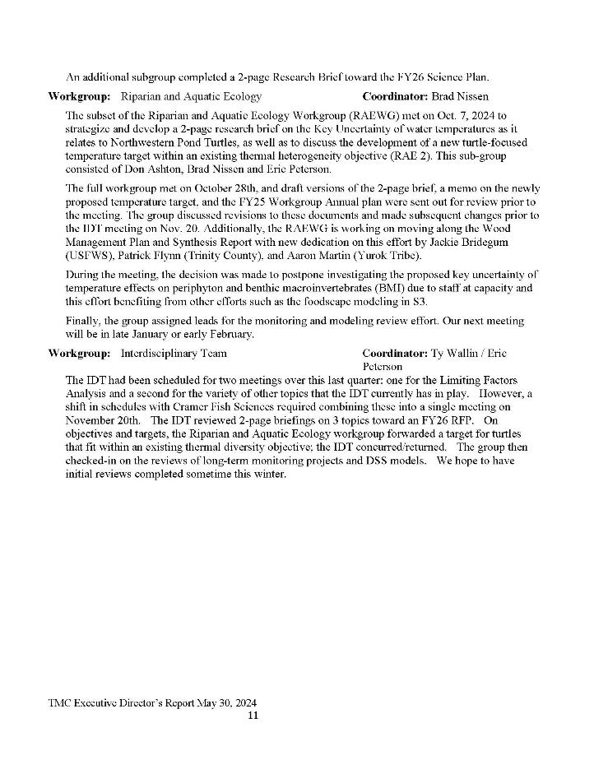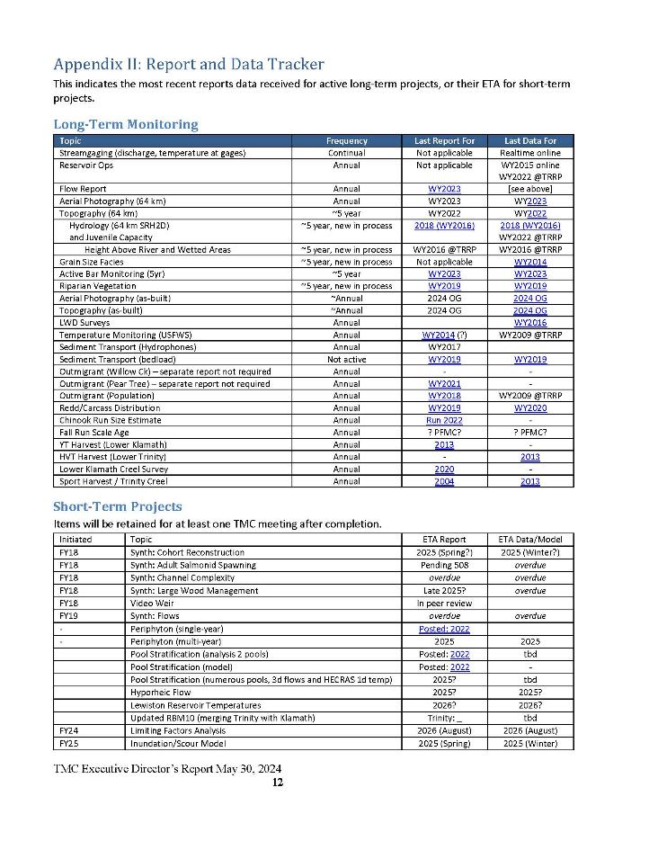

Central Valley Operations Update (Elizabeth Hadley)
We are in storage conservation mode. Which is what we're dealing with this time of the year. Shasta is 60% full. We’re at minimum releases. Trinity we are at 68% full, minimum releases. Minimum releases out of Lewiston, 300 cfs. We do have the tunnel outage right now that's expected to end around mid-March, because we're doing repairs in the tunnel. So, as you heard, we had some issues with some potential increased flows out of Lewiston, and there were some side flows coming into the reservoir. We may very well see that again if we have another giant storm, like we did awhile back. In the future, for awareness, if that happens again, our Operations Office will contact everybody and try to do it before it happens. We'll be dealing with that until mid-March.

Three other quick items: 1) I know that it was brought up that we have a request for exploring a temperature control device. We do have it on a schedule to do a value planning study for that late spring, early summer. What a value planning study is, from Reclamation’s perspective, is it looks at what are you trying to achieve and identifies all the potential alternatives that you could look at to get to that goal. It's my understanding that it'll help achieve what this group is looking for. I don’t have anything else to say, other than it’s on the schedule, and we'll start going down that path later next year. When we get there, we'll have more information on the schedule. I want to let you know, we're headed that way. It's exciting that we've actually got a commitment to have folks explore that.

2) Regarding the Trinity River Hatchery BIL project, $65 million BIL money to essentially revitalize the hatchery. We are on track to try and get a design-build contract out for award. We're looking to solicit a contract mid to late January this year, so we're trying to move forward as quickly as possible.

3) Lastly, I know everybody is awaiting Reclamation’s response on TMC’s motion on winter flows. My response is that I can't talk about it because we are under litigation. Apologies if there are any questions about it. I can't answer.

Public Comments
No public comments received.

Reports and comments of TRRP entities
MO: Is the hatchery modernization funding obligated and secured?
EH: No, we’re working really hard to get it obligated up to the middle of January. We’ve got a team prioritizing that over a lot of other projects. We’ve pulled people from other departments to expedite that as quickly as possible.
MD: There will be a presentation about that after lunch, so it might be good to hold on to questions until Dave Klepp’s presentation.
MO: Does it have something to do with the time it takes to get a contract?
EH: Yes.

TMC Discussion and Comments

Trinity River Hatchery Coho HGMP and Integrated Populations Management (Seth Naman)
SN: Does someone want to remind the group what this agenda item was about, or the genesis of this agenda item?
MO: The reason why I somewhat strongly advocated is quite a few years ago, there was a severing of the mitigation responsibility and function with the TRP natural production. It took the form of a legal opinion that some folks have been aware of, and I've talked about before. But since that opinion there has been sporadic and inconsistent information on fish population management. The integration of the population and some of the objectives of the Trinity River Hatchery and after fair amount of discussion at the last meeting, the idea was that the HGMP would be a vector for that integrated population management. And I guess the reason, NOAA was there is on the regulatory side of it, they approved the HGMP. They were part of the development of it, but the permittees of the Trinity River HGMP are actually the Bureau of Reclamation and the State of California. Acknowledging that, and at times the program has talked about the science groups. IDT has talked about population integrated management. So that's part of the reason that I was interested in talking about it.

If you haven't heard, I guess you can't take action today, but for informational purposes, I wanted to be able to frame some information that will be useful for future actions.

SN: Okay, anyone else or does that cover it?

MD: That covers it, Seth.

SN gives his presentation. Questions and comments follow immediately below with presentation in its entirety provided below.

Public Comments
No public comments received.

Reports and comments of TRRP entities

TMC Discussion and Comments
MD: I have a research background in genetics, but I'm not a fish biologist, so one of the things you raised with the integration of steelhead was infrequent mismarking of hatchery steelhead could be problematic if they're treated as wild. If this is done at scale, is that really a risk? I mean, is there enough hatchery introgression that could be misinterpreted as wild that would be genetically problematic?
SN: To understand this problem, you really have to go through the exercise of figuring out what the mismark rate is. At the Trinity River Hatchery it’s really low. In some cases, less than a percent. But then when you go through all the steps, when you expand out into adult returns for a large hatchery program, even a low mis-mark percentage can add up. ... Say for steelhead... there’s 448,000 fish released. Let's just say the mis-mark rate is 1%. That's what, 4,480 juveniles? So, if you release 4,480 mismarked juveniles and then the fish come back at a smolt-to-adult return rate of let’s say 3%, that’s 134 unmarked adult steelhead returning to the hatchery. Again, you're preferentially selecting unmarked fish that come into the hatchery, thereby increasing their contribution to broodstock relative to their representation in the overall hatchery returns. I don't know what the total number of adults spawn for steelhead is at that hatchery offhand, but let's say it's 500 or something, 250 pairs. You're preferentially selecting all of the unmarked fish that come back to spawn into that mix (250 pairs). Now your release of 1% mismarked fish contribute to a much larger percentage of the broodstock than they represented in the juvenile releases. This is the problem of even small percentages of mismarked juveniles in large juvenile releases without actually knowing if unmarked fish returning to the hatchery are mismarked fish or are actually wild fish.

MD: Could you mitigate that by collection of fall steelhead broodstock in Junction City by collecting them earlier in the year and holding them at the hatchery, the same way we do with Coho?

SN: In Junction City the probability that there are mismarked hatchery fish is certainly lower than if they have returned to the hatchery.

Unidentified speaker: They also don't hold. They don't ripen well when they're held. So, it's not like Chinook. You put them in there. It’s clean. Coho tend not to survive well, and steelhead don't tend to ripen. So, like the hatchery currently, if they come in and not ripe, they’re sent back. Just keep coming back.

JLee: For Seth, you brought up a lot of challenges in an integrated hatchery program for steelhead and Chinook. They seem surmountable with enough effort. Without an ESA listing status for those species, what would it take to actually do an integrated hatchery program?

SN: It would just take the commitment of Reclamation and CDFW. If they're listed on the ESA, then Reclamation and CDFW have a legal obligation to develop an HGMP and follow the recommendations of NMFS. Because they're not listed Reclamation and CDFW aren’t legally bound to do those things. But there's nothing preventing those agencies from doing that, so it would really just be them taking their own initiative.

JLee: Has anybody gone so far as providing information that would help Reclamation achieve the doubling goal?

SN: Those things can be modeled.

BP: I will add that Warm Springs National Fish Hatchery in Oregon does integrated hatchery, wild population of spring Chinook salmon focus. But it is a somewhat different system. It's not a mitigation hatchery, and it's not a terminal hatchery. So, it's not at the upper limits of the river. But they do have a weir, and 100% of the fish that enter through get determined whether they're natural origin brood stock or hatchery origin brood stock. They have a fairly complex process for determining which fish are coming in the hatchery and which fish are allowed to then return upriver, what fish are culled from the system and not allowed. Hatchery fish aren't allowed to spawn in the wild and are not spawned in the hatchery. Those fish are provided to the tribal partners’ subsistence. It's a different focus. It's focused on tribal subsistence and making sure that the hatchery doesn't dilute the genes of the wildlife. So, there are some examples of it being done successfully, but they don't have a mitigation-production goal that the Trinity River hatchery has. So, that really complicates it.

MO: Is Warm Springs in Oregon?

BP: Yes. Warm Springs National Fish Hatchery.

MO: It’s on the Columbia system, then?

BP: Yeah.

MD read a comment made by Brett Kormos in the meeting chat. He said, “Integration is not prohibited by mark rates of less than 100%, and post season code wire tag analysis allows for assessment of integration rates. Lower mark rates just disallow intelligent and specific selection of natural origin brood stocks.

LG: So, Bill on that Warm Springs that you're talking about, how hard would that be to replicate here?

BP: They're doing like 750,000 juveniles as opposed to 4 million. That's complicated back end. But also, they have basically a dam there that all fish have to go through a holding pen before they're released, either into the river, directed into the hatchery or harvested. That could potentially be done with the Junction City weir or something similar, but at Warm Springs they have an actual concrete structure.

The US. Fish and Wildlife Service operates that hatchery in partnership with the tribe, and its purpose is for tribal trust responsibilities. Again, the purpose of the Trinity River Hatchery is largely mitigation for dams and blocking of habitats. That's not the case there.

LG: It's not apples to apples, right? But it could work here.

BP: There's an example of where it is working. But whether it can be scaled up to the Trinity is probably cost-prohibitive.

MO: The Dworshak National Fish Hatchery changed ownership from the Service to the Nez Perce Tribe. There's some pretty innovative things that they've done.

BP: There’s some hatcheries in Arizona as well that have been transferred to the tribes along with water rights.

MO: This administration switched it from the Service fully to the Nez Perce Tribe. It's mind-boggling when we went on a field trip up there and looked at that versus the one that's being modernized. I guess we can't take motions, but I'm really concerned. I’m assuming and hoping that the $66 million modernization money is secured. But that's just one small part of that. That is a precursor to a lot of the innovative things that can be done with management. There's mitigation facilities. There's conservation facilities. There's a number of different approaches that can be taken and explored.

But whenever you guys get done with questions, I just had the last couple comments, if I could. Minor comments more than anything.

MK: Thank you, all very good conversation. I just wanted to share that the existing hatchery tech team is incredibly focused on Coho salmon for obvious reasons related to the listing. Many of the recommendations Seth referenced earlier for the Coho program are rooted in the HSRG reports that came out in around 2012. There were accompanying reports that were generated during that same time period for both the spring and fall Chinook programs as well as the steelhead programs that also provide suggestions and recommendations for quota changes to those programs as well. That could be the foundation for additional conversation, moving forward if that is the direction that we are collectively trying to move. It wouldn't necessarily be starting from scratch. In response to, “Could we implement this at TRH?”, program size is obviously a huge hurdle. It’s not easy, even at the size associated with the current Coho program. There are certain strategies and techniques that are being used, for example at Iron Gate/Fall Creek, that are more detail-oriented than is being implemented at TRH simply because of the program size. It’s not to say that they can't be implemented at TRH. But while you're spawning 300 females for Coho on the Trinity side, over on the Klamath side we're spawning 70. Volume matters, and the complexity increases as program size goes up. We just have to be respectful of that. It's not that these things can't be done or shouldn't be done, but it's an increasing level of difficulty and complexity. I would suggest that if we were to try to implement additional integrated management strategies, the next program that seems to be most ripe would be the steelhead program. As Seth described, they're already 100% marked, which certainly helps in real time brood stock management. The program size is also much smaller than the Chinook program. We can incrementally work our way through these things if that's the will of the team. I would also share that there's a fair amount of genetic material that has been collected over multiple spawn cycles within the Coho program. It could be leveraged to help address some of the questions related to unmarked stock origin, so to speak. There could be some opportunities to collect additional samples, particularly from the steelhead program, to help inform some of those question marks as well, so that we can be in better shape moving forward. So that's just a couple comments. So, thanks, important topic.

MD: Any more questions for Seth or discussion?

MO: I'd like the meeting minutes to reflect the potential of strongly advocating that Bureau of Reclamation obligate and fund the $66 million modernization of the hatchery. I can't make a motion, but I'd still like to make that be in the minutes. Secondly, I'm glad that we're getting weighed-in there, because one of the missing elements in our opinions, we have strong ones about it, there is not a management structure since probably seven years, if not longer. There is a remnant Hatchery Technical Team (HTT) but the MOU and the governance board was dissolved a number of years ago, and then it expired. Those are all things that can be done by the regional management at Reclamation to address some of those things.

The overlap area here, I think it's worth noting, the limiting factors analysis and the overlap there is pretty apparent to me, at least. Also, the HGMP requirements specifically targeting for reevaluating production numbers. I don’t know if folks are aware of this, but since 2014, there was an EPIC lawsuit that was against Reclamation and CDFW, I believe Yurok and Hoopa Tribe both intervened as defendants. But one of the outputs of that is reduction in Coho production of 500,000 to where it is today, 300,000 and steelhead was 800,000 to 448,000. They also took a run at Chinook but knocked off on that.

So those are all in place, though, but the evaluation metrics that he's talking about here, and it really was mind boggling, all that PNI and pNOB and all that stuff. And it's really, I won't say, apologize, but there's just a lot of complexity and all that. But the basic thing there, though, is there's very limited natural production for Coho all the way down to our neck of the woods. We very seldom see them. We see some evidence of them by the juvenile traps. There's been some studies when the NOAA put together the recovery plan, sampling and different tributaries. But there's no known, and when they go through the weir at Willow Creek, the timing is a little bit, maybe early to get all of them, but by and large, when they go through the Willow Creek weir or the HVT selective harvest weir, 98-99% of them are marked fish, so very little evidence of natural production. So those things, though, are precursors to evaluating the HGMP whether there's a change in production numbers.

We are very concerned about that, because we can harvest selectively the hatchery Coho at the weir. That's been an issue that the Hatchery Coordination Team (HCT) has taken on. But really, there's not a decision-making process in place there. They talk about a lot of things and debate things, but there's not been a formalization of a decision-making process since the expiration of the MOU.

Somebody could tell me what year it is. You could look it up. It was seven years ago, maybe longer. So that's a concern there. When you look at the other species, you raise a question, “What do you need to do for steelhead to reevaluate that number?”. It was 800,000 and that's directly contributing to the recreational fishery. That's the only fish that folks can harvest in Trinity basin is hatchery steelhead. So those things are very important, the evaluation of those. I think that was all I wanted to cover. But bottom line is the ID team, when they convene the joint meetings, there's a lot of room to talk about these things as far as integration. A lot of that it crosses over the information for the hatchery and HGMP crosses over into things including Limiting Factors Analysis. So, I think there's a strong need. And the last thing I would say, though, is the other data and information that I spoke of earlier is also very important here. And the example is with Coho salmon, the Pacific Council have what's called the harvest control rule. The data and information from the Willow Creek weir is directly an artifact of evaluating the impacts to hatchery product, natural production. But it's built into the PFMC season modeling and how they model their salmon season. So, there's an overlap there, directly with data there. Moreover, more recently now, at the Fall Chinook dam removal work group, there's also a big overlap with the Trinity program that process there. That's all my comments. I just think it's really complex and really hard to keep the eye on the ball. But at the end of the day, our objectives are to evaluate, assess whether it's going to be meaningful harvest numbers for our fishery. And when we do that, it also includes the fishery, so that's our opinion.

LG: So, knowing this is coming down the road, trying to get ahead of the game (undecipherable). So, about complexities of this, do we have an impetus at the beginning point and we're going to start to make these changes like he said. If you’re 4xing the steelhead and the Coho, which is not 40xing, it's 4x so it's not the heaviest lift in the world. Are we ahead of the game? Are we starting the game? Have we not thought about the game? And when do we begin trying to implement things that the money is going towards. The hatchery will prove to be prudent.

I think there's a lot of building blocks in place for Reclamation to take action on management structures, oversight. There’s going to be a new facility. There's going to be ample opportunity there to if there are big... and that I understand we were allowed to participate in that Yurok as well. We know, interactions, the evaluation, the engineering, and all of that. The thing that took place. But now when it's constructed here, you need to have something to build up. A structure is one of them. A full acknowledgement of either overlap between natural production and mitigation responsibilities is another one that's... The term that comes to mind is integration, and the fact of it is, you know, if it spawns outside if it’s not marked, you don't know if it's a hatchery fish until you do some genetic work. We're not going to do that. It’s cost-prohibitive. So, we can do some things that are innovative, that increase harvestable numbers of fish. Those are all great program. That's what the law says for this program. Restore pre-dam levels, not just fish for spawning and also dependent fisheries.

LG: I just want us to be prepared for the (undecipherable) we have to be used and to make this $68-$70 million project as effective and as efficient as possible and not be chasing our tail, be ahead of the game, you know what's coming. We just saw a little preview of what's to come. It is coming. You know it's going to happen. So, I think that us being ahead of the game, instead of kind of chasing it, is the way. And then those blocks, you know, they are in place, we just started figuring them out. You know, the heavy lift of the heavy lift. We all do it in our regular jobs, but sometimes there's the things you have to do to get things right.

This is a big thing. Our community has been cut out of recreational salmon fishing for two years now. It economically fills the community for three, four or five months. As a county supervisor, we strongly would like to see that come back. And we do see the hatchery modification modernization as part of that. We are, I want to say depending on it, but we need to depend on something fish-wise to get back to where we were. Tourism is economically driven. It's a huge part of our town. It’s a huge part of tribal for both of you. So, there's a lot at stake here, getting this right and the starting of this early. We know it's coming. No reason to not begin the process, taking the first initial stages of this and start to build off it. I see no reason to wait for anything, unless anybody here knows a reason why. It seems like there's enough information and knowledge in the room to begin the initial steps of what we might be doing and what we want to do as we move forward.

BP: I think a lot of those conversations have happened in the Trinity River technical team. Those conversations, those plans, are partly why that funding was secured, basically obligated, was based on this conversation. There could be more progress, or better communication is formalizing this relationship between the TRRP and the hatchery. That's what

Mike is speaking to. What we need to do as the TRRP is ensure that what's happening at the hatchery isn’t at odds with our goals or that our goals are being considered by hatchery operations. So, I think that's where, historically, like when I started in the early 2000s, TRRP wasn't allowed, might not be the right word, didn't talk to the hatchery. There wasn't that recognition. I think there's been steps to try to do some cross communication, but I am no longer involved in that discussion.

MO: The service has been involved, HTV probably since the dissolving of the MOU.

GK: Thank you for recognizing me, George Kautsky HV fisheries. Fascinating conversation, I like to see this follow up when it was a year ago, last December, at the council meeting that we gave the presentation on integration of natural and hatchery origin salmon management in the basin and integrating the efforts of the restoration program and what's going on at the hatchery. You were touching on this earlier, but I kind of joined it in midstream. But one of the points that we made there in that presentation last year is working towards increasing basic productivity of natural fish through hatchery practices would be, as I understand it, we could maximize use of natural origin brood stock, identify brood stock in both Chinook and steelhead. We're already doing that in Coho, as you know, using Junction City weir for recruiting brood stock and making a population that's integrated and expressing an increase in productivity in natural environment by minimizing domestication and not just Coho, but also Chinook and steelhead. I just want to emphasize that. Thank you.

MO: But can we make the notes reflect that I strongly advocate Bureau of Reclamation do what they can to obligate the $66 million BIL funding for the hatchery contract.

EH: We’ve got Dave Klipp’s presentation coming and I think it will alleviate any of your fears.

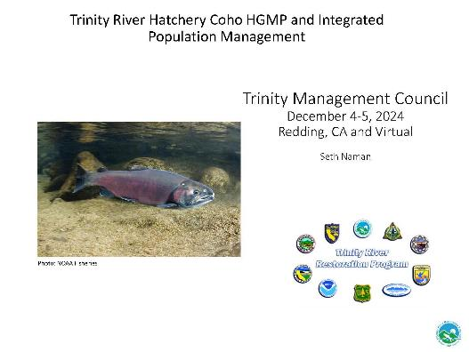
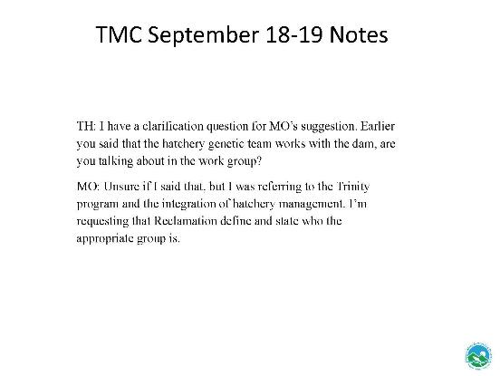
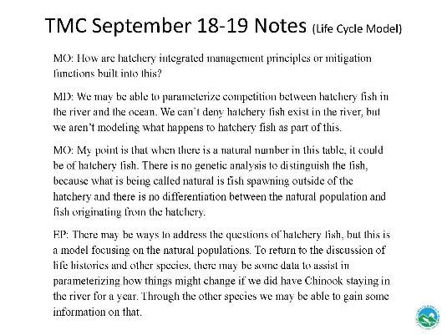
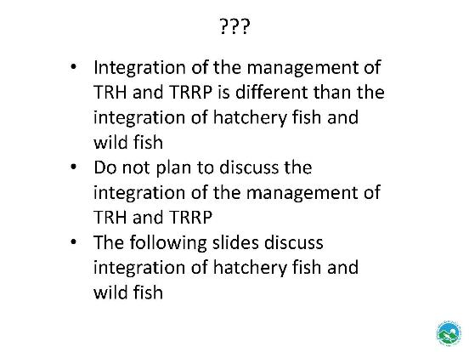
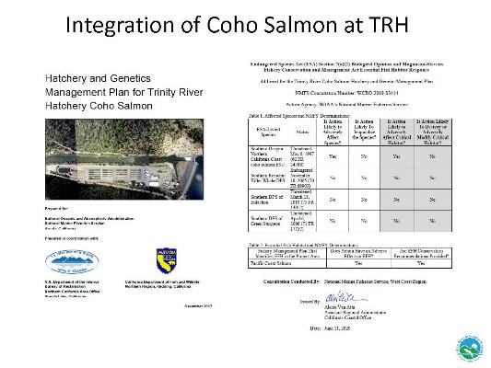
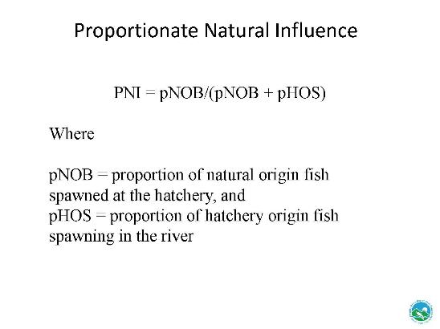
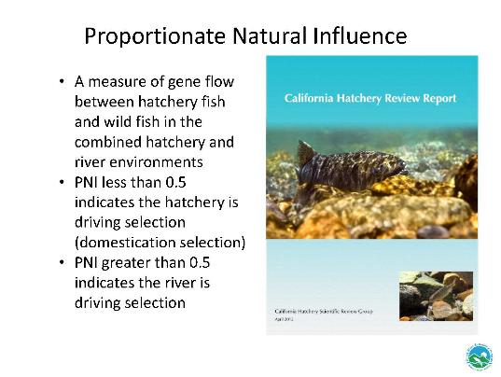
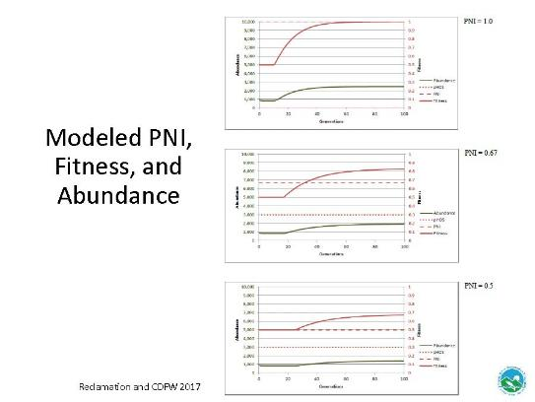
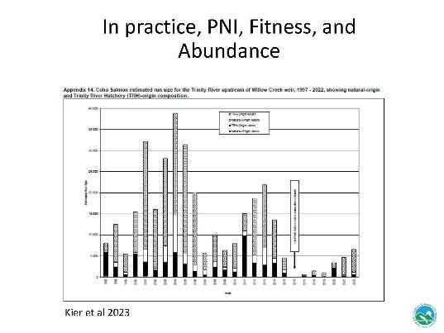
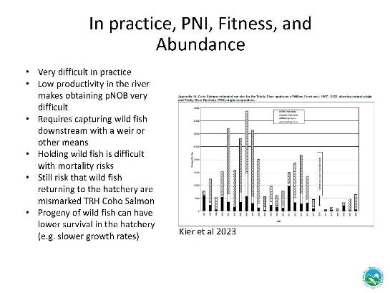
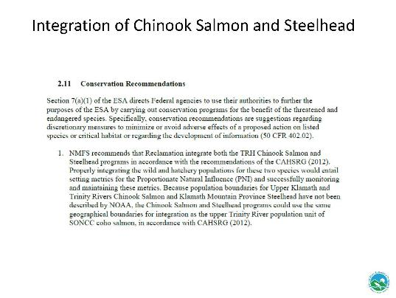
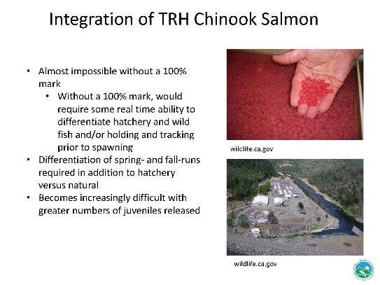
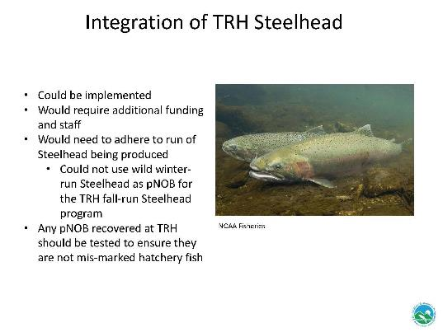
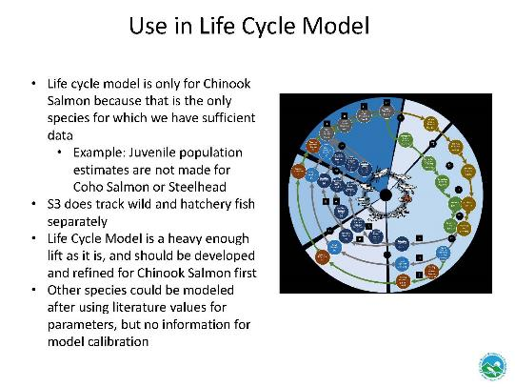
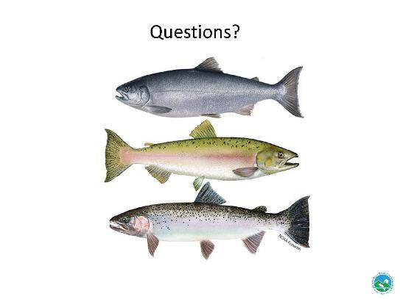

Lower Klamath Flow Augmentation Release Synthesis Contract (Emelia Barnum)
This is Emelia Barnum from Bureau of Reclamation. I’m going to talk a little bit about the Lower Klamath Flow Augmentation Release Synthesis Contract. For some context, for people who may not be aware, since 2002, when there was the large salmonid die-off, flow augmentation releases from Lewiston dam have been used to improve the environmental conditions in the lower Klamath River. They've been used 10 times since 2002. The average volume of water used during those events has been approximately 31,000 acre-feet. Since that time, there have been no large-scale adult salmon mortalities.

The environmental conditions that we've been looking at are fish disease, (Columnaris), high fish densities from relatively large run sizes, low river flows, so below 2,800 cfs for instance, and relatively high water temperatures that can slow or delay the migration of adult salmon. The process typically has been that the long-term plan technical team meets and discusses the monitoring of those factors and then makes a recommendation to Reclamation leadership, to implement an increase in flow on the lower Klamath River to reduce the likelihood of the fish die-off from those factors.

We did put together a package to synthesize information since the 2002, timeframe including the physical, chemical, and biological variables and disease factors. We've included dam

removal now, as that's a new factor in this situation. The original solicitation received no bidders. The reasons that were given by folks were the timeline for the contract, which was approximately one year, was too short, and they had competing work and lack of staff. So the professional services contract was reframed to more clearly define the tasks, shorten up some of the tasks that were identified as perhaps a little unnecessary, and lengthen the timeline of the contract from one year to 18 months. The package was submitted to contracting. It was just assigned to a contracting officer this week. Given the procurement lead timelines, a solicitation can be expected for the synthesis of the data to begin in March 2025. Any questions?

Public Comments
No public comments received.

Reports and comments of TRRP entities

TMC Discussion and Comments
BP: Yes, Bill Pinnix, USFWS, and I'm just curious if the contract does talk about a workshop or some other piece, rather than just the synthesis?

EB: Yes, I think that’s the culmination of the synthesis would be a conceptual model, and then a a symposium, to discuss the findings.

MO: Well, some folks have heard my views on this. I've advocated strongly. We've been a part of the FARS stuff all the way up to in court, pending some of it with Interior. Completion of the EIS in 2017. There's an EIS for this action, and by it uses proviso one water, I believe. So that's a discretionary 1955 legislative legacy that's been interpreted by the courts pretty consistently. But my concern, though, is we've dodged bullets. There's been outbreaks. There's very specific protocols over time. There's been an emergency at least once where they double the flow. The infection rates and yet, like Emelia said, we haven't had a large-scale fish die-off. I've expressed a lot of concern about just standard and quote, unquote adaptive management of the FARS releases is one in which we just haven't had a fish die-off so everything's okay. I think the condition factor of the fish is really evident this year and worth looking into. I'm not sure exactly what happened but we saw a really, really high columnaris. We're getting the pathologist from the Fish and Wildlife (Pullman?) Office to evaluate it. I think the preliminary stuff I've heard is the columnaris lesions on the on the fish. 50 to 70% of them went through our weir that we placed in the river. So, my concern, though, is the condition factor and the services we're working on, the service on a project to assess some of this stuff. We really need to dodge bullets, and I don't think any administration wants to have a large die-off like that in 2002. I hope, with the dam removal goal, that there's never any large-scale fish die-off like that again in the future. Potentially one of the outcomes of the dam removal on the Klamath. We don't know that. So, I think when it's taken so long and talked about and advocated, I just get really, really anxious about that. And I'll just say that we submitted a joint three-tribe proposal. I just want to get it done. So, however it gets done, and if the timeline she's talking about gets us there with full input or participation, that's great. But I just don't want to be talking about this a year from now again. It’s well overdue that we modify, we take action, and there's just a lot of responses. Lots of variables to assess development.

EB: Mike, I might hear you. We'll be talking about this, because the contract will be about 18 months to completion. But we'll be working together to look at the findings and whatnot. So hopefully we'll have a conclusion at the end of that that we can talk about and have this symposium. But I definitely hear what you're saying.
MD: Anyone online have questions?
Lunch

Hatchery Modernization Update (Dave Klipp)
I am a contract employee for Reclamation’s northern California’s area office. My job title is strategic program advisor, and I have been assigned as a co-project manager for the Trinity Hatchery Modernization Project. I’m here to give you a brief on what that project is and its status as of today.

Public Comments
No public comments received.

Reports and comments of TRRP entities
Note: The following report was updated on December 17th and not identical to the version provided at the meeting on December 4th. It is being shared here so that TMC members have access to the latest version available.

Trinity River Fish Hatchery (TRFH) Modernization Project
Update for the Trinity Management Council, Dec 17, 2024

Status Board:
Project Phase: Acquisition
Funding status: Funded, $65.9M | Budget status: Within budget
Schedule status: On track | Milestones completed: Value Planning study, Project Charter, Design-Build PR Package submitted
Project scope: Modernize nearly all aspects of the hatchery. Water quality and flow through the facility will be improved for resiliency to environmental extremes. The project will correct deficiencies with buildings, power supply & distribution, domestic water, sewage system, roads, exterior lighting, and other infrastructure, with improvements to support modern aquaculture. Design life for the modernized facility is 50 years.
Upcoming activities, Acquisition Phase: Prepare procurement plan and solicitation.
Synopsis of Activities in Progress. The project team is assembling the Design-Build procurement package. Reclamation awarded a contract for Hatchery modernization NEPA services on Aug 30, 2024. Reclamation’s Technical Service Center conducted hazmat surveys/assessment of the facility. The report is expected this month. The survey report will be a part of the Design-Build requirements document.
Project Team:
Project Function | Name | Title, Organization | Contact
Co-Project Manager | David Klipp | Strategic Program Advisor  NCAO | dklipp@usbr.gov
Co-Project Manager | Trang Nguyen | Project Manager  Regional Construction Office | abhattacharya@usbr.gov
Contracting Officer | Matt Byrne | Acquisitions Branch Chief, CGB-3800 | mbyrne@usbr.gov
Environmental Lead | Keely Watland-Bakos | Natural Resources Specialist, NCAO | kwatlandbakos@usbr.gov
Subject Matter Expert | Derek Rupert | Fish Biologist, NCAO | drupert@usbr.gov
Subject Matter Expert | Emily Van Seeters | Fish Biologist, NCAO | evanseeters@usbr.gov
Notional Milestone Schedule:
Design-Build Procurement Package to Acquisitions | Dec 16, 2024 | Completed
Project Management Plan | Jan 31, 2024
Contract Award | July 31, 2025
Design Complete | July 2026
Decision to Construct | October 2026
Construction Completion | September 2028

TMC Discussion and Comments
JLy: How much was allocated?
DK: $65.9 million
LG: What is the escalation price?
DK: 12-15% per year. Escalation will include 3 years for design cost and 4 years for construction costs.
EH: Can you go into detail what happens after December 16? Because I think Mike’s concern is that we allocate money, so please go into detail about what happens after 12/16. Money committed 1 week after 12/16. Money is physically moved and obligated and impossible to use for another purpose.
DK: We are going to have the procurement package into acquisitions by the middle of the month. They are going to take about a week, and they will have that money committed?
EH: Did you hear that?
DK: It’s put into a category that sets aside money for this project. Obligation happens at contract award.
EH: Let me just clarify. Once we turn the package over to acquisitions, they physically move the money into this specific project one week later. Then it is essentially obligated to that and pretty much untouchable.
MO: That’s my question, how solid it is under the authority of this administration to obligate and make sure the money is spent where they said it was going to be.
EH: That’s why we’re expediting everything.
MO: This is still under the present administration?
EH: Correct. We anticipate the money being committed before the end of the calendar year.
MO: Thank you. That’s my concern. It is a major milestone to have the modernization funded, and I don’t want to lose it.
MD: Is there still time to add in a new restoration program office in the hatchery design (jokingly)?
DK: One of the leading design recommendations from the 4 Peaks study was to take this hatchery building and combine it with the headquarters building into one building. That possibility is definitely in scope, and we like that one, because we could keep hatchery operations going 365 days a year while we build that new building. When we’re ready, we can cut over hatchery operations to the new facility.

MK: There's been a fair amount of work done to date, I believe, on the planning. How much additional changes to design and specific tweaks are yet to be determined?

DK: That's a great question. Our next milestone is to award a design-build contract. As that contractor gets going, they're going to do some pre-design activities that include creating two alternatives, at least two alternatives, to modernize the existing hatchery for us to evaluate. They're going to go through an analysis that's required by our policies. They're going to recommend a preferred alternative to Reclamation. Reclamation is going to select an alternative, and then the contractor is going to proceed with a continuing design of that selected alternative. At these stages, there's going to be opportunities for input to be able to shape those alternatives. And so, our stakeholder engagement, stakeholders be able to weigh-in during things like alternative reviews and even the design reviews of the selected alternatives.

MO: We've done a fair amount of work up there for many, many years. One of the things that we understand from the recon, you guys done: it’s built on spoils, from maybe the dam or something? And this sinking thing that was up there, that's all been engineered. It's going to be fixed, and all that stuff, as far as compaction and all the issues related to that.

DK: Yes, that’s going to be a requirement. We’ve done some geo-technical investigations. We have a pretty good idea of what the substrate looks like. If the contractor needs to, they’ll do more geo technical investigations and design the foundations to solve the subsidence problem.

MO: Is there any part of the projects related to any kind of temperature concerned about the hatchery?

DK: Definitely, the 4 Peaks Study recommended modifying the hatchery intake to provide two levels of intake water, one near the surface and one down lower. That would be the first line of temperature control, and it would be selectable. So, depending on what the hatchery needed, they'd take off the top for warmer water or take down deeper if they needed some water that was cooler. But because the temperature of the water is so important, it may not stop there. We may have supplemental machinery to be able to cool or heat the water as part of the design. Those additional things are still part of the design process, but they will be under consideration.

JLee: That hatchery reach, it's been identified by our design team as a potential place to do some restoration work. The Yurok and state design group has invested a little bit of time in an existing conditions report. I'm just wondering if it’s worth dovetailing channel rehabilitation into our hatchery modernization project. Is there any opportunity that you've seen, any work that needs to be done to the mainstem related to the release points from the hatchery that we can time right for that?

DK: The project is definitely going to consider the outfalls from the hatchery. There's four of them to make sure that they're appropriate for the releases today. Back when the hatchery was built, the standard flows was 150 cfs in the river. It's a lot more than that at times now, and the outfalls aren’t engineered for the current river levels. So, the design is definitely going to be taking a look at that. As far as other activities in the river that are being planned, that's the first I’ve heard about it. We should start discussion soon if we want to have some kind of synergy between the two projects. Are those in-river projects going to be adjacent to the hatchery?

JLee: Well, you know, that's a possibility, but it's really preliminary. The hatchery-reach itself isn't a ROD site. But we've been using it as a sediment augmentation site for years now. Based on all the fish that spawn, it’s one of the highest-density areas of redds. It has a lot of potential. So we don't have a conceptual design or anything, or TMC authorization to do that, but people have been talking about it. It seems like if we were to do something we should probably start talking about it soon before you guys get too far along with the hatchery. Maybe we can que it up at an upcoming design team meeting and start a conversation. Would you be our contact?

DK: Yes, myself or Babi Bhattacharya. He’s my co-project manager, or Derek Rupert. He’s our lead subject matter expert on this project. The one-page project status is available for distribution, and it has all of the project team’s contact information.

MO: So the review process that you want to went through for change orders, once the money is committed and it's done, that first step that you talked about earlier it’s committed and obligated, and federal government's stand point it’s for this project, and even if it gets modified, it'll go back Reclamation’s budget if there’s cost over-runs or change orders.

EH: What happens is we assign it to a specific line item or work order, so to speak, and the money gets moved and attached to that so that it can be spent. So, once it gets moved out of the giant pot of BIL funding it is attached to that, then it becomes obligated. If we don’t spend it all, usually we have to deobligate it.

MO: It seems like some sort of contracting obligation would come in too.

EH: The first step would be to put it in the funding source. The next step would be to award it to a contractor. But just by moving it into the first step gets it committed. That’s different than contract award which we are awarding to an entity. This is committing it to a project by the end of this calendar year and then we are awarding it to a contractor by the spring, and then they will be able to build it.

Approval of Agenda

Public Comments
No public comments received.

Reports and comments of TRRP entities
Motion to approve the December agenda was made by EH.
KM seconds the motion
Discussion of Motion
MO: I’d like to raise the concern I raised when they weren’t here, that the agenda got downgraded to mainly informational in nature. We had an issue with an item on the agenda that was removed. We did take action, and I shared the letter with the staff here that we are going to take it up with Interior instead of USBR. We talked at length at the coordination meeting about the agenda. Somewhere between that time and today, it has been downgraded to informational only and not a lot of action items. It’s not very efficient to say the very least.
JLy: I’ve been out the last 3 weeks and have missed email and communication traffic.
MD: My understanding of how the conversation played out regarding USBR engaging the PFMC. It was raised by CDFW that is was not within the Restoration Program’s purview, so Hoopa took it up through parallel channels to Reclamation, and they sent a letter. When I reviewed the notes, I did not see that as an agenda item that was supposed to be on this December agenda.
MO: Mr. Chairman, that wasn’t what was stated earlier. But if that’s the case, CDFW doesn’t have the authority to say what is within the purview of this body.
MD: There was no commitment by anybody that this was going to be on the TMC agenda.
MO: I read the minutes and there was some information that was incorrect. Those are coordination meeting notes. But the fact of it is, there were no Chinook fisheries for 2 years now for the Trinity River, and that’s fact. That’s an artifact of the management process that we’re talking about. For us to say based upon an agency’s recommendation that’s not an item we can take up doesn’t seem appropriate to me. We have an interest in half the surplus. That’s what the law says. Half is one whole at some point. It’s by nature in our interest to be concerned about it, to be a part of it. At some point the outputs of the action are directly applicable to what the law says about restoring fisheries. If it has an effect, positive or negative, it seems appropriate for us to be talking about it.
MD: I think that we’re talking past each other. I’m not saying that the State of CA said it shouldn’t be on the agenda. I’m saying that when it was discussed, it seemed that Hoopa agreed they were going to take it up outside of the TMC.
MO: When did that happen? We were working on it all the way up to the agenda being (completed). The staff said that we thought it was at the ID team or one of the work group meetings was still on the agenda. And then we just finished the letter, and I changed it because it was pulled off the agenda anyway. So, we’re talking past each other, but it got removed from the agenda before we knew anything about it.
JLy: I do remember, Mike, you agreed to send a...

MO: A form of the issue would be raised by form of a letter.

JLy: ...letter to Reclamation, and that HVT would take up separately.

MO: Understood because I was having a hard time even with my own staff getting them up to speed exactly what we’re trying to accomplish there. So, we did that. It doesn't mean this group all didn’t know.

I don’t know where I need to take it up, maybe on the co-management side of things with others. We’re having a bear of a time over there with stuff. I think it very directly drives what's available for harvest in the Trinity River. That's a pretty positive statement, a pretty clear fact, how all these other processes are and what they are, but it seems like at least coordination, communication or acknowledging where it fits in and how it affects us would be advantageous.

Motion: Elizabeth Hadley motions to approve the December agenda.
Second: Kelli McElroy seconds this motion.
Outcome: The motion passes unanimously with no opposition.

USBR: Yes
USFWS: Yes
USFS: Yes
CNRA-DWR: Yes
TC: Yes
YTFD: Yes
HVTFD: Yes
NMFS: Yes

TRD Reconsultation Update (Kristin Hiatt)

Public Comments
No questions for public.

Comments of TRRP Entities

TMC Discussion and Comments
MO: For meeting minutes if nothing else, a lot of folks have expressed a lot of concern, including us, about the Trinity being left behind. We've tried every way we could, including most recently, the understanding is long term operation plan is done. That was agreement amongst the parties. We've done things like submitted amicus briefs to inform them of the concern we have. There was a status report, and I guess refile that request, but the fact of it is the law and the precedent, and I’ve said this consistently, because our participanting in the co-lead meetings that the law and the interpretation of the courts of the laws all really date back to the 1955 legislation. The Trinity priority, first and foremost, including the cases that we've been through since the ROD was signed in 2000, all consistently reinforce that Trinity water, water supply for Trinity is the first priority. And so that intuitively would make sense to say, well, maybe we should have done the Trinity first. There was a fair amount of time that was delays and all of those things, getting on board with the process. But we've known about it a long time. The Trinity hasn't been reconsulted on for a long time. As I said earlier in the meeting, I guess they’re subject to litigation now including in the Trinity, and the whole long-term operations plan is ripe with, litigation drove that where it's at. So, when there's changes and modifications in deliverable and water supplies to different uses in this state, there's going to be a whole another round of litigation. We just simply feel strongly that you don't need the Trinity. On some parts of it is a foundation of a lot of industries and economies. But we'll see how it goes. I think it's worth pointing out there were some real, real important things that when the last time we changed administrations, the very laws that created this program were eliminated. And so, there's going to be some, hopefully better times ahead, but there's some potential things changing dramatically as we all know.

JLy: Thank you, Kristen. Appreciate your updates. All right. Well, if we have extra time, we can take a motion for the September meeting minutes.

Approval of September Meeting Minutes

Public Comments
No public comments received.

Reports and comments of TRRP entities
Motion to approve the September meeting minutes was made by RO.
KM seconds the motion
Discussion of Motion

MO: All right, you guys are tired of me saying it. The issues in at that meeting were fairly well (undecipherable) in lot of discussion. Time put into the meeting and for it to dissipate into this quarterly meeting is a cause of concern.

JLy: Yeah, again, sorry. I missed a lot of the communications in the past three weeks.

MO: Could I elaborate? We had a pretty thorough discussion of limiting factors analysis, the Pacific council thing, among other items, the hatchery and fair amount of discussion.
Then I know specifically, the last coordination call was extended because of the discussion about the agenda. To now say whatever that time and input into that was, get to this meeting, and we're informed that nothing, I'm not sure it actually could be even taken today. In one case, a miscommunication on what we're concerned about, but we'll continue. We made presentations on it, so it wasn't like it just came out of the blue. We made presentations back at prior meetings about issued a concern that the path and then were to then move forward and the process, and then just to kind of get dropped out there at the end of it is a concern.

JLy: Yeah, I hear you, and my understanding is that there were drafts of meeting minutes. We all have an opportunity to review them. If there’s anything missing or incorrectly stated, it's an opportunity to write those comments in the minutes. It's the same with the agenda. Draft agendas were sent out. So, if topics were missing, that would be a place to...

MO: What do you mean sent out? I thought that was the discussion we had in the coordination meeting was the agenda and all the items we were talking about then. I don't know. It's fine. I don't know, but the part about the meeting minutes that just amplifies to me, the nature, concern, substance of the issue that we’re talking about. But if it just gets dropped out for some of the other comments, which I just heard on one of them, then, maybe we need to talk about more detail. Maybe that's a subject for not an Executive Session, but an informal Executive Session.

MD: I will raise for the TMC that while not everybody got the meeting minutes for September immediately, when we realized that it was being blocked to some external senders. We did resend that. I've subsequently sent the October and November monthly coordination call minutes, and I haven't received edits from any TMC members on any of those three sets of minutes. So I really do want to put it to the members who sit on the TMC that if it's important to you that the discussion is accurately captured, and particularly as it relates to future agenda topics, that that's accurately captured, I can't know that unless I get minutes that are edited to reflect what was stated. I mean, we did get 125 pages of minutes. I will say Brad’s minutes on the last meeting were probably the most detailed and accurate minutes I've ever seen for a TMC meeting. It's practically a court stenographer’s translation of the meeting. If something wasn't conveyed clearly, but it was accurately reflected in the notes, we can always elaborate in some sort of annotation so that the record reflects what the intent of the statement was, even if it wasn't conveyed in a way that, in hindsight, is easy to decipher. So all this is to say, please review the minutes and send back edits so that we know what we're shooting for when we're trying to get these meetings lined up, and so that the record accurately reflects the history of discussion that leads to what does or does not happen in a TMC meeting. It's been really, really helpful in addressing issues over the last several years to be able to go back and review the TMC minutes and the discussion as it was recorded that led to various decisions that have been made. How did we get here, so that we can reconstruct the past a little bit and figure it out. So, it really is important for us and our ability to do our jobs and for the public, that those notes are accurate. So again, please review the notes.

JLy: Any comments or questions regarding the meeting minutes for September? Those who are in favor of adopting the September meeting minutes, raise your hand.

MO: Abstain.

JLy: Motion passes. Thank you.

Motion: Radley Ott motions to approve the December agenda.
Second: Kelli McElroy seconds this motion.
Outcome: The motion passes.

USBR: Yes
USFWS: Yes
USFS: Yes
CNRA-DWR: Yes
TC: Yes
YTFD: Yes
HVTFD: Abstain
NMFS: Yes

Thursday, December 5th, 2024

(Scheduled from 9 a.m. – 3:00 p.m. PST)

Welcome and Comments on Non-Agenda Items (Justin Ly)
Justin Ly, Acting Chair welcomed everyone, initiated introductions, and asked for comments on non-agenda items from the public and TRRP agencies.

Public Comments
No public comments received.

Reports and comments of TRRP entities
None received.

TMC Discussion and Comments
Mike Dixon: Thanks to everybody who came to dinner last night. I think we had 12, and it was great conversation.
Justin Ly: Well, we're on to the next topic, which is USFS Wildfire Crisis Landscape Strategy in Trinity River Watershed.

USFS Wildfire Crisis Landscape Strategy in the Trinity River Watershed (Bobbie Miller, Marcus Nova, and Keli McElroy)
BM, MN, and KM provide an interactive presentation. The text of their oral presentation along with questions and comments follow immediately below with presentation slides provided in their entirety below.
BM: Good morning, everybody. I've not spoken to the TMC before, so I'm really grateful to be here, and speak about the Forest Service Wildfire Crisis Strategy. Myself, Marcus Nova, and Keli McElroy are going to speak each for maybe about 10 minutes, and then we'll just leave that last 15 minutes for any discussion.
Please feel free to raise your hand and engage at any time as we talk. I'm going to speak about the origin of the Wildfire Crisis Strategy, which is a pretty big program that got going in the Forest Service in 2022. Marcus is going to talk about what our Trinity Wildfire Crisis Strategy Team accomplished in those couple years where we got quite a bit of funding, 2023 and 2024. Kelly, our vegetation lead for the Shasta Trinity is going to talk about how the wildfire crisis strategy informs our vegetation management going forward in the Forest Service. Spoiler alert. The Forest Service is concerned about managing wildfire and making more resilient forests and protecting communities.
I was the program manager for the Trinity Wildfire Crisis Strategy landscape for just about a year last year. So, most of last year I was the lead. The Shasta Trinity and the Six Rivers have done some reorganization of the program. Cory Davis, who is on the line, is the lead right now.
A little bit about me, I've been working in the Klamath Mountains for over 20 years. I've spent most of my time on the Klamath in fisheries and planning, so I kind of fashion myself a planner and a fish biologist when I'm lucky.
So like I like I mentioned, it didn't come out of thin air, right? These are just some major milestones that the fire management and Land Management agencies have kind of gone through over the years.
National Fire Plan, Healthy Forest Restoration Act, which is still around. The National Cohesive Wildland Fire Management Strategy was a really big milestone and a big deal in guidance policy that is carried forth today. So, all these efforts with people realizing that the scope and severity of wildfires in the West is just getting so massive that the agencies need to do something different. So, in 2022, and I really think in no small part due to Randy Moore, our regional forester. When he was in California, he was really focused on addressing the atrophy in the agency. We had just been very reactive and not as strategic. So Randy Moore, when he went up and became the Chief of the Forest Service, I think he really was on a mission to get this unprecedented investment from Congress. So I think to his credit, the Wildfire Crisis Strategy in January 2022 got 1.4 billion from the Bipartisan Infrastructure Law. And then in early 2023, they got additional funding from the Inflation Reduction Act so two back-to-back years of injected funding into the program.
First year, they selected landscapes nationwide, and the second year they selected 11. The Trinity Wildfire Crisis Strategy landscape was in that second selection for the designated landscapes.

MO: So, when you refer several times to Trinity, the geographic scope of that to Trinity water.
BM: So, this is our Trinity landscape. The black line delineates the designated area, and all these blobs are the larger fires since 2010.

MO: Reservation is up there on the top.
BM: Part of the Hoopa Valley Reservation is in the Trinity landscape, and then the other part of the Hoopa Valley Reservation is in another priority landscape, the Klamath River basin. Thank you, Mike. I really appreciate that.
You know, it's hard to do new things in the government, but it was the public I think is still confused. It was a challenge to get our agency to work across boundaries. You know, Six Rivers, Shasta, Trinity. It was also kind of different for the public to understand, like, well, what about our local people? You guys have this new team? We got a lot accomplished and Marcus is going to speak to that, and we brought a lot of investment to Trinity County, which I think was huge.
Marcus will summarize funding to Trinity RCD and the county. It really was an unprecedented amount of funding. Our Trinity landscape marks like one of the highest in terms of wildfire risk and difficulty in treating.
About 20% of this landscape (there is a recent paper about) is actually operable for mechanized equipment. Otherwise, it's like climbing hills and cutting trees down by hand. So, it's a very challenging landscape to work in. Incredible value is at risk as you all are well aware of. So, it got marked pretty high. I was going to go over criteria by which the Secretary of Agriculture decided that the chief should judge to select the landscapes. The criteria was wildfire exposure to buildings in the wildland urban interface (WUI), but also exposure to underserved communities, indigenous peoples and lands, sources of drinking water, habitats for native fish and wildlife and critical infrastructure and utility quarters.
So, the aim was to use new authorities to ramp up hiring and ramp up forest health and fuels reduction treatments in the Trinity landscape. So, the Six Rivers and the Shasta-Trinity banded together in a way that they never had before between the Forest Supervisors. Hiring in the government is always interesting. So, the hiring effort for our Trinity landscape team was kind of opportunistic and we ended up with, in some areas we got a lot of people, like GIS, and then in other areas that we really needed like archaeologists, we got none.
Because of the way hiring went, our team was not able to just function as a like “take work off the forests and take the load off of them.” Because we weren't a cohesive team, we were kind of deployed through the Shasta, Trinity, and the Six Rivers. So, that's why the Forest Supervisors have now made the decision to integrate us back into the units. So, we don't have a Trinity Wildfire Crisis Strategy Team anymore. We have a task force, so we have the individuals on the Six Rivers and the Shasta Trinity who are still very engaged in this work. But organizationally, they've kind of shifted it.
This is a snippet from the website where they were when they released the 11 new landscapes. This was the stats run down from the Trinity. And I think at first it was these two separate and then the map was adjusted. It's not the entire Trinity Basin. There's definitely areas of the Trinity watershed that aren't in our landscape.
MN: I've been working here with the Forest Service in Northern California area since the late 90s. I was recruited last year to be on the Trinity WCS team for implementation. We were originally given a $35 million pot of money. It was tailored back a little bit, but we were able to take at least about $26.5 million of that and directly inject it into contracts and agreements on this landscape.
This (slide) is showing the communities within the landscape reaching down to that southern Trinity County piece all the way over there into the North Coast just past Willow Creek. We go all the way up into close to the upper part of the Trinity Watershed there just past Trinity Center. As Bobbie says, we have a sister landscape. That's the KRB, Klamath River Basin. It's really huge. That extends all the way out to the Modoc, but it's also under that special designation. So, they would just be right off the map here. So, it just kind of flows, it continues in and so there's a whole other group of folks working on that one.
But this was a pretty big landscape, and as Bobby mentioned, you saw a lot of that fire severity and fire history there. That was pretty significant. We'll talk a little bit about this, but we have been pretty strategic on how we've placed our treatments across this landscape and trying to put a little bit of work across this whole “phoenix rising out of the ashes.” We've been pretty good about trying to spread some of those projects around. There's 67% of this landscape that is actually federally owned.
Before we had this designation, really looking back into the early 90s and the Northwest Forest Plan, some of the spotted owl issues, the agency in general has slowed or did slow a lot of their work. We know that this has led to a tremendous amount of fuels accumulation. We've been having a lot of issues, and we were not able to reduce a lot of the timber volume and a lot of the fuels treatments to the proportion that we were able to in this last year. Part of that is regulatory issues also funding issues. We are compartmentalized even as an agency. Because we're in different forests, it's sometimes hard to work across boundaries, and that is what has created some inefficiencies up until we decided to try to put in this strategy.
So, starting actually late 2023, we put on our core team. We all broke up into different parts, working on different areas, and I should say there was a core team, but really we were still relying heavily on the Shasta-Trinity and the Six Rivers regular staff as well as our partners. So, big folks that were helping us were our tribal friends, our watershed center, the Trinity County Resource Conservation District, also some of the other agencies is BLM and NRCS.
As mentioned, we were able to take that $26 million. We were able to do 16 partner agreements and then $9 million of the 26 went into contracts. We had originally anticipated about a 7000-acre target. This has been put into contracts or agreements not necessarily work that has currently happened, but it will happen. That’s 25,000 acres in this one fiscal year. Injection of funds and partnership agreements and contracts. You can see the breakdown there, and how that all played out with prescribed fire acres. We have under the fire and fuels programmatic EA, which is a Six Rivers NEPA document. It allows for up to 20,000 acres a year of either counting wildfire that has a resource benefit, meaning that wildfire may be burned through the landscape and produced some really good ecological effects. So, we can count that as a target. And the Six Rivers could basically put in fuels treatments or prescribed fires. Programmatically up to that 20,000 acres.
So, with the Boise Fire we had about 3200 acres that met that resource benefit. So, that was really good. Then of course, over 20,000 acres of non-fire fuels treatment.
As much as we just want to say that these accomplishments led to a bunch of surveys. We both have the RCD and the Watershed Center helping us with NEPA projects. And then we were able to put money into youth programs. This investment actually is leading to about 200,000 acres of analysis, so NEPA analysis that our partners are helping to lead. So, that's pretty significant. Again, the point of these landscapes was to try to approach a strategy at a landscape level.
So, looking at 200,000 acres of analysis across that landscape is huge. That's pretty impressive. And this is just to show you how we have leveraged our funding.
So, that initial investment of $35 million has helped to line the pockets of a lot of those partners in watershed centers, which have then created some matching funds. They've been able to go out and get their own grants and apply for money. By this initiative, the strategy is really helping to propel some of the other work that the folks are doing out there on the landscape. So, this is an older list. There's even been some other things that have happened since then. One of the things too internally we have the Joint Chiefs Program, which we've been able to put in for the third round of funding on that. The first two rounds were successful. That's been a really good pot of money to help get work done on the landscape.
We have really grown our partnerships, so that's been working with Trinity, Humble, Shasta counties. We've been working with those nonprofit groups. We're working with industry groups, tribal groups. We have been very involved with the Trinity County Collaborative, so we've really felt and believe that we have really pulled down a lot of walls and be able to create a lot better working relationships and I think approaching things collaboratively and really engaging the public and listening to them as an agency and strategizing things to accomplish the work at a much greater pace and scale. Part of that is that we've been able to also inject a lot of jobs into the Trinity County Market. The picture off to your left, there is actually a couple gals out there serving for the watershed center, and I believe they're now the second largest, the watershed and research training centers, the second (correction: third) largest employer in Trinity County now over 100 employees.
Another thing is our tribal relationships. We've done a better job of interfacing, even stood up some field trips where we just engage with the tribes specifically and listen to those concerns. We've also, you know, really looked at the ecological knowledge and the legacy of our tribal partners and how they have managed the woods for eons. And then over on the Mad River District, we even started a Native Health and Native Hands Burning Assistance program that's being led by Kristen Lark, the District Ranger over there. And we were able to take some of this funding too, and we're able to put it into a Tribal Forest Protection Act (TFPA) agreement, which is with the Hoopa Valley Tribe. So, part of that agreement helps also with youth crews, fuels reduction. Hoopa has a really great vegetation management program. And so we're utilizing their resources to come out onto our projects and help us with fuels reduction. They're going to be working out of the (Hyampom) area. They're on the local Trinity. So that's been a really great partnership. The Forest Service doesn't have the same resources as we used to as far as on the ground, and the staffing. So it's very important that we look for avenues to enlist help rather through our tribal partners or rather as contractors or our nonprofit groups, because they are really going to be the manpower behind a lot of the implementation that we're doing now and into the future.
Thank you.
RO: What is hazardous fuel reduction?
MN: it's any type of vegetation that's typically outside of a normal maybe a level that we would have seen before pre-European settlement so, ladder fuels, you know, stems per acre that are far greater than what the normal carrying capacity of that land would be. So, it's that vegetation that would ignite and basically lead to a catastrophic wildfire. We would need to remove those things that I just mentioned in each specific treatment. It’s just an umbrella term that covers many specific treatments.
We are trying to reduce those fuels to put the ecosystem back into a more normal fire resilience ecosystem.
MO: You mentioned Hoopa, you said the one up in the (Hyampom) area, but obviously we've had catastrophic fire a number of times right on the boundary of the reservation. Is this inclusive of that those near reservation lands as well?
MN: Absolutely. (Undecipherable), who's the fuels planner there on the lower Trinity Unit. I believe he's been working really closely with your guys’ management team, and they have several projects in the hopper and we're looking at, I forget the name of the project, but I believe some of your crews are out helping them right on the boundary line of your reservation area.
JLy: You mentioned about all the various agreements and contracts with the various parties. We're working with your regional office on programmatic ESA coverage. Are all those agreements that you have with the various partners basically intended to fit in the consultation that we're having with the regional office or are you planning separate consultations for those?
KM: The contracts and agreements that we have in place either are for future planning efforts or for implementation of projects that already have coverage for. I think we are still retaining fish consultation. We're working with a third party. We’re not doing anything different than that at this time.
JLy: Are those contracts for implementation or are they for planning?

KM: Both. So contracts proper, I think we've got them for surveys, for archaeology, but we also have them for implementation of the pilot project that is out west of Hayfork that we have the NEPA coverage from a couple years ago and implementation of some of those and extensive fuels reduction activities that don't come close to paying their way out of the woods that are very important to protection.
JLy: If Shasta Trinity is retaining fish consultations (instead of the USFS Regional Office), where are you guys at with consulting with NMFS?
KM: We are not approving any NEPA documents without consultation. But yeah, we can follow up afterwards.
MO: The presentation references the Northwest Forest plan. What is the official status of that? Has it been approved? Has the alternative been selected?

KM: No, I think it's currently out for public comment. Think it's out for 120 days and hasn't been approved. It's still kind of slowly moving through that process, and I would encourage you to provide comments in that effort.
This slide goes along with leveraging funding to grow our internal opportunities for when we have sales that generate, if we have 2% sales that generate funding that funding can be reinvested into the into the land which is a better mix than when it's all super-expensive. That's less sustainable for us. It's also coincided with other opportunities that subsidized all biomass. Biomass does not pay its way out of the woods. Biomass is generally considered less than 10 inches in diameter, and while there are small markets for it. But it's very important to remember.

You can see all the different colors are associated with different projects that we have going on. So, as part of the Wildfire Crisis Strategy, things that we've started in the last couple years, we have the Hyampom Community fuel break right around our community risk reduction project, which is right around the community of Hyampom. That's the purple there. That is getting super close to going out for draft. We are working with NMFS on consultation on that one. Bowerman Fuel Break, which is above the dam is getting pretty close too. That's a categorical exclusion.
So, that'll be a decision that is coming out in probably the next few months. We've got a Parks Trinity fuel break that's coming down from the north. The other big one that we just started scoping in the last couple weeks is the North Trinity Community Protection project, which follows a lot of the ridge lines and main roads in north Trinity County. That's super exciting. That's almost 13,000 acres of treatment up there.

I’m Keli McElroy, assistant staff officer. I'm very invested in the Wildfire Crisis Strategy because I wrote the proposal that got us into the program and have championed this for, for Trinity County and a little bit of Humboldt. I love what it's doing for the area.
We've been investing in our local partners which is going to help increase our capacity to do more. Watershed Center has taken a lead on our fuel break project and kind of getting themselves up to speed on what we're looking for and planning and analysis to meet NEPA standards. They are then moving to following Bowerman. They are moving to the Junction City risk reduction project and then we'll be starting to look at the Trinity divide through a grant with NFWF. The Trinity Divide is what the Carr Fire was held on and goes in and out of public and private ownership, so that'll be a good one to get rolling too.
The next big project on the west side, once Hyampom is wrapped up, is the Big Ranch project which is substantial. It's about (35,000?) acres that goes into the Six Rivers, a little bit over by Salyer. All fuels reduction and a lot of those surveys are accounted for through wildfire crisis strategy funding to get a jump start as we have a real hard time internally surveying that kind of land base. So, that's huge.
Another one of our larger projects that the Six Rivers is leading is about 8,000 acres on South Fork Mountain, and that covers both the Six Rivers and the Shasta-Trinity. That should come out for scoping in the next couple weeks, I think, or maybe we'll wait till after the holidays.
And then the Trinity County RCD. Their first project is going to be looking at ingress and egress into the Trinity wilderness. Some of these access points, and so that will be awesome to be working with RCD and getting them up to speed. The Wildfire Crisis Strategy has really helped kick start these actions.
MD: I saw one of the slides, and I'm sure it was just like a snippet of various things that have been done. But there was 200,000 acres of northern spotted owl surveys and archaeological surveys and things of that nature that have already been done associated with various projects and I'm sure you know from our watershed PEA discussion that Lauren has raised that our own cultural resources folks are being challenging to work with in terms of leveraging like determinations of need, but adequacy for ground disturbing activities because of the archaeological component. So, I'm wondering if there's any potential synergy between the work that's been done that could help facilitate permitting by other agencies that we're trying to do through our PEA for watershed restoration.
KM: I think archaeology is probably the pinch point everywhere. But certainly shouldn’t be resurveying what's already been done. So, for archaeology, once you survey, that should be the survey. For spotted owls, it’s an annual thing.
MD: Yes, really, it's the arch stuff where we shouldn't. We're running into this with other projects like, we just surveyed this. Why are they demanding a archaeological survey? Why are they not accepting this report? I want to facilitate information sharing between the different agencies to make everybody's lives easier.
KM: I like it. Good plan.
JLee: Great presentation and my question has to do with the last slide, but it relates to the whole presentation. One of the first slides showed the map of all the fires that have happened recently and then you guys went into all the effort that you're putting in to address that and then, I guess my question is: have you done modeling or formal predictions of what the landscape will look like in, say, at a significant time step, say you know 20 years or so as a result of all this action, especially in terms of fire severity, frequency, area and effects on watersheds.

KM: We have, and we've invested in some funding with the Watershed Center which also models some of that. We had a team out here that was helping us with some modelling. One of the projects I didn't mention, because it's not specifically funded by the wild player crisis strategy, but it was sparked by our inclusion into the Wildfire Crisis Strategy is that Trinity prescribed burning NEPA, that is, is moving through the process and that is a pretty large effort that will be utilizing a lot of those fire footprints and that predictive behavior and focusing in on where can we leverage the good fire that has happened? I know it's not all good fire, but some of it is and retaining those good fire effects moving forward instead of losing that as time goes by. And the modeling following fire, we look at reforestation and the likelihood of natural regeneration versus what we really need to be focusing our energy on salvage and active reforestation is also pretty huge.
LG: So, all this money has been allocated already? We have been meeting with Ben, Tara and Rachel twice monthly and the last few months we've been hearing about severe cuts in Forest Service dollars. Does that affect any of what we're talking about?
KM: It affects none of what we've talked about today. We are fortunate to get the modification to the neighbor agreement with Trinity County this year. That should be unaffected by future cuts. What we were expecting to come in in the future is probably not coming. But what is obligated should be safe.
LG: Yeah, it was interesting to me how such a rosy picture turns out unrosy really quick. Like two meetings ago were great. And then two meetings later, we’re screwed.
MN: I think what's really important to remember is these designations is what the win is, and because this is a 10 year strategy, we didn't get the second year funding, but that doesn't mean third, fourth up to the 10th year, we won't be eligible. And so the fact that we've established a designation, we created this really great first year out the gate, matter of fact, we were, there's a national team, RIP Team, don't ask me what the acronym stands for, but it's the main controlling group over all these landscapes nationally. They actually showcase this landscape, the Trinity landscape, because of the accomplishments we had. I think there's just such a good precedence with the work that's happened. We have hope for the future too. So, it's just going to weigh in year by year. But I think we have good things to look forward to.
LG: Yeah, I think you're working with Kelly Sheen and Nick who are fantastic at what they do.
KM: They are helping us to be good investments, which is, you know what, what you want to look like.
VR: This presentation is fantastic. I love seeing maps and spatial distribution of where the fires have been and where the future treatments are. That's awesome.
A question I have came to mind when that map with like the thinning and prescribed fire versus the no treatment and thinning only map was displayed. I was kind of curious if the Forest Service has any data or information on areas where there's been thinning and prescribed fire, and it's provided a benefit like we saw increased owl occupancy or increased marten or other sensitive species or anything like that that we can point to. For us, when we do consultations, it makes it a lot easier to let you know we've been really trying hard to provide for the Forest Service with a lot of flexibility to make consultation easier and having that kind of data would make it even easier and provide some data to point to. I was wondering if you have seen anything like that or if there's any data that that we could use along those lines.
KM: I can't think of anything off the top of my head, but let's talk offline and get a better handle on what you're looking for and what we can support.
VR: OK
MO: I had a question about the timber production, but the picture showed it being primarily the timber types of harvest. Is that all like fire damage stuff, or is it any other?

KM: No, not all of it. Junction City will be still fire damaged stuff, but like Big Branch… will be fitting for forest health and fire resilience.

MO: I was just curious because that's kind of related to observing the community impacts over time. And then the whole potential movement back around timber producing and some of the positive attributes of different timber harvesting. But also related to that some of the other stuff, biofuels and all that, does that include things like wood pellets and all that kind of stuff, but you said it doesn't pay to get it out of the woods?
KM: So, we do have some biomass facilities. So, there are some.
MO: It just seemed like especially products and resources which could make somebody an income. It seemed like it probably should be potentially explored for the opportunity. And my last big question, the watershed there and the fire damage and the runoff of that noting that one of the winter flow variabilities at the delta there. Is the landscape there? The question I have is that those upper tributaries that the delta are forming, they’re in mostly Forest Service watersheds and ownership. I was curious on what your perspective of that would be. Water is going to be used to mitigate for something happening on your lands. Does that make sense? We'll get those specific winter flow variability analysis thing about the delta formations partly because of the runoff in the delta formation largely coming off of your lands would be my guess. What is the Forest Service responsibility relative to Reclamation for mitigating?
KM: We do have environmental analysis for hydrology and for fish. That should help with some of that prediction. We are looking at other restoration activities. I didn't list the extent of all of the restoration activities that we’re doing.

MO: Whose NEPA coverage is going to cover it?

KM: If we’re treating on FS lands, it will be USFS
MD: Simone Groves has her hand up.

SG: I worked a little bit through a contractor on this sort of project last year with botany, surveying and bee surveying and wildlife surveying, and I just wanted to comment to Vicky a little bit. There's some people you could ask about beneficial results of fire on ESA listed species and one gentleman might be Brian Dykstra, who works under the Native Health Native Hand's project. He's been working with the folks who are regulating the rare listed bee species and they are working on a project to track and record beneficial effects of bees recovering after fire, since they're like ESA listed species, that is known to have beneficial reactions to fire.

Public Comments
No public comments received.

Reports and comments of TRRP entities
None received.

TMC Discussion and Comments

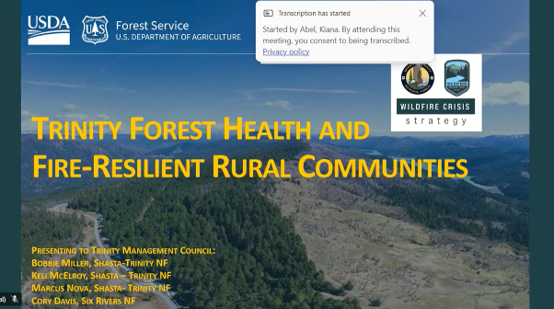
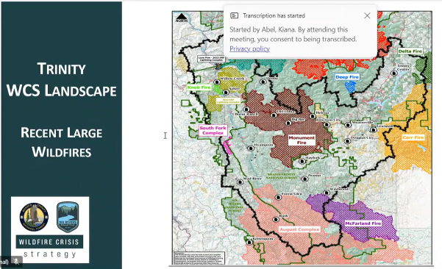

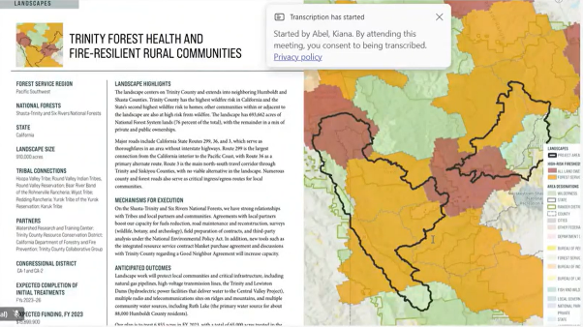
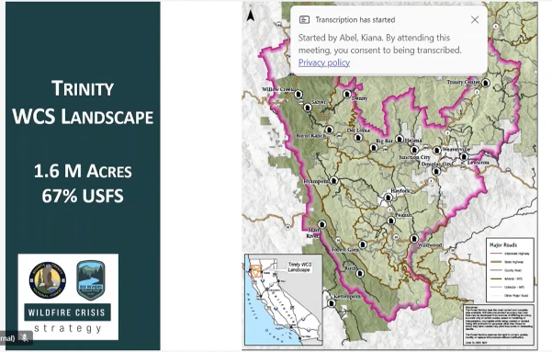

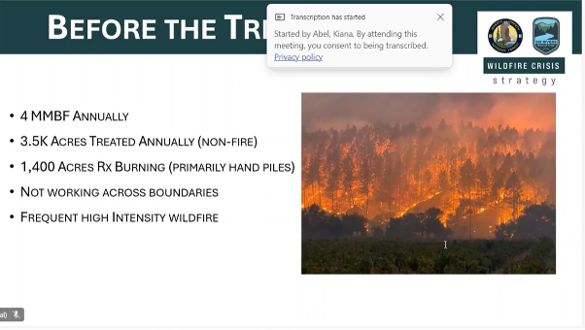
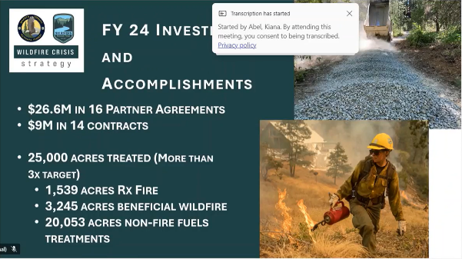

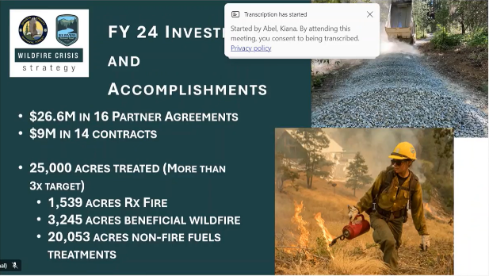

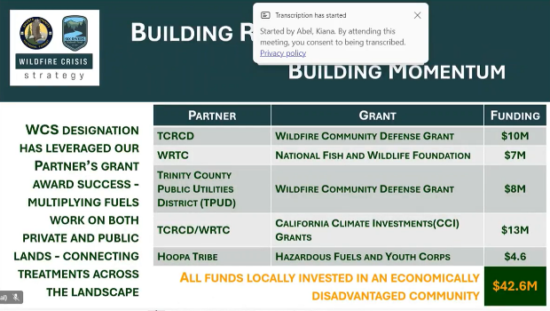

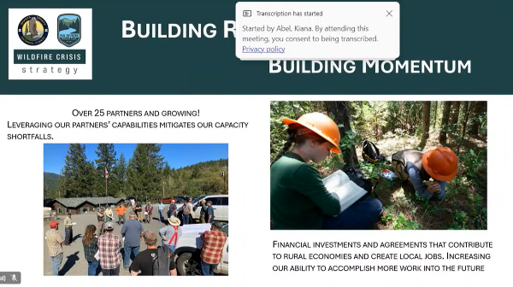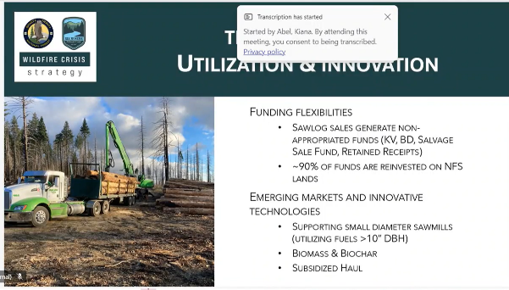

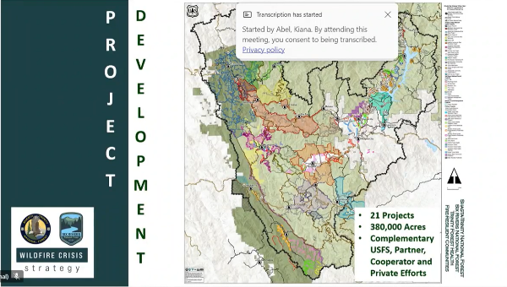

Hoopa Valley Tribe Work Outside the Mainstem Trinity River (Justin Alvarez)
Justin’s presentation is transcribed below with questions and presentation slides immediately following.
My name's Justin Alvarez. I work for the Hoopa Tribal Fisheries, and one of the hats that I wear is the Habitat Division Lead. And that's the section of our office that oversees all of the restoration projects and the staff there. The TRRP does a whole bunch of various projects all over the mainstem, but that's not the only place that fish go. They like to hang out in the tributaries, including on and around the Hoopa Reservation at the lower end of the Trinity before the confluence of the Klamath. So, we have a couple of projects that we've done outside of this group.
So, fish grow all over the place. So, just to highlight, this is production from tributaries in Hoopa through the years. We do fyke surveys, so we got these funnel traps that we put into the creeks and then we catch the little salmon and steelhead as they emigrate out. And we've been doing that since about the early 90s. So, we have records going back. On the left-hand side of the screen, that's the cumulative production by year. And then on the right side, you can see the individual creeks.
All these creeks that we sample are perennial, but some of them are tiny, like in the summer, they only go down to about 3 CFS. Some of them go up to 1000 CFS in the wintertime and then bigger creeks like Supply and Mill go all the way up into the Trinity Alps Wilderness on one side and all the way up to the boundary with the Redwood Creek watershed on the other. Those will go up to 6 or 7000 CFS in a good winter storm. But if you look at the overall production, sometimes it's over a million fish in 2013 that were produced just on the tributaries on the Hoopa Reservation.
The first project is Soctish Creek. It's a fairly small perennial stream. It ranges from about 800 CFS in the winter time to about 5CFS-7CFS in the summer, and right here on the far side you can see a little waterfall. So, there's a diversion for irrigation. It was put in about 100 years ago. It's a concrete lined pipe that runs down into a cistern and then goes through an open canal for a little while until it goes over to some fields for irrigation of those people's personal gardens and then some agricultural bigger fields for people raising some cattle. But as soon as they put that hardpoint in on the Creek, as the water shoots over it, it goes off the edge of the pipe and starts digging everything out.
It didn't take very many years, I'm sure, before it was a small waterfall that's impassable to the fish because it's not a deep pool underneath it. If they do manage to jump up, there's this like 2 inch deep, really fast water. So, they hit it and then just get shunted back down. So, it's been a complete barrier for a very long time. And so, for the last 10 years, it's been on my list of things to try to get to fix.

Last year, we actually did. So, this is just one photo point. First one is as it was before. Then we put in a diversion to route the water around the project as we were building it. And what we did was a roughened channel. So we trucked in a whole bunch of gravel. Hoopa has roads and aggregate plant where they harvest gravel off of the river bars. It was just a few miles away from the main stem. I had a whole bunch of different sizes that we built into a matrix. We would take dump trucks, jump it in, excavator would go and deposit it where we saw within the appropriate mix. And then we take fines, sand and dirt and we take one of the irrigation pumps like we used for the watering up on here and put it up to a host and use blast all the fines into that matrix to fill the interstitial spaces, so you don't have subsurface stream. Because we still want it to be flowing, because fish have a hard time swimming through gravel. Also, the people like to go and hang out there in the summer. It's nice and shady, and sometimes people use it as a swimming pool.
So, this is the jetting in process and at the end, before we opened up the dam again (our constructed temporary dam) then that's what it looked like at the end of that. So, this is the beginning and the end. So, first, we got the diversion, then electro-fished to get all the coho had been hanging out in that little pool and a bunch of Pacific giant salamanders and dace and other fish and other fauna. It was funded by a USFWS Partners program. They had a whole bunch of BIL funding.

After the ‘64 Flood, all over the place, all of the tribs in Hoopa were diked and channelized as they were restored so that they would never flood and impact people again. Really efficient at routing sediment and water. Not the best thing for the critters that live there, but it's good for the houses that are in the floodplain adjacent.
So, the two ways that you can deal with that is you can either lay back your levees and open it up, or you can take your whole channel and lift it. If the whole channel lifts, then it also creates floodplain habitat with small increases in water. And so that's what we ended up doing here, because even though we didn't take out the levee in this section, we were able to raise this, that is, the whole channel for about 150 meters and, so all of a sudden it's much more connected to the channel on either side. And then we went through and added a whole bunch of large woody debris, some wood jams. And then when the Army Corps was building their levees, one of the things they like to do was use riprap or whatever was handy.

So, they used old car bodies. Because we already had excavators and machinery in there, we were able to take out eight or nine car bodies that had been there since ‘65. This is a giant dump trailer that Buddy's Auto Center came over and helped us with. When I called him up and said I, we have some old car bodies and they were going to send a tow truck. I was like, no, no, no. They’re going to disintegrate as you drive down 96. We brought in, I think 5 truckloads of stuff out of there, and there's still more, but at least that one section is now devoid of scrap metal.
This is just a panoramic of the before and after from that one spot so you can see all the large debris we brought in and how much more effective. It's a better functioning stream. So that one's done and there's just a little bit of work that we'll do next summer just to enhance that.
On that same creek, we’re actually going to start a new project in this coming year. It's the same funder, and we're just funded for design. So, the mainstem Trinity is right behind these all the words that you can see there and on the left third of the screen you can see a channel going from bottom to top. It's all lined with alders and cottonwoods and stuff. I just took this picture two days ago.
So, that's why they all look like it's wintertime. But that's where Soctish Creek is. That whole channel, not just the channel itself, but the whole corridor, is about a half-acre from Pine Creek Rd. down to the mainstem. And so, we're going to lay the levees back and open it up to about 6 acres of floodplain channel. So that'll be designed this coming year. And then we'll get funding, and hopefully be able to do it in the next couple of years.

On that same creek, we’re actually going to start a new project this coming year. It's the same funder, and we're just funded for design. The mainstem Trinity is right behind these. All the words that you can see there and on the left third of the screen you can see a channel going from bottom to top. It's all lined with alders and cottonwoods and stuff. I just took this picture two days ago.
And that's just a different angle. So, you can sort of see it perspective in the upper right side. Right over here was the Mill Creek project, which is right across that we did back in 2017. It's super cool and doing very well.
Another project that's been on the docket for a long time. This is the culvert underneath Hwy. 96 right before you get to the high school as you're headed north. It's about a one and half minute walk from my office, and it's just another shotgun style culvert that has a pool below and it's a total barrier to fish even at higher flows. It’s about a 4-foot drop from the pool there, so we're going to do something similar to what we did in Soctish Creek where we bring in new sediments and build up that bed and put in a whole bunch of larger material that aren't going to get scoured out, and then we've been talking to CalTrans about addressing that particular culvert for 15 years or so, and maybe someday it'll make a list of ones that they actually get to address, but in the meantime we're going to try to get it passed.
This is actually not a perennial stream, but it does still get spawning. There was a handful of years ago where it's right next to the Firehouse. It's right next to the road trail that goes right past it. So, somebody's walking by and saw like two dozen Chinook string, and it's only 150 meters from the river to the highway. So, it has potential.
There's an elementary school and a high school in Hoopa. And oftentimes, the teachers reach out because they want their students to get engaged in restoration type activities or learn about the stream or fish. And so, this last summer, we had a bunch of 8th graders come out with our restoration specialist, and George got to go play with them too. We've got a bunch of tools and gloves. Some of them were not excited about using tools and doing manual labor in the sun. They just asked if they could make bouquets. I see all these wildflowers if you pick them, they won't seed and then you can make that your contribution.
On our current bigger project so, on the left you can see the bus yard on the other side of the elementary school and the high school. On the right-hand side of the screen there's a field and then the tribal headquarters with the senior nutrition in the background. So, this is right in the middle of Hoopa. Very, very visible. So, I'm not allowed to mess things up because everybody would see it and know.
But this is Supply, and we've done a whole bunch of work in Supply Creek since 2015 and ‘16. This is the Loop Rd. that cuts across the middle. Upstream of Loop Rd. is a big restoration site that we did in ‘15-’16. Downstream, you can sort of see the scallops on the right-hand side of the Creek. That's where we laid some of the Army Corps levy back, but we couldn't go very far because there's houses there and a community garden where we can get our most bang for our buck in this lower section is over here in the screen and where you can see, we've started doing work.
So, there used to be a road that went from Loop Rd. straight down to the highway, which is just at the off the screen. The green big patch of blackberries is a septic field that serves the BIA campus. And so, a lot of the offices and houses over there still go there, but that's going to get replaced hopefully in 2026. But in the meantime, we're taking that road.
This where it used to be 8 feet above the grade of the rest of the sting is adjacent is now a 15- foot trench. And so, the Creek is going to come all the way over here and then come along and then we re-routed the road and levy, so that we don't flood the bus yard and then put a, wetland swale to deal with the storm drain that currently empties out. In this one little patch of green, we left the tree so that the excavators and dozers wouldn't accidentally run it over. Instead, it's going to pop out up here. Then it'll just drain alongside the road and then cut under it. Go down this way, just like it used to.
This is the newest one. We just got the rest of the funding to complete it last month. So, we'll be able to knock this out mostly this coming summer. And then once the septic's gone, we'll decommission that and put a nice off channel pond and some additional channels up there.
The last thing that I was going to say so in addition to this BIL federal money, we've also had some nonprofits reach out to us wanting to fund work specifically within the Klamath Basin, but they were donating money to tribes. The Bella Vista Foundation was one of those. And so, we've been building a lot of beaver dam analogs for the last 10 years. I like using them as icing on the restoration sites. Once you see how they're developing and think, “if only this was a little bit deeper, or if it was developing this thing, but I can make it happen faster”. That's what I like to use the BDAs for.
Our source, Three Gs in Arcata to get untreated hosts was bought out by Dazey’s, and then they didn't have access to them anymore. So, we called around all over the place and we managed to get some, but we had to order entire truckloads, so we got posts that are 7 feet long and about four inches diameter. So, we have them and because we got them through a grant, we're just making them available to anybody within the Trinity Basin that's doing restoration work. So, we've already given a few bundles to the Watershed Training Center. We gave a few bundles to the Yurok Tribe to take up into the undamaged stretch for use up there. We're still going to use a bunch in Hoopa, but if any of you have partners that are working. Deadwood is one of the intents.
If you have partners that are interested in building analogs and don't want to pay for posts, they can just contact us and then bring a truck down and we can load it. They have to unload it themselves. It's something that we're providing in basin for no cost.

Public Comments
No public comments received.

Reports and comments of TRRP entities
None received.

TMC Discussion and Comments
BP: I had a question about the Soctish Creek. There was a diversion there before. What was the fate of that?
JA: It's still there. We just covered it back up and we put bigger substrate just downstream of it. And then I'm going to build a Beaver Dam analog about 10 feet downstream, so that it pools up. And so, you don't have the same scouring effect, so it won't re-dig itself.
BP: But the diversion, it still can flow water out? And is there any like, screening, or is it subsurface?
JA: Yeah. There is screening. It wasn't adequate or at least it wasn't up to modern specs.
And so now that it's accessible again, they’ve been working on fixing that. And then the Public Utilities district is working on reconfiguring that whole system to modernize. And so, they're going to try to make it into a hydropower and irrigation combination. So that in the wintertime when there's no solar available and power gets knocked out, they don't have to worry about PG&E dragging big generators to power Hoopa. So, they're talking about some small micro grid type stuff.
MO: So, there's a legacy of a whole bunch of irrigation that dates back decades. Irrigation district, ditches on Soctish Creek. I grew up and ate vegetables out of the water that was produced out of Soctish Creek. I grew up also by Supply Creek and ran around chasing fish around there. I saw the flood in ’64. So, anyway, that’s the point of that irrigation stuff that’s on our mitigation type things. On most of the ones of major irrigation versions we have fish friendly intake systems on Mill Creek and Supply Creek. This one is another one that adds to that. And so, there's that part of it that we've tried to mitigate that way. I think we're working on a flow study also to like what's the proper volume there. In the end, on a bigger front, looking across the board on the land within the reservation, an active solid stable irrigation system potentially out of the mainstream of the river, and that's been complete so, those are things that we're working on, but we're also actively trying to make it fish friendly.
JLy: Any other questions or comments?

KA: Justin, thanks for this presentation. I see so much potential for science on the river presentation from you. And I think it would be awesome if we partnered with the Fish and Wildlife Service. If you threw in one of the restoration projects that we funded as well, you know, be it be cool. We could do it in Willow Creek, something like that. If you're interested, if you have somebody else, you'd like to assign to that presentation, let's talk about it for next year.
JLy: Great suggestion. Any other comments or questions?

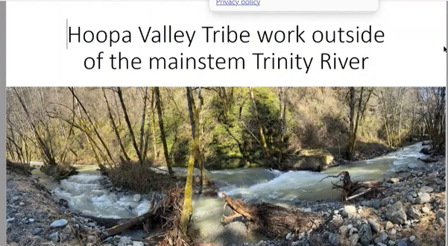
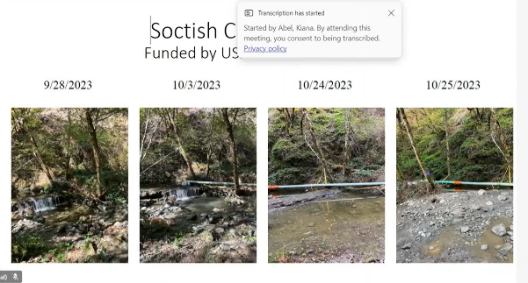

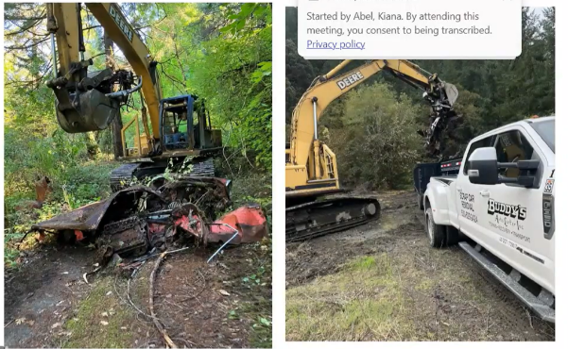

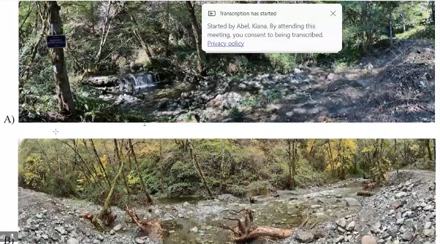
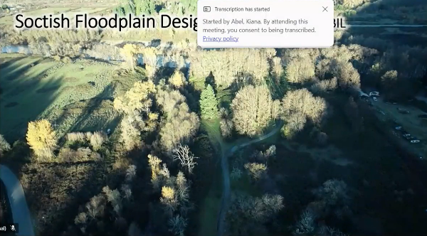

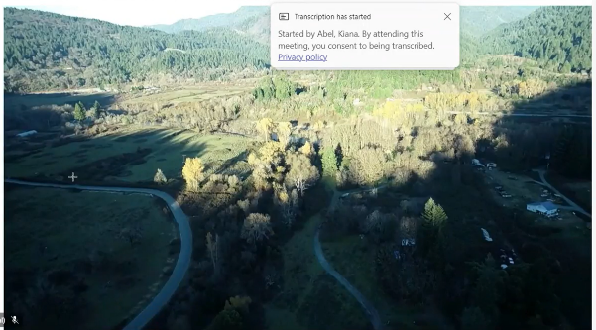

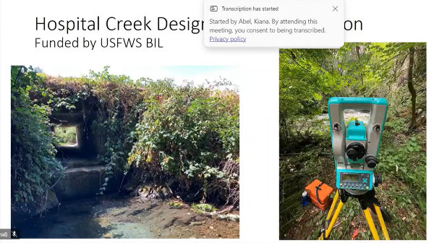
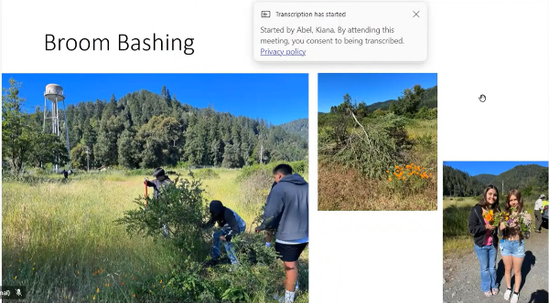

Break

TMC Bylaws Discussion (Justin Ly)
Justin Ly, Acting Chair welcomed everyone, initiated introductions, and asked for comments on non-agenda items from the public and TRRP agencies.

Public Comments
No public comments received.

Reports and comments of TRRP entities
None received.

TMC Discussion and Comments

TMC Decision Items Including Bylaws and Voting for Officers (Justin Ly)
JLy: We’ll open up discussion on the bylaws to get some resolution on things going back to December of 2022. Brett Kormos had a motion that was approved. It was contingent on the refinements document being approved by the solicitor.

Public Comments
No public comments received.

Reports and comments of TRRP entities
None received.

TMC Discussion and Comments
Amendements to Bylaws

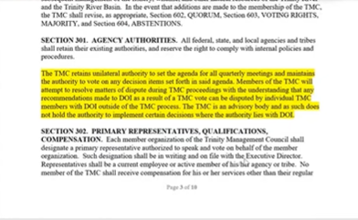
JLy: The motion in question was highlighted in the yellow text. It says “The TMC retains unilateral authority to set the agenda for all quarterly meetings and maintains the authority to vote on any decision items set forth in said agenda. Members of the TMC will attempt to resolve matters of dispute during TMC proceedings with the understanding that any recommendations made to

DOI as a result a TMC vote can be disputed by individual TMC members with DOI outside of the TMC process. The TMC is an advisory body and as such does not hold the authority to

implement certain decisions where the authority lies with the Department of Interior.”
MD: So that's the language we're talking about, but I want to confirm that the rest of the document is the right version.

After some discussion, it was determined that the version of the bylaws shared on the screen was amended in June 2024 and will be updated on the TMC website.
JLy: So, does TMC want this language in the bylaws stating that we have our own right to develop the agenda? Or do we just say, since the regional directors did not include it in the refinements document…
MO: We were one of the major proponents of even doing the requirement years ago. It dissipated down into a lot of, time frames, attrition, well, non-attendance among others, but on the solicitor's review of anything, it was verbatim taken. Whatever they said was you didn't question it. So, throughout the process, now it doesn't surprise me that now the final review, somebody looked at it and they took another look at it and there's some problem with something. So, I don't know what we can do about it.
JLy: We're not talking about changing the refinements document, and that was already approved. We're talking about whether TMC wants this language in the bylaws for ourselves.
MO: Well, you just said there was a reference to the refinements and that got eliminated. Now you're going back to fixing the problem over here. Is that what I'm hearing?
JLy: Yeah
RO: Instead of having the refinements, right? So, we've got all of these other actions that we've approved as a council. The executive session is done. We voted on it as a council. I think the goal of this here is Mike wants to get these inked. Before we do that, Justin is asking, hey, do we want to take this language that we wanted to put in the refinements but legal said “no”, or they didn't recommend it, right? Do we want to put that in the bylaws, correct?

JLy: Yep.
MD: So they struck it in the version of the bylaws that was included in the program document. But that doesn't mean that TMC couldn’t change it in the bylaws.

MO: So if somebody wants to take a shot at it and see where it lands, I don't. I remember the incident when this became an issue which was the Assistant Secretary for Indian Affairs weighed-in and pulled something out of the agenda. This is the aftermath of that. So that doesn't mean it won't happen again. You guys wanna take a shot at it? I'm not sure how I'll standby saying productivity or productiveness of that action or not.
JLy: Yeah, understood.
RO: I think Mike makes a really good point, and you very well may be right. I remember when Brett made this, and I think there's a lot of utility in it. It may not have a lot of teeth, but I think if we don't have the ability to at least set our own agenda. That's one of the fundamental principles of being a management council, albeit we’re advisory, but if we can't advise on things as a group, that is difficult. You know what I mean?
LG: Yes. So just to add to that a little bit, we'll say the supervisor’s agenda comes out on Friday night for Tuesday meeting. This is the only group that I'm with that has a floating agenda that
can be changed pretty much up to the to the last minute. I don't think that is a productive way of doing things as far as researching the items when they came up with the last minute. I would like to see it happen more firm. This is the agenda, and this is what we're gonna do. No change.
MD: I think that's unnecessarily limiting. The county's agenda does come out the Friday afternoon two business days before the supervisors meeting, which gives it the ability to have some finality, because there's not a much of a time window for it to change. Our bylaws state that I am to release the approved agenda from the chair two weeks prior to the TMC meeting date. There's a lot of things that can change in a two-week period. That's ten business days. People get sick, people have doctor's appointments that come up unexpectedly. People's kids are out. Whatever the case is, we routinely have to reshuffle presentations because of how early I have to post an agenda. We could reduce the time window at which I'm required to post an agenda, that's almost counterproductive, because it gives TMC less time to prepare for the topics that are likely to be on the agenda. So, I can see both sides of it, but I think we're talking to two different sides of the same thing, which is that it's frustrating when an agenda changes. But if we want the agenda posted in advance, we have to be flexible to when the actual topics are presented and what those topics are.

JLy: Perhaps there could be a compromise. You know, we post the Agenda 2 weeks in advance, knowing that there may be some changes. But two days before the actual meeting, we need to basically lock down. How long that is, we can decide and figure out. What would it be like four days before the meeting?
LG: Yeah, I think some presentation items should be locked down for the people that are doing their preparation. Decision items should be set a little bit earlier, so that the group go over those, make a decision with their people, and come up with the best solution that we can. Presentations are always great. Nor do I want to put off anybody setting up a presentation and all of a sudden you know, hey, you're not doing it. So maybe we can find somewhere in the middle.
RO: I think the only decision item I've seen come off has been that September one at Weitchpec. All those other decision items, they may have moved in order a little bit.
The county has the Brown Act. We don’t have to abide by that but there is some utility, and it gives certainty for the audience to know, “I need to be in attendance at 10, or I want to hear this presentation or hear this decision item”. Lots of utility in “locking down” the agenda.

MD: The other difference that provides some more certainty on the way that their agenda is presented versus ours is there are no times on the Board of Supervisors agenda other than start time. It’s just going to happen in the order that it's on the agenda.

RO: Getting back to this language that we have here, I’ll throw out a motion just to keep things moving along. I do recognize what Mike (Orcutt) has to say. I think there is a lot of validity in it. It may be futile, for lack of a better word, but I think it does have value in my eyes of being a management council. If you're willing to take a motion, I'd make a motion to adopt as written.
JLy: Thank you. Do we have a second?

An earthquake warning is issued on phones and the earthquake is felt in the building.
MO: Mr. Chairman, people are moving for other reasons here, so we should suspend this discussion at this point or what? Here's my comment on the oversight, and I remember exactly, because I was a part of the reason why. The Interior Department, we’re advisory to them, the hierarchy and the authority of all of that, I don't fully know it. But in that case, they reached down and said, “Pull this item off the agenda.”. They could probably do that at any point in time. So, that's my issue with that on the outside influences. On the inside influences I am concerned about the issue I raised at the start of this meeting was we talked at length in September about an issue. We talked about it at length on the coordination call meeting, and it was on the draft agenda. Then I was told what the action is not on the agenda.

I think there's a lot of criticism about G2G, but we'll take it up government to government and do it that way. The point here though is that this program has overlaps into the areas that we think are important. But if it has to happen the authority of the reclamation regional director will receive this program in some way. I'm concerned about that because… And then coming into this meeting, well, most of it's going to be just for informational purposes. We're not going to take a lot of any action. So, selectively one’s (agenda items) we take action on, one’s (agenda items) that get removed, those are the inside important things that I'm concerned about. The other stuff on the outside is going to happen no matter what you do. I'm concerned about what gets placed on the agenda and what doesn't get placed on it and then how that gets influenced.

JLy: Yeah, I hear you, Mike. So, if you have any suggestions regarding internally what is proposed for agenda topics.

MO: You'd probably have to delve into what authority the chairman has. I think the chairman has a lot of authority would be my guess. But staff advises you and the chairman could say this is the final agenda that would have been helpful to me and I would work with my staff on the issue that I brought up to earlier this week and I’d have provided a copy if anybody's interested. But we'll be taking it up with the meeting with the regional director.

LG: So, Justin, this time, our board, the Brown Act, runs through the CAO and yourself, being the Chair, for what agenda items are on the agenda, what presentations are presented, how long they last, and trying to keep the time schedule. I know you have a time schedule on these, but we try to keep the time schedule and very rarely meet that time schedule. Is that the way things go over here? An agenda item comes to you. You think about it, talk to somebody else about it and say, “this is what we need to talk about next time?”.

MD: No, we take stock of the topics that were proposed at the previous TMC meeting and anything that the chair recommends. I propose an agenda based upon the availability of presenters. I review it with the Chair or Vice Chair as appropriate, and then, whatever the Chair and Vice Chair decide is what gets posted.
JLy: We share it with TMC so that if we miss something, you let us know. We make mistakes too. So that's kind of like the checks and balances. TMC gets the opportunity to review the draft agenda. If there are suggestions, we'll most likely consider it and then incorporate it, especially if it's oversight.
LG: Fair enough.
RO: Ultimately the chairman does have discretion on what makes the agenda and what doesn’t. There are rare times when we’ve had issues that we can’t talk about at the meeting. I get that.
MO: The concept of looking at individual agency protocols is probably useful. You guys are
under the Brown Act, right? So, those are useful things, but investing all the authority in the chairman, I’ll have to think about that one, but it’s only federal employees anyway that could
serve as the chairman or vice chairman. Well, I represent the Tribe. We have our own ways we do things. But anyway, I'm not sure there's a willingness or urgency today. I'll just say that. To do this one we might want to have a little sidebar discussion. I would suggest that if there's no urgency that motion makers or seconders put it on the table here today and then have that other discussion and then we can then look at this a little more thoroughly.
JLy: Do you want to make a competing motion to table this specific topic?

MO: For now, yeah, because it is, like I said, I know other stuff on the outside and that's the way this organization's been run for 25 years, and there could be intervention anytime. It's an interior program. There's a delegated authority, and all those other things, but on the inside, that's where I have some concern about that.
JLy: I heard a competing motion to table this topic.

LG: I’ll second for discussion.
RO: I have two thoughts come to mind here. You know, there's not a ton of urgency. We've been sitting on this language for two years, right? Another three months, two months, whatever is not going to kill us. But some of the things that Mike is talking about are other things. One is the timing of our agenda, like when it comes out, we want we get a consolidated language in there. If we want to discuss how we set the agenda, that's another item. But a lot of the other conversation hasn't really dealt with this language. But I'm not going to die on that sword. If we want to push it, I'm fine pushing. But just recognize, I think there's other things that we're talking about here that are that are separate from this language.
JLy: Yes.

LG: If it’s not time sensitive, I think we need to push it forward until we get it right.

JLy: On this specific paragraph?

LG: Yes.
JLy: I agree. Any other comments or questions about this?
There were none.

JLy: Alright, we'll vote on the motion to table. Radley made a motion to include this in the bylaws. That was seconded. And then we had a discussion, and Mike Orcutt made a competing motion to table this topic. And we had a second by Liam on that. We just finished a round of comments related to the table. And so, if you would like to comment.
EH: Would somebody be able to reiterate why we're requesting the table?
JLy: The thought is that there is no specific urgency to this, and that ultimately if Interior wants to change our agenda, they still have that right because, federal agencies, especially the Interior agencies, like Reclamation are under Interior and follow their leadership requests. So, there

may not be teeth to this language, and so, it may not be all that effective. It might just be like a feel-good thing.

MO: Ultimately, I'm not sure we're trying to convince anybody of anything, but I would just say that it's about the outside influences when this is taken. My concern is about inside. Internal, we have pretty direct control of. Let's have that discussion perhaps at an executive or whatever discussion. We can put together this and or any additional language for future action.
JLy: We're ready for a vote. Those who are in favor of tabling this topic raise your hand. It's looks unanimous. Motion passes.

JLy: There are other parts of the bylaws that may need work. Some suggested changes as well.
James is looking at the specific edits and is incorporating them. All right. So just yesterday, you know, we had this situation where our chair recently retired and as the vice chair (I) became the acting chair. I was not available yesterday morning, because I had just gotten back into the country. I think it’s helpful for TMC to have a backup to the Vice Chair in case the Chair is not available, and whenever there's a change in the Chair, vice Chair role, my first set of edits is for us to basically have a vote to replace the Vice Chair when the Vice Chair becomes the Chair upon the former Chair’s departure/absence.
Motion: Mike Orcutt offers a competing motion to table the previous motion to adopt proposed language that would amend the bylaws.
Second: Liam Gogan seconds this motion.
Outcome: The motion passes unanimously with no opposition.

USBR: Yes
USFWS: Yes
USFS: Yes
CNRA-DWR: Yes
TC: Yes
YTFD: Yes
HVTFD: Yes
NMFS: Yes
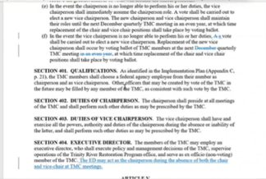
So, “in the event the chairperson is no longer able to perform his or her duties, the vice chairperson shall immediately assume the chairperson role. A vote shall be carried out to elect a new vice chairperson. The new chairperson and vice chairperson shall maintain their roles until the next December quarterly TMC meeting in an even year, at which time replacement of the chair and vice chair positions shall take place by voting ballot.” So that basically says if, let's say Don, retires, right? I become the chair immediately, right?
MD: Not the acting chair, the actual chair.

JLy: Yeah, I've become the actual chair, not just acting. So, that leaves the vice chair position open. And after it talks about having an election in December in the next December quarterly meeting in an even year. So, if there happens to be a change in the chair role where the vice chair becomes the chair, and it's not an even year, we have to wait almost two years, potentially before we can replace the vice chair, and I think that's way too long. I think whenever there's a need, we should vote on the vice chair replacement at the next quarterly meeting or at a special meeting. We shouldn't wait that long. So that's what the edits are addressing.

And then, if the chair and the vice chair are not available for whatever reason at a specific TMC meeting, I'm proposing that the Executive Director acts as the chair in their absence. And that's what the proposed text in Section 404 talks about. And this is just a suggestion.
EH: Just one thought on the Section 404. Would it be beneficial to have that all taken when there’s consensus in TMC to do so? TMC may say, you know what? We actually don't want to have a meeting.
RO: If you don't have a quorum, you can't take any action.

EH: Even if you did have a quorum, should the TMC members that are present agree to it?

RO: I think that's the function of quorum. If you have a quorum, you keep business moving. If people can't show, then keep going. You could then take that discretion out of respect to the folks that can’t make it.

MD: At that time, you would decide based on the members who were present, who built the quorum, would be able to decide are any of these topics time sensitive or not in such a way that we should defer until one the other Members are present?
LG: So Mike, are you saying if we have a quorum, would we still defer, perhaps?

MD: I'm just saying that that could be decided at the time of that meeting based upon the circumstances rather than defining strictly.

JLy: The TMC at present could revise the agenda to exclude a certain topic, because such and such person who is so critical is not there.

LG: I’m just being the devil's advocate. Say something came up on the agenda and someone was not happy with it or wanted to prolong that vote and they decided not to show up. The committees that I'm on, if there's if there is a quorum, we move forward. So say I didn't like it, but then there's no quorum, then that gets pushed off for three months.

JLy: The only time that I would think of deferring a topic is if somebody who should be leading the discussion is not there.

MD: Right. So, let's say example, like Mike had wanted to have a conversation about integration of hatchery and natural origin fish populations. We queued up Seth to come talk about the HGMP as a model, and then Mike couldn't make the meeting. Well, we might reconsider discussing that topic, because Mike was the one that called for that agenda topic.
JLy: That’s for the TMC to decide whether Justin or the alternate is prepared to discuss the topic that Mike originally wanted to discuss.

LG: Would we first not call on Mike’s alternate? I think that's the role of an alternate. If I can’t make it, my alternate could come here and make a quorum.
JLy: As the chair, I cannot make a motion to what I suggest. So, I would invite TMC to consider the edits and somebody make a motion.

MD: Do we want to do it as Radley proposed where you vote on the changes in 400(f). and then vote on the changes in 404 so they don't get bogged down? I think that was what you had said at the beginning of this?

RO: Yeah. They are a little bit different. I'll make a motion that we adopt 400(f) as written.
TH: Second.

JLy: Thank you. Any comments, questions about 400f?
MO: Can you make the font bigger? So, the blue is the new replacement?
JLy: Correct.
MO: This is just for the voting and nothing to do with the agenda.

JLy: Correct.

MO: Alright, a little bit though, because the chairperson has that authority in relationship to the agendas.
JLy: Right, but indirectly this is more about having the vice chair replacement be voted on.

MO: That's a separate issue. Fair enough.
JLy: Any other comments or questions?
BP: I'm just curious why we would remove the specificity of when the vote takes place with the vice chair but not the chair?

MD: Justin and I talked about this right before the meeting, and it's because the existing language for the chair says that the existing vice chair fleets up to chair automatically. So, that problem is already sorted out. The problem that we leave ourselves with in our existing bylaws is, like Justin said, there could be potentially almost two years where we don't have a vice chair coming in behind the way it's written. And honestly, that's a shame on us, because even Justin was referring to himself as the acting chair. In fact, he was the chair per our existing bylaws.

JLy: I am the chair, for the moment. Any other comments or questions regarding 400(f)? Not seeing any. We'll vote. Those who are in favor raise your hand. Motion passes unanimously.

Motion: Radley Ott motions to adopt 400(f) as written.
Second: Tim Hayden seconds the motion.
Outcome: The motion passes unanimously with no opposition.

USBR: Yes
USFWS: Yes
USFS: Yes
CNRA-DWR: Yes
TC: Yes
YTFD: Yes
HVTFD: Yes
NMFS: Yes

All right, let's scroll down to what is 404. So this addresses, in case both the chair and the vice chair are not available.

MD: Which is to my knowledge, only happened yesterday, but it can always happen again.

JLy: Exactly, it's rare, but we want to have the ability for the E.D. or somebody else, if TMC wants to elect somebody else temporarily, that's possible as well. This is just a suggestion.

MO: The rule book also transcends into other areas as well because, for example, where is it required that only the officers can be federal employees? That's out of the record decision information. So, there are other guiding documents that influence this?

RO: It references the implementation.
BM: So, is it the use of the word “may” in there? It's just to allow whoever is present to like the TMC to decide. It's not a shall. It could go either way. How is the “may” determined? Is the E.D. going to do it or are we not?
MD: Tough conversation because sometimes ambiguity can be really helpful in situations that you didn’t see coming, but also, it can be, you know, challenging and you don't know what that means when we have a future TMC that wasn't present in these discussions And I have to say like I'm on board with Liam in some ways about, you know, the chair and vice chair absent, we would potentially not hold a meeting, and I think that that could be gamed nefariously, if it's the right word, but you could use that to not hold the TMC meeting and having the “may” gives the TMC members who are present wiggle room on that. I could see it going both ways.
But maybe you rely on people's good intentions and commitment to serving TMC, to not manipulate the agenda.

LG: But just keep in mind the words “may” and “shall” have very different legal interpretations. And we need to keep that in mind.
RO: I’ve been noodling through that may versus shall, right? I think this gives the bylaws the opportunity to keep business moving forward. I'm trying to decide if that's a good thing or a bad thing. I kind of like “may” as it stands just because it gives us the opportunity if we do need to continue to move forward. It gives it direction to do that. I guess I'm trying to figure out what will we not want it to be a “shall”.
MD: Yesterday, I was a little uncomfortable operating in that gray area if you didn't perceive that. I could step in and lead a TMC meeting and we could actually conduct business. But we can also decide that in the absence of the chair and the vice chair, that it really wasn't appropriate to proceed if we keep it as may. I guess it would give us the flexibility to different circumstances. I don't even know what the topics of discussion on the agenda would be, but it may really be inappropriate in some circumstances for us to proceed without both the chair and vice chair, and this gives us an out if we need it.

LG: So, are we in agreement to move shall to may?
MD: It's already “may”. We were debating inserting “shall” instead of may.
JLy: I would recommend adding after the E.D., I would say the E.D. or acting E.D. because sometimes you're not here, Mike.
MD: The one thing that this gives us, the chair and vice chair are elected as individuals.
I can delegate my executive director responsibilities to an acting. Because if I'm not present, I will have an acting and that person is the executive director for these purposes.
JLy: It just makes it more clear.
MD: If it adds clarity, I don't see where that could get us into trouble really.
MO: So you're moving on and we're modifying more here? I'm not comfortable with this one.
JLy: Do you have suggestions on it?

MO: It is what role or not and where there are different overlays. There's an overlay of different things that speaking to the authority of the executive director that influence things.
RO: Do you have any other alternatives when we don't have the chair, vice chair?
MO: Probably, the chairperson or vice chairman could evaluate, and if there's not, there's not going to be a quorum. You can't take action. You probably should notify somebody ahead of time.

JLy: But like yesterday, there was a quorum. It wasn't a lack of TMC membership.

MO: So, that that's the example that we're trying to fix here, then I'm not comfortable with other issues, and the delegation of that for this position. I think we might want to talk about some others, if you want to hear the whole story on that but, that's my concern.

LG: I’d like to talk about it now if you have concerns.
MO: There's a whole overlay of executive sessions. I'm not sure the executive director participates in that or not. I don't think so, but that's one example, but there's other ones where there's other open. These are the bylaws, what are the other ones?
I got to think about it here. But not just the bylaws, there's another document as well. Programmatic EIS was the one that established who can be vice chairman of that?
That's a rule book open. I call them rule books, but I think there's another one here too. The vice chairman is not you (Justin Ly) were the last person because Donny left? Is that how that worked? And it couldn't be just delegated, because that was another fixed problem, right?
RO: It’s an elected person.
MO: See, that's where you know you look at all these rule books and everything. And that's what's so confusing to me.

RO: That’s what we’re trying to clarify.

MO: You guys changed it now. So that's why I'm not comfortable. That's all I know. I'd have to do more research on it.
EH: It basically says, ‘If there's nobody here, if there's no chair or vice chair you ‘may’, you don't have to, but you ‘may”; and it gives us the option of making that decision. But we can say “no”. We could say “no”.
MO: So, the point of it all, in my opinion, is whether we put our time in to come to these meetings and we're going to take action or not. I mean, whether I go to the meeting or not, I ask Justin Alvarez that there is or there isn’t. I don't like to hear when I get here, “well, there's some extenuating circumstances that we can't even take action now”.
MD: That's what this addresses. So, if this amendment to the bylaws had been in effect, I could
have called a motion yesterday in Justin Ly's absence and it wouldn't have affected the agenda. In the absence of that, they're in a gray area where arguably we could have had to cancel the TMC meeting altogether. And so, this just provides some contingency for us to move forward with TMC.
MO: The one example about the September meeting people didn't even take action for the rest of the meeting when that agenda got modified. We're still going to fix here, but the interior intervention?
Several people are talking simultaneously. Not all conversations were recorded.
EH: So, I guess my question to you, my guess would you have preferred that we cancel this meeting yesterday?

MO: Or this wording could be modified like you should have the question made when you do it this way. Do you take action or not? I'll just I need to do some background because every time we've done this, I'll know they changed that voting protocol over here, and then this one over here. And I've just said consistently, I think when you have the full rule book out and that's trust factor, it might be, because we've never had that for a long time, but the last five years, maybe longer. Somebody's gone back and fixed some of these things and they say, oh, no, they changed that at the last meeting. So that's what I'm cautious about this, if that makes sense. You can turn it into that other item that we prefer this one. I don't know what the federal protocols or regulations, even I don't know if that's applies here, but in an official meeting, that's my concern as an entity from the outside, not a federal entity to say well, go to the meeting, we're going to do this, that and the other. I report back to something's going to be done. And you get there and you say well, no, because they close the rules that we couldn't do it or something like that.

Unidentified speaker: So, I have a question here. Can you scroll up to the Section 400 where it talks about officers?

Discussion ensues about Section 400 and the ability of the TMC to establish other officers as the need arises.
MO: So, you're just going into that area and mixing up the alternate?
BP: The idea is we have two officers but chair and vice but we can establish other officers as needed. Is this a need that would eventually fix this?

MD: You're saying that instead of amending the language regarding the executive director responsibilities, we should amend the bylaws to establish another officer and then add another line saying that officer can step up.

RO: Yeah, that’s not a bad solution.
MD: If we don’t have enough federal employees, that would be the problem, right?
Several people speaking at once. Undecipherable conversation.
MD: So, in the absence of the chair and vice chair, the TMC alternate of the chair can step in.

RO: But here's the deal, when we elect somebody, we're electing that individual and then when we step away from that, you could have somebody that the Council may not really want to be the chair. Still, it's the same kind of thing, right? You could have an alternate that nobody really cares for and all of a sudden they're chair for day. You could have some unintended consequences there.
MD: You're electing a person based upon the perception that they're competent in their leadership for the TMC, and that may not be the case for their alternate. I can't think of TMC alternates right now where that’s the case. But you never know.

JLy: Should be pretty darn rare, right? It’s not that common where the chair and the vice chair are not available for a TMC meeting. So, is it really going to be that risky?
MD: I would say the same thing with your existing language. Either way, the risk is low, but it's whatever people in TMC have comfort with.

LG: So, in the past, have we ever seen that happen where there wasn’t a chair and vice chair?

RO: No. Yesterday was the only time.
JLy: Yesterday, I had already planned to not be here, and Seth would be my alternate, but because this was not already in the bylaws, I felt obligated to come here from SFO and be part of the afternoon meeting. But if this was addressed, I could have rested at home.
RO: So, if we were to add that alternate language and not have a third person, just have that alternate language, that would probably reside under if we want that alternate to be under, the chairperson. It would probably reside under the duties of the chairperson. We would say, “in the absence of the chairperson and the vice chairperson, the TNC alternate for the chairperson may act as a chairperson during the audience. just take that language and put it under the duties of the chairperson. I’m sorry I’m being presumptive, but I'm trying to place it there so, we can make a motion. So, if we move that up to 402…

JLy: I think it should probably belong where you have the succession.
RO: The only reason I put it in the chairperson, is because it would be the alternate to the chair.

JLy: So, you're suggesting the chairperson may preside at all meetings in the TMC.

LG: If it says you shall do that, you legally need to do that.
MD: Well, if the chair's not present, then everything else comes in. But if the chair's present, the chair shall preside at the meetings. Otherwise, what's the point of having the chair?
LG: I think I would just change shall to may, just for openness.

JLy: Yeah, I see what you’re saying. So, the chair would be like legally obligated to be there at all meetings.

LG: And some people can argue the fact that it's just shall and you're not here. But we don't have the meeting because someone's like…

RO: But you have contingencies, right? Yeah, but in 403 it says, “during the absence or inability of the latter shall perform the duties as prescribed by the TMC. So, you do come contingencies to use.

LG: That's the reason that I would make that all coincide by changing “shall” to “may” just so it all fluctuates. It has fluctuation in it.
EH: I’m going to disagree. To me it reads cleaner because the chair is supposed to do their job. We're requiring them to do that, but then if you don't have those, then you get the “may” that we may decide.

RO: The “shall” has claws, because right below you have something that says in the absence of that, so it's not limiting us to only the chairperson. If the Chairperson's not there, I think the strength of the “shall” goes way, because you have other language that speaks to that absence.

LG: It makes sense. I'm trying to clear it up.

JLy: I hear what you're saying.

LG: I think when I get the whole understanding of this, what we're going through, I'm seeing those two words come back and bite you.
JLy: Yeah. So, to address your concern, Liam, I understand what you're saying. We may want to add unless unavailable, the chairperson shall preside at all meetings.
LG: Sure, and it gives you the latitude you need.
EH: But I think we already say that in the duties of the vice chair. In the absence of the latter, that's the whole point.

JLy: No, if we just focus on the word, the chairperson “shall” preside at all meetings.

MD: Unless unable or unavailable.

JLy: That's what I'm saying. But if you just take that phrase, if the chairperson is not available, the chairperson shall still preside at all meetings, it's very binding and by adding, “unless unavailable comma, the chairperson shall preside at all meetings”, that enables the chairperson to not necessarily be at that meeting. Does that make sense?
EH: It does. I don't think it's necessary. I think we’re going to wordsmith this to death. I think it’s fine the way it is. It’s been like that forever.
LG: I agree with Justin. Bylaws come back and bite you all the time. So, I think we should fix it or give it as much variability as possible with the understanding of the people in the room.

JLy: I don't think it hurts to add the “unless unavailable, the chairperson shall preside at all meetings”.
MD: I like, “when present, the chairperson shall preside.”
RO: I'll make a motion to adopt this language: Under duties of chairperson, to add the term

“when present”, after “shall” in the first sentence. The chairperson shall, when present, preside at all meetings…

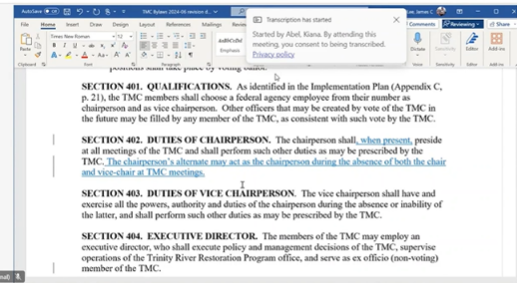
LG: I'll second that.

JLy: Liam seconds. Thank you. Comments. Questions.
MO: So we didn't modify the 404. We went up there and fixed the problem in 402.

LG: And delegated authority to the alternate.

JLy: Yes. Any other comments or questions about this particular motion?
OK, we'll vote. Raise your hand if you are in favor. OK, motion passes unanimously. Thank you.

Motion: Radley Ott motions to add language in section 402 so that the phrase “when present”, follows “shall” in the first sentence. The chairperson shall, when present, preside at all meetings.
Second: Tim Hayden seconds the motion.
Outcome: The motion passes unanimously with no opposition.
USBR: Yes
USFWS: Yes
USFS: Yes
CNRA-DWR: Yes
TC: Yes
YTFD: Yes
HVTFD: Yes
NMFS: Yes
JLy: Any other suggested changes to the bylaws? This is the time.
MD: I'm going to get a copy of that as marked up and find somebody at CalTrans who can print it so that we can sign it.
JLy: OK, while you do that. Last call for bylaw proposal.

TH: So, this version will not have the language about the amendment.
RO: Yes, we will not have that version.
JLy: OK. Voting. Do you want to do election?
MD: Wow, I was thinking this was going to be in the afternoon. I have that prepared if you want to use it.

2025 Meeting Dates

JLy: Why don't we jump to topics for March TMC meeting, then. Alright, Mike, so for TMC monthly meetings…

MD: We've historically done the 3rd Thursday except for when the third Thursday conflicts with the holiday.

JLy: Is that going to be an issue for folks? Monthly meetings. Third Thursdays.

EH: You gotta go month by month.
MD: The quarterly meetings are March, June, September, December.

JLy: You know, we've just kind of said, third Thursdays. And if the primaries can't make it, that's where the alternates are. That way, it kind of saves us the hassle of having to, like, let’s go through our calendars, for, every month.
They've got, they've got them where they've got them on the yearly thing and they go, there's always some modification to change anyway, so.
EH: So, we're looking at March 20th, June 17th, September 18th and December 18th.
Is that correct?
MD: That might be a little late for December. We haven't always done the quarterly meetings on the 3rd Thursdays, but if it works on people's calendars…

Various discussions over which members are eligible for voting as well as primary and alternate representatives. Paper votes for TMC chair were collected and counted by Mike Dixon.

MD: In a landslide, 6 votes to 1, Bill Pinnix is the new TMC chair.

Paper votes were collected and counted by Mike Dixon.
MD: It's not decisive with seven of eight. We need Mike Orcutt’s vote. Although I will say we may need to revisit because two people voted for Bobby and one person voted for Keli and I don't know if it was totally clear who was in the running for the vice-chair.

JLy: Officially, it's Keli, as USFS’ primary, right?
MD: Yeah. I think we need to re-do it. All right, standby.
Justin Ly: Only three people are eligible now, Elizabeth, myself, and Keli.

Paper votes collected and counted by Mike Dixon.
MD: All right. You can inform Keli that she is our new Vice Chair. That's cool. It's a big flip in our leadership. Justin is not the vice chair or chair for the first time in a while.

TH: Is that official, as of right now?
MD: Yes, that is now official for the rest of the meeting.
MD: We were skipping ahead to the dates, Bill, because DJ’s not available till after lunch.
BP: OK. So generally, we hold our meetings on the 3rd Thursdays monthly.

MD: James, I got 2 markup versions. I don't have a clean version sent to me.

JLee: Let me resend that.
MD: One says clean, but it has markups on it.
EH: The first date I had was March 20th, the second date. It falls on a holiday so that one can't work. June 19th, which is Juneteenth. And then I’ve got September 18th and the last one was December 18th, which I think everybody agrees is too late. So, we might want to move it up to December 11th.
MD: I'm not available the week before The second week of June I’ll be in Hawaii for my retirement from the Coast Guard.

LG: I won’t be here. I’m leaving on the 16th. I come back on the 2nd of August.
MD: Is Heidi available?
LG: Yeah, she should be available.
JLy: Could somebody put the dates on screen for me?

Ty Wallin shared his screen and typed the dates during the discussion regarding availability for quarterly meetings.

Discussion regarding dates and availability for monthly conference calls.

MD: I'm going to send out calendar invites for the whole 12 months.
BP: If there's not any other comments on the dates, then let's break to lunch. The next speaker is scheduled to talk at 1:15. If you could be back here at 1:10 so we can start popping at 1:15 so that we can get out of here earlier than scheduled.

Regular Meetings:
March 19-20
June 17-18
September 17-18
December 10-11

TMC Update Calls:
January 23rd
February 20th
April 17th
May 15th
July 17th
August 21st
October 16
November 20
Lunch

Yurok Tribe Restoration Projects Beyond the Mainstem of the Trinity (DJ Bandrowski)

DJB: Thanks for having me, Mike. Thank you, TMC, for the opportunity to present. My name is DJ Bandrowski. I'm a project engineer program manager. You probably remember me from my days at the TRRP. I served as a civil engineer and then Implementation Branch Chief from 2008 to 2015. In 2015, I joined the Yurok Tribe and have been there ever since. I work for the Fisheries Department under Barry McCovey. Of course, Tim is our Natural Resources Director. Tim and tribal leadership had a vision of this holistic view of large-scale restoration projects outside the Trinity basin but primarily focused on the Trinity.
Since 2015, and even before with the watershed department, the Fisheries Department started gaining some momentum, again, based on Yurok leadership's vision and started enhancing the different places that we were going to be working including dam removal. Of course, dam removal started happening decades prior in the planning phases and all the lawsuits that ensued, etc. But in 2015, momentum started kicking up and we start developing a team of folks within the tribe that can really handle large-scale restoration projects. I was tasked with that mission along with many others, and we started working on projects outside the Trinity.
We started the first one with Limekiln Gulch. Then in partnership with the Hoopa Valley Tribe in 2016, the Bucktail project. That ensued an awesome partnership between the Yurok and Hoopa Valley Tribe and on-the-ground implementation activities and that's been carrying on ever since. We just finished implementation of Upper Connor Creek on the Trinity. That theme of partnership with other tribes really just carried forward. The Tribe's vision was to really focus on large-scale restoration across the Klamath Basin and outside the Klamath Basin as true stewards of the landscape, but in partnership with Karuk Tribe with Modoc Indian Nation, Shasta Indian Nation, Klamath Tribes, and other tribes on the Sacramento River, etc.
During that time, we really just started building momentum but really focus was on dam removal. That was obviously the tribe’s priority. So, we started building our technical team and operations team to handle the need for that project. One of the biggest things that happened during this time was the formation of the technical team as well as our construction team. Development of the Yurok Tribe Construction Corporation, development of a design and technical services team within the Fisheries Department, which I currently manage.
A shout out to all the all the folks at the Yurok Tribe that have been carrying out the vision of stewardship. It doesn't just start with those that have gone before us. It's those that are carrying
it forward. This [collage – displayed on-screen] is a shout out to our some of our young tribal members that are now engineers, geologists, surveyors, some are finishing up their PhDs some are graduating with engineering degrees from Cal Poly. It's really exciting to see. Every time I hear about someone that's at the Tribe getting their degree, whether it's business administration, finance or geology, we want to try have a place for them to be able to come help perform restoration for their community. Within the Fisheries Department Design and Technical Services program, we have approximately 65 employees and growing rapidly to handle the restoration work across the basin.
But what I really want to focus on here for a few minutes is the Klamath Dam removal project. We've just finished the largest, along with many other partners, the largest restoration project in the history of United States with the removal of Iron Gate, Copco and JC Boyle. Many of you are all familiar with this project, so I don't want to go into too much detail. I have a video that I'm going to show off some of the recent activities and now end with some even more exciting news that you've probably all been hearing about across the news outlets.
Aerial images of Copco Reservoir 2018 and after drawdown in 2024 were shown and details of the re-seeding efforts were discussed.
The formation of Condor Aviation in 2022 was discussed. The program will allow the pursuit and monitoring of restoration projects with aerial and LIDAR imagery. All 3 reservoirs were mapped monthly during drawdown.
A partial documentary of Klamath Dam removal from Shane Anderson’s Swiftwater Films was shown.
DJ: After 100 years, fish have returned to the Klamath and are spawning. They have exceeded the expectations of I think any biologist including guys like Mike who have been working on this for a really, really long time. They have made it all the way to Spencer Creek. There have even been reports of them in fish ladder at Keno, really blowing everybody's expectations.
Pretty exciting. The reports are somewhere in the neighborhood of potentially up to 5,000 fish have made it past Iron Gate. So, it's really exciting, something to celebrate. The tribes continue to do the work, along with many of the partners. But there's a lot of work ahead.
This summer we'll be working with RES to do heavy civil construction, restoration action similar to like what we would do here on the Trinity, but in Jenny Creek, Beaver Creek, Scott Camp Creek, and then Spencer Creek, including large wood placement, flood plain lowering, removing those legacy settlements. The Yurok Tribe, along with in partnership with all the other tribes and the other basin have received a grant from NOAA to do post dam removal restoration in areas that are outside of the Klamath River removal reparations influence.
Where the reservoir footprint is upstream of that they don't have jurisdiction to do restoration. So, we just received a large grant to work with the other tribes to help design, monitor, and implement projects across Jenny Creek, Shovel Creek, Long Prairie Creek, and Spencer Creek, etc. So, that's super exciting. I think this is going to be a long-term effort for the next decade.
Some projects a little bit closer to home. This is Clear Creek. The Yurok Tribe received a grant from the Bureau of Reclamation CVPIA program as well as California Department of Fish and Wildlife to do large-scale restoration across Clear Creek. Forest Health Project is one of them, gravel augmentation, large wood placements, population monitoring, performance monitoring for fisheries habitats. Kyle DeJulio is a project manager on this partnership with the Bureau of Reclamation, US Fish and Wildlife Service and many NGOs across the basin CDFW, Cal Trout, RCDs, etc.

Some other projects that we've been working on just recently is the Kapusta and Shea Island projects right here in Anderson and in partnership with Chico State Enterprise, River Partners, DWR, local tribes Redding Rancheria and the Wintu-Nomlaki Nation putting in large wood, side channel habitat across the various projects on the Sacramento.
This is O’Rew (Orick Mill Restoration Project) in Prairie Creek, which is a tributary of Redwood Creek on the coast. We've been working on this project for about 5 years. This will be the trails gateway for the Redwood National Park in partnership with Cal Trout, Save the Redwoods League, Redwood National Park, and many others.
Another big project we've been working on is McKinney Creek Post Fire Restoration Project.
We've received a large grant to work with the Karuk Tribe, and Mid-Klamath Watershed Council, Watershed Research and Training Center and various other folks to help support postfire restoration.
MD: So, nothing for Mill Creek or Hunter Creek? You guys have been so busy, you couldn't even put it into one presentation!
DJB: I tried to give some highlights, but we've been working in a lot of different places near the Smith River and Mill Creek.
Additional Restoration projects were listed including projects in Alaska.

Public Questions and Comments

No public comments were received.

Questions and Comments of TRRP Entities

TMC Discussion and Decision

BM: I had no idea how far flung your work is. That’s amazing. Really inspiring. That’s amazing.

TH: Is Upper Spencer Creek PacifiCorp ownership?

DJB: No, Spencer Creek is Green Diamond. Shovel Creek is owned by Pacificorp. Parcel B lands, which is all the area that was the footprint of the reservoir went to the State of California and was transferred to the Shasta Nation.
BP: The only item left is topics for the March. So, you want to spend a few minutes talking about that?

MD: So just for the purpose of having the list so we don't miss something. Definitely, we're going to talk about the spring flow proposal. We’ve tried and failed multiple times to do various field trips. I've got most of the TMC out to see Oregon Gulch. I’d really like to see Indian Creek with the TMC in March. The challenge with that might be that it’s all wet. But we can go out there, and those who want to explore on foot can get wet. Bring waiters, otherwise there's overlooks. So that's something I want on the agenda for the end of the second day is a tour of Indian Creek, if people are willing. It's a pretty cool project and it's going to look amazing in March.

TH: And we're starting phase two of it.
MD: You (BP) and Ty were going to work on possibilities for a non-FACA public engagement.

BP: Yeah., we may try and give a presentation before March.

MD: Given that it's in Weaverville and the millions of dollars that the Yurok Tribe has gotten from us (TRRP), State of California, and Reclamation from BIL to do it, maybe we could hear about the Weaver Creek floodplain project on the portion of Weaver Creek below the confluence of East and West Weaver. They have 100% design and they're working on environmental permitting, so it might be a good time for them to talk about that since it's locally appropriate.
RO: Checking on science, I know that something came up.

MD: Eric’s deferred topic. Updates on objectives and targets and how they align with our monitoring efforts. Is there anything that you guys feel like you're not hearing updates on from us? There's a lot of stuff going on in the background and sometimes it's hard for me to remember what we've briefed you on recently.

RO: We deferred the (vote) on the bylaws.

MD: I’ll drop by the store on the way home and get Liam’s signature if he has stopped there.

BP: That’s a good start, and we continue to build it out in January.

BM: There was the bigger conversation of the hatchery and the TRRP.

BP: I think it would be good to keep conversation going.

MD: It’d be helpful to frame the objective before we put it on the agenda. It has been less productive than it could be when people aren’t necessarily sure what it is and where we are going with the topic.

RO: What about the focus? I heard Kiana entertaining a new group or task force for public outreach. I think that is different than the FACA conversation. It could be a task force or reaching out to individual partners to ask, “what are you looking for from the message?”.

MD: Why don’t I come up with a proposal so that you have something to react to and we can spin it in whichever direction the group wants to go?

RO: I think Hoopa and Trinity were both interested in that, so glad to hear that it’s something we might want to think about.

Adjourn

