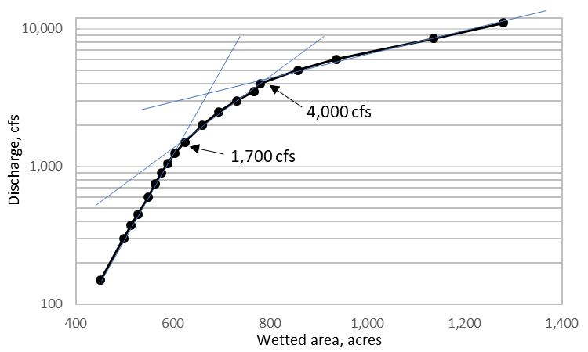
Functional flow considerations in hydrograph development (Buxton 2020)
Primary production, macroinvertebrates: Duration of inundation for establishment of biofilm is 28d; pioneer macros 35d, peak macros 63d. See below figure for mainstem channel-connected wetted area versus discharge relationship modeled for the restoration reach with SRH2D.

Foothill yellow legged frogs (FYLF): Vary flows before peak discharge to delay FYLF breeding until after the peak flow event to prevent scour of egg masses on bars.
Riparian recruitment: Maintain moist soil on surfaces wetted by 2,000 - 4,500 cfs for cottonwood recruitment beginning in the average seed dispersal period (May 15-May 28) and lasting 21-29 days. During targeted period, flow stage should be ≤0.46 m below targeted surface. Following peak discharge in targeted period, recede stage ≤0.10 ft per day at Trinity River at NF Trinity River gage.
Fine sediment transport: Depending on the targeted area for transport of fines, discharge should be increased above 3,000, 1,000, and 2,000 cfs at Lewiston, Limekiln Gulch, and Douglas City, respectively. Continue to increase flow above threshold discharge to maintain entrainment and routing of fines. Increase flow above 4,500 cfs to deposit fines outside the main channel.
Bed load transport: Increase flow above 3,500, 2,500, and 2,000 cfs at Lewiston, Limekiln Gulch, and Douglas City to mobilize the coarse armor layer. Afterwards, flow increased steeply to a short peak followed by a rapid decrease in flow generally maximizes loads per unit volume of water due to clockwise hysteresis that is common on the Trinity River. Successive high, short peak discharges typically transport a cumulatively higher load and route more coarse sediment than a high peak that is maintained for a protracted period.
Geomorphic change: Rapid decreases in flow from stages that inundate banks waterlogs and promotes collapse of banks that encourages adjustment of channel position (meandering), wood recruitment, and formation of diverse edge habitats for fish.
EIS up- and down-ramp rates
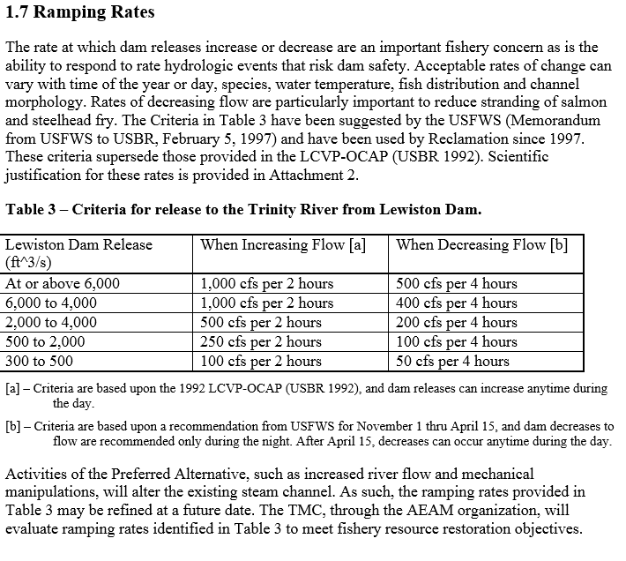
Water temperatures for salmonids:
1) The 7-day moving average of daily average temperatures should be maintained between 13.0 – 16.5 C at the Trinity River above NF Trinity River gage.
2) Meet temperature targets for juvenile salmonids (in Celsius)
3) Meet temperature targets for adult salmonids (in Celsius)
Hatchery fish: Provide 600 – 1,000 cfs and increasing flows for a week following that start of hatchery fish releases (April 20, May 18, June 15 targeted for WY20).
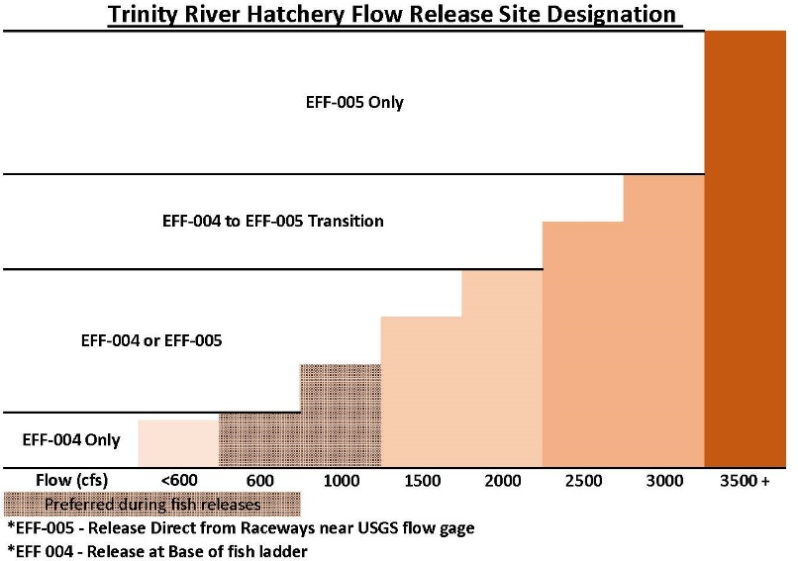
In-channel construction: Release discharge from Lewiston Dam ≤1000 cfs from July 15 - September 15.

