Interdisciplinary Team Meeting Draft Agenda

March 5, 2025
0900-1600

Coordinators: | Eric Peterson and Ty Wallin
Desired Outcomes: | - LFA phase 2  - Continuing conversation with CFS on data and getting it to them  - Forward movement toward FY26 RFP  - Consensus on forwarding Flow and Augmentation recommendations to TMC  - Discussion of Environmental Flow Study Plan path forward
Please review: | - FY26 Proposals (to be emailed late Feb. 28th)  - Flow and Augmentation recommendations (separate email)  - RAE Workgroup Memo on turtle target (separate email)  - Monitoring and DSS Review assignments (appended)  - Environmental Flow Study Plan draft outline (attached email)
Please bring: | - Positive energy and enthusiasm!
Locations: | - Weaverville TRRP Office, conference room  - Arcata FWS Office, 1st floor conference room  - Microsoft Teams Need help?  Join the meeting now  Meeting ID: 220 130 107 812  Passcode: Xf27F8nZ

[continued on next page]

Agenda
Time | Topic – | Presenter or Lead  (Peterson / Wallin unless otherwise)
0900 | Limiting Factors Analysis, Phase 2 Kick-off with CFS  - See agenda (pending) from CFS | CFS / Peterson
1100 | Break
1110 | Review Agenda, ID notetaker for remainder of meeting | Peterson / Wallin
1115 | TMC Agenda Review | Peterson / Dixon
1130 | Workgroup Coordinator Reports and Workplans  Please be prepared to give your report as you will for the TMC meeting, and to give an overview of your Annual Workplan.  - Design  - Watershed  - Fish  - Flow  - Physical  - RAE  - IDT | Workgroup Coordinators
1145 | Objectives & Targets: RAEWG: Turtle target  (See email) | Peterson / Nissen
1200 | Lunch – online: put hand up when you return
1300 | FY26 Science Planning: Parsing out proposal reviews to workgroups  1310: Presentation/Questions on Tributary Sedimentation Proposal  1330: Presentation/Qs on Foodscape Modeling in S3 Proposal  1350: Presentation/Qs on thermal diversity for turtles Proposal  1410: Parse out reviews to workgroups | Peterson / Wallin
1420 | Break
1430 | Spring Flow Recommendations | Flynn
1500 | Augmentation Recommendations | Pittman / Nissen
1515 | Monitoring & Modeling Review: Status Check with Workgroup Coordinators  - Any identified needs? | Peterson / Wallin
1530 | Environmental Flow Evaluation Study Plan  - Might be just a brief discussion, then set a special meeting in the near future for more thorough discussion? All workgroups? | Peterson
1600 | Adjourn

Appendix A: Workgroup Annual Cycle

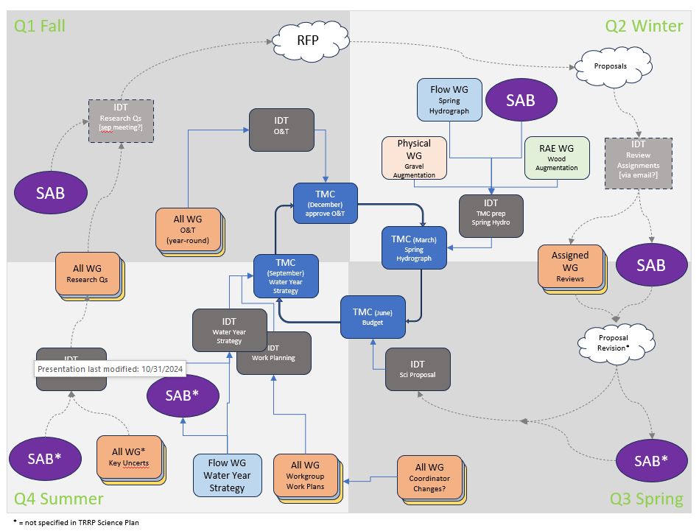

Appendix B: Monitoring and DSS Review Assignments

The IDT is requesting that workgroups conduct reviews of monitoring and modeling activities. The review form is attached and activities are assigned below. Reviews will be coalesced and summarized to inform the Program on optimizing our activities, and for presentation to the TMC. The SAB will also provide a review of our reviews. No deadline has been discussed, but this review was identified by the Science Plan for FY23 and 24. It would be nice if the product from these reviews could feed into the TMC's FY26 budget discussions (next June).

The intent of this project includes identifying information gaps. Should your workgroup realize a need for an activity that is not currently being conducted, you are welcome to propose it. Please try using the same form; contact me if the form just isn't working for that purpose.

Your workgroup may assign effort as it sees fit, with one exception: individuals who are among the leaders of the activity being reviewed should not drive that review. But, you may certainly reach out to the activity's leaders to gather information.

Some assignments indicate a secondary workgroup. For these, the primary workgroup should have their review checked by the secondary before submitting back to the IDT.

I acknowledge that some items that are split due to the TMC budget may best be merged for purpose of review.

This is going to be a significant amount of work! I appreciate your efforts!

Program Office:
- Aerial Photography - 40 mile, annual
Design Team:
- Aerial Photography - as built
- Terrain - as built
- LWD Survey
- Construction Impacts (DSS model) [secondary WG: Flow]

Fish Workgroup:
- Chinook Run Size Estimate (mark recapture at Willow Ck)
- Chinook CWT-Fall (mixed into 1 and 3)
- Fall Run Scale Age
- Outmigrant
- YT Harvest (Lower Klamath) (part of 1)
- HVT Harvest (Lower Trinity) (part of 1)
- Redd/Carcass Distribution
- Lower Klamath Creel Survey
- Sport Harvest / Trinity Creel
- Temperature Monitoring (not at USGS streamgages) [secondary WG: Flow]
- Juvenile Abundance (S3 - DSS Model) [secondary WG: Flow]
- Temperature (RBM10 - DSS Model)
- Note: to my knowledge we have neither monitoring nor modeling for some targets within Fish objectives 5, 6, 9, 10, 11, and 14

Flow Workgroup:
- Streamgaging (Flow, Temp, other) [secondary WG: Physical]

Physical Workgroup:
- Terrain / SRH2D- 40 mile [secondary WG: Flow]
- Detrended DEM [secondary WG: RAE] [contact myself and Jeannie McSloy for current method]
- Grain Size Facies Map [secondary: Fish]
- Active Bar Monitoring
- Sediment Transport (Hydrophones)
- Total bedload transport at DC (DSS Model) [secondary WG: Flow]

Riparian and Aquatic Ecology Workgroup:
- Riparian Vegetation Mapping
- Targets, Cottonwood Initiation [secondary WG: Flow]
- Encroachment Risk model [secondary WG: Flow]
- FYLF population and metamorphosis date [secondary WG: Flow]
- Note: to my knowledge we have neither monitoring nor modeling for the second target of RAE 3

