Meeting Summary
Flow WORK GROUP
Thursday, February 6, 2025 9am-12pm
MS Teams

Participants
Todd Buxton (USBR/TRRP), Oliver Rogers (USBR/TRRP), Patrick Flynn (TC)†/*, Kiana Abel (USBR/TRRP), Kyle DeJuilio (YTF)*, James Lee (USBR/TRRP), Mike Orcutt (HVTF - left approx. 11:30), Justin Alvarez (HVTF - arrived approx. 9:35am), Karl Seitz (HVTF), Chris Laskodi (YTF), Galen Anderson (USFS), Ty Wallin (FWS), Ken Lindke (CDFW)
*notetaker
†coordinator

Outcomes of the Meeting
- The Workgroup decided not to recommend any changes to the TMC-approved wet-season flood hydrographs despite the Safety of Dams releases. The release will still be “scheduled” but will be made invisible throughout most the Feb-Apr period by the SOD releases (provided they are released at 1500 cfs), aside from three peaks that will exceed 1500 cfs briefly. If the SOD release is at 3600 cfs, then the wet-season flood hydrograph will be made invisible throughout the winter baseflow period.
- The group agreed that focusing spring release hydrographs on wet/extremely wet water years was best
  - There are three scenarios to be developed:
    - a wet year with 180,000 af released in the winter
    - an extremely wet year with 180,000 af released in the winter
    - an extremely wet year with 220,000 af released in the winter
- There was a request to have the flow scheduler updated after each water year
- There was a request to have the flow scheduler updated for the WY2025 season
- The group generally agreed that limiting the number of hydrographs that will be submitted and reviewed/modeled to two or three per scenario as described above
- The group agreed to use actual releases for modeling purposes through the day that modeling begins, then use scheduled releases
- Modelers were identified
  - RBM10 – Laskodi
  - Temps – Lindke
  - S3 – Laskodi
  - FYFAM – Ashton
  - TARGETS – Bair/Groves
  - Bedload (if desired by Physical WG) – Buxton
  - Facies mapping - Buxton
- Hydrograph priorities for WY25:
  - Fish WG temp objectives (Asarian et al. 2023)
  - Laskodi asked hydrograph developers to consider a fairly simple hydrograph curve rather than many peaks to ease monitoring considerations
  - All of the considerations included in Buxton’s 2022 functional flow considerations
  - Potentially consider developing hydrographs that may not have an 11k cfs peak, because of the multiple ~11k peak flows the river has already seen at North Fork due to storms (this could be up for discussion).
  - Conversely, there is reason to schedule another 11k cfs peak or multiple to encourage the continued dramatic increases in active bars over the past 5 years (again this is open to antiquity)
  - If spring WY classification is ex wet, consider a hydrograph with relatively low releases from Lewiston to allow the high-magnitude tributary flows to overtake the temperature regime rather than the cold dam releases
Action Items Derived During the Meeting
- Flynn will convey the decision to Science Coordinator Eric Peterson to determine best way to communicate to IDT/TMC if needed
- Flynn will ask Peterson to update the flow scheduler for WY2025 by the 2/13/25 meeting
  - Flow scheduler needs to include the hydrographs that are implemented during winter baseflow period
- Flynn will schedule upcoming meetings in anticipation for 3/5/25 IDT meeting
- Flynn will contact modelers to inform them of the schedule
- Buxton will draft up the winter baseflow hydrographs (accounting for SOD releases) and send them to CVO
- Flynn will contact PWG Coordinator Pittman to see if there was a desire to have bedload modeling done.
- Laskodi will reach out to TSC to get updated RBM10/temperature modeling information related to juvenile rearing target
  - Potentially Russell Perry can also help with this
Summary of Meeting by Agenda Items (agenda item lead in parentheses)
- Review current information related to safety of dams releases and hydrologic outlook (Flynn)
- Flynn reviewed the information that Buxton had sent out to the Flow Workgroup regarding the status of the safety of dams releases. They began right around Jan 1, when the descending limb of the synchronization flow was halted by Central Valley Operations and a steady 1500 cfs began to be released. Flow then increased from 1500 cfs to 3500 cfs on Friday, 2/7/25.
- Flynn reviewed current hydrologic conditions including the CNRFC ensemble forecast for Trinity Reservoir, which showed that likely we would see a wet Feb B120 (shown below from the 2/6/25 meeting date):
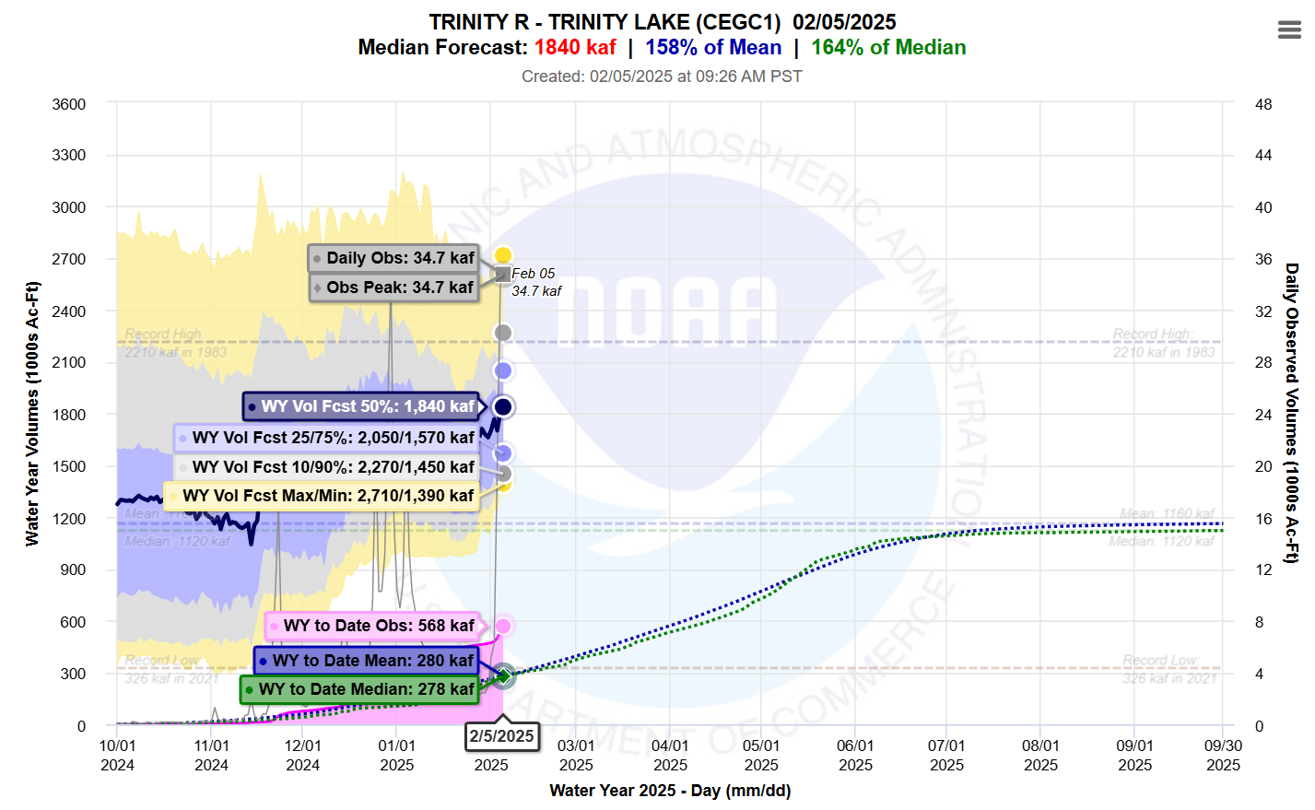
Figure 1: CNRFC ensemble forecast from Trinity Reservoir from 2/5/25 (forecast had not yet been updated to 2/6/25 at time of meeting)
- Flynn reviewed the CNRFC forecasting tool for the North Fork Trinity gage as a way to show short-term outlook on river conditions
- Flynn also reviewed the current decision space that the workgroup was working within, given that a sync flow had happened, shown below:
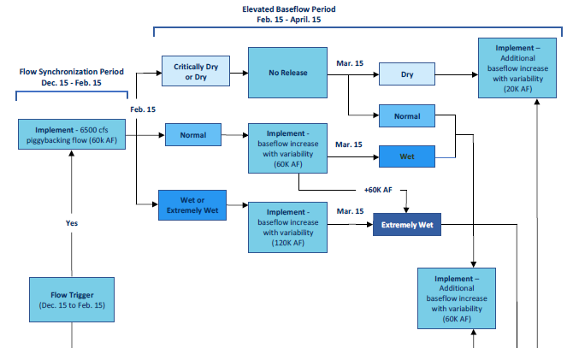
Figure 3: Winter flow ruleset and current scenario

- Flynn asked Buxton to show some of the available hydrographs that the WG could choose to implement given the safety of dams releases.
- Presentation of available prospective hydrographs for Normal and Wet years for elevated baseflows (Buxton)
- Buxton presented two hydrographs for consideration. These are the same hydrographs that were approved by TMC in 2023. The first would release 60k during the Feb-Apr period; the second would release 120k. These do not show additional water that would be released as a result of the March B120. Buxton presented the hydrographs as originally approved and partially implemented in WY2023, and also showed them as additional water released on top of SOD releases. Shown below:
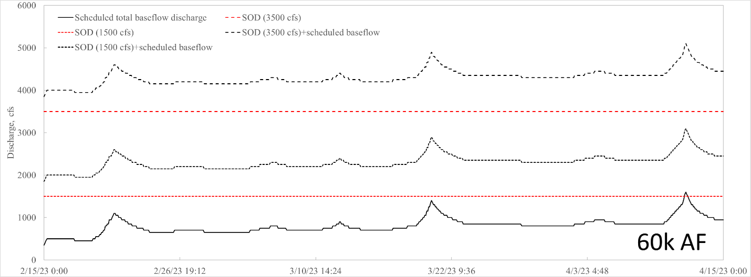
Figure 3: 60k release from Feb-Apr
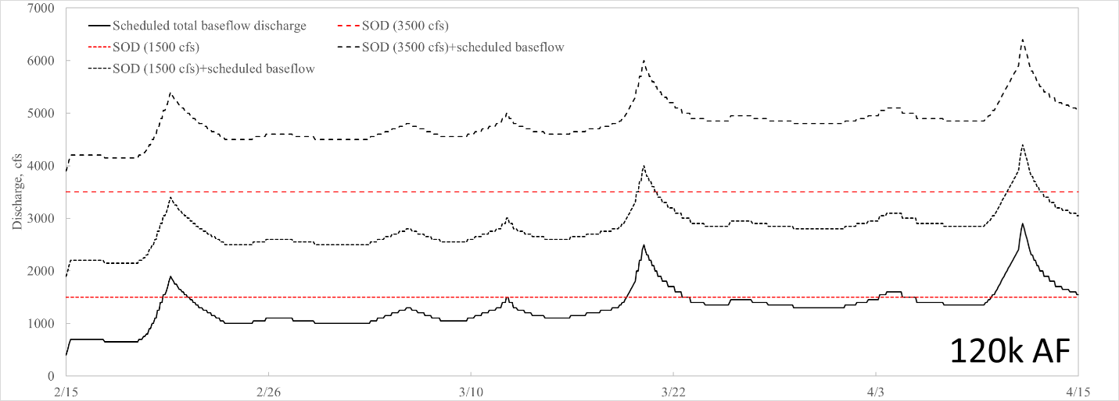
Figure 4: 120k release from Feb-Apr
- Discuss options on how to move forward with winter baseflows (All)
- The group considered the merits of adding the elevated baseflow volumes on top of the safety of dams releases. DeJuilio said that high releases during this time period may scour alevins that are currently still in the gravel. There seemed to be a general feeling among the workgroup members that, since so much work had gone into the winter flows to get them approved, we should not try to reinvent the wheel just because safety of dams releases were going on. The group debated the merits of allocating the flow volumes based on the winter flow ruleset even through safety of dams releases may make them “invisible” most of the time. The result of this is that there are three peaks (in the 120k af allocation) and a very minor single peak (likely immeasurable - in the 60k af allocation) that may rise above a 1500 cfs safety of dams release. If the safety of dams releases continue at 3500 cfs, the elevated winter baseflows will continuously be at a lesser magnitude, and will not be visible in a hydrograph, although the volumes are still allocated and, technically, being released. This still moves water out of the spring, and does not force the Flow WG to try to get approval to release winter baseflows on top of the safety of dams releases, which the group generally through was a rabbit-hole that should not be explored at this time.
- Lindke was concerned about the potential of what would happen if the SOD releases ceased and we chose to implement the hydrographs that Todd showed. In particular there was concern about the de-wetting of currently wetter floodplains if there was a large drop in magnitude of flow.

- Develop workgroup recommendation to IDT/TMC for how the Flow WG would like to move forward on winter baseflows with regard to safety of dams releases (All)
- After a robust discussion that considered the merits of each option, the group decided to implement the elevated winter baseflow hydrographs that were approved by TMC in 2023 despite the safety of dams releases. Some variability may be realized with the peaks in the 120k af allocation if the SOD releases return to 1500. This option also guarantees a backup plan if the SOD releases cease altogether – namely, the elevated winter baseflow hydrograph would continue to be implemented as was approved by TMC and some variability would be realized.
- Buxton agreed to work to CVO and draft up the hydrographs that they would need to implement the group’s decision.

- Spring Flow Planning discussion (Flynn/all)
- There was still about an hour left in the meeting, so the group turn its attention to spring flow planning in prep for the IDT meeting on March 3.
- Flynn reviewed some meteorological forecasts that showed about average temperature and precipitation for the next three months.
- The group reviewed considerations for hydrograph development including those from the Flow Study, and Todd’s functional flow considerations from 2020
- The group envisions that there will be three potential water volumes that will need to be modeled for:
  - a wet year with 180,000 af released in the winter
  - an extremely wet year with 180,000 af released in the winter
  - an extremely wet year with 220,000 af released in the winter
- There was a request for the flow scheduler to be updated for the WY2025 season and to have it updated on a regular schedule after each season is complete.
- Specific considerations discussed:
  - Lee mentioned considering changes to summer baseflow
  - Foothill yellow-legged frogs were discussed, but given that the most likely scenario is either a wet year or ex wet year, and frogs usually see the most benefit at dry and drier years, this isn’t the best year to be developing specifically for frogs
  - Fish considerations:
    - Asarian et al. temperature objectives
      - See appendices of Asarian et al. for daily rampdown hydrographs to manage the recommendations
    - DeJuilio mentioned the Stewart/DeJuilio work on inflection points at 1500 and 4000 cfs (included in Functional Flow considerations)
    - Laskodi asked for a fairly simple hydrograph curve, rather than many peaks to ease monitoring considerations
    - The group discussed the objectives that are included in the flow study, specifically the geomorphic objectives. DeJuilio said that the flow study objectives related to geomorphic may have already been met, at least partially, from the releases in the winter, and also due to the storms that took place already this year (i.e. the upper river has already seen ~6500 cfs, lower river has seen ~11,000 or so at least, North Fork saw ~11,000 in early February) and this needs to be taken into consideration for this year’s planning
    - Lindke ask if approaching flow planning in this way (perhaps without a peak release) would make it challenging to return to baseflow early, as is a long-standing flow objective
    - DeJuilio said not necessarily; the flows could potentially hold at, for example, 6,000 cfs for three weeks and burn up a lot of volume that way
    - Buxton pointed out that the flow study is outdated, and that repeated 11,000 cfs flows are not necessarily a bad thing, given that we are seeing some objectives of management actions show up, in particular the dramatic increase in active bars over the past five years, which is the time period we have been seeing more 11,000 cfs flows
    - DeJuilio agreed with Buxton but was concerned that fines are being evacuated too frequently with the high flows. Should be worked out with Physical WG. He also brought up risk of riparian scour due to high flows.
    - DeJuilio mentioned that lower dam releases in ex wet and wet years was actually beneficial, because the tribs are flowing so high, and the tribs are at the proper temperature, so they could take over the temperature regime, rather than blowing up the regime with a high dam release.
  - Flynn thanked everyone for their input and brought the discussion to conclusion given the time remaining in the meeting. Flynn expressed opinion that 2/13/25, 2/19/25, 3/3/25 meeting schedule is still the best approach and expressed intent to go forward. Asked group for input to this. None specifically stated.
  - The group suggested to Flynn to reach out to modelers to let them know of the tight schedule. The group discussed who does what modeling. Flynn will reach out to the modelers to confirm timing.
  - Buxton asked if the facies mapping is done. DeJuilio asked of the hydraulic model was done. Alvarez and Wallin mentioned that it should be done as of three or four weeks ago. Buxton said that if we had the hydraulic model done for the facies mapping done by the last week of February we could do that modeling as well. Buxton could do.
  - Bedload at Douglas City
    - Buxton said the data is now 7 years outdated. DeJuilio has advocated that it doesn’t tell us much aside from the flows have gotten higher. DeJuilio said that he doesn’t think it gives us any specific metric we can point to and that the scour modeling is preferable if the data is available.
    - Buxton said he could do the bedload modeling if there is a desire to have it done.
      - Flynn said he would reach out to PWG Coordinator (Pittman) to see if there was a desire.
  - Lindke asked if the updates to the juvenile rearing target reporting format had be completed. Historically it has been 7DADA over or under the target. DeJuilio said that there was a desire to measure the stream length within the bounds of the target rather than 7DADA. The model is currently not set up for that metric. There was a request put in to have RBM10 updated to make this possible. Buxton said that Russell Perry said the model can do this output but it is buried deep in the model and not available in the GUI. Perry said he could do this for us if we asked him.
    - Laskodi said a modeler in TSC named “Drew” (unknown last name) has been doing the model as well. The group asked Laskodi to look into it. Lindke said he could try to do it locally if we could get the workflow or some info.
  - The group discussed that we wanted to limit the number of hydrographs developed to 3 per WY scenario, but that we only wanted to have 6 modeled. We could potentially model 9 if there is a need.

