September Quarterly Meeting Notes

TRINITY MANAGEMENT COUNCIL

September 18th–19th, 2024

9 a.m. – 4:45 p.m. PST

Humboldt Bay Aquatic Center. 921 Waterfront Dr.

Eureka, CA 95501

MS Teams Video Conference

Trinity Management Council (TMC) Members in Attendance (09/18/2024 and 09/19/2024)
Name | Representative Seat
Justin Ly | National Marine Fisheries Service (NMFS) Core and Vice Chair
Mike Dixon | Trinity River Restoration Program (TRRP) Executive Director¹
Liam Gogan | Trinity County (TC) Core
Tim Hayden | Yurok Tribe (YT) Core²
Elizabeth Hadley | U.S. Bureau of Reclamation (USBR) Alternate³
Mike Orcutt | Hoopa Valley Tribe (HVTFD) Core⁴
Radley Ott | California Natural Resources Agency Department of Water Resources (CNRA-DWR) Core
Keli McElroy | U.S. Forest Service (USFS) Core
Bill Pinnix | U.S. Fish and Wildlife Service (USFWS) Core
Others in Attendance (in-person):
Eric Peterson (TRRP-USBR), James Lee (TRRP-USBR), Shane Quinn (YTFD), Ken Lindke (CNRA-DFW), Tyler Wallin (USFWS), Vicky Ryan (USFWS), Brad Nissen (USFWS), Kiana Abel (TRRP-USBR), Patrick Flynn (TC)
Others in Attendance (Microsoft Teams):
Justin Alvarez (HVTFD), Brett Kormos (CNRA-DFW), Morgan Knechtle (CNRA-DFW), Patrick Flynn (TC), Roman Pittman (NMFS), Chris Laskodi (Yurok Tribe), Ellie Andrews (citizen), Francisco Martinezcuello (Trinity Journal), Kyle De Juilio (Yurok Tribe), Trevor Morgan (CNRA-DWR), Oliver Rodgers (TRRP), Roman Pittman (NMFS), Brian Bommarito Bureau of Land Management (BLM), Elizabeth Hadley (TRRP-USBR)
Notes: Brad Stumph (Chloeta)

Wednesday, September 18th, 2024

(Scheduled from 9 a.m. – 4:45 p.m. PST)

Introductions (Mike Dixon, Chair)
Welcome and Introductions
Justin Ly, Vice Chair, will be filling in for Don Bader as acting chair for the meetings. He asks that everyone TMC primaries introduce themselves followed by people in the room and then by those joining online. Attendees on one or both days are listed above. Any omission of attendees outside of the TMC is accidental and regretful.
Before addressing the first agenda item Mike Dixon mentions the voting protocol for in-person voting and abstentions because the issue has surfaced in the past. Don Bader is unable to attend the meeting because he was assigned a detail in the regional office. It all transpired quickly, and Elizabeth does not have the freeboard in her schedule to attend in-person.

Approval of Agenda
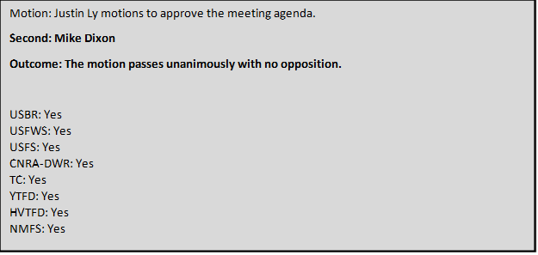Approval of June Meeting Minutes
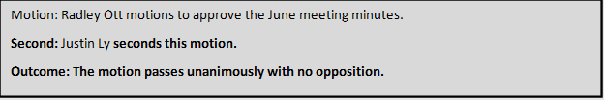

Comments on Non-Agenda Items (Justin Ly, Chair)
Justin Ly asks for comments on the agenda and invites the public to comment.

Public Comments
No public comments received.

Reports and comments of TRRP entities
MD thanks TMC for patience while he was away on orders. MD was working with the Philippine Coast Guard to help combat illegal fishing in the SE Asia Pacific Region. MD will be retiring from the Coast Guard in June of 2025.

TMC Discussion and Comments
MO – Would like to see USBR get involved in sport fishing coordination and consultation process on the Klamath R. There are concurrent meetings today [in Eureka and Klamath Falls] and increased coordination would benefit both groups and should be kept in mind for future agendas.

Program Updates (James Lee/Mike Dixon)
Recognition of Staff and Partners
JL has done a killer job of covering MD’s duties as well as his own and keeping the Upper Conner Creek project moving despite some challenges. EP continues to make progress with the reconsultation efforts both with the alternatives and proposed actions continuing to be developed. There has been good feedback on modeling and discussions about governance.
Kianna did awesome at the Science symposium this spring and did an excellent job outside of her normal scope of work.
Oliver has been leading our design team and critical in sighting restoration work and keeping overall perspective.

Director’s Report
Trinity River Restoration Program
P.O. Box 1300, 1313 South Main Street, Weaverville, California 96093
Telephone: 530-623-1800, Fax: 530-623-5944

NC-152

MEMORANDUM

To: Trinity Management Council
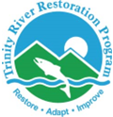

From: Mike Dixon, Executive Director
Trinity River Restoration Program

Subject: Director’s Report

Date: Sept 17, 2024

Major TRRP activities between June 2024 and September 2024 include:

Organizational Updates

- The solicitation for the Secretary position is closed and a cert was issued with applicants.

- The TRRP Data Steward remains vacant. Initial recruitment paperwork has been submitted and it is in queue for soliciting. It will be hired as a GS 7/9/11/12 Natural Resource Specialist.

Budget Updates/Adjustments:
The FY 2024 budget set aside about $345,000 for the environmental services contract, which expired and was re-solicited this year. The solicitation took longer than expected, and a contract won’t be secured until after the end of the fiscal year. To avoid a gap in environmental services, a six-month extension to the current contract was approved, and funded at ½ the typical annual rate instead of the $345,000 that was budgeted. This resulted in a budget surplus. There was already a surplus anticipated due to position vacancies. The combined surplus was approximately $450,000. With this surplus, I propose to supplement three tasks in the Annual Funding Agreement with the Yurok Tribe: as-builts for Upper Conner Creek, completing the Indian Creek watershed restoration project, and gravel processing at Sawmill. The rationale for this proposal will be presented as a decision item during this meeting.

Implementation Updates
Sky Ranch Channel Rehabilitation Site: Little change since last quarter. The design is at 60% and the VE study was completed; and a right-of-entry with the private landowner was established. The land transfer between USFS and BLM is expected to be completed this summer, after which TRRP can initiate NEPA. Depending on the availability of funding and the land transfer, the project may be constructed in 2025 or 2026. This project is the priority after Upper Conner Creek, although the land exchange must be completed before TRRP can move forward with planning.
Evans Bar Channel Rehabilitation Site: No change since last quarter. The design remains at the existing conditions report stage. A meeting between designers and neighboring landowners was planned for the week of September 16.
Sawmill Gravel Processing Site: A draft 90% design was prepared by the Yurok Tribe and State design group and is expected to be finalized in October. The EA for the project was completed in July 2024, so this project will be ready for implementation in 2025.
Upper Conner Creek Channel Rehabilitation Site: This project began in August 2024. The project was envisioned to be a one-year project, but delays in NEPA/NHPA postponed the start date enough that the project cannot be completed this year and will continue through 2025.
EA Development
- Upper Conner Creek and Sawmill Environmental Assessment (EA)
The Upper Conner Creek and Sawmill EA was completed, and a FONSI was signed in July.
- Sediment and Wood Augmentation Along the Trinity River Restoration Reach Project Environmental Assessment
The Sediment and Wood Augmentation EA was completed, and a FONSI was signed in July.
- Watershed Programmatic EA
Work on the Watershed PEA continues and is forecast to be completed in late 2024 or early 2025.

Public Outreach Update
Publications and Education Materials:
River Riffle – June, July and August
- Current Conditions: Flow, Temperature, Fish Health & Monitoring
- Program Updates
  - June: TMC Meeting Recap, July: Upper Conner Creek Update, August: Science Advisory Board, Sediment and Wood Environmental Assessment, Upper Conner Creek Rehabilitation
- Articles
  - July: Temperature Diversity in the Trinity River, a River System in a Mediterranean Climate (Lindke, Buxton, Lee). August: On Fish, and Fire (Peterson, Asarian)
- Spotlights: Common Wolly Sunflower, Milkweed, Grey/Ghost Pine
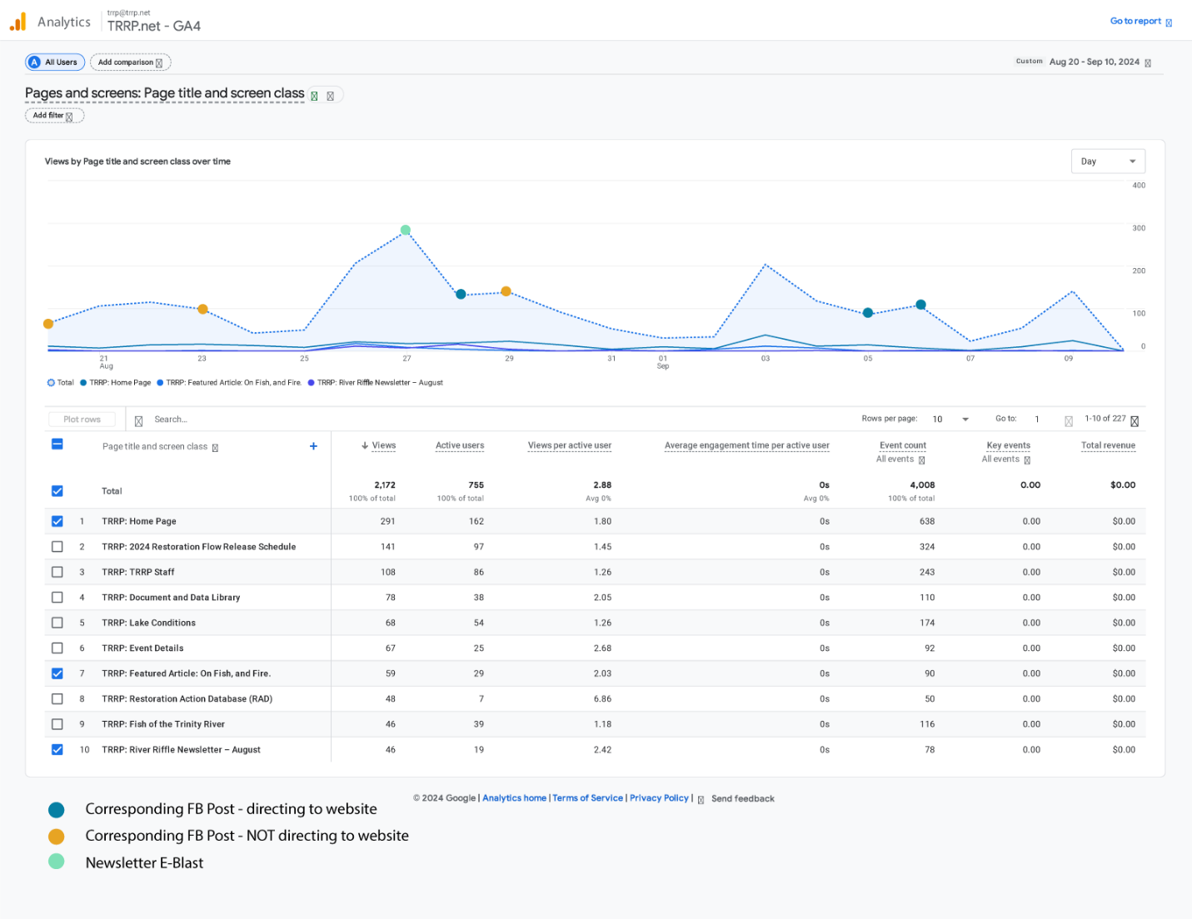

The TRRP Facebook Page is up 40 followers since our last meeting. We are currently at 1059 followers.

- Top post in the last 90 days was a post about Cal-Poly Humbolt, Klamath Basin Field Course River Tour.
- Impressions: 2196 | Reach: 1974 | Engagement: 351
- Reactions: 85 | Comments: 5 | Shares: 4
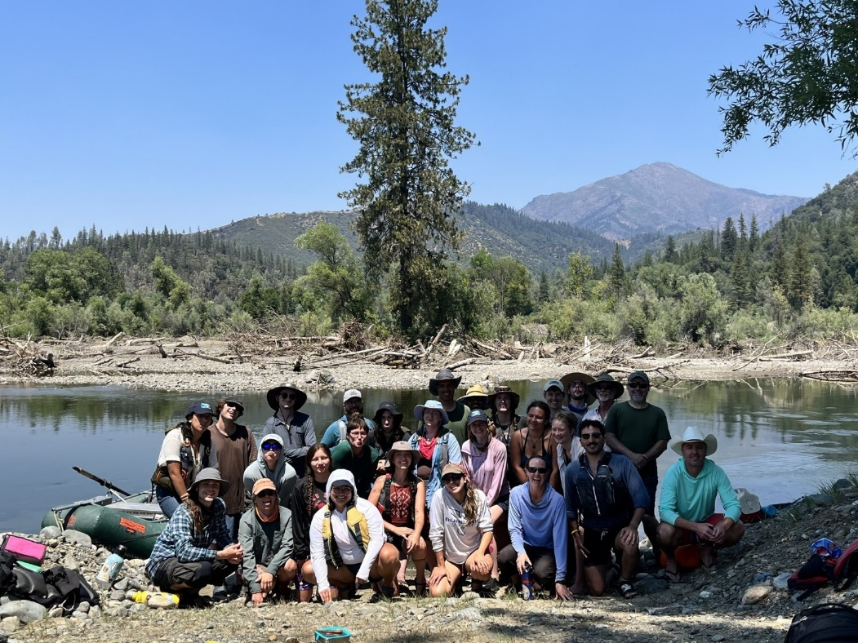

Public Events and Environmental Education
July 24: Science on the River (34 ppl)
- Derek Rupert, Fish Biologist with the Bureau of Reclamation – Northern California Area Office, “Lower Clear Creek Restoration – A Review of Habitat Restoration Efforts Occurring Over the Past 30 Years”
August 28: Science on the River (45 ppl)
- Todd Buxton, Hydrologist and Fish Biologist, Trinity River Restoration Program, “Stratification of water temperatures in pools on the Trinity River”
Educational Outreach
June 7: Hoopa Fish Fair – Fish and Fire Ecology Lesson
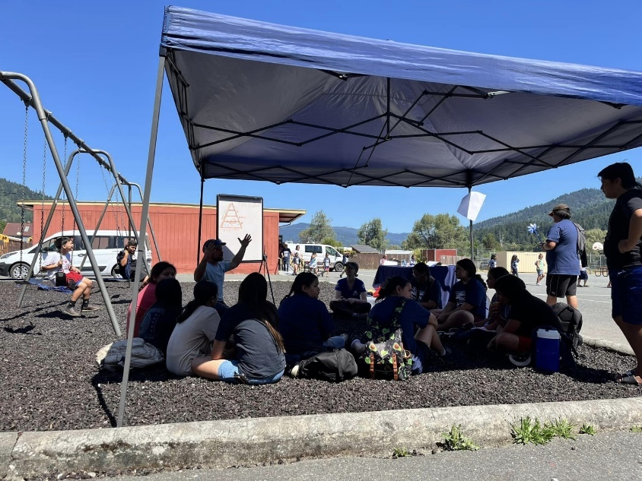
June 10: Douglas City 4th Grade Class at Oregon Gulch (4 stations – thank you Brian, Greg, Dave, Oliver and Elliot!)
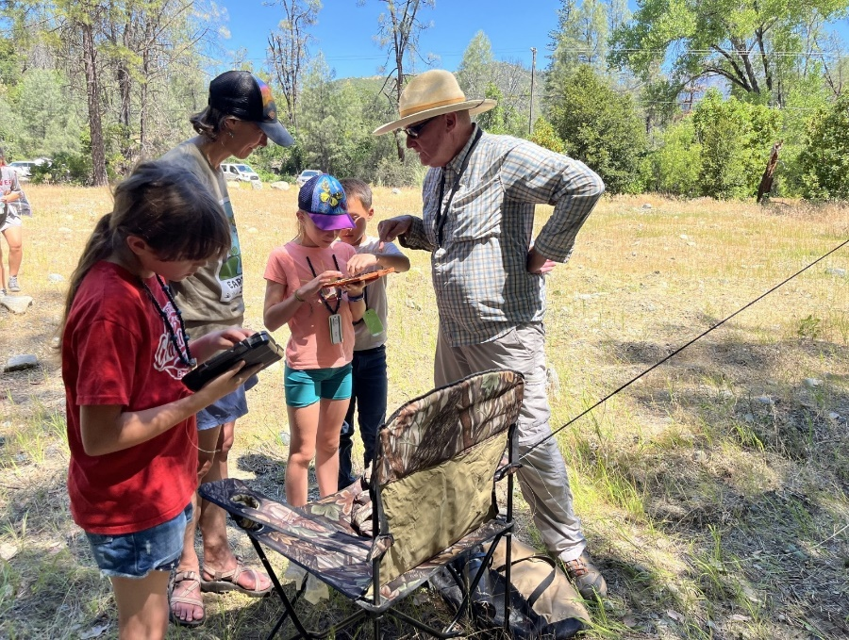
June 24: Ascend Wilderness Hatchery Tour (kinder group) – thank you Chris!
July 8-26: Weaverville Summer Day Camp
- 46 students (Grade levels: 1-6th) participated over three weeks
- 16 field trips and collaboration with 21 organizations, agencies, and community members who led 55 activities. The campers explored five different swimming holes, and they only had seven bee stings!
- In collaboration with the Fish and Wildlife Service, TRRP provided one of the educational outings. The activity was focused on riparian mapping.

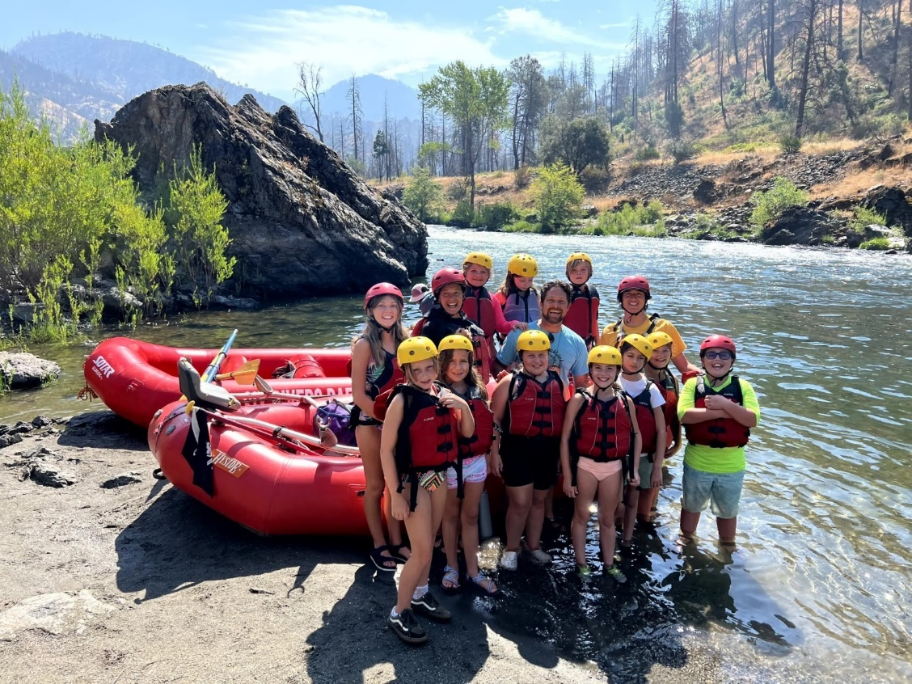
July 10: Cal-Poly Humboldt – Klamath Basin Field Course River Tour (Thank you: Seth, Ken, Patrick, Justin, Kyle D., and Greg!)
August 7: Ken Lindke met with Trinity County Supervisor Jill Cox at the JC Weir (Thank you Ken!)
August 9: Hoopa Sovereign Days (Thank you: Todd and Oliver!)
August 27: Float with Trinity County Representatives (Thank you: Seth, Ken, James, Patrick, Duncan, Justin, Kyle D., Kyle S., Chris, Greg and Wes!)

Landowner and Stakeholder Notifications
July 17: Neighborhood BBQ at Junction City Campground

Upcoming

September
- Sept 18-20: Bar 717 Environmental Camp
6th Graders from 6 schools: Weaverville, Burnt Ranch, Hayfork, Lewiston, Trinity Center, Van Duzen/Ruth

- Sept 25: Science on Tap – Josh Smith and Bridger Cohen, The Watershed Research and Training Center, “Trinity Meadows – Lost and Found”

October
- Oct 5: Salmon meets Harvest Festival
  - Need Program Volunteers
- Oct 12: Trinity County Public Float – Evans Bar to Junction City Campground
  - Need Program Volunteers
- Oct 23: Mike Belchik – Klamath Dam Removal (unconfirmed)
- TBD Event 1: Environmental Flow Management Changes

November
- Nov 13: Darren Mierau from CalTrout, “Key Lessons Learned from the Klamath/Trinity programs that we’re applying to the Eel River”

Science Update
- Limiting Factors Analysis (LFA). Phase 2 (implementing the study plan) contract was awarded via NFWF to Cramer Fish Sciences (CFS). The IDT met with CFS on September 11 for a kick-off meeting. Numerous datasets were identified that TRRP partners will need to supply to CFS to ensure project success, and more are expected to be identified in the future. The project will include quarterly meetings with the IDT (at a minimum). Total project timeline is 2 years with final deliverables due August 2026. Further details will be provided in a presentation to the TMC.
- FY25 Science Priorities. In June, the TMC approved a request from the IDT to fund 3 projects for FY25, contingent upon IDT concurrence with project revisions. Revisions were made and concurrence was presented to the TMC during the July conference call. This enables monitoring of Benthic Macro-Invertebrates (BMI), initiating a model toward foodscape, and assessing riparian response to channel rehabilitation designs. Paperwork is underway for funding BMI work through USGS/CalPoly Humboldt. Other funding is expected to be provided through AFAs with tribes for calendar year 2025.
- FY26 Science Priorities. Per the Science Plan, the IDT began discussion of FY26 priorities in June. The focus is on 3 Key Uncertainties: nutrient flux, fish production, and temperature. Initially 5 questions were identified across these uncertainties, however one has been deferred until more information is available from the Limiting Factors Analysis. The IDT is requesting workgroups to write briefs on the remaining 4.
- Objectives, Targets, Monitoring and DSS. The IDT requested workgroups review Objectives and Targets in preparation for reviewing monitoring and modeling of Targets; thus far the groups have not identified any changes to Objectives, but found several refinements for Targets, plus a need to add one target to address Northwestern Pond Turtles. Objectives and Targets are then being used as a foundation for a review of monitoring (per the Science Plan) and DSS (per request by the Flow Workgroup). The IDT has listed activities needing review and parsed those reviews out to workgroups. Reviews should be completed in time to inform the TMC’s efforts next year on the FY26 budget.
In Review or Final Edits
- Gough, S. A., R. B. Smit, K. Lindke, K. De Juilio, C. Laskodi, G. Kautsky, and B. Matilton. 2024. Assessment of adult salmonid spawning in the Trinity River. Arcata Fisheries Technical Report TR 2024-71. [pending 508 compliance]

Final Publications and Reports
- Buxton, T. H. 2024. A method for scheduling Lewiston Dam releases to mimic diel variations in flow on unregulated streams. Report for the Trinity River Restoration Program (TRRP). TRRP, Weaverville, California. Available: https://www.trrp.net/library/document?id=2648.
- Buxton, T. H. and J. McSloy. 2024. Mapping active and exposed coarse bars and fine sediment deposits in the restoration reach of the Trinity River, California. Report for the Trinity River Restoration Program (TRRP). TRRP, Weaverville, California. Available: https://www.trrp.net/library/document?id=2656.
- Trinity River Restoration Program (TRRP). 2024. Trinity River Restoration Program Objectives and Targets Summary. TRRP, Weaverville, California. Available: https://www.trrp.net/library/document?id=2654.
Synthesis Reports – See Appendix II.
Incomplete:
- Cohort Reconstruction – coding nearly complete, analysis pending
- Large Wood Management – rebooted, annotated outline out for review
- Flow Synthesis – regaining momentum
- Channel Complexity

Design Reports- See Design Workgroup Report below
Environmental Reports and Findings
- U.S. Bureau of Reclamation Trinity River Restoration Program (USBR-TRRP), North Coast Regional Water Quality Control Board, and U.S. Bureau of Land Management (USBLM). 2024. Sediment and Wood Augmentation along the Trinity River Restoration Reach Environmental Assessment and Initial Study. July, 2024. DOI-BLM-CA-2023-0033-EA, CGB-EA-2022-028, California State Clearinghouse No. 2008032110. USBR-TRRP, Weaverville, California. Available: https://www.trrp.net/library/document?id=2652.
Post-Implementation Reports
- Five Counties Salmonid Conservation Program (5Cs). 2024. East Weaver Creek Dam Intake Relocation & Dam Removal Project & McKnight Ditch Water Conservation Project. Report for the Trinity River Restoration Program (TRRP). 5Cs, Weaverville, California. Available: https://www.trrp.net/library/document?id=2649.
Final Data Packages
- Buxton, T. H. and J. McSloy. 2024. Active Gravel Bars 20231030 RM. Data Package for the Trinity River Restoration Program (TRRP). TRRP, Weaverville, California. Available: https://www.trrp.net/library/data?id=161.

Appendix I: Technical Workgroup Briefings
June 2024

Updates have been prepared for the Trinity Management Council by the Trinity River Restoration Program Technical Workgroup (WG) Coordinators.
Workgroup: Fish Coordinator: Chris Laskodi
The Fish Workgroup did not meet this quarter. Several topics came up during the recent IDT meeting that will be addressed in the next quarter including finalizing new targets/metrics to be incorporated into the DSS and objectives and targets. In addition, we plan on reviewing ongoing monitoring and modelling efforts.
Workgroup: Design Coordinator: Oliver Rogers
The Design Team met on August 15th, for a quarterly meeting and received updates from the State of California-Yurok Tribe Design Team, Hoopa Valley Tribe Design Group, and the Federal Design Team. Topics covered included an update on the Sawmill Gravel Processing Site Rehabilitation project. The 90% Project Report is drafted and under review and the designers are finalizing wood design calculations and updating design plans to 90%, anticipated to be complete by the end of September 2024. - The YT/State of California Design group for the Evans Bar project met on July 15th and are planning a meeting with landowners and representatives from TRRP in the coming months to address considerations/concerns with the goal of generating conceptual designs that can then be reviewed by the Design Team WG. - The Federal Design group provided an update on the land transfer that has delayed the Sky Ranch project, with an anticipated completion of 6-8 months per BLM. A meeting with landowners is being scheduled for late September 2024. - The DWR Design group provided their recommendation for the Steel Bridge channel rehabilitation site after reviewing Scott Kennedy’s (DWR) preliminary investigation from 2008 and conducting a site visit on August 9th. Due primarily to site constraints and existing habitat, the recommendation from the DWR Design group to the Design Team WG is to refrain from a large-scale channel rehabilitation project at this time and explore alternatives including large wood placement and gravel augmentation. The DWR Design group will generate a memo to describe project possibilities. - Additionally, the Design Team WG was provided with a Draft Existing Conditions Preliminary Scoping for Remaining Channel Rehabilitation Site Template. The various Design groups are continuing the scoping process upon further clarification from TRRP’s Implementation Branch.
ASCE released 2023 project award winners: Water Project – Oregon Gulch – Trinity River Channel Rehabilitation Project.
Workgroup: Flow Coordinator: Patrick Flynn
The Flow Work Group met on 22 July, 9 August, and 19 August to review flow proposals for the period between 01 Oct and 15 April, as directed by the TMC at the June TMC meeting. The group was successful in reaching consensus on a proposal submitted by Trinity County that includes implementation of the Winter Flow Variability project. The Flow Work Group briefly discussed FY26 Science Planning during its 19 August meeting. The workgroup’s proposal for Water Year 2025 will be presented during the TMC meeting.
Workgroup: Watershed Coordinator: Justin Alvarez
The Watershed Workgroup has not had need for a meeting this quarter.

Workgroup: Physical Coordinator: Smokey Pittman
One of the sub-groups formed in the May 2024 meeting (the bar area subgroup) met to discuss assignments and next steps. The bar area sub-group identified potential tools and considerations for developing gravel storage targets. At least one member of the Physical Workgroup provided peer review for TRRP’s June 2024 report, “Active and exposed coarse bars and fine sediment deposits in the restoration reach of the Trinity River, California.” Workgroup coordinator Pittman met with TRRP’s Lauren Alvares to discuss the Sediment and Wood Augmentation EA and developed a plan for her to present the EA at the next workgroup meeting, as the physical workgroup will be responsible for developing sediment augmentation plans.
Workgroup: Riparian and Aquatic Ecology Coordinator: Brad Nissen
The Riparian and Aquatic Ecology Workgroup (RAEWG) met on Sept. 3 to discuss the current proposed list of key uncertainties for FY26, reviewed and revised the Objectives and Targets relevant to our workgroup, updated the action tracker spreadsheet, and discussed the status of the Wood management plan synthesis report, as well as the RAEWG’s role in the upcoming Limiting Factor Analysis (LFA). Discussion on key uncertainties included interest in bringing in modeling suitable turtle temperatures. The workgroup is drafting language for a target specifically related to maintaining suitable temperatures for turtles and revising two other targets, intending to finalize these revisions before the November IDT and December TMC meetings. Our next meeting will be at the end of October to continue finalizing the Objectives and Targets relevant to RAEWG.

Workgroup: Interdisciplinary Team Coordinator: Ty Wallin / Eric Peterson
The IDT has been busy! The team had two full day meetings (June 25th and Sept 11th) plus one brief meeting (July 17th). For the most part, activity has focused on the items listed at the beginning of the Science Update (Limiting Factors Analysis, completion of the FY25 Science Priorities, initiation of the FY26 Science Priorities, and the Objectives-Targets-Monitoring-DSS Review). Additionally, the group has addressed tracking of recommendations from synthesis reports and mapping out future workload (which will be presented during the TMC meeting).

Appendix II: Synthesis Reports Tracking and Estimated Completion Dates
Synthesis Reports
Project No. | Brief Title | Involved Entities | Proposed  Due |  | Status
TRRP-2018-002 | Tributary Delta | Program Office (POC: Todd Buxton, TRRP) | March 2019 |  | Published in Ecohydrology 2022;e2463
TRRP-2018-003 | Fish Habitat | HVT, USFWS, YT, USBR TSC (POC: Damon Goodman, USFWS) | 2nd Q 2019 |  | USFWS portion Posted; YT portion Posted
TRRP-2018-007 | Juvenile Chinook Production | USFWS, YT, HVT (POC: Bill Pinnix, USFWS) | July 2017 |  | FINAL POSTED
TRRP-2018-009 | Cohort Reconstruction | HVT, USFWS, CDFW (POC: Ken Lindke, CDFW) | 2nd Q 2019  Cur.ETA mid-2024 |  | In progress
TRRP-2018-011 | Adult Salmon Spawning | USFWS, HVT, YT, CDFW (POC: Steve Gough, USFWS) | 2nd Q 2019 |  | Report complete; awaiting 508 compliance.
TRRP-2018-018 | Bed Mobility and Scour | HVT, USFWS (POC: Geoff Hales & Scott McBain, McBain Associates) | 2nd Q 2018 |  | FINAL POSTED
TRRP-2018-019 | Cottonwood Seed Dispersal | HVT (POC: John Bair, McBain Associates) | 3rd Q 2018 |  | FINAL POSTED
TRRP-2018-021 | Riparian Encroachment | HVT (POC: John Bair, McBain Associates) | 4th Q 2018 |  | FINAL POSTED
TRRP-2018-022 | Sediment Storage | HVT, USFWS (POC: Geoff Hales & Scott McBain, McBain Associates) | 4th Q 2018 |  | FINAL Posted
TRRP-2018-025 | Channel Complexity | HVT, USFWS (POC: Smokey Pittman & Scott McBain, McBain Associates) | August 2019  Cur ETA ? |  | Delayed- uncertain timeline
TRRP-2018-027 | Fine Sediment | Program Office, NMFS, HVT (POC: Todd Buxton, TRRP) | July 2020 |  | FINAL POSTED
TRRP-2018-032 | Water Temperature | YT, USFWS, HVT, USBR, NMFS (POC: Eli Asarian, Riverbend Sciences) | May 2019 |  | FINAL POSTED
TRRP-2018-033 | Large Wood Management | NMFS, YT, HVT (POC: Scott McBain) | April 2018  Cur.ETA 2024 |  | In progress
NA | Flow Synthesis | HVT et al. (POC: Justin Alvarez) | Mid FY 22  Cur.ETA: July 2024 |  | In Progress

Completed reports at https://www.trrp.net/restoration/adaptive-management/synthesis-reports/.

Mike Dixon provided high-level highlights of the Executive Director’s Report including:
NEPA
NEPA documents were completed that had been slowed by Cultural Resources review. The Sediment and Wood Augmentation EA was completed and a FONSI signed. Additional augmentation sites are now available for the time and cleared through the planning process to develop an annual large wood budget and augment in regions that are deficient.
Because the Upper Conner Creek EA completed later than expected didn’t allow for implementation of the entire project this year but is clear for completion next summer.
Staffing
We have recruited for a secretary position a couple of times. A cert is in place, but it has been challenging to get someone to relocate to Weaverville for that GS-level. We are focusing on local candidates. Some have not made it through the USA jobs process and we may need to do some counseling on the USA jobs process.
EP has been covering the data steward position. It has been advertised and closed today. We have done well recruiting for higher level technical positions.
Interviews have wrapped up for the Riparian Ecologist position vacated by Veronica Yates.

Budget
A decision item for later in the agenda is $450K surplus resulting from cost savings, primarily salary. Three priorities will be brought to the TMC:
As-builts for Upper Conner Creek
Gravel processing and staging. The EA has been completed for the Sawmill Closeout design and the way is clear to process and stage gravel.
Completing Phase I of the Indian Creek tributary restoration project. A mining claim on BLM land which had blocked a portion of the project has lapsed. But rights of entry and permits are still in place. There is a narrow window to complete the stage zero project as it was originally designed.
Q: MO – Asks for clarification on the process for a surplus and receiving recommendations.
A: MD – We don’t have a clear protocol. Sometimes when we approve the initial budget, part of the motion will be what would happen with surplus funding. We didn’t anticipate a surplus because we thought we would need extra funds for Upper Conner. Having received an additional $2M from the Regional Director’s office for Upper Conner Creek, we don’t. So, we internally developed recommendations where we think those funds should go, but I think the agenda item is the time to talk about it.
We can’t fund an idea that hasn’t been permitted yet. That’s why Indian Creek is a such a fortuitous opportunity. We have all the permits, and it was already designed. We just didn’t implement as it was designed. But certainly, if there are other shovel ready projects we can talk about them later today.
MO – So we can put it on the table if we want some other consideration for any other ideas. Thank you.

Implementation Update (James Lee)
James Lee provided a summary of sites as provided in the Director’s Report including Sky Ranch, Evans Bar, Sawmill Gravel Processing, and Upper Conner Creek.
James Lee also provided updates on EA Development as included in the Director’s Report.
MO – Q: Regarding the Sawmill Gravel Processing Site. Is that a restoration?
JLe – A: Gravel processing is the primary purpose. It’s owned by the BLM, so we will have to do some channel rehabilitation there to close it out. There are opportunities. It is well known in the program that there are issues with the design and some additional floodplain lowering occurring there. So there is more than remediation. We are going above and beyond and creating habitat benefits.
RO – Q: Will that impact future gravel processing?
JL – A: Yes. We will have a stockpile on-site and move gravel to other areas. The intent is to combine gravel extraction and processing with floodplain lowering.
RO Q: Is this another processing site in that section of river that will replace Sawmill once it gets closed out?
JLe A: Trinity House Gulch is one, but that’s it. We’ll have almost a decade’s worth of gravel (from Sawmill).
MD – Q: Is there an update on the Sky Ranch Land Transfer?
KM – A: BLM and USFS are coordinating to make sure the requirements of both agencies are being met. USFS submitted their package, and it was returned sometime in August with questions about how the legal description was written. It is a priority for both agencies and not sitting somewhere.
JL – The goal is to implement the project in the summer of 2026. NEPA delays provide additional time for Sky Ranch. After UCC, Sawmill is the only other shovel ready project but is not as high priority.
MO – Not clear on delay for construction. If there is a way to help, we would be willing to engage. States that USBR normally give a report on the EA for winter flow variability that was being noticed at a coordination meeting, and he hadn’t seen confirmation. For the $450K surplus did the construction group collectively make that recommendation?
JLe – A: It was made internally within TRRP. The fiscal year is ending in a couple of weeks and 2 of these 3 tasks would be paid for in FY25 anyway. The as-built is in process. Indian Creek is the only optional project and will be discussed later.
MO – We don’t have the winter flow EA that’s pending TMC vote as I was told by Donnie at the coordination meeting. We gotta do the signatory authority, right? Delegated to him anyway, right?
JLe – Yeah, I believe Elizabeth would be signing if the motion passes. Just the EA is done, but there is not a signed FONSI.
Kiana Abel and Eric Peterson also provide Public Outreach and Science Updates, respectively, and will provide more in-depth discussion later in the meeting.

Public Comments
None given.

TMC Discussion

Break

Water Year 2024 Flow Recommendations from IDT (Patrick Flynn)
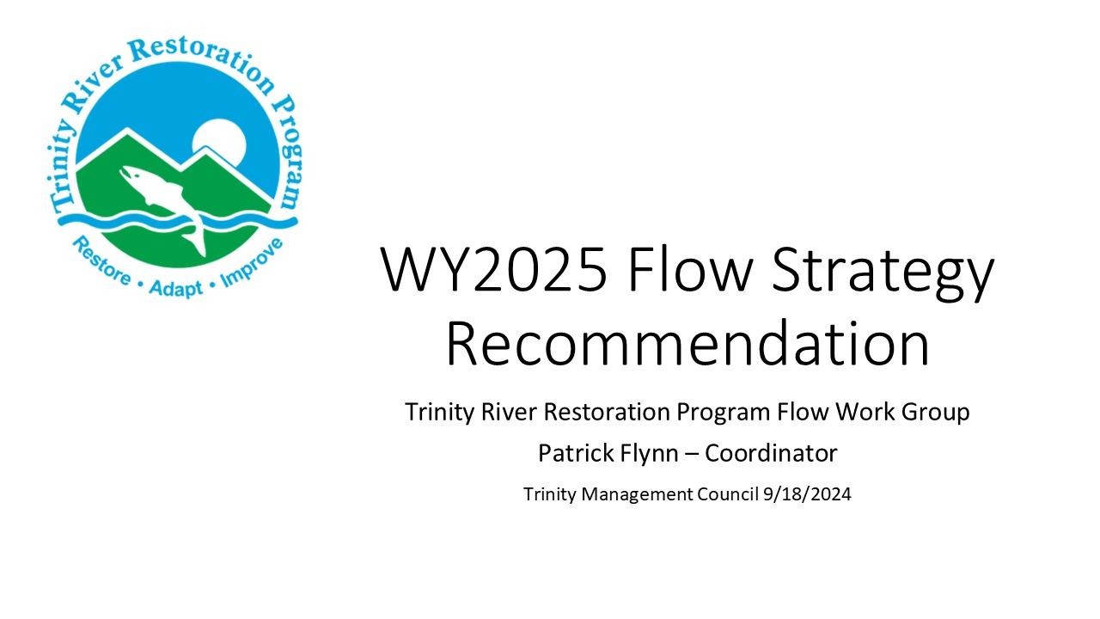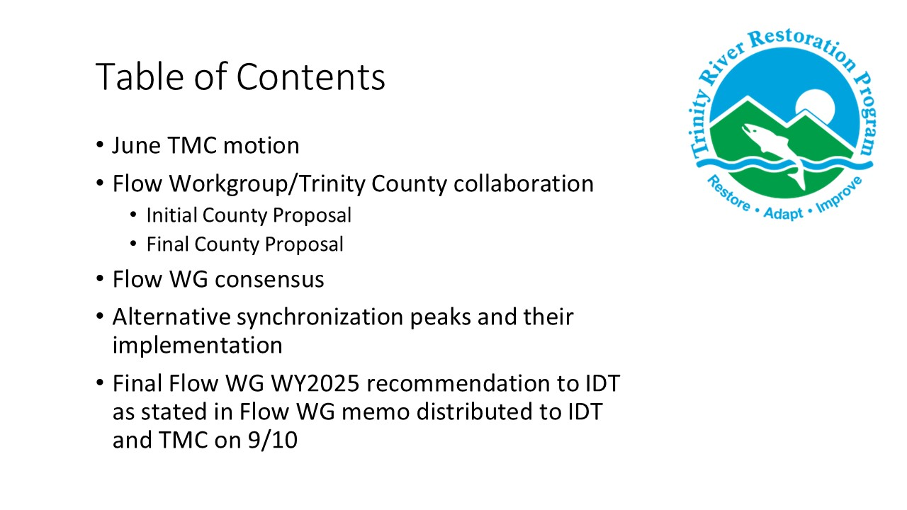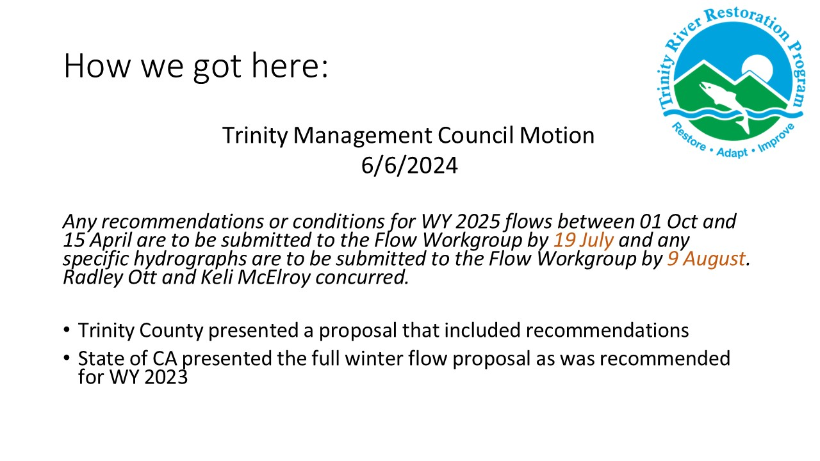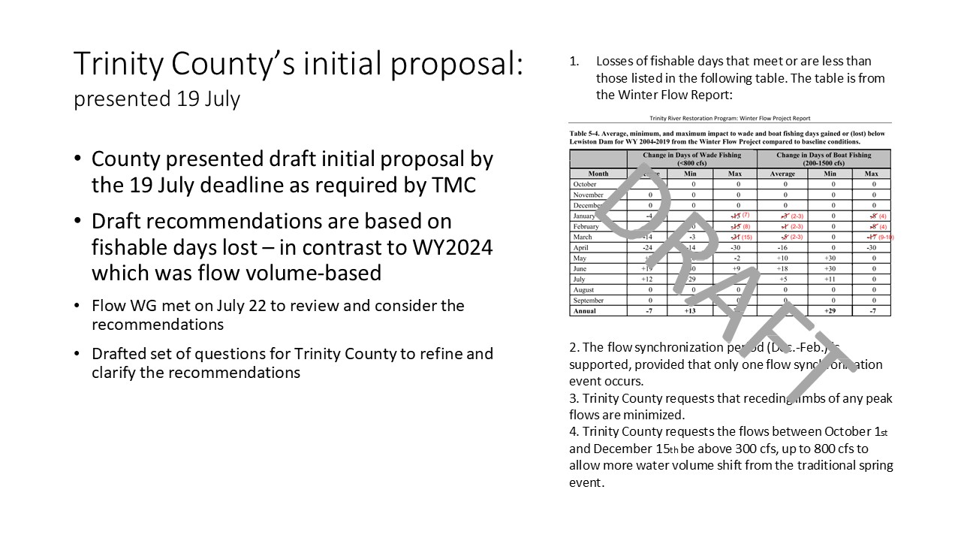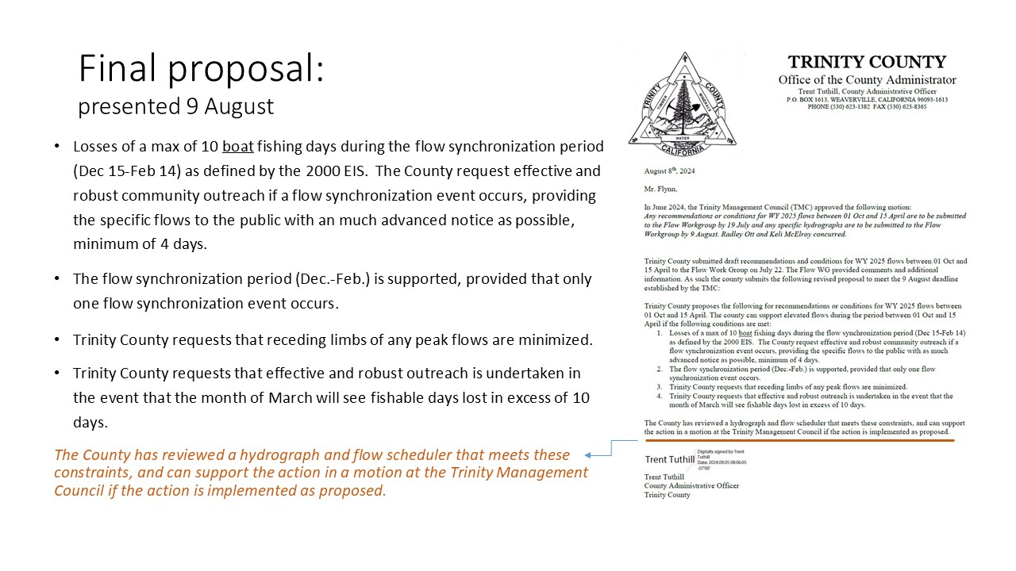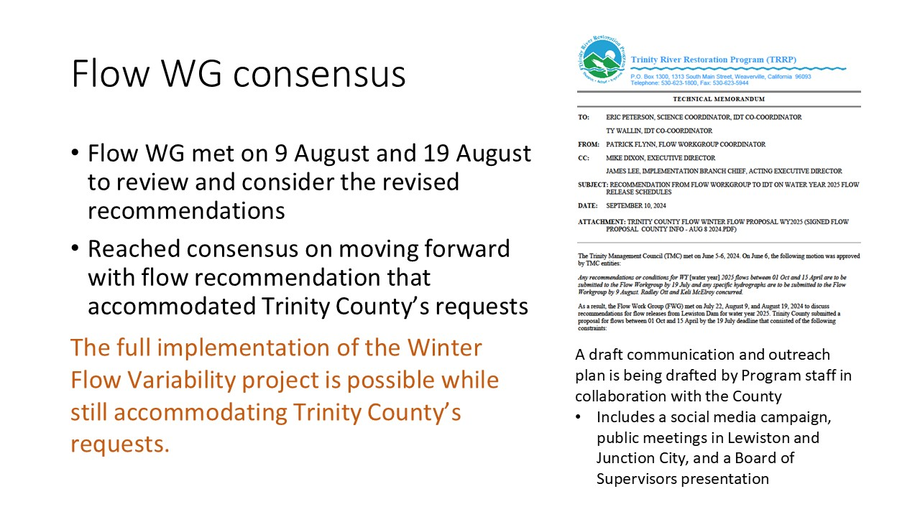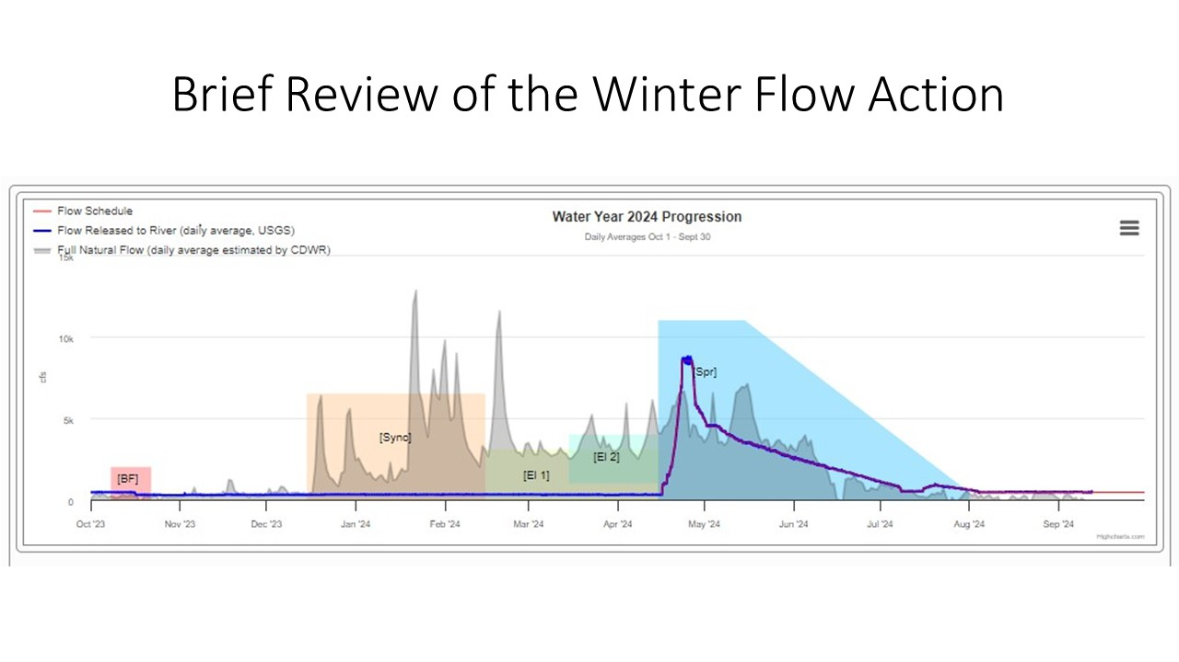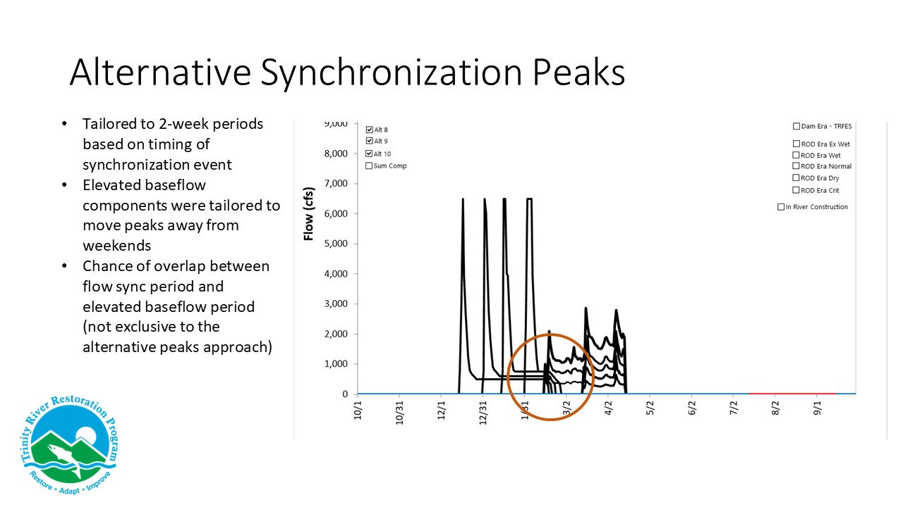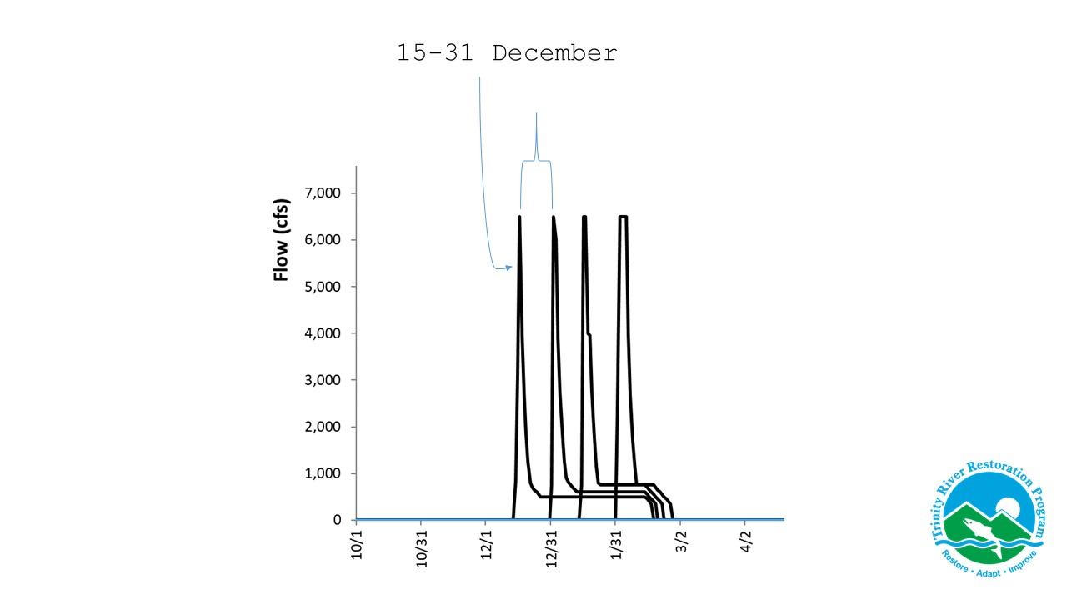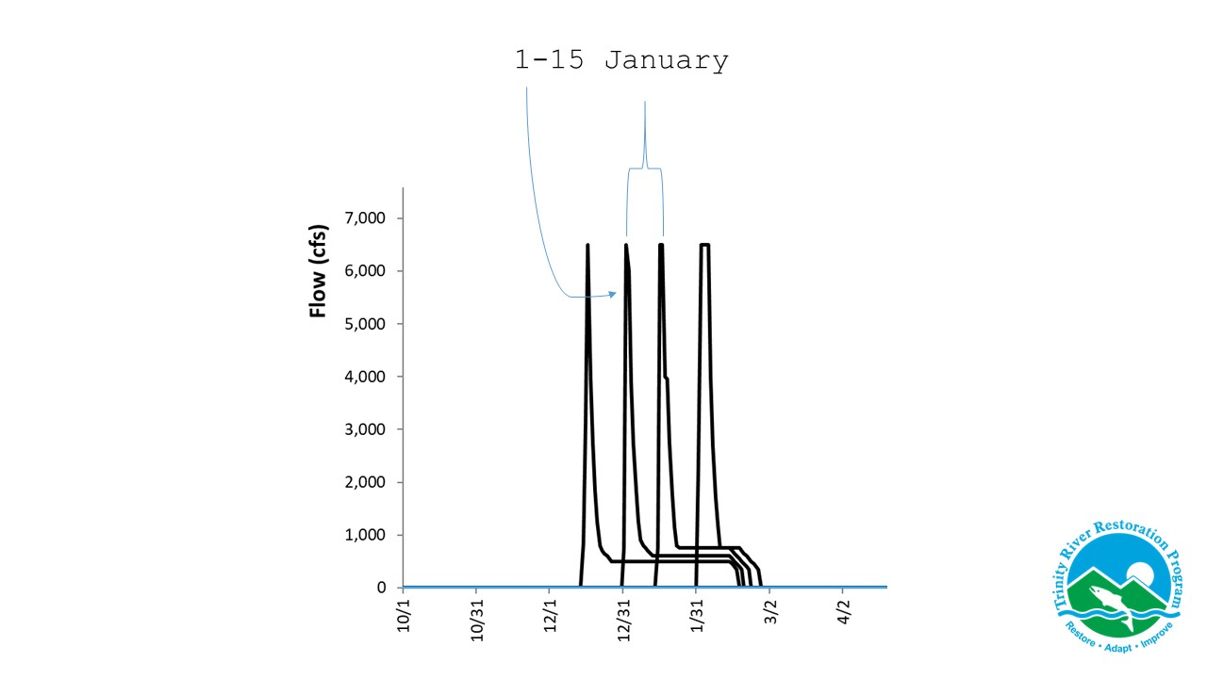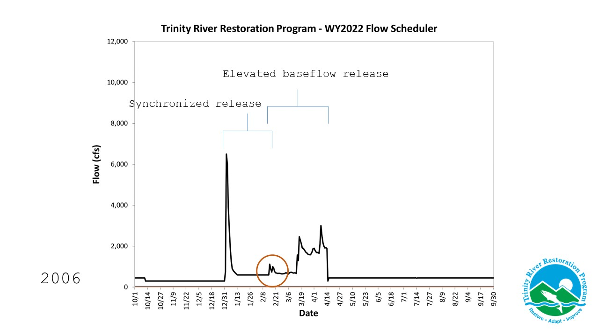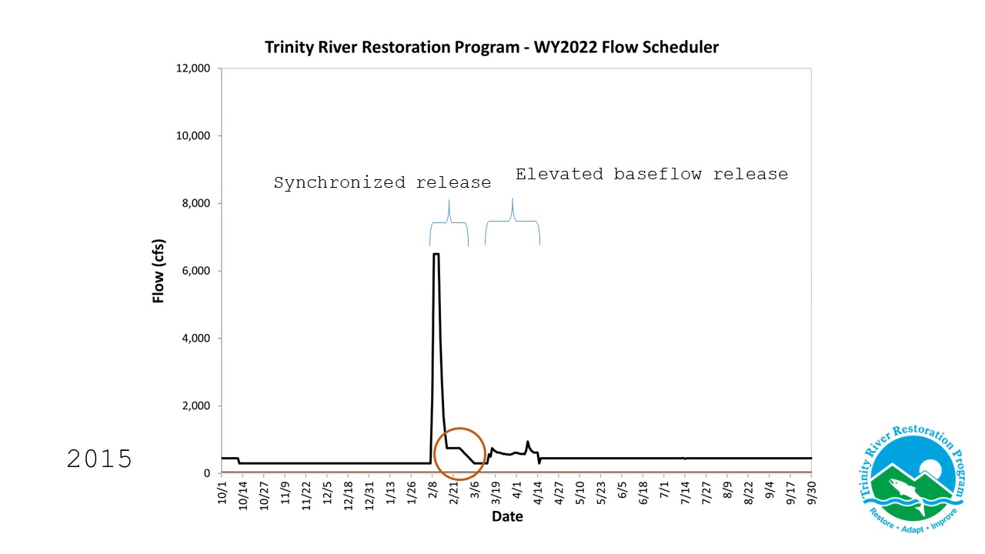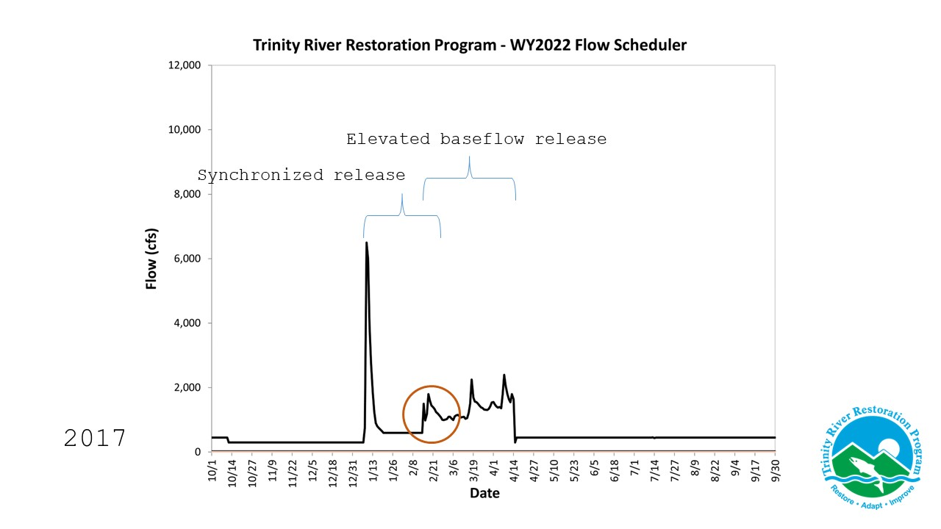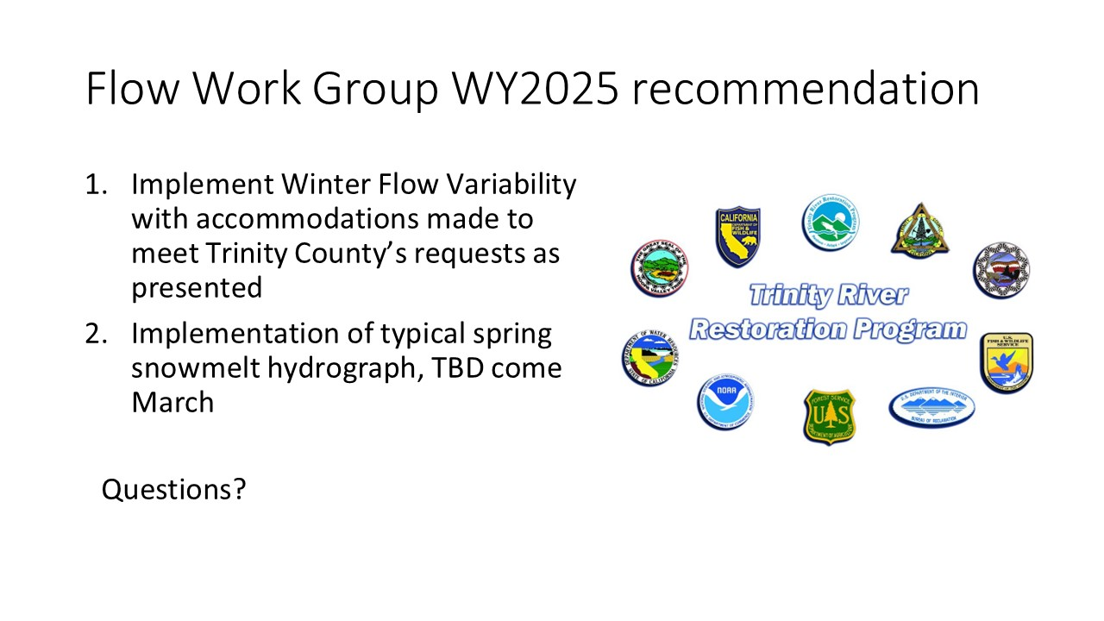

Comments of TRRP Entities
MO – Regarding the synchronization period from December 15 to February, I thought the original EA was 60,000 acre feet, but did you say it changed to 50,000?
PF: No, it’s 60,000 acre feet.

MO: I believe a lot of this has been vetted in an injunction request. One of the issues that the court didn't take action upon was that the summer base flows go to 450 in three to four weeks depending on the water year. There is increasing concern for spring run adults in good years. We’re seeing a poor spring run this year due to disease. You (PF) stated that the CDFW presented winter base flow variability in the EA, is that right?
PF: That was my interpretation. It was presented by Ken with CDFW. He presented the almost identical memo that was presented for water year 2023, which was the implementation of the winter flow variability project as described in the winter flow EA, without any tailoring, to accommodate Trinity County.
MO: Suggests an overlay of EA and Trinity Co. recommendations. Also, my understanding is this concept of fishable days, which is a volume of water measured at the end of the day? Is that the metric you’re using?
PF: It's not related to volume of water. It's only related to fishable days.
MO: The CFS and flow rates are modified because of that volume, which might be the same, but the flow rates are changed. The EA should have been an EIS. The program is navigating the impacts to fishable days as they have historically with trout opening days. There is moss in river at 450 base flow which alludes to emerging ecological factors that aren’t accounted for. The winter flow variability that was produced and developed by Reclamation and later adopted by this group has not accounted for the Steelhead in January and this has a direct effect on the Tribe’s fishery.
TB: You (PF) stated that there's a limitation you can't exceed 1500 for more than 10 days in Lewiston, but then you also stated that you have to recede your peak flow as quickly as possible. Wouldn't staying below 11 non-fishable days be the constraint regardless of your recession rate?
PF: It depends on how you think about it, the county's proposal requested staying below both fishing days definition of 1500 defined in the EIS and then also requested the quick receding. The work group considered those two constraints and agreed on consensus to approach in this manner. That's why these have alternative synchronization pieces that were developed, to specifically meet those two requests.
TB: There are implications for rapid recession rates, and they are lack of bed material sorting and the importance of bed material sorting to species as it gives different species availability for different biological activity. If you decrease as fast as you can, there's negative implications. If you reduce those flows for sorting those different size sediments and we're losing some ecological benefit of this flow action by doing the rapid recession.
MO: The recession rates are consistent with the ROD?
PF: Yes

MO: But his (TB) concern is about other ecological factors that affect the fry and that’s the same rates in the ROD?
PH: The proposal meets the rates that are as stated in the records.
MO: Best available science could mean that additional vetting is needed for the new approaches proposed including life history and overlay of ROD flows with the new approaches. Ecological issues may not be accounted for on the lower parts of the Trinity River, for example, the south fork was monitored after discussions from the vice chair to release more water, but the lower river was not. For the record, I think the debate should continue the evaluation and the governance and oversight process, because this is a major concern that we have expressed throughout the process of the Central Valley project improvement action program and EIS that the Tribe signed in 2000. Our hope is that the continued dialogue with DOI will lead to a definition of violation and an action that can be taken, because we don't want to relive the Trinity Law and the litigation. The ROD could be changed dramatically within the next 3-4 months. The CVPIA was completely eliminated as an environmental restoration project a year and a half ago due to the Tribe’s advocacy. Funding for restoration could be in doubt. Litigation expected and the Trinity is being left behind. MO offers to share letter. There is the lack of an enforceable definition of concurrence.

Public Comments
Franciso Martinezcuello: Requests PF’s position and title.
PF: I am the flow group coordinator and work for Trinity County.

TMC Decision – WY24 Flow Recommendations from the Flow Work Group and IDT
RO: I’ll make a motion.
Ly: Before we do that, we’re going to pull up the bylaws because Mike Orcutt requested that we make sure we all understand the voting structure.

Sections 603 & 604 from the bylaws provided on-screen.
SECTION 603. VOTING RIGHTS, MAJORITY. It is the intent of the TMC that as
designated representatives of member agencies and tribes, there will be active participation in
setting policy and making decisions for the Program. No member shall have more than one vote.
Except as provided in Section 604 below, seven affirmative votes are required to pass a motion when all 8 members are present, and six affirmative votes are required to pass a motion when 6 or 7 members are present.

SECTION 604. ABSTENTIONS. The need for abstentions should be rare. However,
circumstances may arise where members of the TMC need to abstain due to conflicts of interest
or other legal constraints which may otherwise be outside of their control. The TMC recognizes

the need to be able to conduct business of the council without being paralyzed through the
inability to establish a voting majority due to abstentions. As a result, the effect of abstentions
upon establishing a majority for voting purposes shall be as follows:
- When eight members are present and one abstains, six affirmative votes are required to pass a motion.
- When eight members are present and two or more abstain, five affirmative votes are required to pass a motion.
- When six or seven members are present and one or more abstain(s), five affirmative votes are required to pass a motion.

JLy: To recap Section 603, we have 8 TMC members and Section 603 says we need 7 affirmative votes to pass a motion when all 8 members are present. For the abstentions, with one abstention there are 6 affirmative votes required and if we have two abstentions, 5 affirmative votes are required.
RO: Motions to adopt the waterflow variability as presented.
KM: Seconds the motion.
JLy: Comments or questions about the motion?
MO: There were two alternative vetted and I think it’s important to get the details of those.
RO: On the last page of the memo there is the conclusion of flow work group recommendations are the two points presented.
BP: It might help to clarify “as presented in the memo”.
RO: Yes, as presented in the memo. Items 1 and 2 are presented in the memo.
JLy: The IDT memo?
RO: Yes.
MO: It does not have to be in this motion, but it would be helpful to clarify expectations of the next steps for USBR. I didn’t know until today that the EA was not approved. Is there anything beyond that? Will it go to the regional director’s next and they’ll be responsible?
JLy: Are you referring to the FONSI not being approved?
MO: Earlier it was stated that they’re waiting for the vote here?
JLy: Yes, that makes sense.
MD: A review of the EA was just completed by the solicitor's office to make sure that it meets the standards they expect, as well as confirming that the modest modifications of the original

proposals to accommodate Trinity County's requests are being incorporated in the existing analysis. That EA is complete, and the signature is pending an action by the TMC that recommends something with regional directors. That process is the same as our typical flow process, where the TMC makes a recommendation, it goes to the two regional directors of reclamation in the U.S. and Fish Wildlife Service who would then make the decision whether to implement the TMC recommendation.
MO: Regarding NEPA compliance, you’re revising the document that is not the same document that would be signed off today.
MD: Clarifies procedural issues on TMC recommendations and that nothing is being proposed outside the scope of the existing analysis. The existing analysis covers this proposal.
MO: The magnitude and duration we just heard was different. That’s why the overlay of the two approaches was what was being expressed. That is subject to more than just taking your word for it. Volumes are consistent but the timing is not.
JLy: In terms of the magnitude, 60,000 acre-feet was stated and that is consistent with the EA.
MO: There are cumulative effects and all kinds of things in NEPA.
MO: Mr. Chairman, how do we expect that to be done to inform us of the next steps or do we want to be more concrete? I know that the state had concerns on past decisions that were not what was presented after they were decided on here.
JLy: MD covered this, but the TMC makes a recommendation to the regional directors of USFWS, and Reclamation makes the final decision on whether to take the TMC recommendation. Is there anything more specific that you’re looking for?
MO: When you look at the report, there's two different alternatives to winter flow variability as originally developed and the revised one. Are we taking the revised one?
JLy: We're taking the Trinity County modified or addressed version that the IDT is recommending. Any other comments or questions from the TMC?
JLy: Those in favor?

Motion: Radley Ott motions to Approve Flow WG WY2025 recommendation as presented in the September IDT memo items 1&2
Second: Kelli McElroy seconds this motion.
Outcome: motion passes

USBR: Yes
USFWS: Yes
USFS: Yes
CNRA-DWR: Yes
TC: Yes
YTFD: Yes
HVTFD: No
NMFS: Yes
LG: Liam and several TMC members thank Patrick, Trent, and team for the effort to find common ground and the best plan possible given constraints. Liam continues that there are many considerations, including the fish economics, and timing and we did our best to comingle all information. This is a 1-year experiment, we will need positive results to continue down the road, and it’s important that we continue monitoring.
MO: Appreciates that Trinity Co. has added some additional expertise. Regarding the issue raised at the onset of discussion, it is unfortunate that the Native Secretary has not been involved. There will be things playing out politically in the next several months here that will have major implications on this program. If HVT loses concurrence, fish advocates will have one less tool to fight with.
Ly: Understood. Thanks Patrick and the IDT. It has been a long time coming for TMC to make an agreement on this.
MD: Checks to make sure everyone can stick to the allotted time in the afternoon.
Elizabeth Hadley: will have to leave by 3:00 this afternoon.
Justin requests that everyone return at 12:45.

Lunch

FY2024 Budget Completion Proposal (James Lee / Mike Dixon) 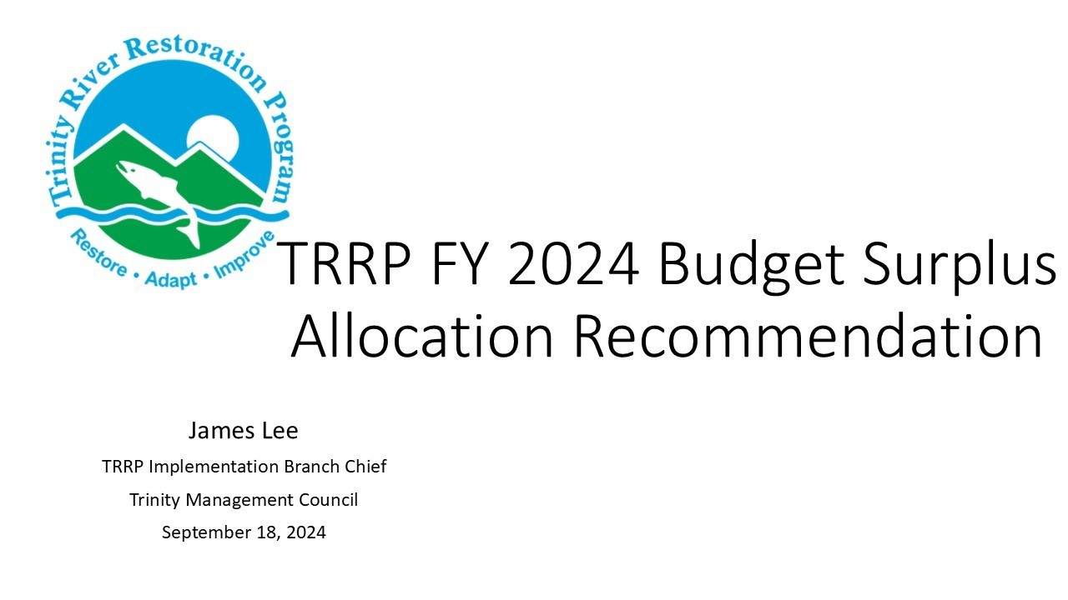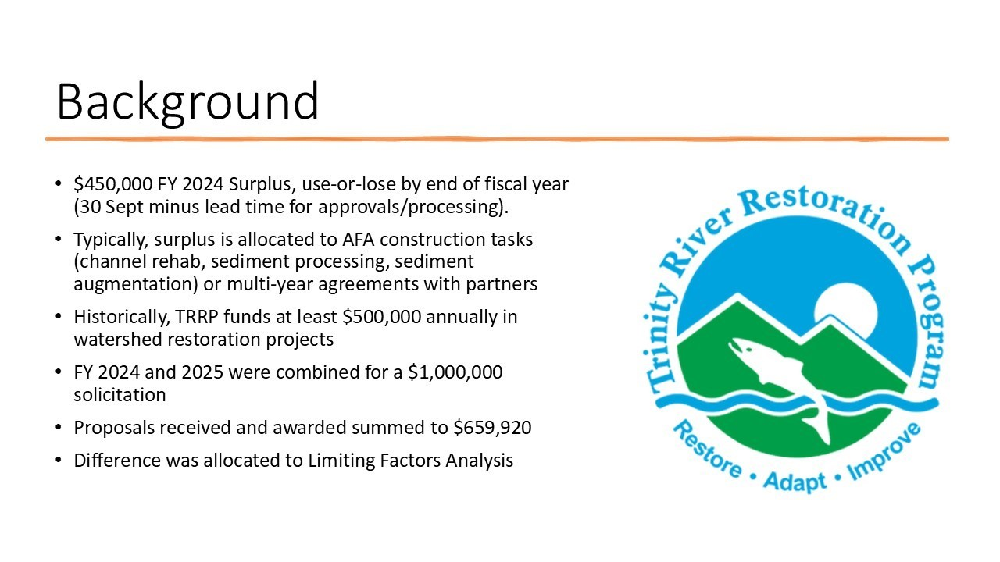
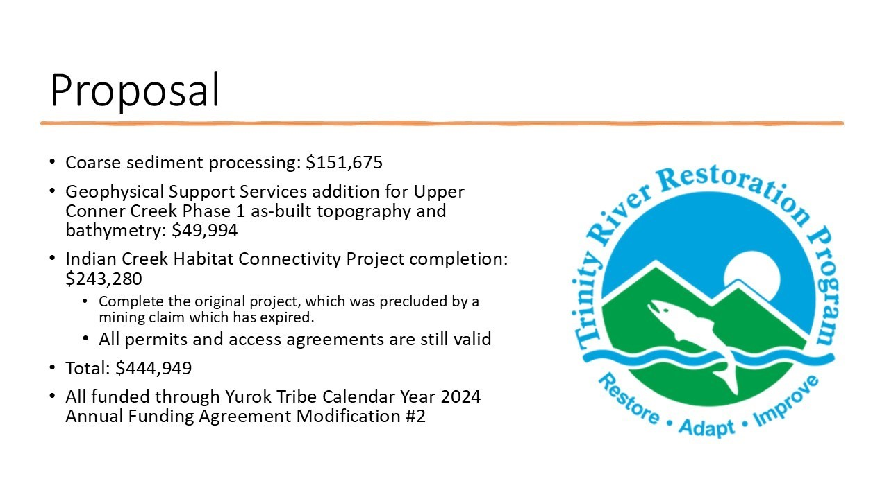 Public Comments

None Given

Comments of TRRP Entities

James Lee provides additional explanation of proposals.
Task 1 – Proposing $150,000 gravel processing – Yurok Tribe can start in a month.
Task 2 – Upper Conner Creek – Constructing this year and would like to get accurate bathymetry and topography by this fall or early winter before floods could potentially change the site.
Task 3 – Indian Creek Habitat Connectivity Project – A watershed project that the Yurok tribe implemented several years ago. It typically dries rapidly in the summer and this project is boosting stream flow. The area is an important tributary for steelhead and coho and is shovel-ready. The upstream part of the design could not be implemented due to a mining claim that has recently expired. Permits and access agreements are still valid. In conjunction with Yurok tribe that can begin construction this fall.
The three tasks would be funded through the Yurok Tribe calendar year 2024 annual funding agreement modification 2.
MD: Regarding Indian Creek valley restoration work, it is fortuitous that the mining claim ended and is time sensitive that actions be taken if the project is to be completed. Per the BiOp, we must be out of channel before October 15th, which leaves a narrow window to execute the right-of-way on BLM land [Note from MD – this was incorrect…The project window extends later into the season because that portion of the project is not currently accessible to anadromous fish due to low flows]. If time expires, we will have to redo the process and make amendments with BLM. The Yurok tribe has the operators and equipment to execute in the timeframe if we fund it. This window may not present itself again where funding, capacity, and timing align.

TMC Discussion

LG: Will this be upstream of the stage 0 project?
MD: It is the top end of the stage 0 project.
LG: That project costs $370,000?
MD: It costs more than that, but that was our portion of it. Approximately two thirds of the project was funded by coastal conservancy.
LG: The $243,00 you presented will cover everything since we already have permits and plans?
MD: Yes, they developed that estimate. Since you’ve been to the site, Liam, do you know where the existing unaltered stream drops in? It’s scoured a pool because it’s coming directly at a bedrock face. The original design had that stage 0 extended farther up into the top end of the valley where it was going to spread out before high velocities hit that bedrock face. It will mitigate the potential for scour there because it will spread out, and there won’t be velocity to degrade the channel, like has happened.
LG: Will it be the same type of project as stage 0 where we go under and put a stack of rocks?
MD: They're basically going to scalp that terrace that's on the northwest corner of that valley and spread that out to the same grade as the rest of them.
LG: That was a good project. I thought that worked well and so did the community.
MD: So did the fish. It was the first place we’ve seen Coho in Indian Creek since the 1990s.
LG: It’s hard to believe it could be that dry for that long and have fish return. It has received immense support in the community.
JLy: How long is the construction work for the project?
MD: The window will be approximately 2 weeks. They will be doing some grading outside the channel to finish off the project afterwards.
MO: The Trinity Restoration Program funds the lower Trinity run size estimation and have given work group reports and census reports for years. Since 2016 HVT has operated a selective harvest weir that has a lot of utility, value, and provides a lot of good information including selectively harvesting fish. Attempts to consolidate these two efforts have been ongoing and approximately three years ago the CDFW director identified the staff with which we needed to work. We’ve discussed this consolidation on multiple forums and have yet to come to negotiations. There is a linkage to the fishery monitoring and a nexus to potentially consider this for funding, could this be added to the list of potential consideration? The original site was a forest service campground, in 1997 the Tribe got the land back, and it is on the west southern boundary of the Hoopa Valley Reservation. The site had to be at the boundary because the interaction with the fishery was the largest concern from the community. The fishery operates, performs, and collects ich and column data sampling. Last year they used the Jack count for the run size estimation in the ocean fishery because the site locations been moved just a number of times upriver and HVT has never been paid for data collected. We have been pushing for funding, even from Congress. We’re at this meeting looking at funding future projects, but this is an immediate need for an active project that benefits the community and fish. Lastly, moss and algal blooms have been a large issue. Net fishing is this location’s primary mode of harvest and this has been disrupted because the amount of moss being caught greatly exceeds the fish.
MD: We met on Monday, and you brought up these three tasks and it was conveyed that there is an open question of whether or not we have legal authority to fund the selective harvest weir, as it has to go through discussion with the solicitor's office. Additionally, I’m not comfortable with funding through the restoration program, because we have protocols for how we solicit, review, and rank that includes SAB review of our science and modelling and monitoring proposals. This would be outside of that. There are concerns about the precedent it sets to fund monitoring projects by going outside of the process funding projects that haven’t been fully vetted at the end of the year.
MO: A lot of analysis has already been completed and opportunity in the HGMP development, since we sample for ich and report on FARs calls. The fish moving through appear to have lesions, and there seems to be an issue with the quality of the fish and water. Pronounced algae blooms in the lower Trinity/HVT reservation.
JLee: Do you think that the water quality is the linkage between the fish health and the algae you’ve encountered or are those two separate issues?
MO: With the FWS, we’re exploring a TEK case study. because I’ve expressed concern over the years that the standard of the study is the fish not dying. The quality of the fish that is affected by management is not being considered.
JLee: EP is doing research on patterns and algae in the upper Trinity to address is this baseline/typical ecological occurrence, do you see some opportunities or hypotheses he may consider?
MO: The offer was made through the Native American Liaison and Fish and Wildlife Service. We’re getting a list of priorities together, and we’re going to get lists that are directly aimed at what we want information on.

JLee: Algae and water quality has been a topic of discussion for a long time.
MO: Algae is water quality issue, and we got money for that. We have had some fairly pronounced algal blooms for the last month on the Lower Trinity in the HVT Reservation.
MD: The main question is algae a bad thing?
MO: During our analysis 15 years ago, there wasn’t anything to attribute to where this was coming from, and there are now new pathways that we need to consider and research. This is a wet year, 450 base flow plus accretion, so there’s speculation about the conditions of the river, like nutrient loading. We need to tie these to ecological explanations.
JLy: Clarifies that this project funds the lower creek weir and asks Mike if he’s wanting to use the surplus finds to fund HVT wier as well?
MO: Under the context that there’s already monitoring, and it is a harvest as well.
MD: James, you showed that there is $659,000 for the watershed projects, were there not enough proposals for the $1,000,000?
JLee: Yes, we funded all the proposals we received and there were only two.
MD: Clarifies that there were only two proposals.
JLee: It appears that implementers are well funded right now.
MD: Spoke to people that have typically applied and there has been a lot of BIL and IRA and some additional funding that's come to the state through like cannabis restoration grants very quickly. A lot of the people we typically fund are struggling to spend the funding they’ve received right now, and we didn’t have the grantees with the capacity to take on more loans at this time.
MO: The selective harvest took 9 years from initiation of consultation. We have an ESA unique to tribal and tribes travel resource management plan that is permitted and is within the confines of operating it within all the impact levels on listed species. But the ones we're harvesting are non-listed species.
LG: Mike has a good point about the monitoring, but my uncertainty is with what the Klamath is going to play without the dams and what are we going to see come out of the lower 40 up the Trinity. I think it would be a behoove us to get a good idea of what is going on early in their cycle up the Trinity River as far as monitoring goes for gill rot, parasites, moss. I guided on the TMC for 35 years and have never seen this in my career, especially this time of year when the water should be cooler. I do think it's something that we should take into consideration, especially with the unknown of what the Klamath is going to do or not do with the dams coming down this year as soon as we can.

JLee: Was involved with Klamath fish health advisory team. Can put LG in touch with the advisory team, as they get field updates on a weekly basis. The effort is encouraging to know how much attention is being paid.
KA: They also publish weekly updates on their website that we share in our newsletter as well.
JLee: There’s more information out there regarding fish health issues.
MO: That’s a separate issue with what’s going on in the climate. The KFAT make it very clear that they're just facilitating the discussion for people to have input by the information and data and they’re not any mechanism for initiating an action. Our group is a 2017 EIS. There was a fall chinook fish kill in 2002 on the lower Klamath and in 2021, due to both tribes holding fish in the lower Trinity, there was a water release under the 55 legislation that allowed for the spring run. Often, in those drier, hotter years they get caught in refugia areas and are susceptible to many different things. This has a known impact to their health and pre-spawning mortality.
LG: Yes, my concern is also the unknown with the dam removal on the Klamath and what may happen there because we know there will be a change and we need to adapt to that. The fish quality issue is something that needs to be discussed.
MO: I’m willing to make a motion to formally request that the Trinity Management Council request and receive approval of participation in the PFMC dam removal work group.
LG: Does anyone have an issue with that?
MO: We need to start discussions on how to actively participate in this.
LG: Agrees. I think we need to get ahead of this.
BP: I think BK, the vice chair, needs to be involved because this is a formal process.
MO: It’s not. There is a branch from your agencies, but there is no reclamation for the interior facet.
BP: I’m curious to hear from BK before we vote on something that we may not have the ability to weigh in on.
JLy: Tim, did you have a question?
TH: I have a clarification question for MO’s suggestion. Earlier you said that the hatchery genetic team works with the dam, are you talking about in the work group?
MO: Unsure if I said that, but I was referring to the Trinity program and the integration of hatchery management. I’m requesting that Reclamation define and state who the appropriate group is.

BK: Was on another call and apologizes for missing the discussion. I’m not sure why the TMC would consider involvement in the Klamath work group, it may be helpful to hear the reasoning before I begin to answer how this could or would happen. Can someone clarify what the purpose or goal would be?
MO: From the onset of our participation in the work group, I have strongly advocated that Interior, the Bureau reclamation be involved because they have the spigots on the Klamath dam removal, obligations at the trinity, bars releases, etc. The monitoring is largely funded by that entity. The FWS does not represent this program, so I am pushing for alternatives to be specific to a sub basin alternative including a process for analyzing Trinity separately because I think it's in our interest to do so since we are a vector from the confluence down, and the dam removal will affect that. We can frame it, but the staff there needs to have access to those work groups. The state has closed the waters to sport fishing for two years in a row and these are direct impacts to the fishery that this group is tasked with restoring, right? That’s what our law and goal statement says.
BK: Mike has brought this to the work group before, but the group hasn’t seen a role for the USBR to participate as this is a fisheries management conversation. The work group is in place to advise the council on how they might manage the Klamath Stock Complex differently as a result of dam removals. There aren't decisions being made or advice being given about funding or about monitoring assessments. We have a need of those tools and that information, but we also already have access to all of those things. The work group is composed of the council, if you decide that you need to be a part of the process, there would have to be a vote to facilitate that outcome. I cannot guarantee that the council will, as the case would have to be quite compelling. I don’t see that there is one at the moment. Lastly, these are public meetings that anyone can participate in. If there's a reason that the Bureau itself feels compelled, or maybe the restoration program feels compelled to understand what's going on or participate, you're welcome to join in that fashion. I hear what MO is saying, but I’m not hearing a reason that the TMC or the restoration program or the Bureau needs to be involved in the work group.
MO: There are no protocols or operating procedures on paper or votes membership.
BK: MO, that’s how the work group is formed
MO: The structure of the workgroup is ad-hoc. Restates that use of this program could help with what they are doing at the hatcheries. The Klamath is another situation, and we have a meeting with the Klamath ROC process and much of the monitoring and management on the Klamath overlaps the Trinity. The USFWS or USBR will fund that and I’m trying to help figure out what is the best fit for this program. The USBR is involved and has a direct link.
BK: That’s DOI.

JLy: Clarifies that MO would like USBR to be involved.
MO: I’d like the consideration.
JLy: would that be the fish work group?
MD: If the gap is representation by Reclamation, the Fish work group coordinator is not a reclamation employee. We fund the position, but they do not work for USBR. USBR does not have a fish biologist position, currently Yurok Tribal Fisheries provides that expertise. Not sure who from USBR would be involved. We have a vacant fish biologist position.
MO: That’s too in depth. HVT, Oregon, and California are all there. We need policies for management actions that consider the tribal parties under contract to you.
JLy: Trying to understand what the actual task is. Reclamation is the gap that you are identifying, we would need figure out which USBR employee would be the public person to fill that gap.
MO: Wants to delegate to TRRP to decide which employee should fill gap. HVT is trying to do it, but does not have the funding or management.
TH: Points back to beginning of the discussion and asks if we’re asking to allocate funds for this?
MO: I want it considered for the potential funding.
BK: To clarify, the work group is offering advice to the council about what added conservation might be necessary to repopulate the new habitat that's being made available by removal of the dams. What we’re talking about is harvest or the potential to forgo some harvest, that is all. The USBR has never had a role in harvest management decisions or things of that nature, which is why I continue to struggle to understand what the intent is of that role.
EH: It is my understanding from my counterparts in Klamath that there are large efforts underway for dam removal, and I don’t want to get in the way of what is already in action. If a motion is I will be abstaining due to lack of knowledge, but it would be best to allow (our) staff to decide to best fill the role so that TRRP does not step on toes of the workgroup.
MO: No one from the Klamath office is participating. No toes are being stepped on. The ideal would be to identify the senior interior policy representative and have them delegate someone from both sides to cover the consultation. Someone from Trinity needs to be available to speak for the Trinity when Klamath decisions that affect the trinity are discussed. Simply wants a voice from TRRP.
BK: It is a technical workgroup, not policy representatives, meant to provide technical advice and does not have the same procedures in place as TRRP or a policy group.

JLy: I want to pull us back into our agenda topic of the available funds and what to do with them and, if we have time, we can rejoin the discussion on the PFMC sub-group. Questions or comments on James’ presentation and proposal?
MO: Funding for future years and projects doesn’t bode well with me when there are immediate topics to address. The recommendations that you’re proposing are all 2-3 years in the future.
KM: Not Indian creek.
MO: Indian creek won’t be done today.
KM: It has to be.
MO: You will obligate the money, if you can, by the end of the FY but the project will be done in the future.
TH: It will be done in October.
MO: They’re going to do the Indian creek work in the next month?
JLy: Yes.
MO: Well, that project is different then.
JLy: I’ll entertain any motion regarding James’ proposal at this time.
MO: Recommends that the Indian Creek watershed be funded per the recommendation.
LG: Just the one project.
MO: Yes, the others on a case-by-case basis.
LG: If I was a neutral observer, I would want to get out in front of the situation with the Klamath, moss, gill rot, and temperatures. Not sure what the mechanism is, but it would be a mistake not to take action now, so that we don’t have to redo this in a year or two. We know that the dam removal will cause changes, and we need to get in front of it, due to the uncertainty of the changes. It was proven last year that silt causes gill rot and I don’t want to keep proving that year after year due to the changes in the Klamath.
MO: We have joint tribal proposals about the FARS and analysis of the fish kill and they have yet to be funded. I would like to add that project to address LG’s concern, as it is an active project that should be funded in addition to the Indian Creek project.
MD: calls on Elisabeth to check-in on solicitation.
EH: This is Paul Zedonis’ project, it is my understanding that the first solicitation did not receive any applicants, and it will be going back out. Reminds everyone that current year funding is what is being discussed and approval has to be granted no later than Friday to get funding. It will be reabsorbed if not spent. Since there are only two days to allocate funds, this is why these

projects are being discussed. The new projects brought up are great but need to be considered in the next FY given the timeline.
TB: It would be dangerous to allocate money to studies that are unknown in cost. To throw money at a problem before we have fully vetted and defined the problem is not the best practice.
MO: The FARS has been around 5 plus years, is that what you’re discussing?
EH: No.
MO: Fish health in general falls into the realm of the discussion. I’m just not sure what we’re talking about.
EP: The science plan provides a process by which we target projects and funding. FY26 is currently starting the planning process, and we could discuss that there. Some of these questions can be addressed in the review process if they are long term questions.
JLy: I’ll add that we have two groups, the KFAT and the FARS, that discuss fish observations, diseases, and monitoring from the different groups.
BP: KFAT team could respond and mobilize for kill response.
MO: That is different from my experience, because previously it was clear to me that the purpose was to only join to discuss the existing conditions.
BP: During the McKinney fire fish kill, that group mobilized and surveyed. It is intended to be a fish kill response network.
MO: They only recommend the actions to others. They’re not officially authorized.
BP: They can’t change water management.
JLy: Regarding EH’s discussion, we are at the tail end of the FY and we need to spend the money or it will be absorbed back into the region. New studies need to be vetted, possibly with FY25 dollars because we only have two days to obligate these funds.
EH: Mike Orcutt made a motion to approve the Indian Creek on its own, was there a second?
JLy: not yet.
LG: Do we take a second and open the discussion to the motion we just had
JLy: We need to second first.
LG: Refers to the bylaws and the need for a second to move into discussion, which was not done in this motion. How did we proceed with the bylaws not understood and followed?
TH: I thought we were clarifying the motion, I’m still unclear.

LG: Would you like to discuss the motion? We need to follow the technicalities of the bylaws and second before discussion as we continue.
JLy: Waiting for a second.
LG: Seconds the motion.
RO: Does not want to disregard MO and LG, but there is a process and a mechanism to get those things in process, but to do that with this type of time frame, it just doesn't seem attainable. After we settle what is currently on the table, I think it would be wise to direct the science plan and science to start thinking about the future funding that was just discussed.
LG: We knew these developments with the gill rot and changes to the Klamath last year and did not take action. I have concern that we are behind on the changing conditions and that we are being proactive rather than reactive to the current situations.
JLy: We currently have a motion regarding the Indian Creek funding, which is separate from the monitoring. Let’s focus on the motion at hand.
MO: Was the FARS analysis excluded from the motion?
JLy: It’s your motion. You only made the motion about Indian creek.
MO: I think the FARS fits into the realm of necessity of fish health.
JLy: Would you like to amend the motion?
MO: I just want it covered, even if it’s covered somewhere else.
BP: It sounds like it's covered if they put out a solicitation, but the funding's been identified.
MD: Yeah, I think there's a separate discussion that needs to happen about whether or not we need to look at noncommercial vendors if we're not getting commercial vendors responding. NCAO has funding and we're trying to get somebody under contract to do that work right now.
EH: Funding is not an issue. We just need to find a contractor.
MD: We’re trying to find a contractor and should possibly talk to the National Fish Health Center or USGS, but that is going to happen because the study plan and funding are ready to go.
MO: Yurok and HVT crews have applied for funding to do the work. If there's no responses on your solicitation, why can't we go back and fund that proposal? This has been ongoing for years. I am vexed because the dam removal and other things happen, and I have to answer to the tribes and the answer will not be good. Since 2002, we have been supposed to be looking at answers and approaches to the diseases.

LG: Is there an expiration date on a motion you had made in the past to do something like we're trying to do now?
MO: It was viewed as outside of the realm of this group and was going to be funded from some other source, and that's where it's been stalled.
JLy: That was not a motion put forward here, that was an application for funding.
MO: The reason for that is because they said it was covered under another source and process.
LG: Did that process get followed up or completed?
MO: We have it, EH just stated there was a solicitation with no response.
EH: We have the funding and are working on a solicitation. This is not being done with money from the TRRP.
JLy; MO, did we get your motion correctly, because we’re going to vote on it now.
MO: I said the Indian creek one and was putting out for discussion the other one.
KM: So, this motion would approve the Indian Creek one and then we would have further discussion on the rest of it?
JLy: Yes, unless someone wants to make a competing or friendly amendment. As is, it is only for Indian creek. Those in favor?

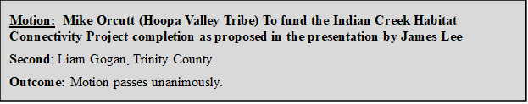
MO motions to approve the 2 remaining recommendations by James L with consideration for FARS analysis.
LG: Are you saying that because of time restraints?
MO: I would consider the joint tribal one. If it doesn’t get picked up, it can after they resume business, right? That’s my understanding of the fiscal year constraints. It is very important that gets stated. This is a reminder. It is a recommendation.
BP: It has been a minimum of 8 years.
MO: Ok, I previously said 5.

BP: It was a couple years before the COVID pandemic, so we do share your frustration.
JLy: Is there a second?
JLy: Can we make sure I captured that correctly to approve the remaining proposed items as they stand with considerations of the FARS study?
LG: I’ll second.
EH: I’m unclear of the caveat and how it stands with the FARS study, because I stated that this was happening in a separate process from this one. Asks for clarification of FARS study clause.
MO: It has to be submitted as tribal proposal, but it will be the responsibility of the USBR to figure out the path forward. The current path USBR is pursuing is not working. We could state it how we would like, but that is getting into who is negotiating and what entity is going to secure the agreement.
EH: I’m still unclear how this corelates to the funding with which we are working because the money for the FARS study has already been approved. We went out for bid. We did not receive any responses to the solicitation. We are redoing the bid and proposal to be able to address some of your concerns, Mike, and to get more interested parties, but that is happening separate from this. Given that, I’m not understanding how that relates to the proposed funding on this list because that seem like two separate things. I am trying to link this together with the second part of your motion. Are you saying that if the FARS project doesn’t get funded in the next two days, that you would rather the money go to the FARS project instead of these proposed items?
MO: You picked up the two that are in the recommendations already, right? This is the secondary, the other amount of money that’s left after the Indian Creek for recommendations from the staff. The goal of the second approach is that if it is already funded somewhere else, if it’s considered for other mechanisms including AFAs, then that works and those are great approaches. It might be doubling down in an attempt at funding. I don't expect us to get the three tribes into some type of AFA between now and Friday, but I do know that we're told that it can be picked up once they resume after the fiscal year whenever the embargo ends. This has to happen and needs to be obligated to somebody. If there is a consideration for a tribal approach or effort, then that would be in the realm of possibilities.
EH: I need to be clear that if this money isn’t spent in these three items, it will not likely go to the FARS proposal, because we already have that money allocated. We are already working on the process for that allocation, so this money would likely go towards something else internally if it isn’t spent in the program in the next two days.
MO: I’m missing something, because this project and the rest of the recommendations are what the proposal first speaks to. It would obligate that money for that.

JLy: What does consideration of FARS study mean?
MO: Motivation to make sure that things happen. If the money goes to a tribal AFA, then that works too because it will be moving towards a path to completion.
JLy: I understand, but as it is written it is vague for USBR and the rest of us to understand.
RO: Offers friendly amendment – To approve the remaining proposed items as they stand with DOI and USBR to make a good faith effort to fund the FARS study.
MO: If the necessity is to obligate one thing to do in the next two days, then that should be the first priority. The second part is a statement to motivate them to get the job done within the next year, so we don’t have this discussion again next year.
JLy: Agreed, I believe the friendly amendment addresses that commitment. Do you accept the friendly amendment?
Accepted by Mike Orcutt and Liam Gogan
EH: I am interpreting this as reformation, because if the funds are not implemented and the study isn’t funded by Friday, then that money does not get allocated. This is a completely separate process and pot of money, that I cannot see the link. I think there needs to be verbiage added noting that this will be completed within the next year, because what we're talking about with this motion and this funding is trying to allocate funds between now and Friday. Trying to link a study that you want done within the next year and Friday makes it very complicated to figure out an approach.
LG: Radley, your motion did not include a dollar amount.
RO: No, it was not intended to have any time lime associated with the FARS study. The goal was to echo Mike’s statement to make it happen.
MD: Radley, could you address that by saying “proposed items as they stand; DOI and USBR will make a good faith effort to fund the FARS study in the coming fiscal year”?
RO: If that makes that it more explicit, yes.
EH: That would make me feel more comfortable.
LG: Can we add “in the fiscal year”?
EH: State the year also.
RO: Federal fiscal year 2025.
Second Friendly Amendment proposed (Radley Ott California DWR): To approve the remaining proposed items as they stand; further that DOI and USBR to make a good faith effort to fund the FARS study in FY25.

EH: Yeah, and state “further we recommend that DOI and USBR”.
Second Friendly Amendment: To approve the remaining proposed items as they stand; further we recommend that DOI and USBR to make a good faith effort to fund the FARS study in FY25.
EH: Thank you, that is much more clear to me.
RO: If that is more clear, then that meets my intention.
JLy: If you can delete “to” for me?
Second Friendly Amendment: To approve the remaining proposed items as they stand; further we recommend that DOI and USBR make a good faith effort to fund the FARS study in FY25.
JLy: Is that the final amendment?
RO: Yes
JLy: Ok, we’ll vote. MO, do you accept this?
MO: Yes
JLy: Those in favor?
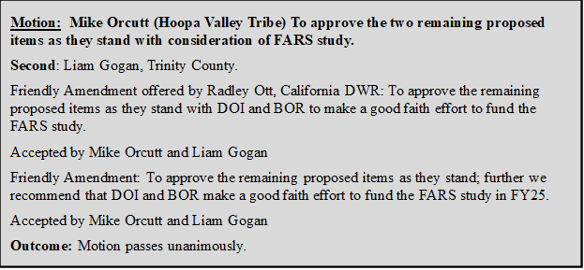
MO: As the FY24 and the new FY25 begins, I would like to have follow up reports on the status of the FARS study obligation of money, including consideration of a potential tribal project.

MD: I hear a future agenda topic.

JLy: I fully support that too.

2022-2024 Outreach Results (Kiana Abel)
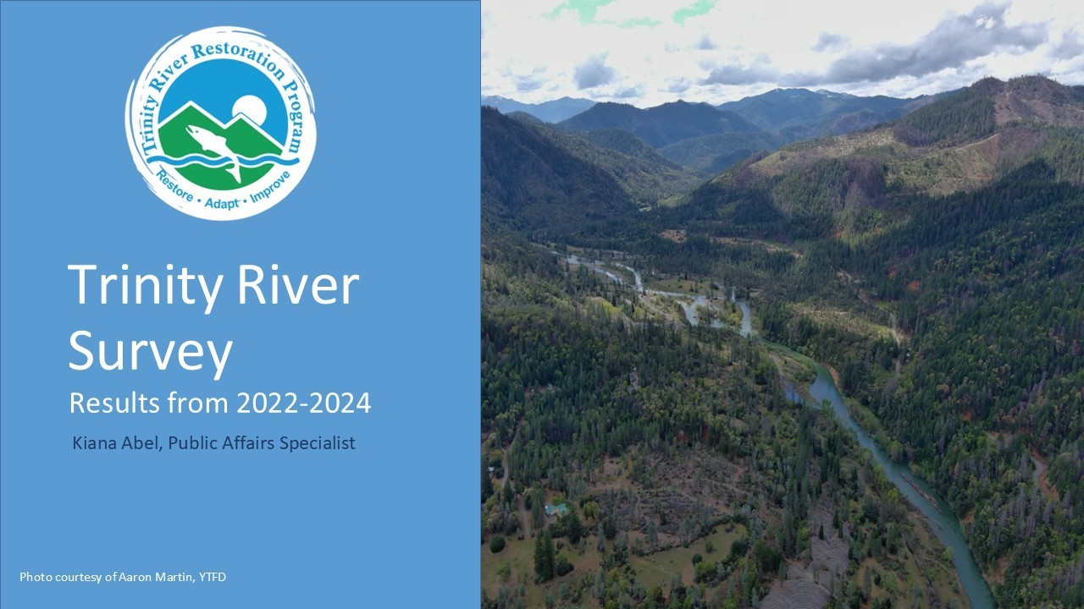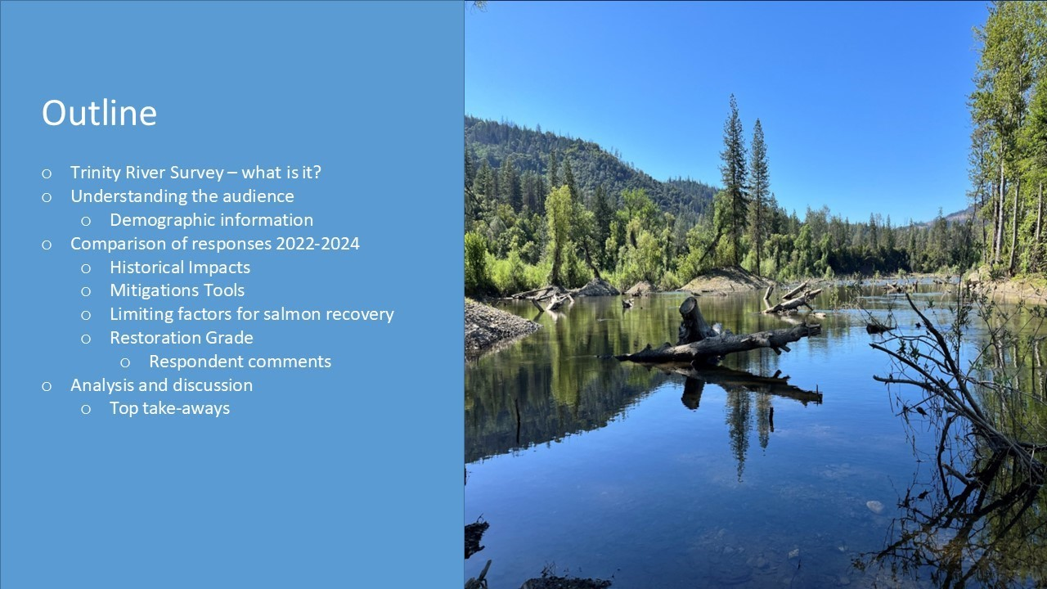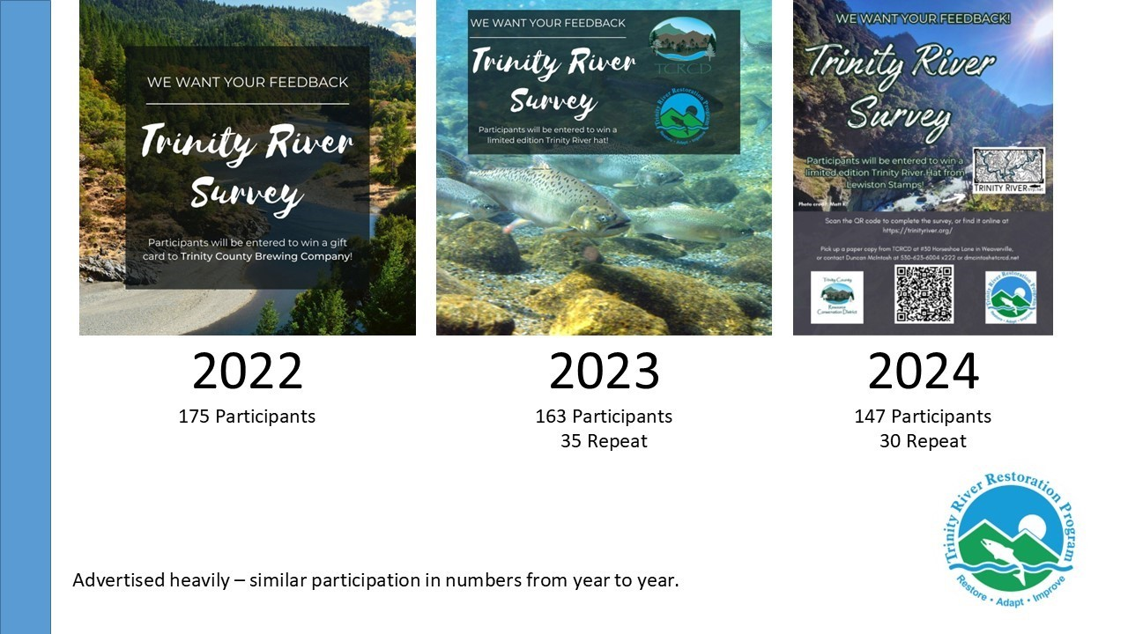
Kiana provides some additional background information to support Slide 3. The survey began in 2014 but was paper copy only until circa 2020. The survey takes 20-30 minutes to complete. It is open for 30 days with incentives [gift cards] that might vary between years. Incentives are sent out through Trinity Resource Conservation District who are active on social with paid posts for the months it is open. The eblast reaches 1,000 people and supported with print, and radio ads.

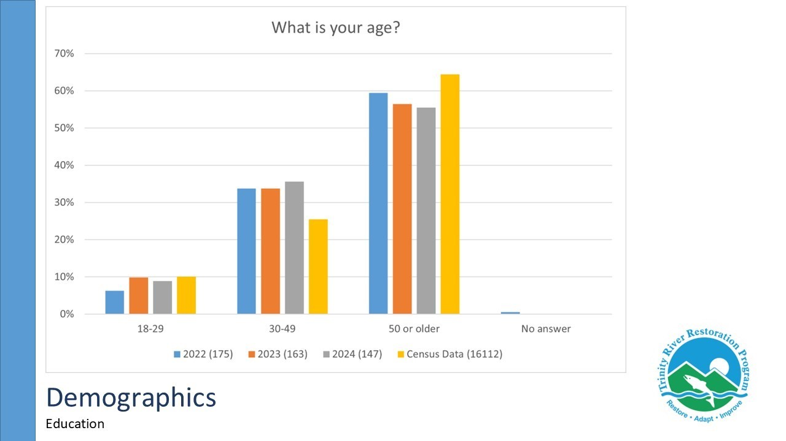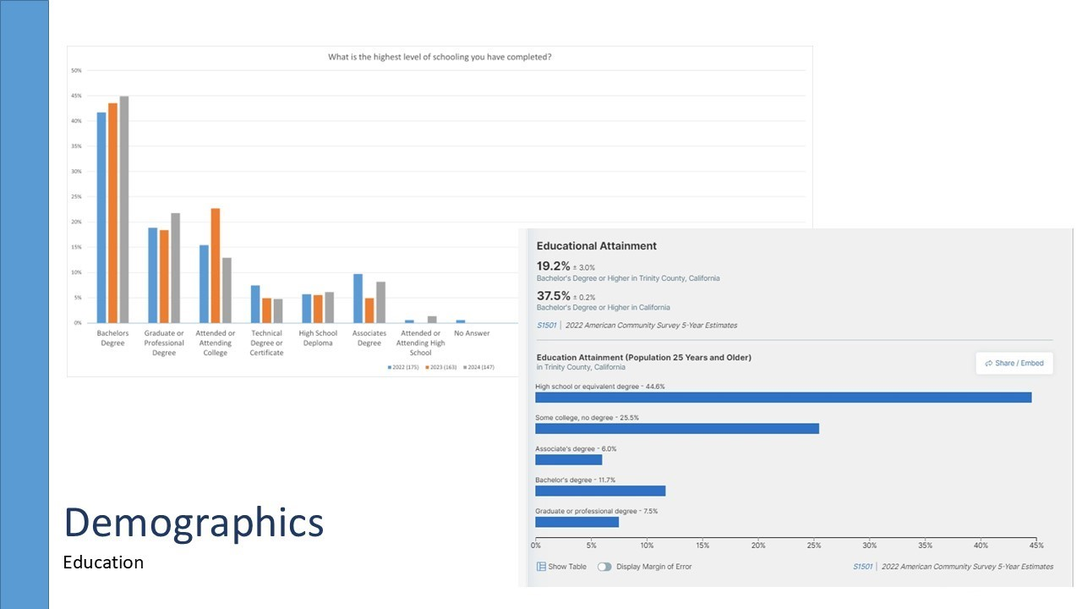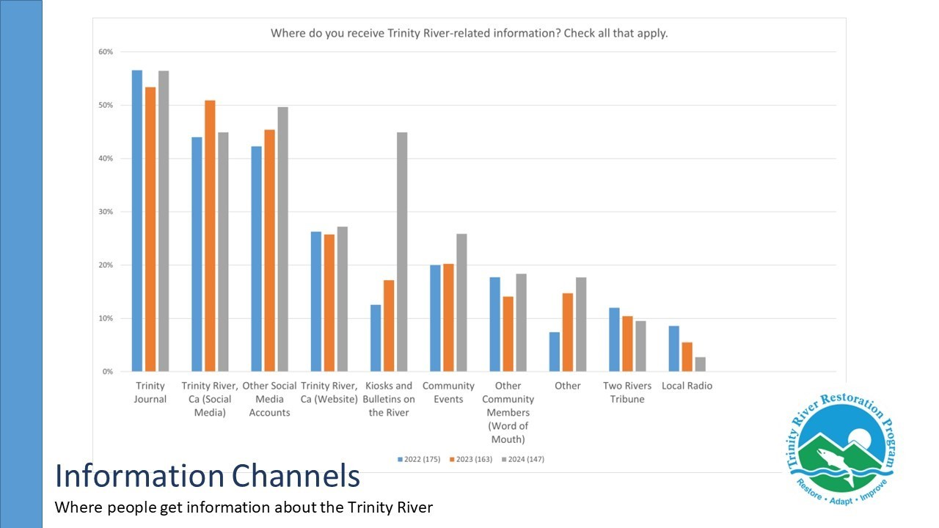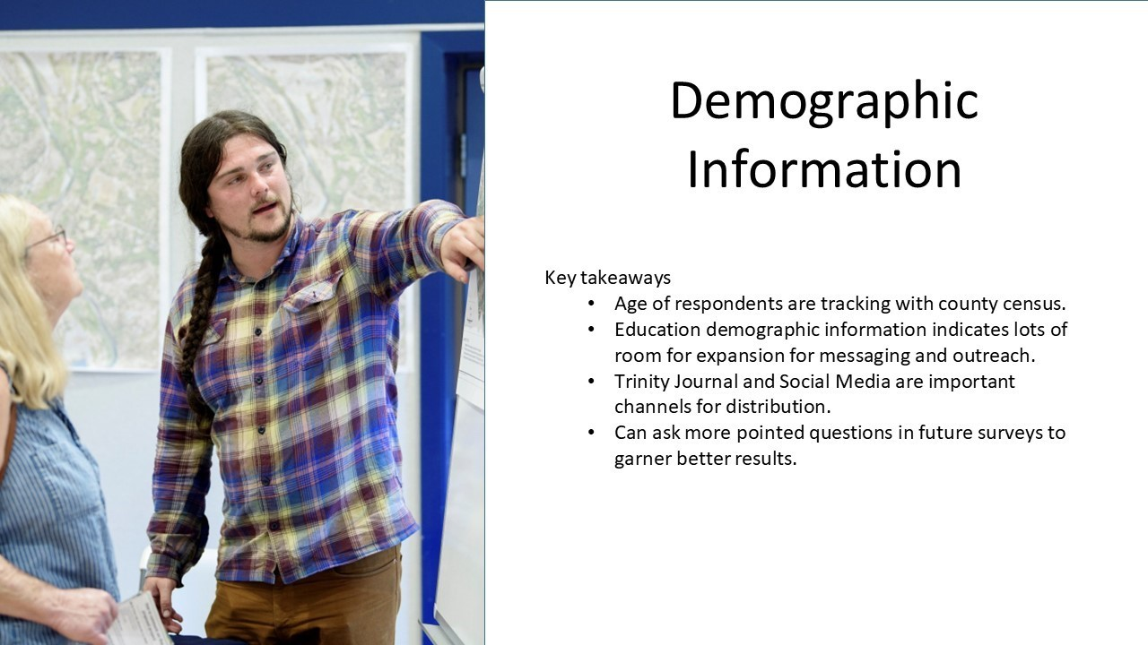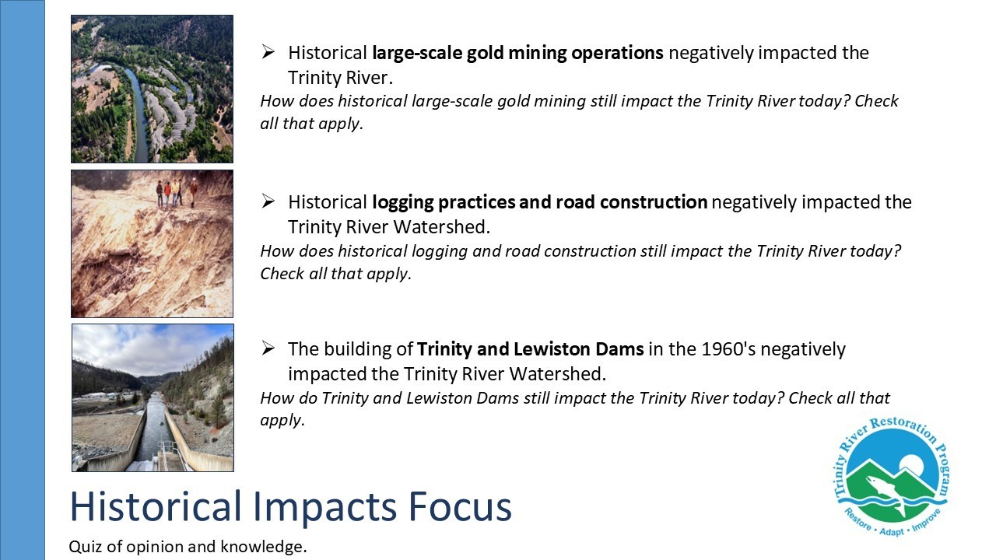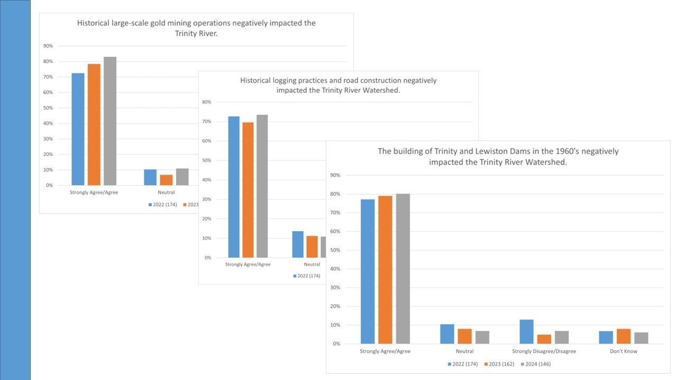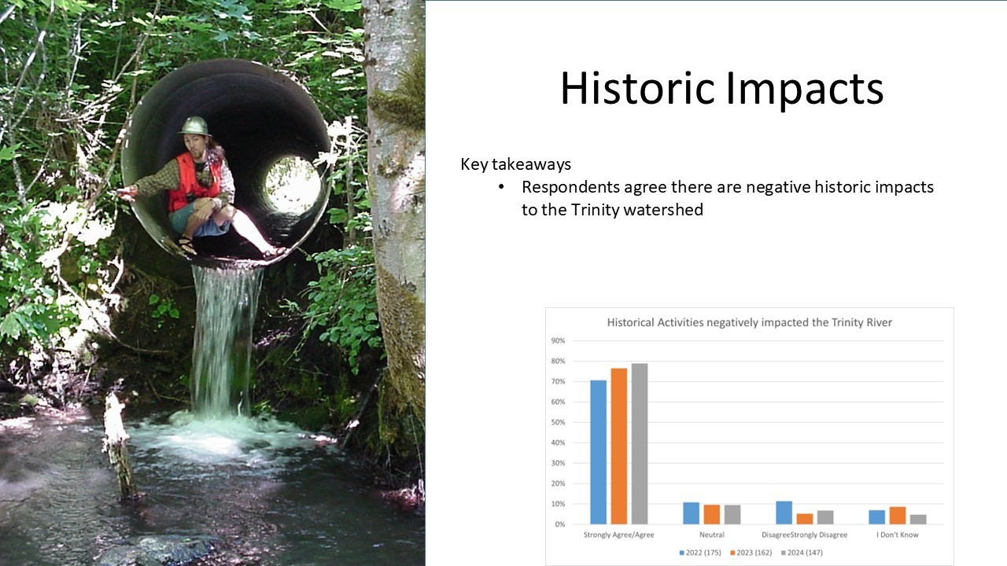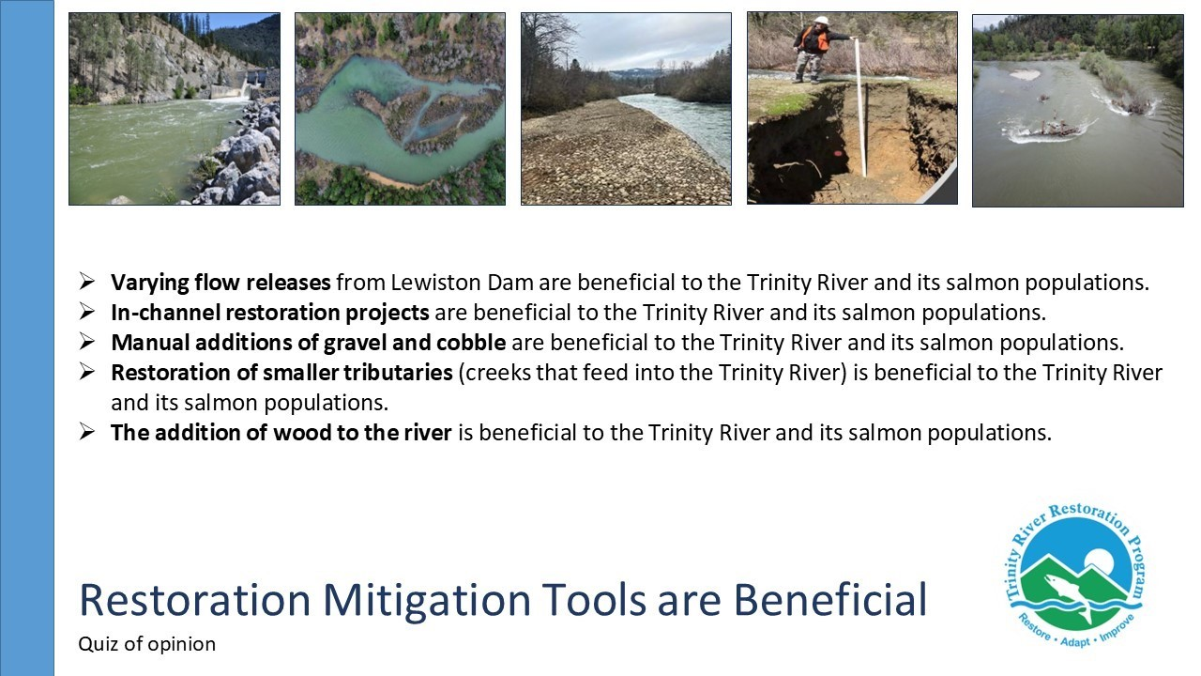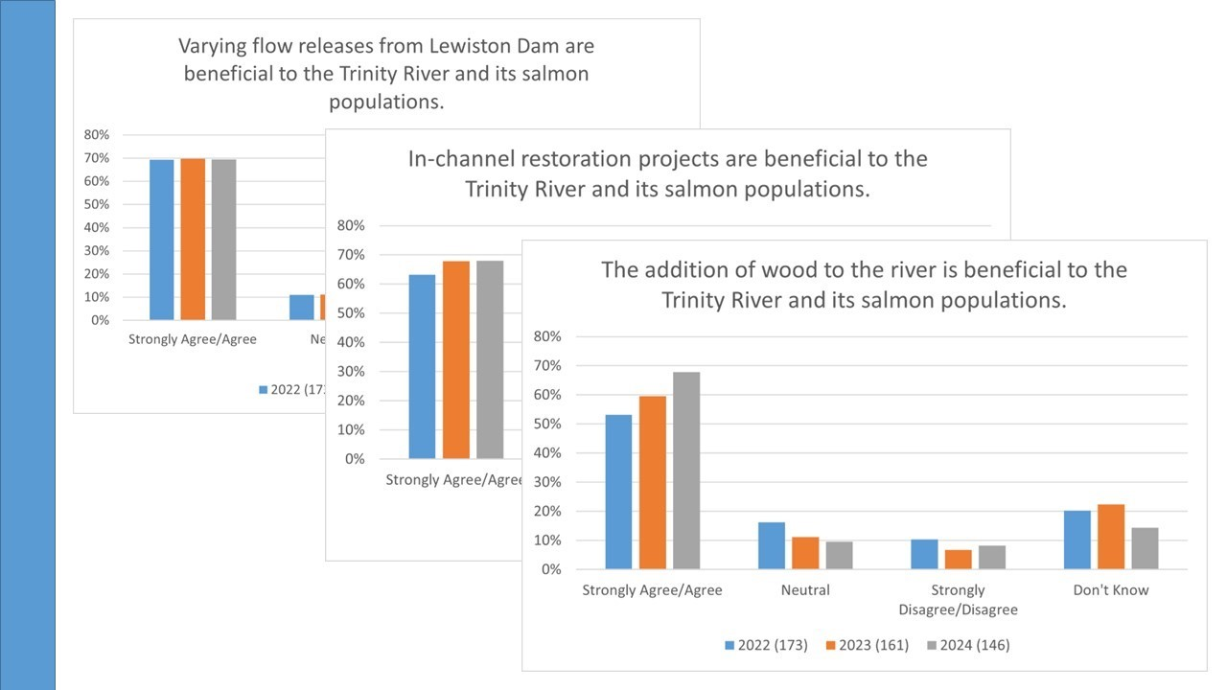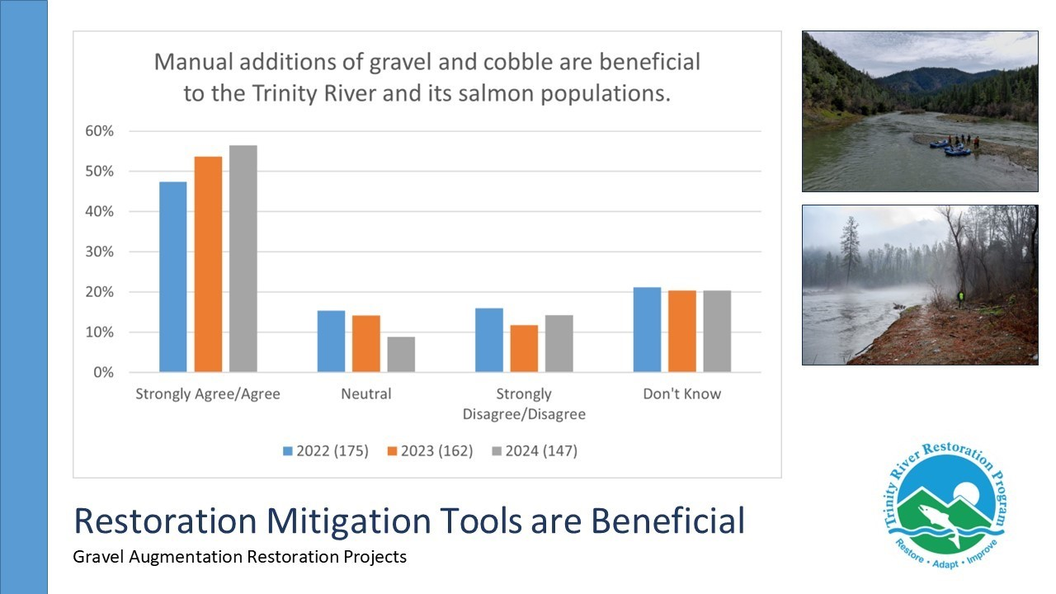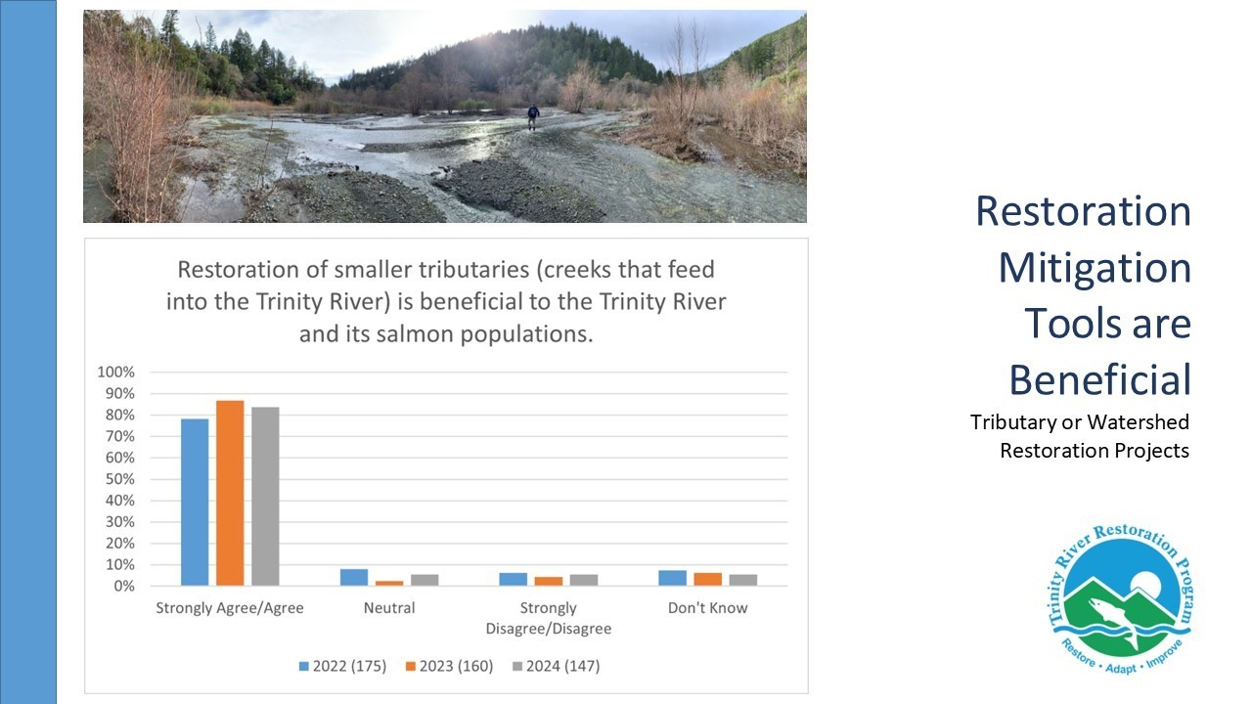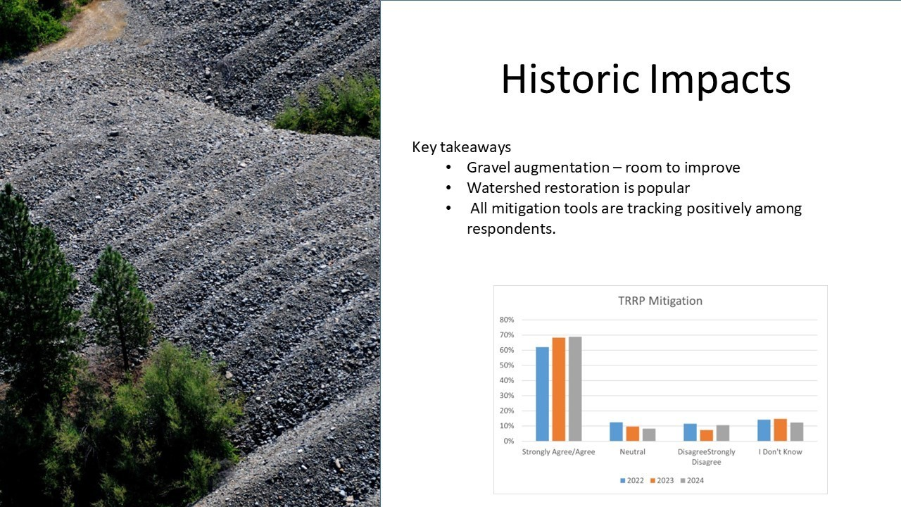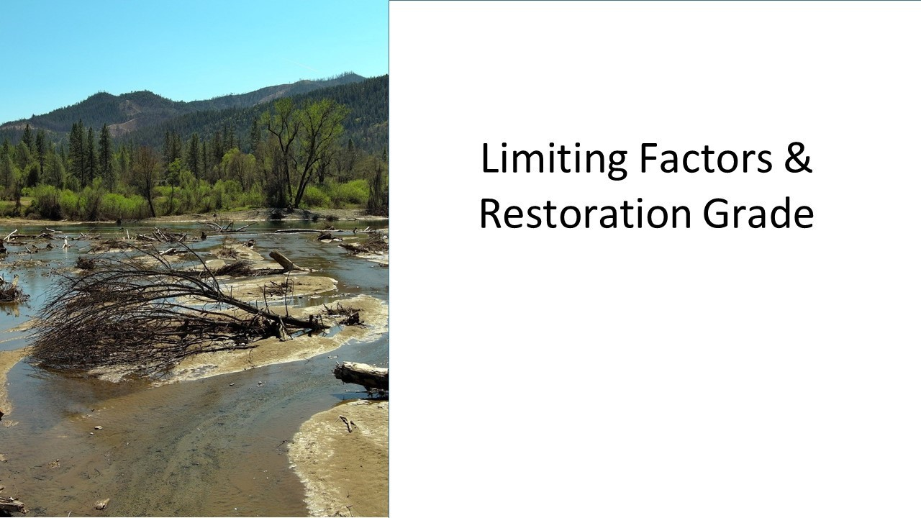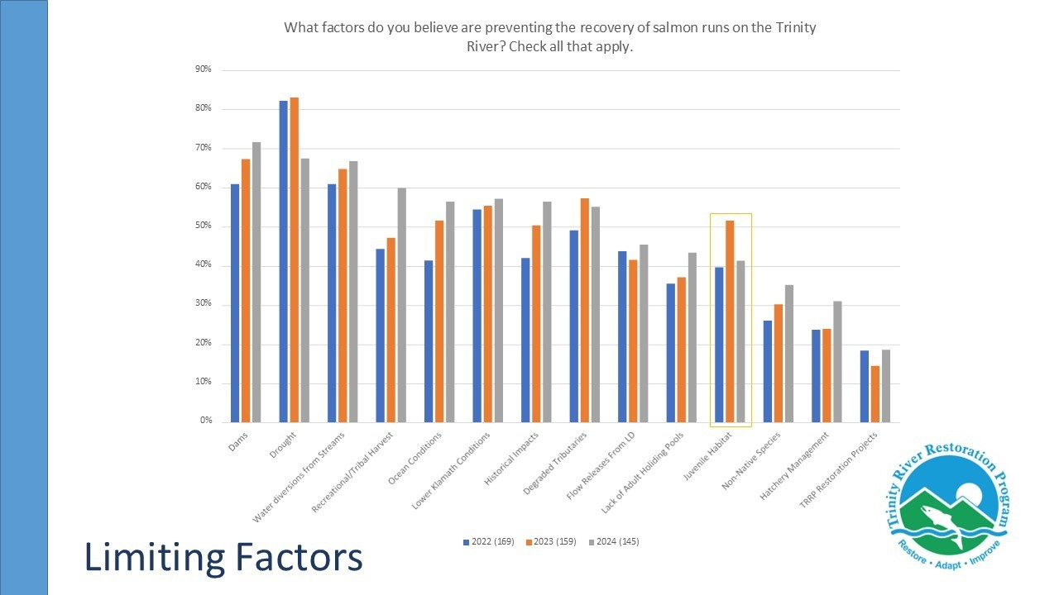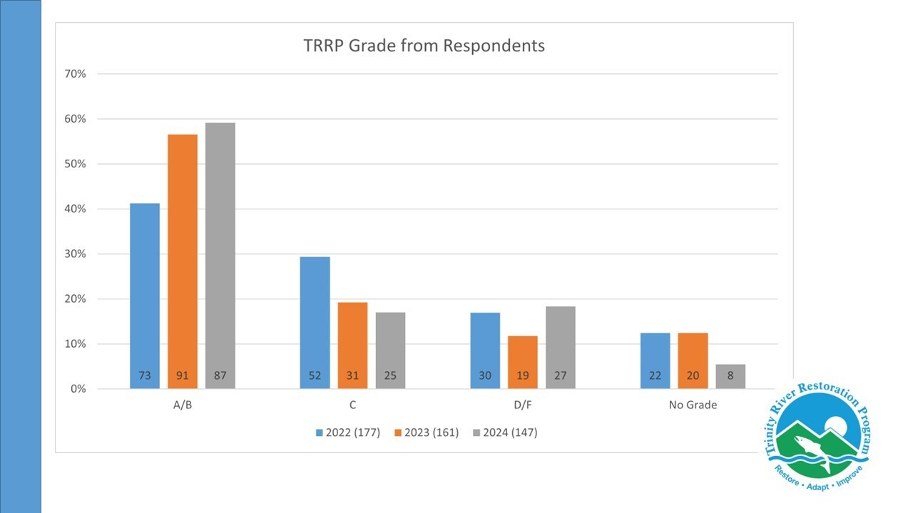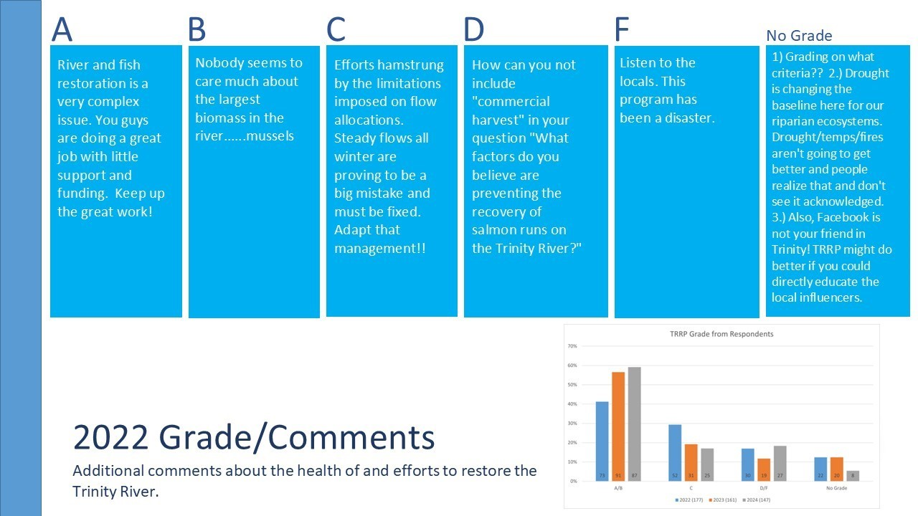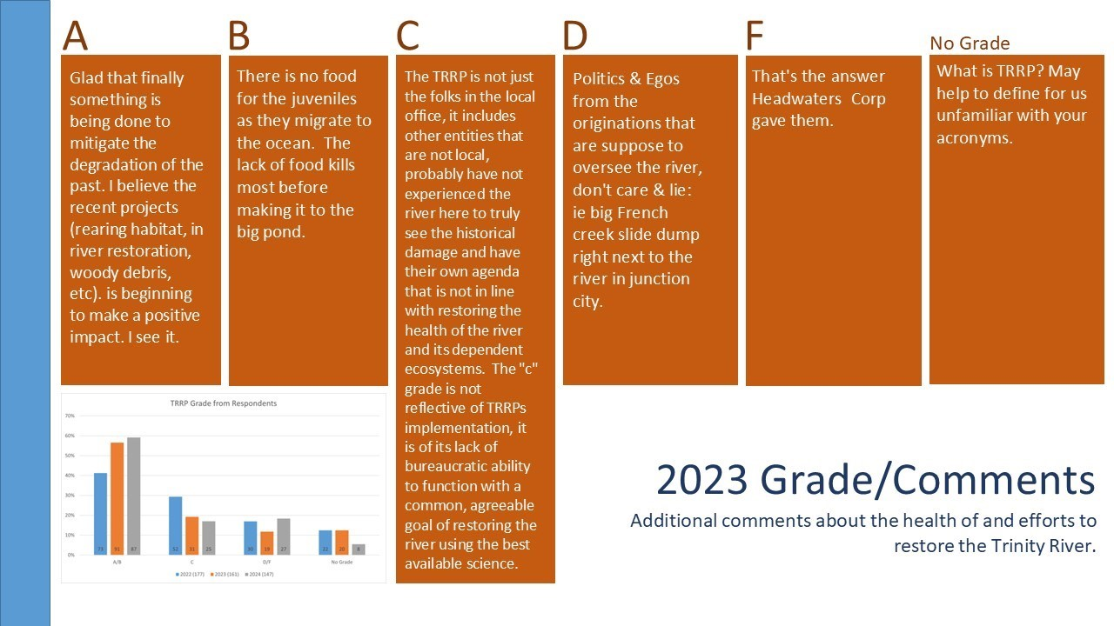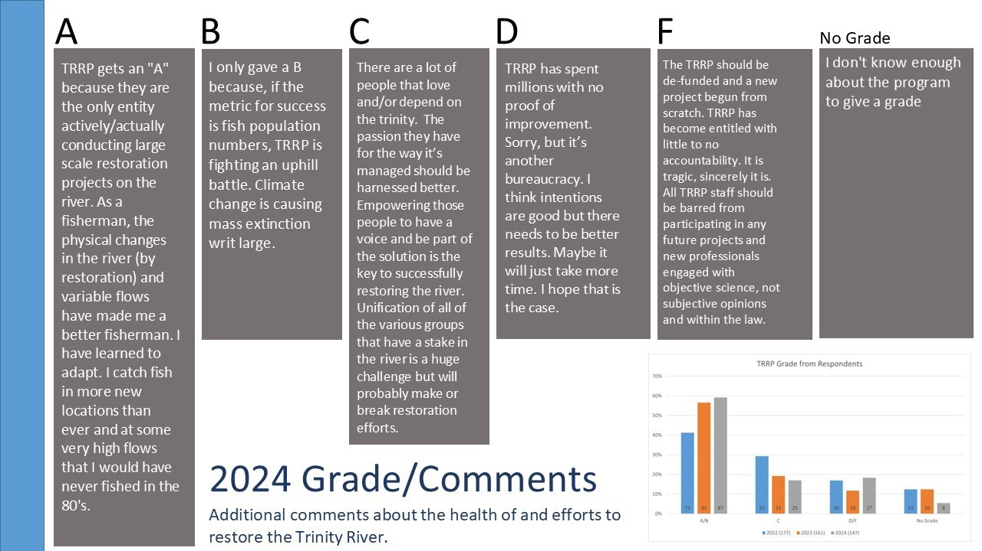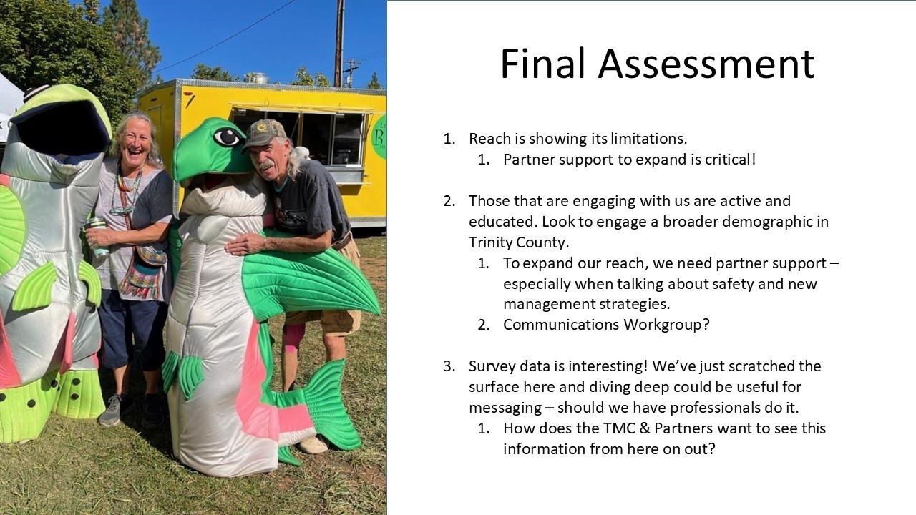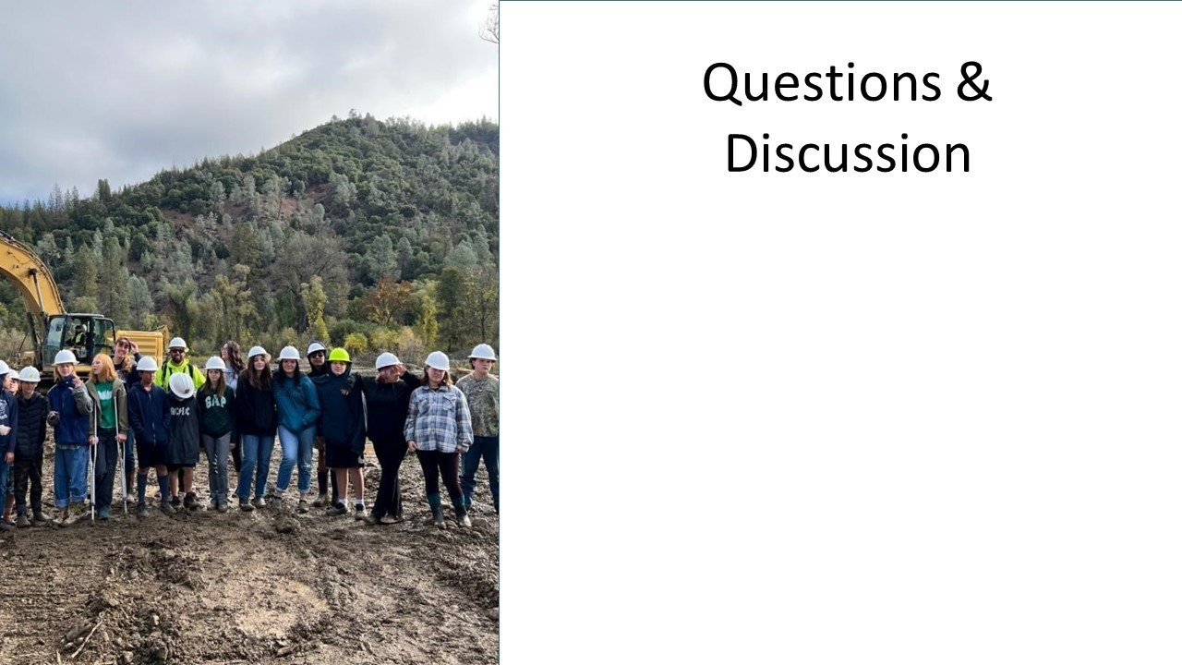
Public Comments

None given.

Comments of TRRP Entities

KM: What time of year does the survey come out?
KA: Last year it was out from January 1st-30th. The survey generally comes out typically comes out in the winter to spring.
JLy: Do you physically mail the survey or send a link?
KA: There is a SurveyMonkey link that is emailed to over 1,000 people. Last year was a record response year. In addition to email, they made flyers with the link, sent the survey to prior respondents, sent it to the CNC, shared on social media platforms, and hosted it on the University webpage.
JLy: And what about the raw data?
KA: The raw data is in the hands of the RCD and the Bureau of Reclamation has files from 2021 and later. I do not know where the paper documents are but am working on locating them. I have a copy of the paper questionnaire, but none of the responses.
MD: The previous grant with the RCD was less prescriptive about how we dealt with the survey; however, this was improved and we’re still seeing opportunities to improve the next iteration.

JLy: Is the last 3 years of raw data accessible?
KA: There are printouts, but I don’t want to send the RAW or WRONG data online.
MD: The data could be anonymized. This is a qualitative presentation, but a statistician or sociologist could view the data from a different lens and see different trends in the data. One of the trends I found interesting was that drought was a high limiting factor. It was rated around 2 through the years, then it dropped drastically in 2024 when a drought had not been experienced and for two years and it became much less of a limiting factor. There is apparent uncertainty in how people view the river based on current conditions.
KA: Agreed. I think there are many factors that were not mentioned. There were comments that ocean harvesting and fire and sediment should be factors in the future.
JLy: I’m interested in viewing the grades, the comments associated with the grades, and how those are rationalized.
KA: In that case, I think there’s a broader view to see how they answered and rationalized their grade and what grades they gave afterwards. There is more information than just their responses.
TB: You said you knew how many surveys you sent out, how does your rate of return change over time? And is there a breakdown of your findings by location on the river or zip code?
KA: I don’t think that’s available, the information given is typically an email address. We could ask more pointed questions about where they live. One of the demographic questions included is “what are the most frequent places that you use on the Trinity River?” and they can answer by checking all that apply. Another demographic question included asks how they recreate in Trinity County.
TB: What’s your rate of return change over time?
KA: It is going down. The rate of return change is around 20 less respondents each year. The lower return from last year was surprising given the climate of Trinity County and the program was a hot topic for many people. We also advertised heavily, extended the reach of our flyers, and had it listed in the paper.
MD: There was a QR code this time that made it even easier.
KA: Yes, we did many things to make it more accessible. We didn’t do any paid advertisements on social media.
TB: It appears there is some inference on lower rates of return could be higher satisfaction with the program, because if someone is upset, they are more motivated to voice their dissatisfaction.

KA: I haven’t seen that in the results. I was expecting more dissatisfied customers based on the 2024 results, but I wasn’t seeing that. I’m hoping to get more people to take it because 175 is the highest we’ve had so far. There are 16,000 people in Grady County, so we’ve captured around 1 percent. I am not expecting to get responses from all, but it would be great to get a higher rate of return.
MD: Referring to photo on the last slide, who is the group in the picture?
KA: This is the 7th grade Junction City Class. Last year they requested to do a tour of Oregon Gulch and the Yurok construction crew. The crews were excited to take the kids out and let them see the machines and equipment. I wasn’t able to go, but they had a good time. Any other questions?
SQ: Can you scroll back to how you get your information? I believe you mentioned that in preparation for the survey you noticed the kiosks and signs by the river, I think that’s the most standout change. Did you say the program put a lot more effort into those resources that year?
KA: We did a lot more by putting flyers out and information on the kiosks, but there is a prescriptive process when they do advertising there. I’m not sure if they were doing more or less or if people were noticing them more. I was working on the graphic design to attract people’s attention better that year.
MD: In 2023 we were doing Science on Tap, we had weed polls, the adopt-a-plot program, there were more events and flyers, and I think the 2024 jump is reflective of these changes and implementations.
KA: Our outreach efforts increased significantly after the 2023 survey with the Science on Tap and start of our Facebook page.

TMC Discussion

Break

Exposed Bar Census Results (Todd Buxton)
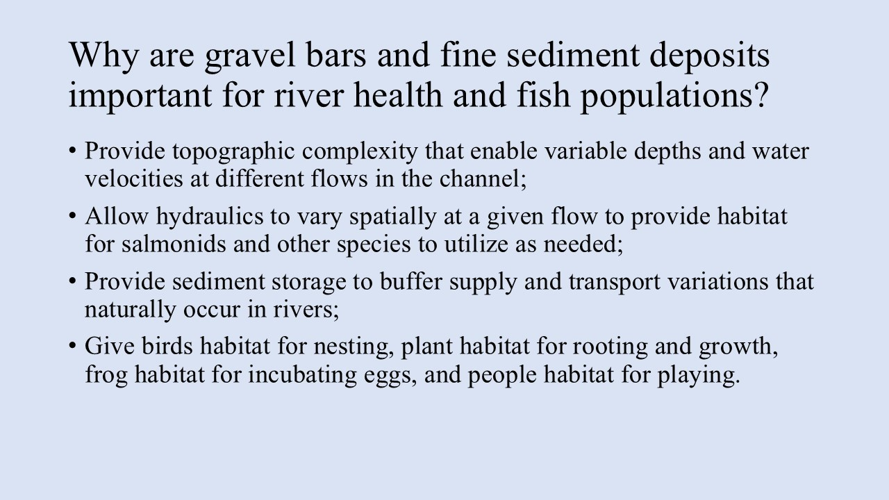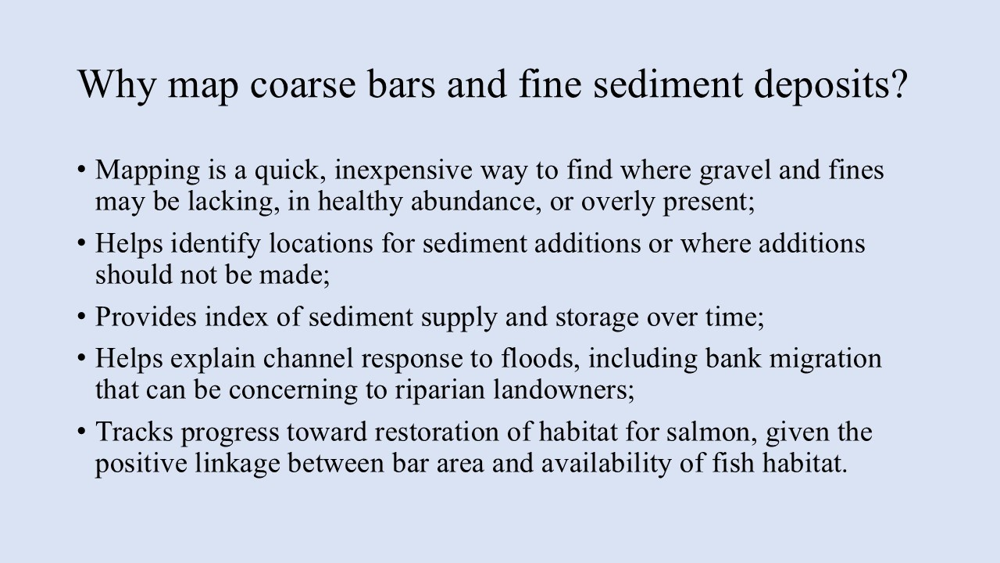
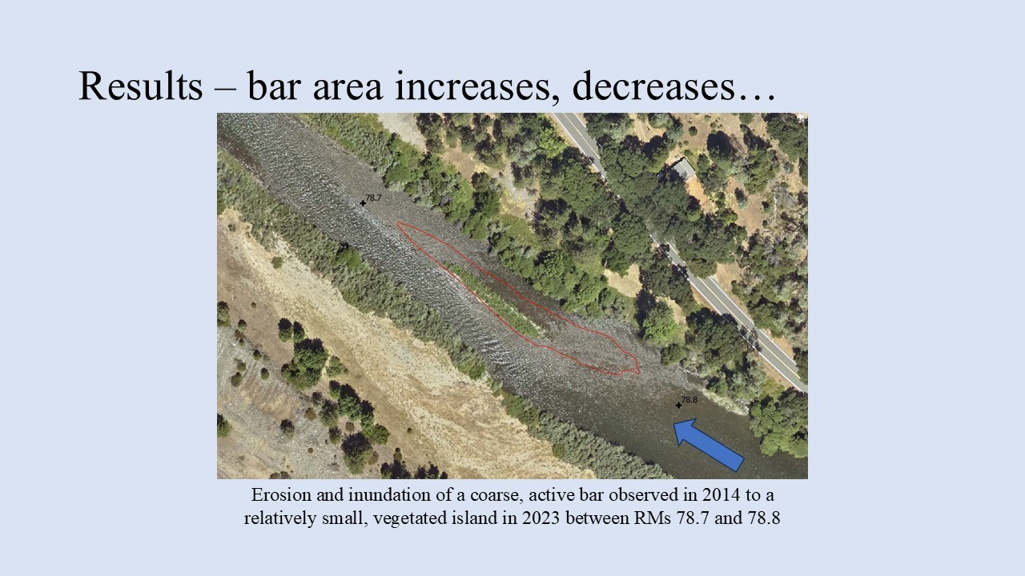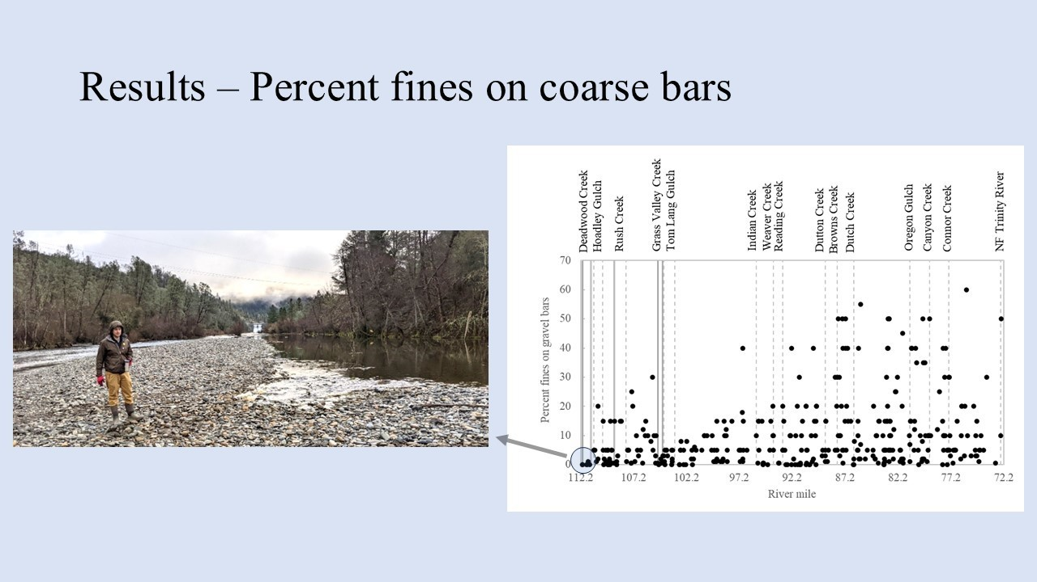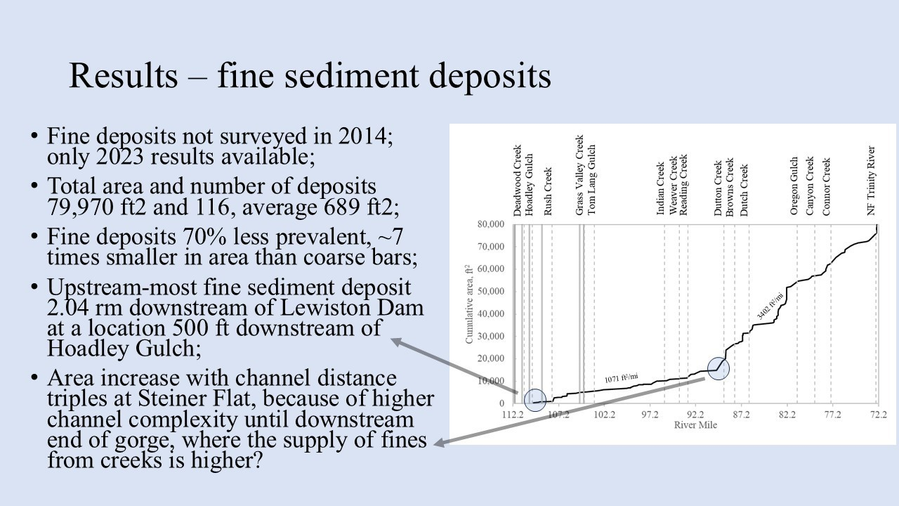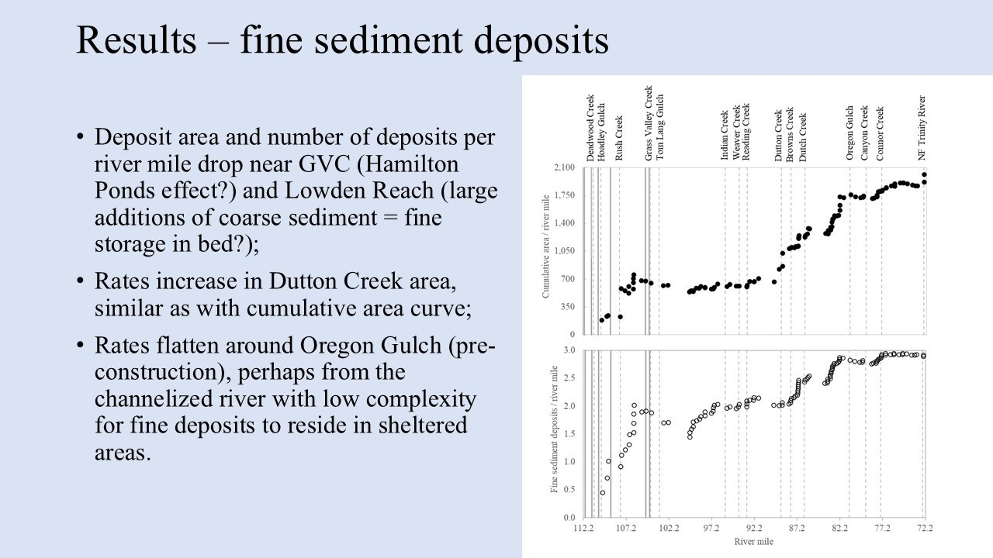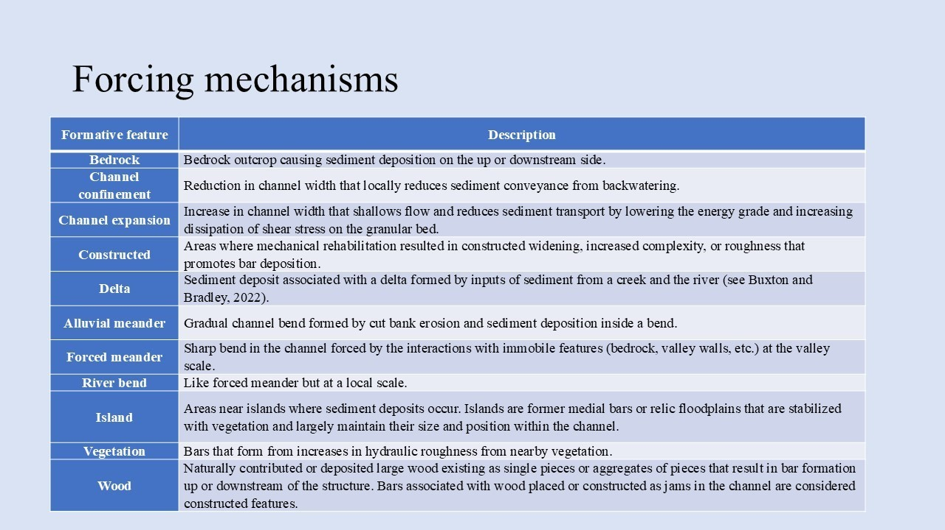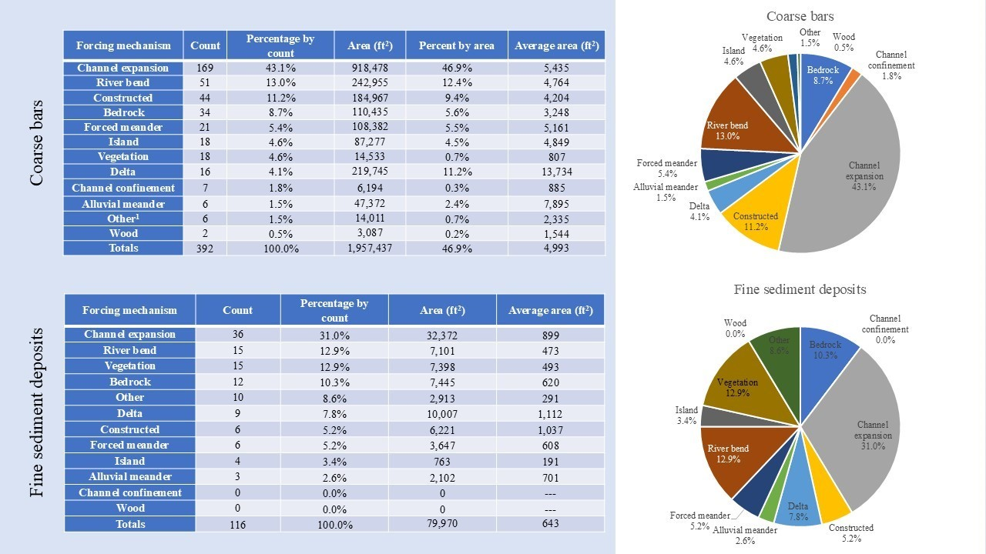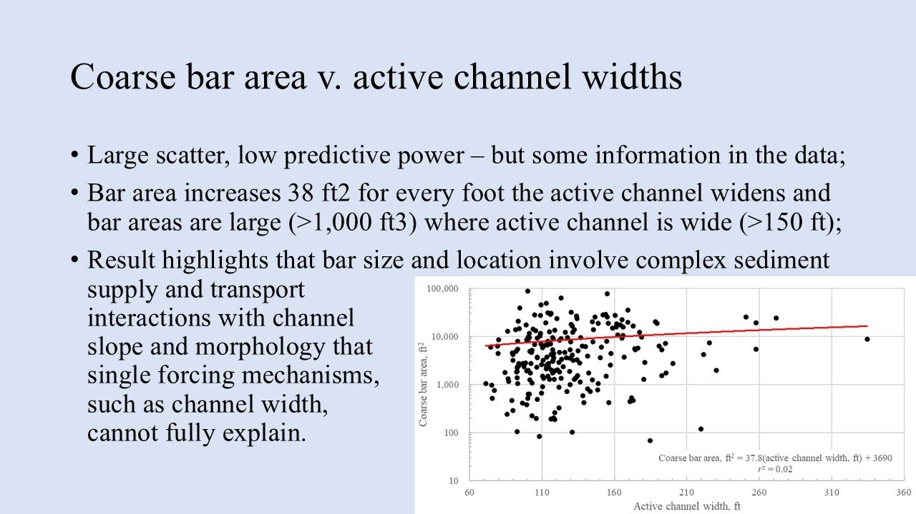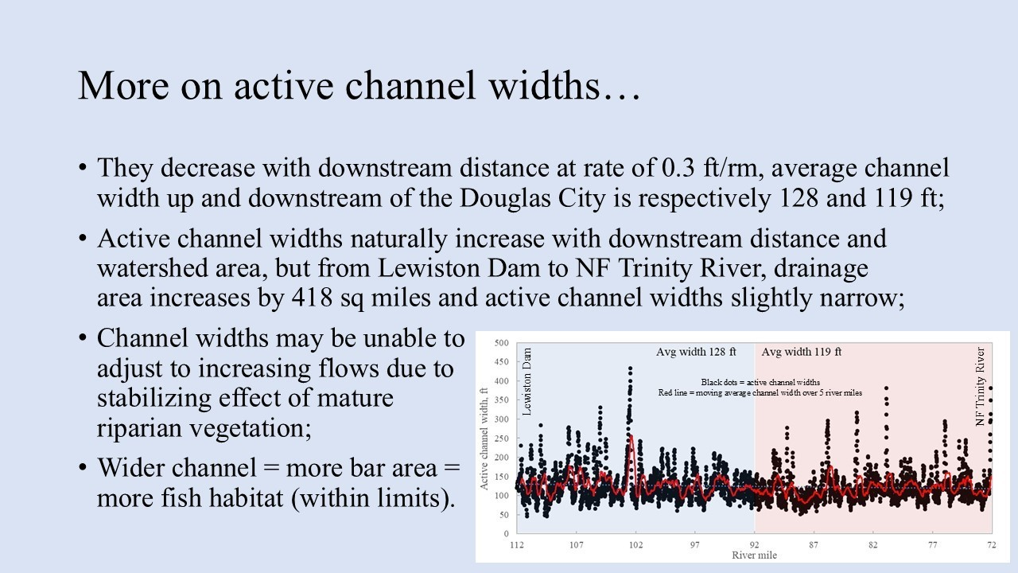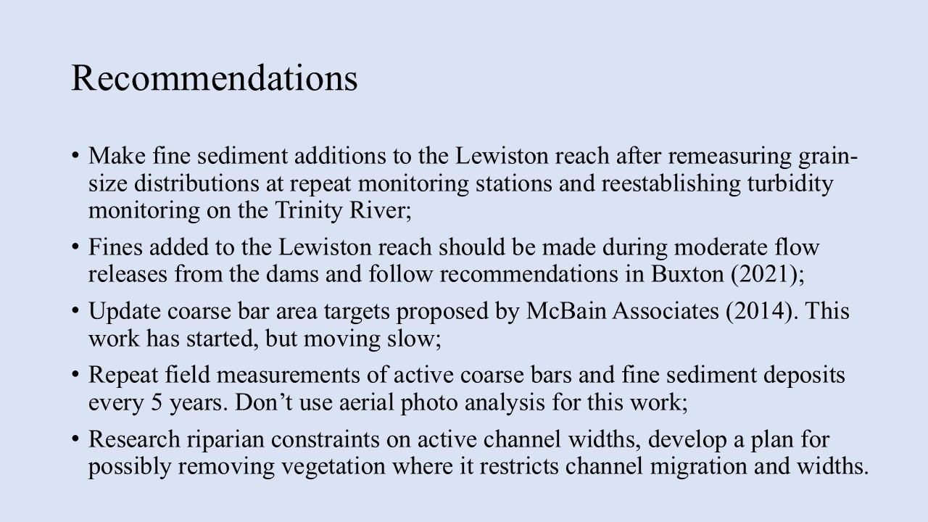

Public Comments
No questions for public.

Comments of TRRP Entities
TH: Is the Grass Valley lowest augmentation area?
TB: Lower ponds have not been dredged in years.
RO: How are estimates of fine sediments <2mm made?
TB: Ocular estimates. Calibrate your eye and measure. This is yard stick science not micrometer science.
MD: What about vegetation density allows for or prohibits active bar transport?
TB: Unknown. There have been some laboratory studies, but I am not aware of a summation. MD: I wonder if thinning on bars could allow for additional energy to move through.
JLee: Could data set be used to target augmentation reaches?
TB: A proxy could be older segments assumed to be functioning naturally or use unregulated stretches in the region to approximate reference stretches.
JLee: The financial resources spent for gravel processing might justify this type of research.

TB: A potential for project for sub workgroup to address.
BP: You showed some data and mentioned the lack of relationship with wood and characterized it as bad. Is that based on what you’ve seen or other systems that we’re not seeing here?
TB: I shouldn’t have been subjective. I am somewhat familiar with loggerheads of log jams and associated large bars in WA versus on the Trinity where we see wood inside the channel or stored on the floodplain. So, there is relatively little wood available to provide roughness for deposition.
Ken [last name unknown, did not sign in]: Currently reviewing long-term monitoring plan. Is there value in having this work repeated periodically? And tied to any other survey or mapping [bathymetry, facies]?
TB: Resurveying the Trinity River channel is expensive. Time stamping mapping would allow us to evaluate the dynamic equilibrium assumption.
Ken: What range of flows do these active bars predominantly occupy?
TB: I would guess, and don’t want to be quoted, that it goes up to less than 1200 cfs.
JLy: How many stations are needed for integrity monitoring?
TB: 3 would be nice.
MD: Is there a recommendation coming up from the physical workgroup for that?
EP: It is not being worked on at the workgroup level with the caveat that it is part of the monitoring review process. Active bars and turbidity are being looked at.
TB: Turbidity would go a long way to further refine a fishing day, not just for flow but to also include clarity.
JLy: Are there recommendations you would like TMC to consider now?
TB: TMC should keep them in mind but should vet them through workgroups or a more formal process than a single scientist.

TMC Discussion

Annual Work Cycle and Workgroup Planning 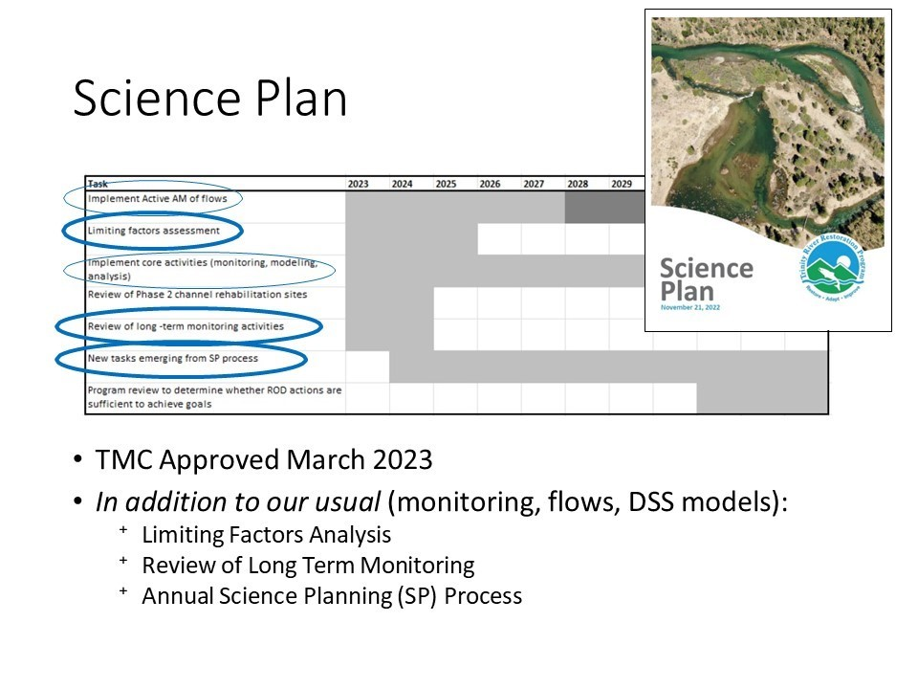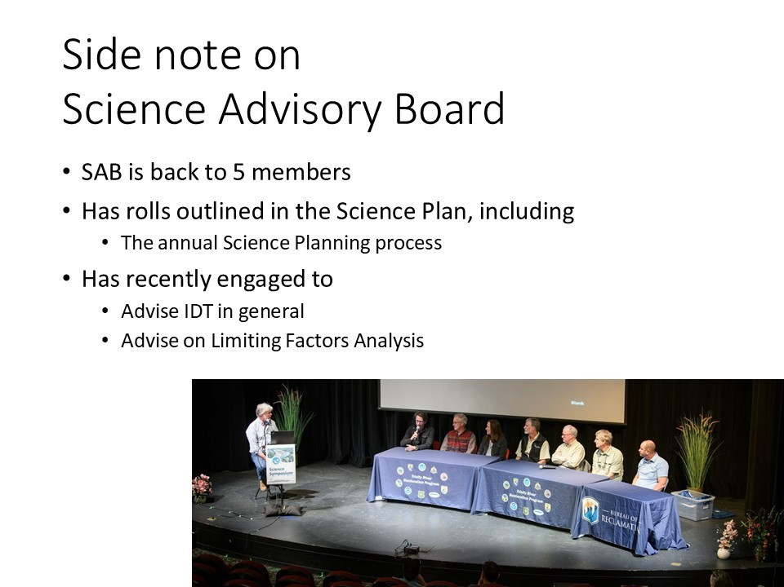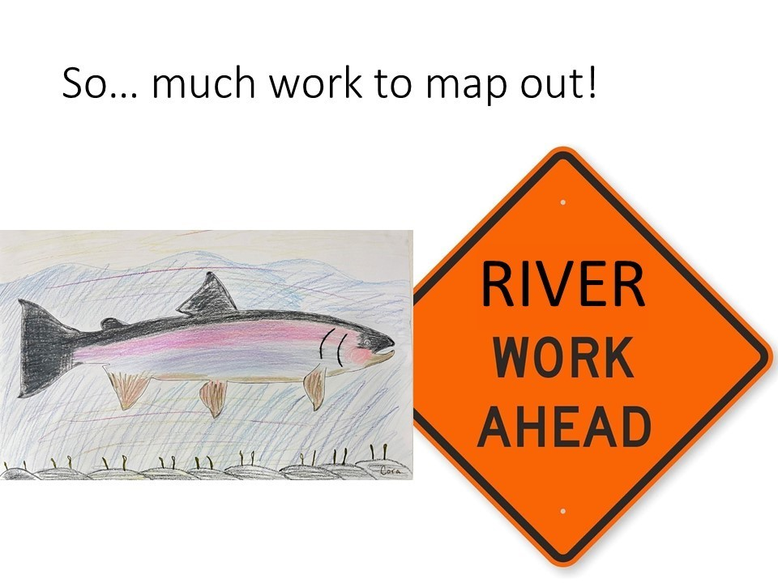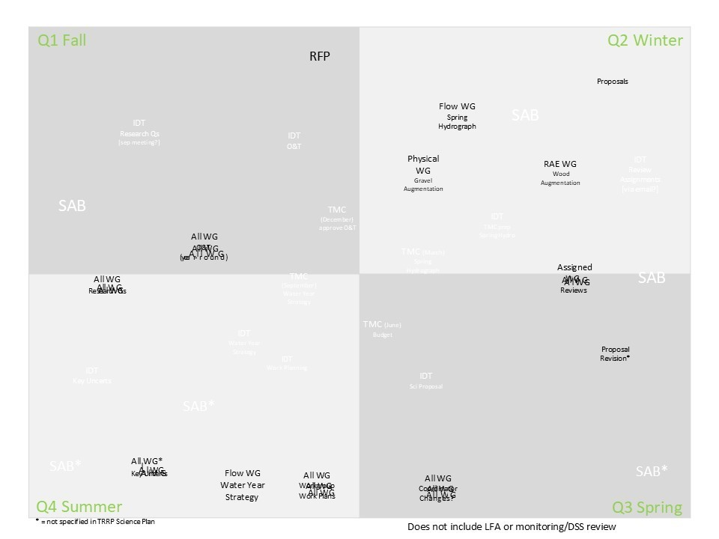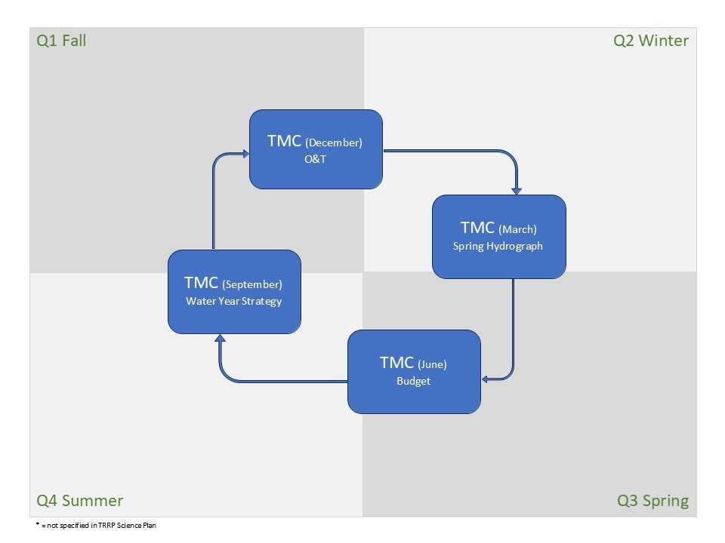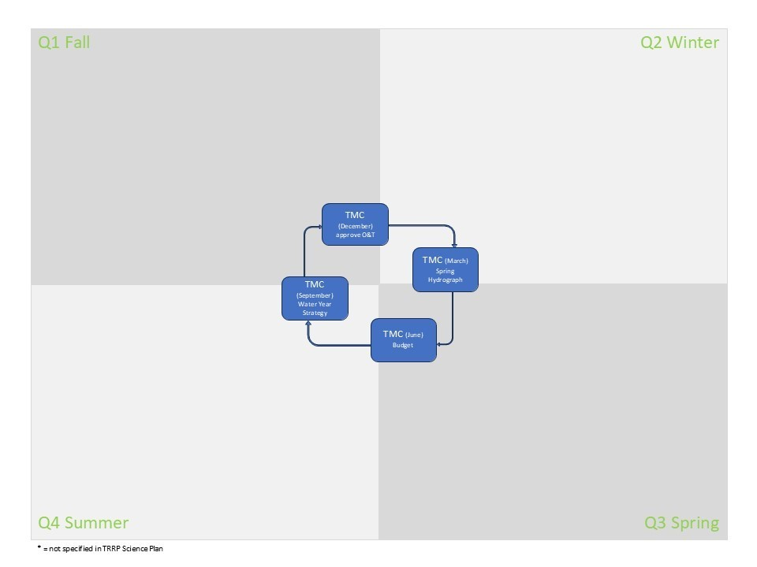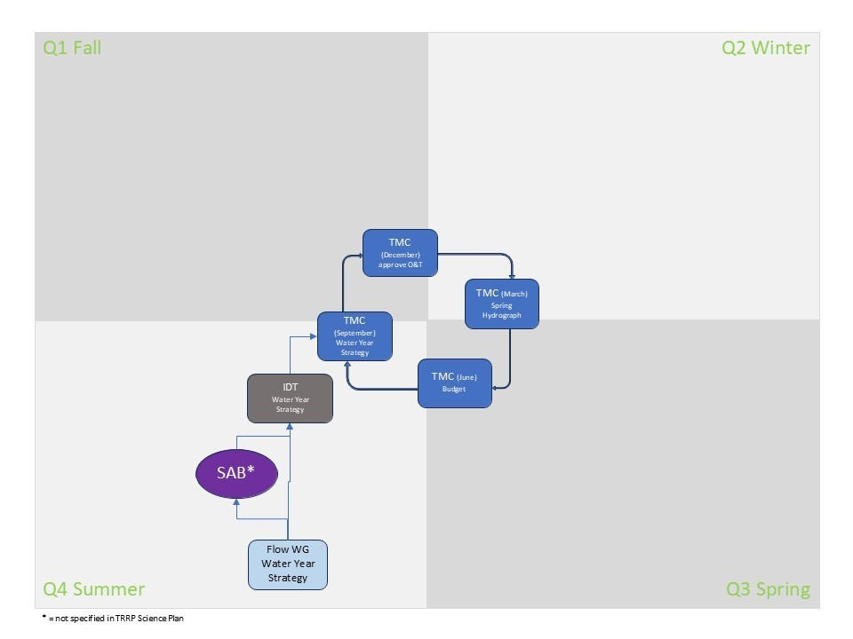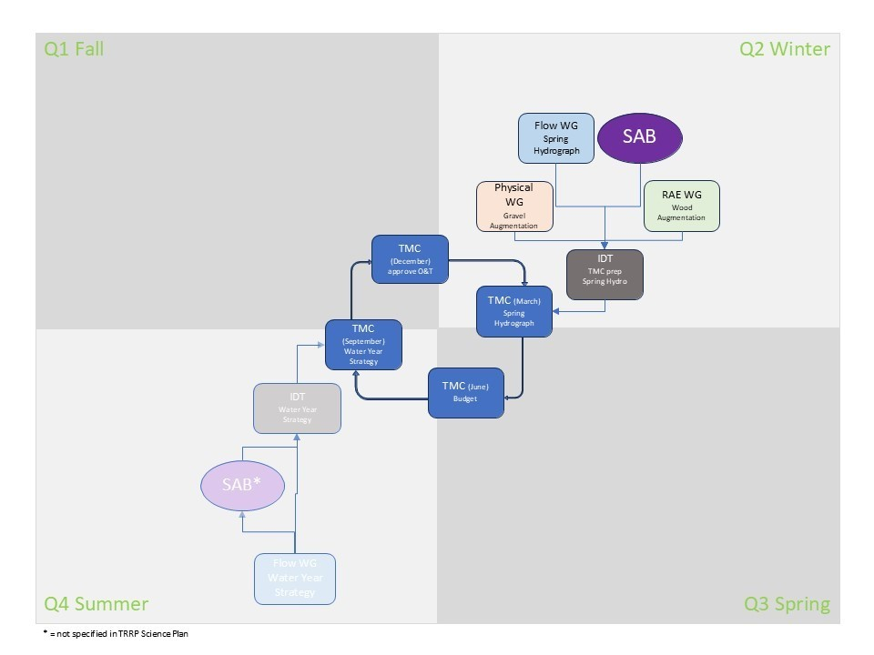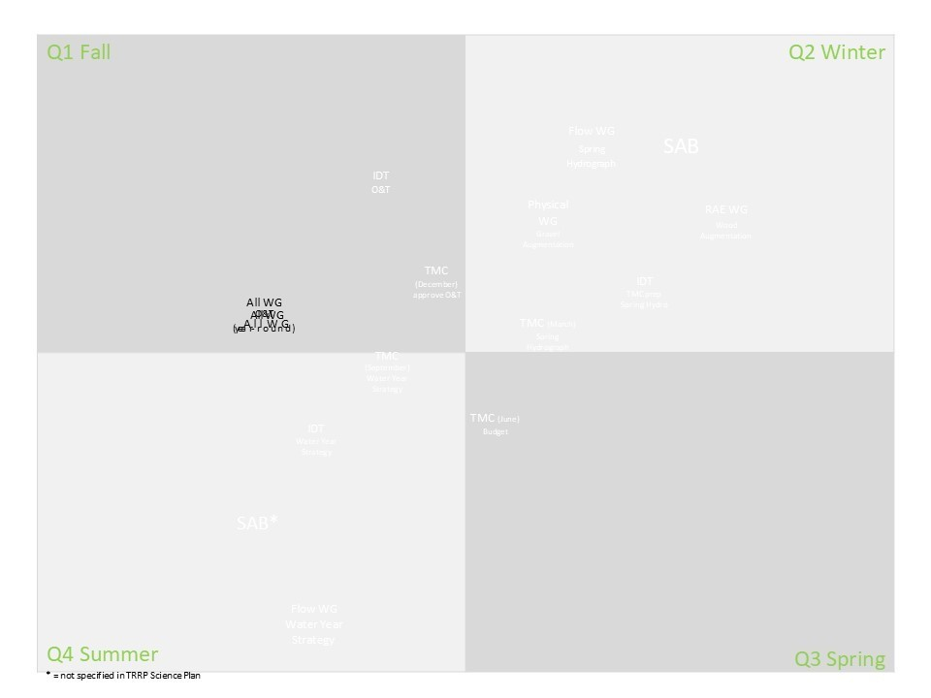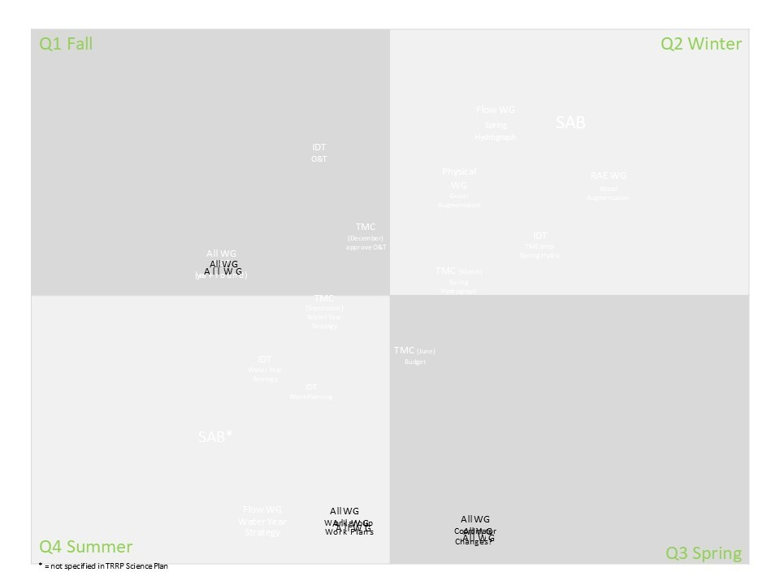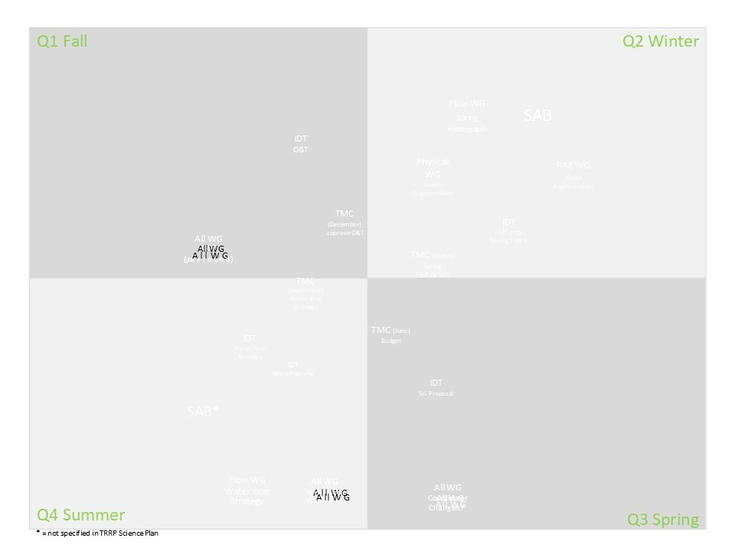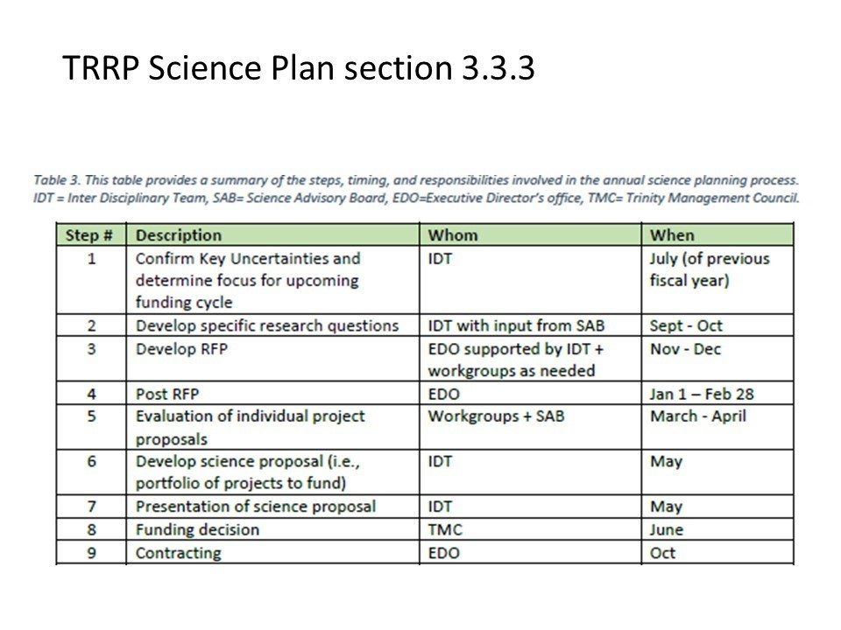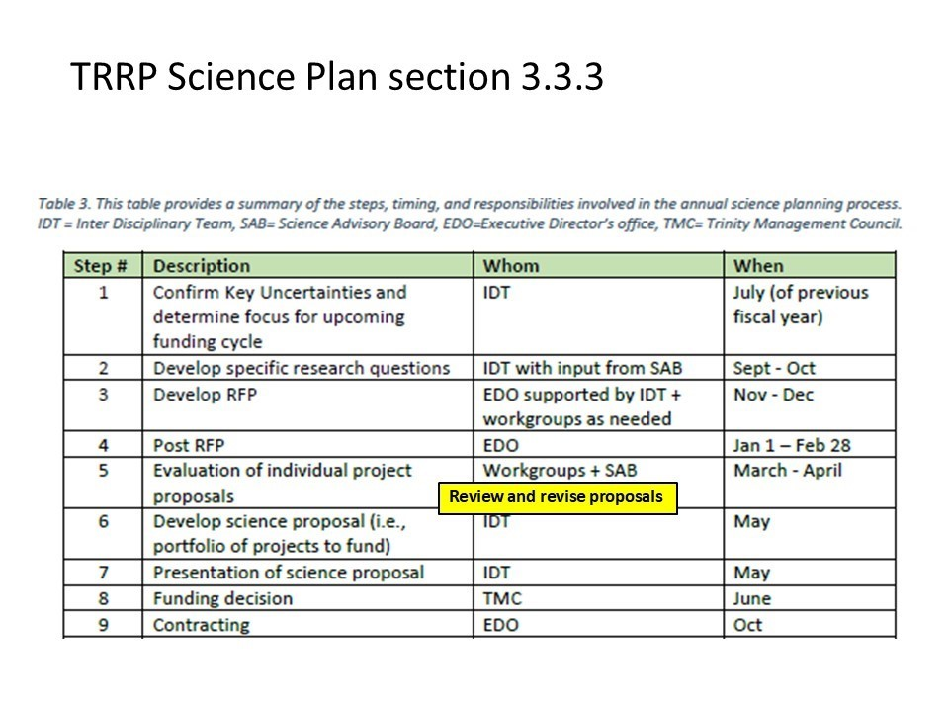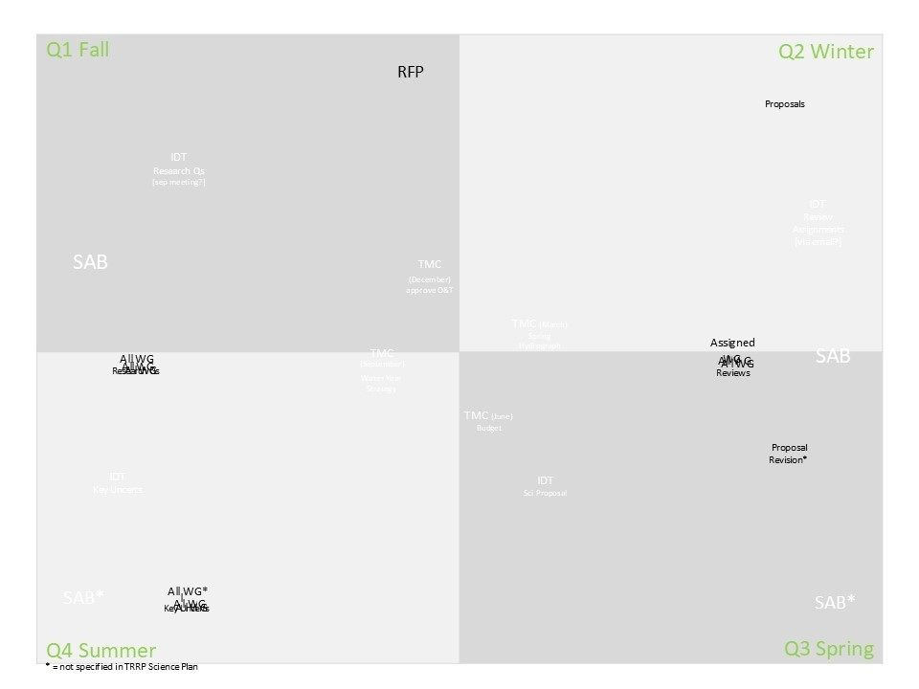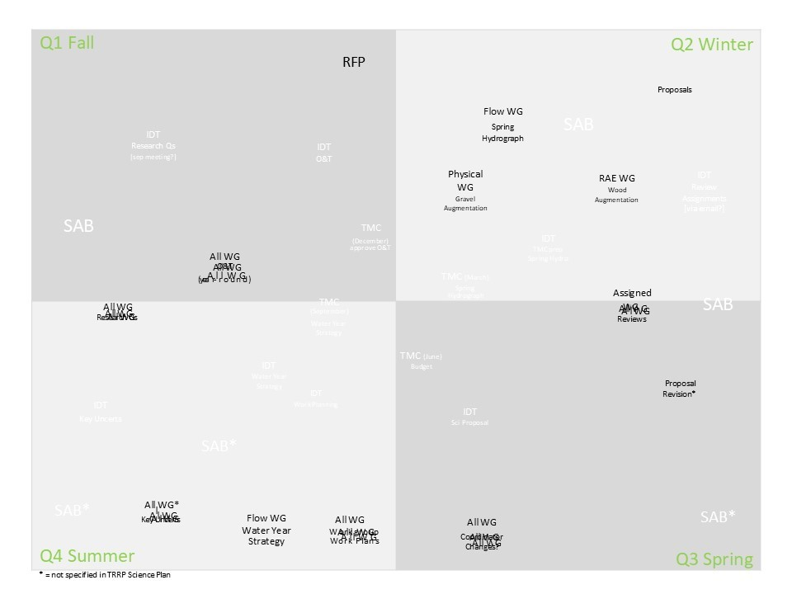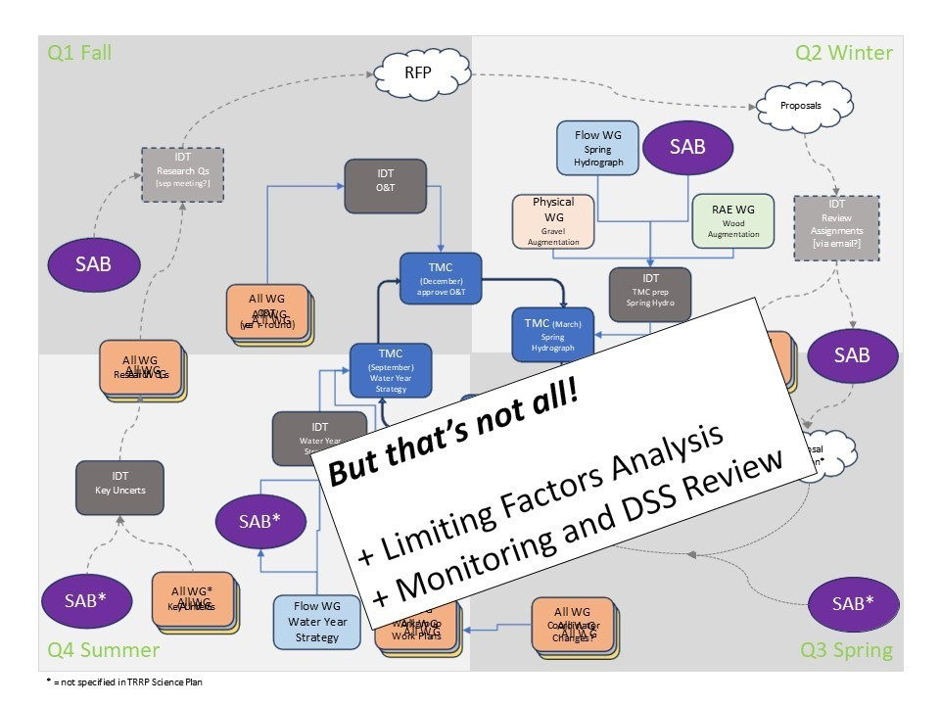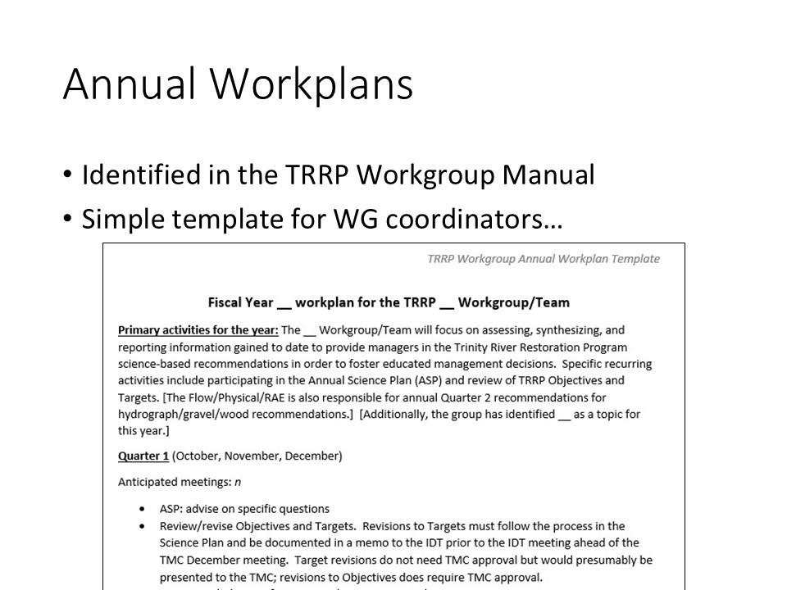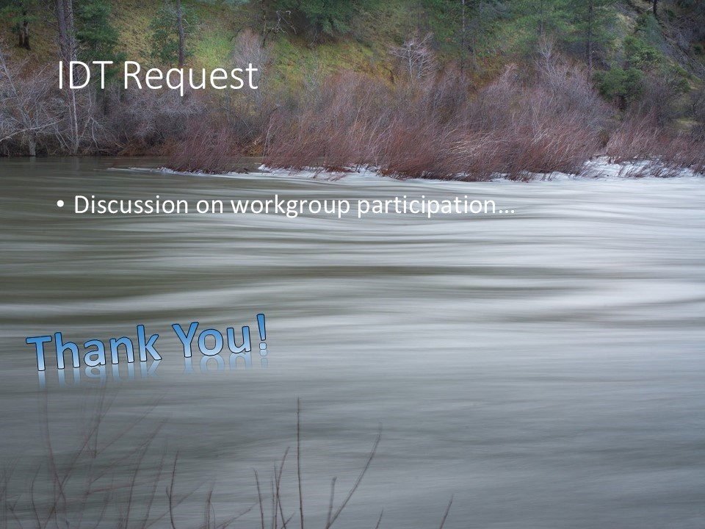

Public Comments

Comments of TRRP Entities
EP – Approximately 12 people who are champions for the program and getting work done. If you are involved in a workgroup, please ensure you are an active participant especially given the coming workload that the Science Plan puts on us. There is risk of burning out the core group and need a larger core group.
MD – Eric is diplomatically asking that if you have people assigned to work groups have them pick up some of the slack.
RO- Asks that needs be communicated so that he can communicate needs for more assistance to his agency. We can’t help if we don’t know there is a problem.
MO- Forgive me if it irritates people, but I want to revisit this PFMC thing. It bothers me, because the dam removal scenario and effects of it might be the management actions. But the

management actions directly affect the way fish are harvested or not in this room. Do you feel it’s necessary to elevate an acute situation where dams are going to be removed? Specific to the Trinity do you think it’s important? And then do you think there needs to be some direction given to you guys?
EP- I feel like we do need some awareness to stop being treated as the Trinity and Klamath combined. Harvest rates do have an impact on our returning adults. So, their decisions on harvest management do affect the objectives and targets in the Trinity River. There seems to be some role for coordination, but I’m not sure what that role is.
MO – Asks the chairman to keep to the earlier discussion in mind for future discussion.
EP- Earlier discussion was focused on reclamation. I think it’s more of a TRRP, broader than reclamation connection that would be relevant to harvest management.
MO – The Regional Director oversees the Klamath and this office which would be one way to cover both sides of the basin.
JLy – I think it is a question for the Reclamation Regional Director. If you want someone from reclamation to be on the PFMC group, or it is a public meeting to at least hop on the call and chime in...
MO – ...That doesn’t work for me, by the way...just say is it’s a major federal agency like USBR that has all these links. The technical stuff is right, but there’s going to be other things coming up like the monitoring plan. There is a monitoring plan on the Klamath I’m told now. Or I’ve seen it now. My frustration is that there is no other forum to bring it up at.
JLy: That request seems to be appropriate for the Reclamation Regional Director because he can decide which staff to be involved with the PFMC workgroups.
BK – The workgroup is working on a variety of different actions. There is new habitat created by removal of dams. The overall capacity of the system will change. The SMSY for conservation objective, spawn escapement objective will change. The WG is creating an interim process over the next 15 years until a long-term management can be created. So, in some ways we are not looking at the Trinity River at all. We are looking at habitat-based models that could tell us what the capacity of the habitat might be. The HVT has proposed separating Trinity and Klamath into distinct management areas with their own specific objectives. This restoration program [TRRP], given its work on limiting factors, cohort reconstruction, etc. might have a role in assisting if and when then management strategy becomes ripe. To be very, very clear the work group won’t be doing that work. We won’t be doing a cohort reconstruction for Trinity Stocks specifically. We won’t be creating a new ocean harvest model for a Trinity-specific management regime. That’s all stuff the council would need to direct a new work group to do. Ultimately agencies or tribes could move those components forward unilaterally and bring them through methodology review

through the Pacific Fishery Management Council. There’s a whole process associated with new methodologies and approving them for use in management as well. That’s where I see there being a role for the restoration program and staff in assisting with that eventuality if and when we get there. Right now the work group is really just aiming their efforts at the interim period for the new habitat itself. And for policy reasons and for others I see why folks would want to hold the Trinity River harmless in any stock complex action that ultimately limits harvest on the Trinity. Staff will be needed at the time these are evaluated but may not be needed while the stock is being managed as a complex. I hope that was helpful. I saw an open-ended question about how can we [TRRP] plug into that process. I think you need to maintain awareness and participate in the meetings to ask questions, make comments, etc.
MO – The management action implicates Trinity River for the last 2 years. Allowable harvest was reduced significantly and effectively closed the Klamath and Trinity recreational fisheries. It is the opportune time to engage on the Trinity so that we are properly accounted for and has its own statutory laws and requirements to restore the pre-dam levels. It [fishery restrictions] could quite possibly go lower, so why wouldn’t we have a separate process for the Trinity?
BK – To be clear with everyone fisheries were not closed because of dam removal or the work of the workgroup. Mike is right that there was an additional buffer added to the conservation harvest control rule or maximum allowable exploitation rate as a response to dam removal. But the fishery in the Trinity would have been closed anyway. It was closed when the dams weren’t even out. It’s all about stock status and abundance and the things that govern fishery management year in and year out. Dam removal has introduced a new wrinkle but was not the driver of the closure.
MO- Actually the emergency rules they recommended reduced the harvest.
BK- There is a big difference between closure and reducing allowable harvest to some lesser number.
MO- It's zero retention of Chinook in the Klamath and Trinity Basin. There’s no adult Chinook taken by non-tribal recreational fisherman.
JLy – That's because of the escapement numbers not because...
MO - There’s no target for no escapement. The control rule was 25%. It would have been 8,000 harvested. That was an action taken by the recommendations of the state.
JLy – Thanks Eric and asks him to communicate needs.
TH – I wanted to let everyone know that Shane Quinn will be assuming the role as our alternate here on the team and is the heir apparent here as our new senior biologist for our Trinity River program. So welcome Shane. I also want to thank Kyle and recognize everything he has done for the program over the years.

Several members applaud and verbally thank Kyle.
TH: I will not be attending tomorrow so that I can work on a historic conveyance of the Blue Creek acquisition to the Tribe.
Informal discussion proposed based on the benefit it provided 6 months ago.

TMC Discussion

Adjourn 4:49

Thursday, September 19th, 2024
(Scheduled from 9:00 a.m. – 2:00 p.m. PST)

Welcome, Comments on Non-Agenda Items (JLy)
JLy opens the meeting by inviting introductions from TMC and anyone who may have joined in-person or online that was not present yesterday. He then asks for announcements or comments on non-agenda items from virtual and in-person participants.
Public Comments
None given
Reports and Comments of TRRP Entities
The following text was shared on screen for TMC discussion:
[text from motion]
The TMC retains unilateral authority to set the agenda for all quarterly meetings and maintains the authority to vote on any decision items set forth in said agenda. Members of the TMC will attempt to resolve matters of dispute during TMC proceedings with the understanding that any recommendations made to DOI as a result of a TMC vote can be disputed by individual TMC members with DOI outside of the TMC process. The TMC is an advisory body and as such does not hold the authority to implement certain decisions where the authority lies with DOI.
[Program Document section II.4]
As directed in the ROD, the TMC guides overall implementation of the management actions of the TRRP, while the Secretary of the Interior retains ultimate authority over the TRRP. The TMC provides guidance and recommendations to DOI regarding the establishment and implementation of adaptive management; physical and biological monitoring results from TRRP implementation; the refinement of the annual flow schedule; and other activities described in the ROD, Implementation Plan, and Science Plan (as adopted in March 2023) until restoration of the Trinity River anadromous fishery is achieved. Members of the TMC will attempt to resolve matters of dispute during TMC meetings with the understanding that any recommendations made to DOI as a result of a TMC vote can be disputed with DOI outside of the TMC process. The TMC is an advisory board and as such does not hold the authority to implement certain decisions where the authority lies with DOI.

TMC Discussion
Bylaws are discussed as a topic for the December meeting.
JLy: In the June 2023 quarterly meeting, there was a motion to enable or change the rules around the executive session. There was anticipation for a motion [in the current meeting] to insert text into bylaws regarding TMC authority, the authority to set agendas.
MD: The motion was to put it in the bylaws but did not specify where. A key sentence about authority to set agendas was pending the approval of the program document through Department of Interior. It said that TMC has unilateral authority setting its agenda. Agenda setting was omitted from the final version of the document. I’m wondering how approval of the program document is relevant to that text and unsure how to insert the phrase into the bylaws. In discussion with JLy, we thought it best to bring that back to TMC for discussion. The topic came up recently, and we didn’t want to have it as a surprise on the agenda.
JLy: Bylaws will be covered in December. I would ask that everyone take a look at the bylaws and make any suggestions for improvements while we are cracking it open again. I'm hoping that we can sign on the second day [of the next quarterly meeting] after we all come to agreement.
RO: Request made to look at bylaws and suggest improvements in the monthly meeting in November, so there is time to process before December.
BK: Requests clarification of omission.
EP: Clarifies that the TMC authority statement was included in the draft for legal reviews, but the final version received did not include that statement.
BK: Asks if someone in the Bureau removed the statement.
MD: Clarifies that he believes someone in the office of the solicitor struck the statement from the final document.
JLy: Was it actually in the draft program document that was sent up?
MD: Clarifies that the version that was sent up had it included.
MO: Arrived late to the meeting and missed the discussion of what was omitted. Spoke to clarify that the TMC attempted to go through great lengths to amend the bylaws and the solicitor’s input throughout the refinement process was not given to the council for further consideration.
JLy: Discusses that what he missed was a discussion of the bylaws and they will be placed on the agenda for the next quarterly meeting.
MO: Clarifies that bylaws will be reviewed at the next quarterly meeting
JLy: Affirms question and asks the group to share proposed text for the bylaws.

MO: Questions if the TMC took action on, voted on, and incorporated the amendments.
JLy: Clarifies that the amendment was never signed
MO: Restates previous question that the TMC made a motion to approve the amended language, but has not taken the next steps towards approval.
MD: Clarifies that amendment was approved, but the formality of signing it in was not completed
MO: Questions if an executive session can be held and states the motion stands as the law of the body. Procedures need to be taken to incorporate the motioned amendment.
JLy: Clarifies that the amendment is incorporated, but not signed.
EH: Kristi Hiatt has joined the meeting

TRD Reconsultation Update (Kristin Hiatt, NR Specialist)
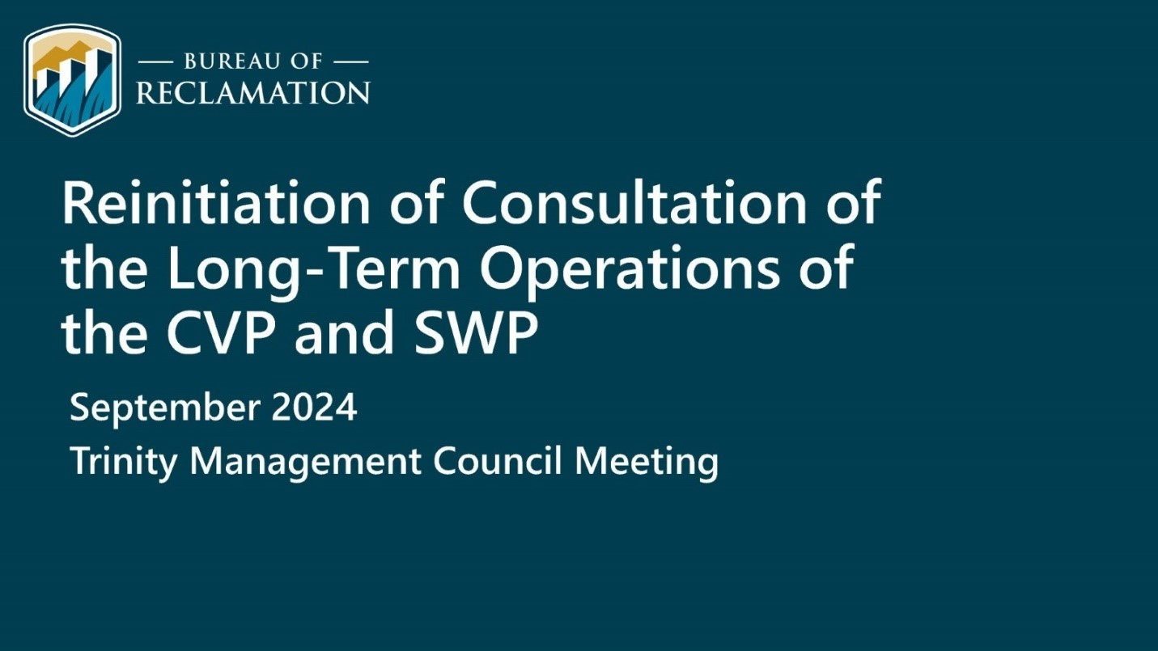
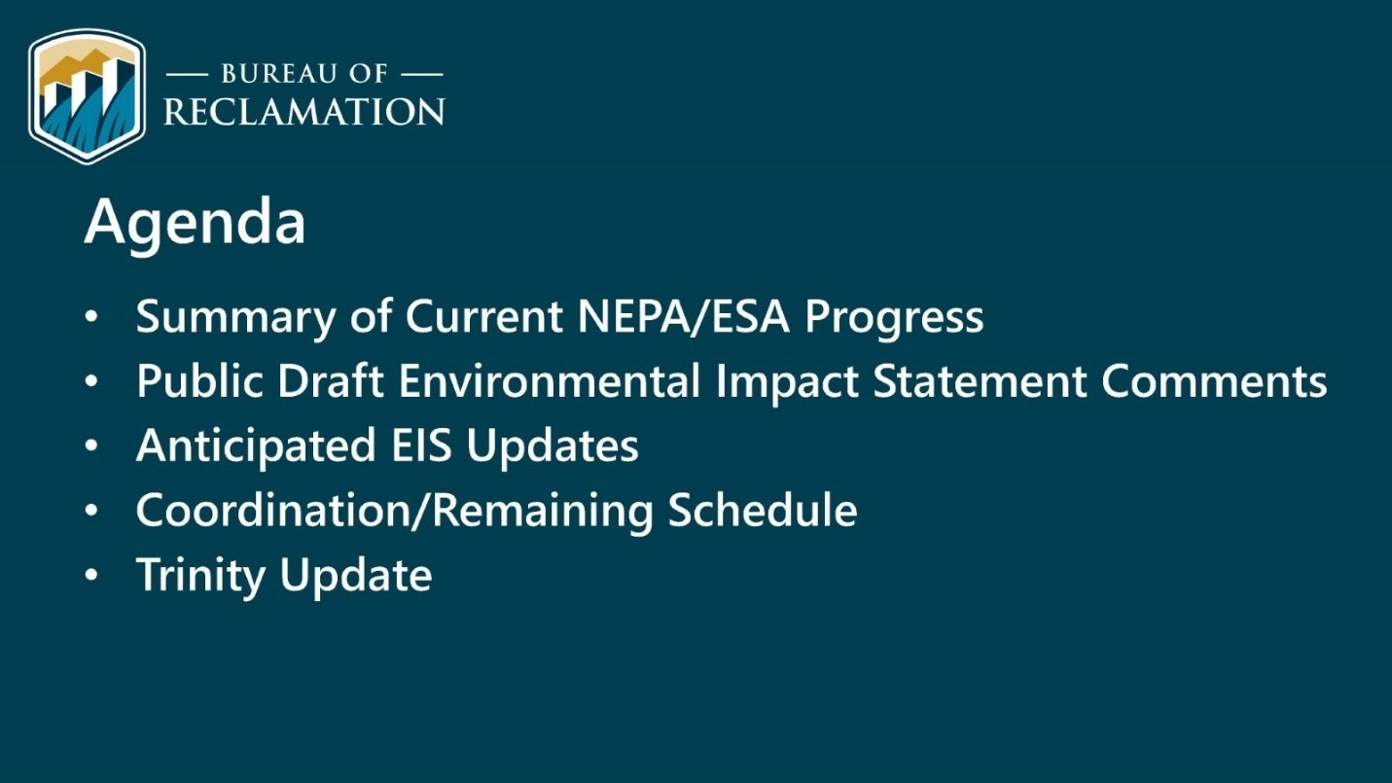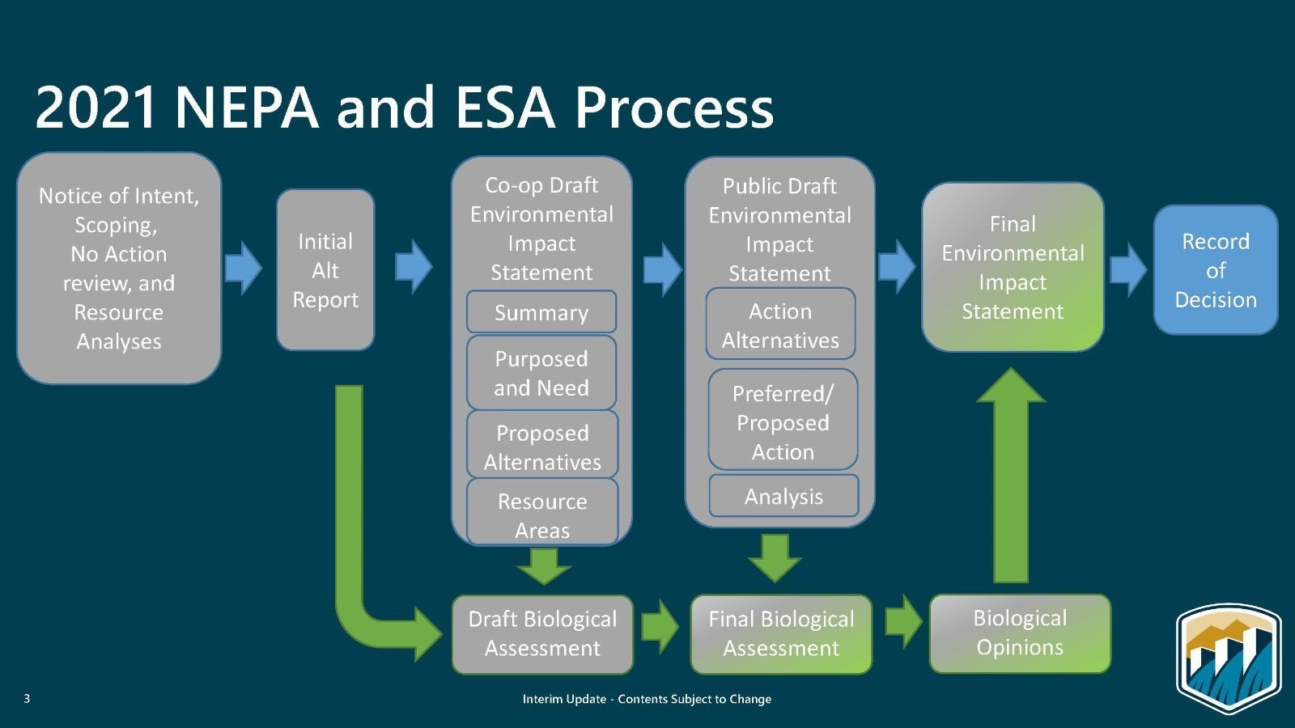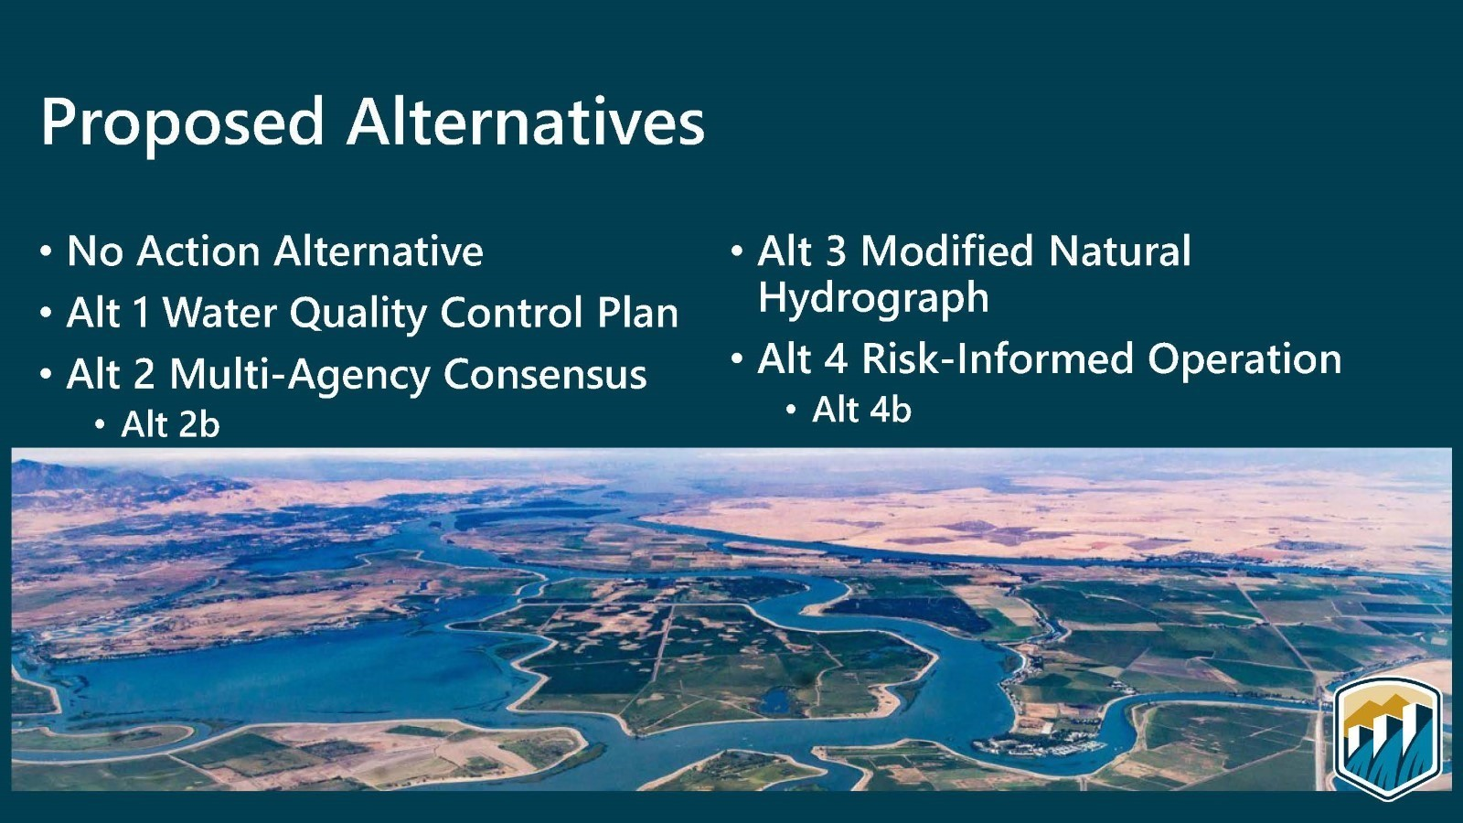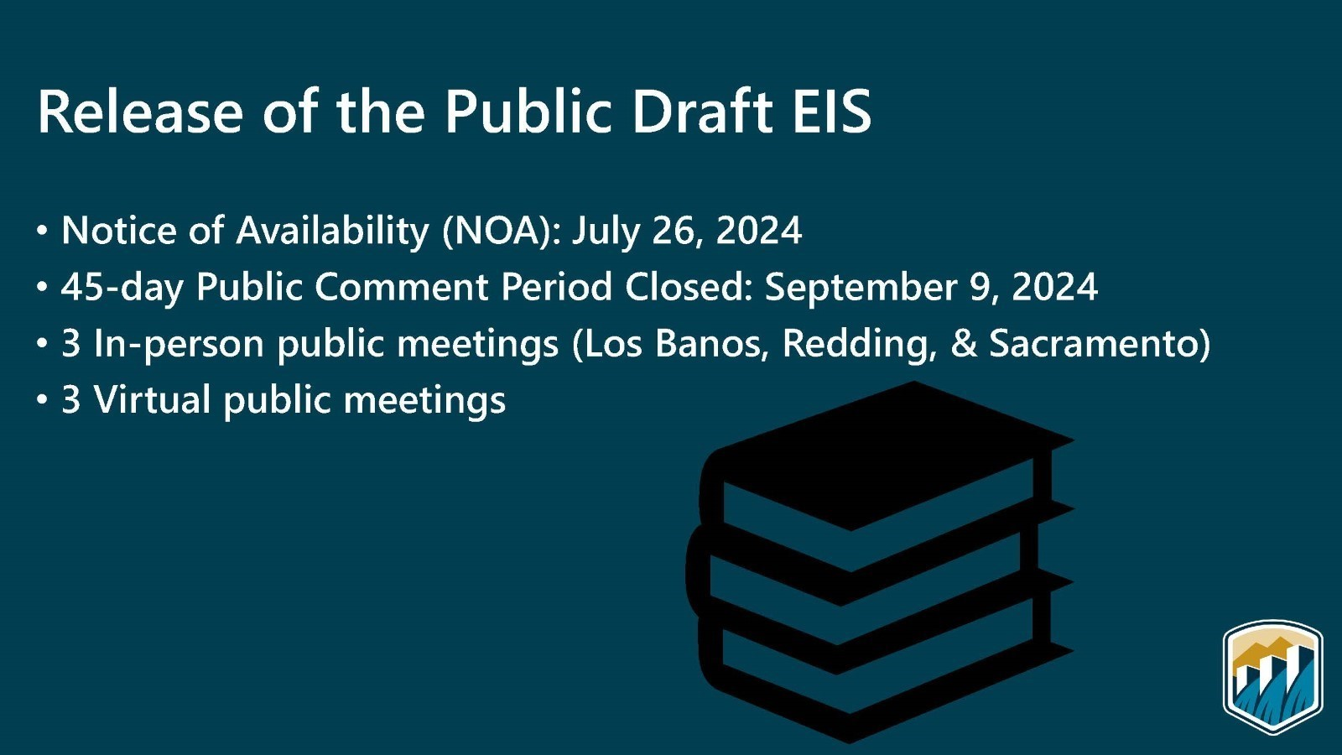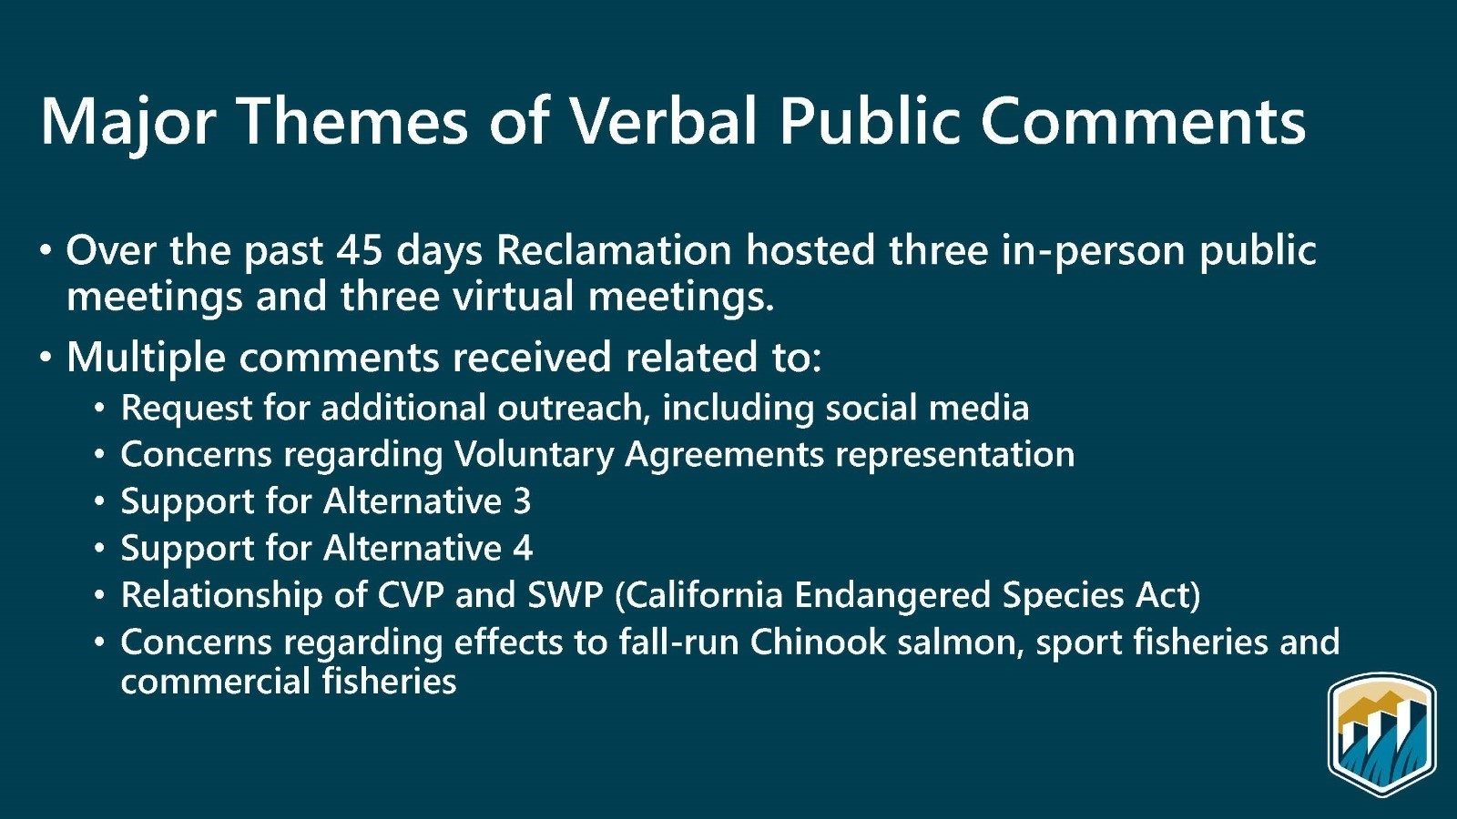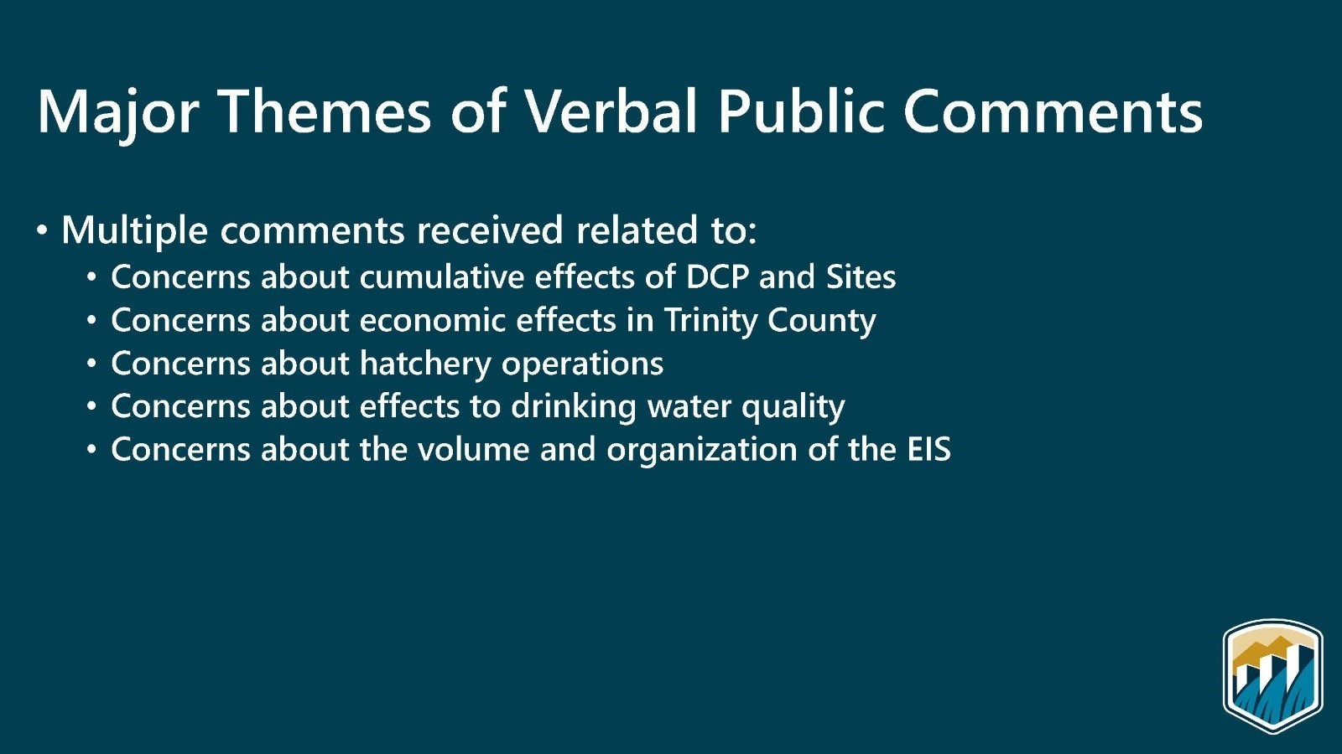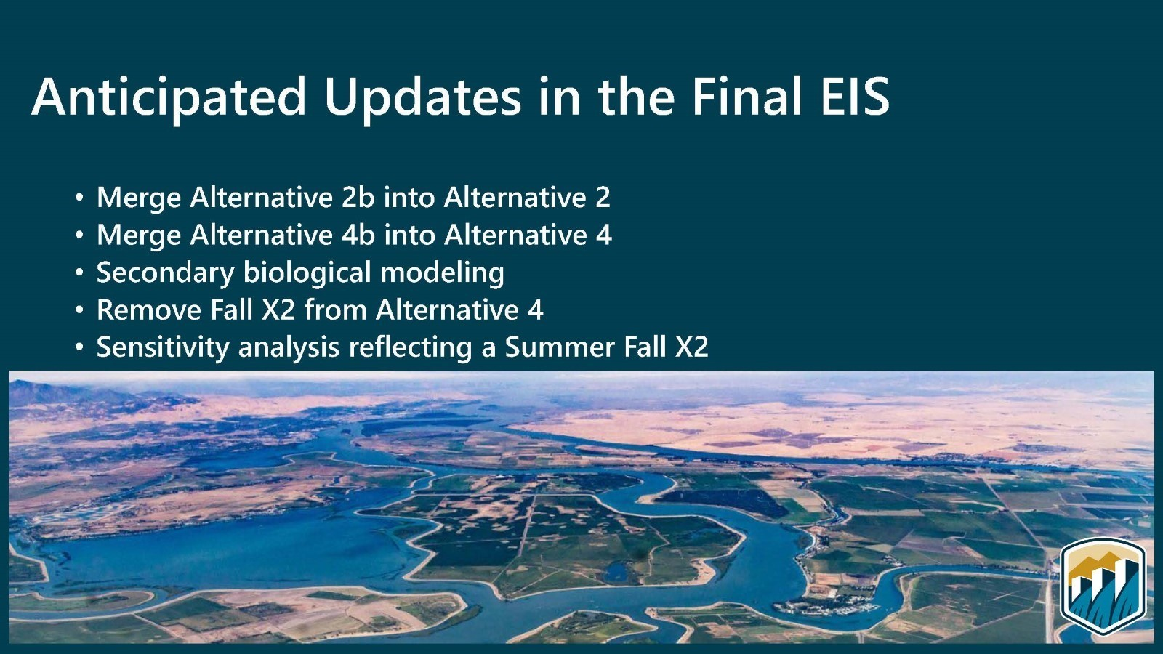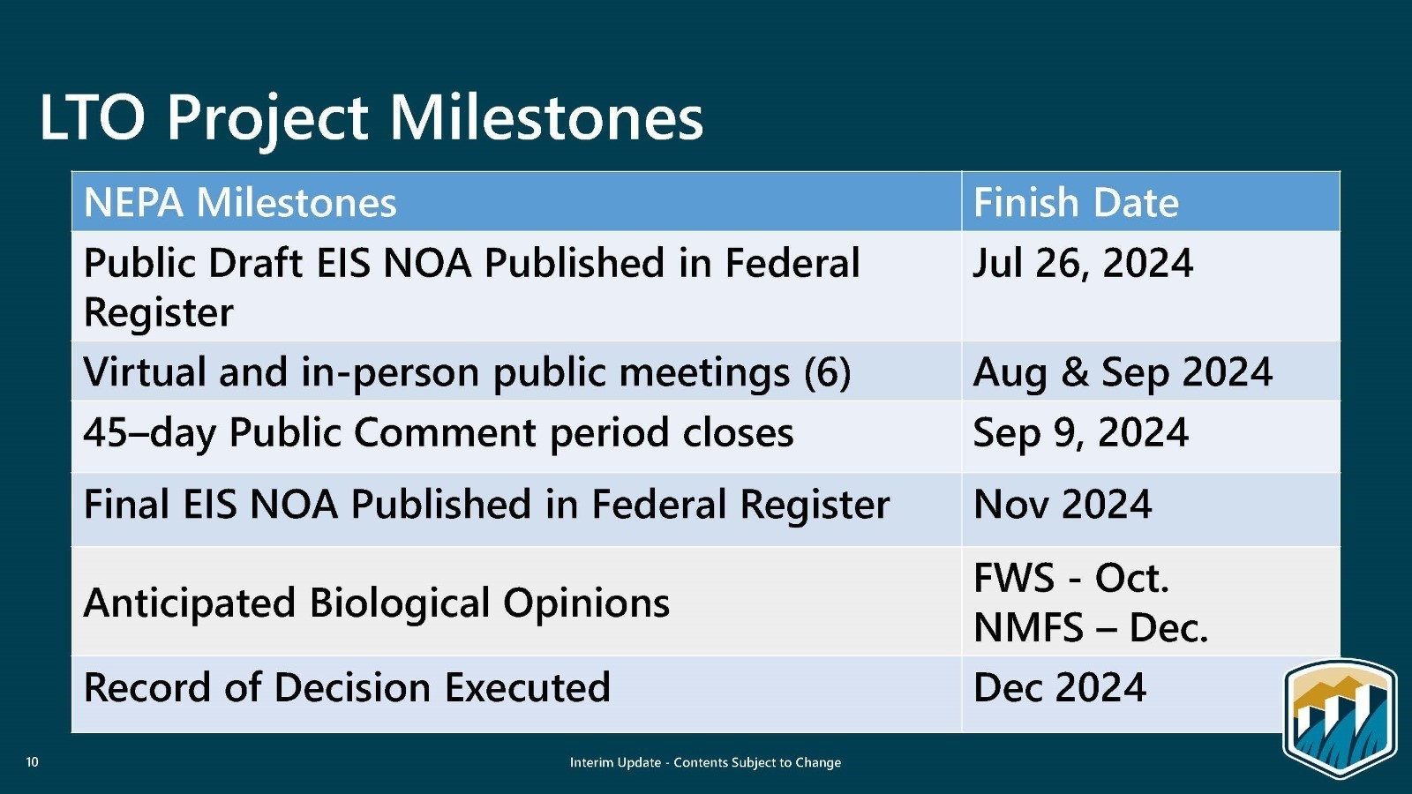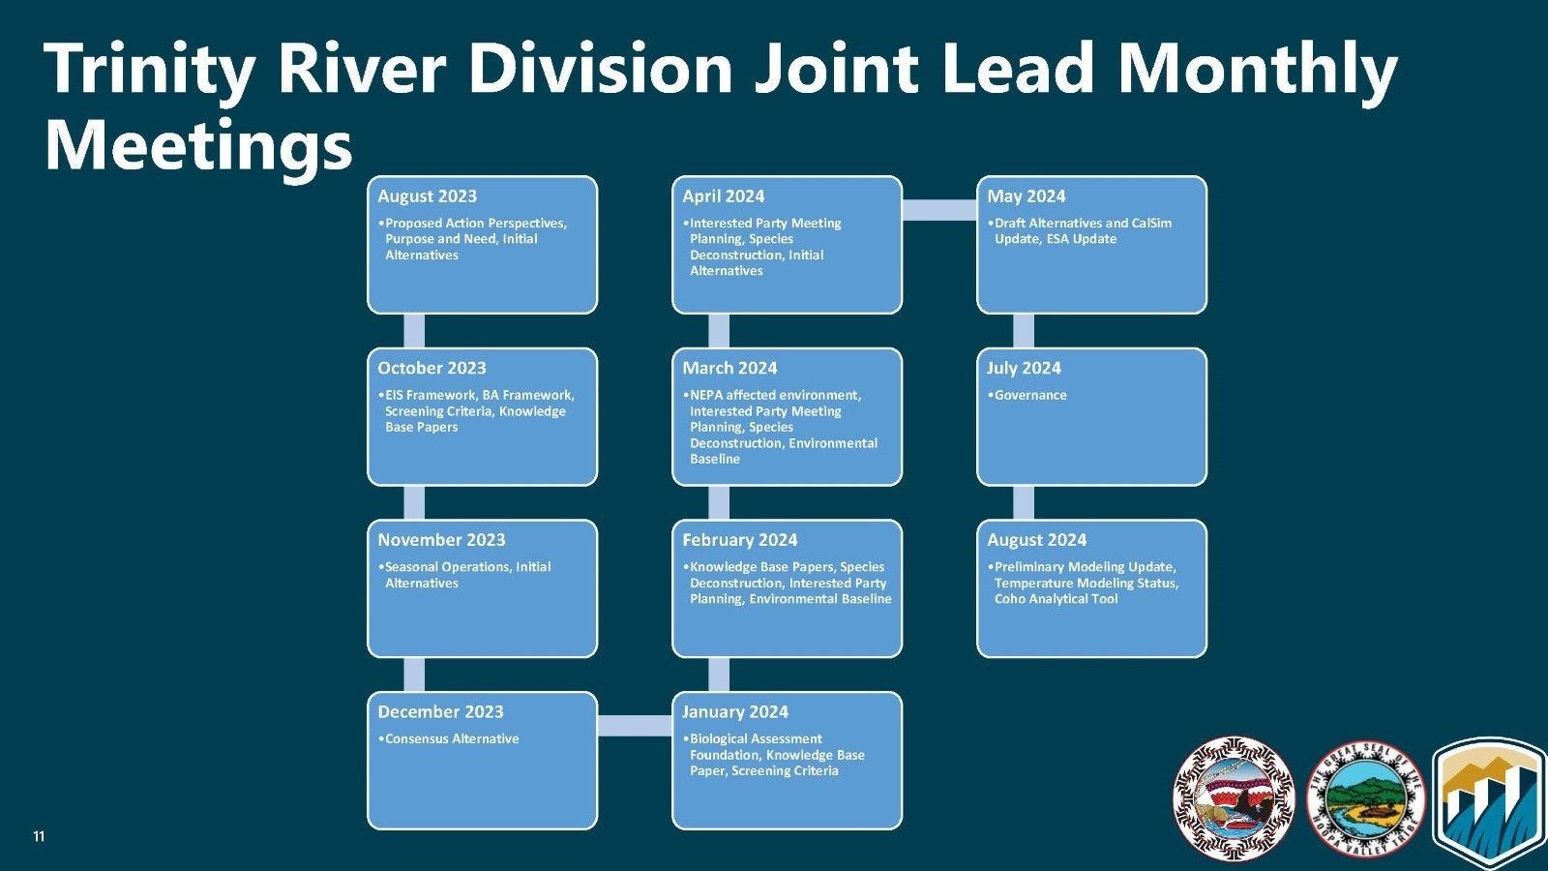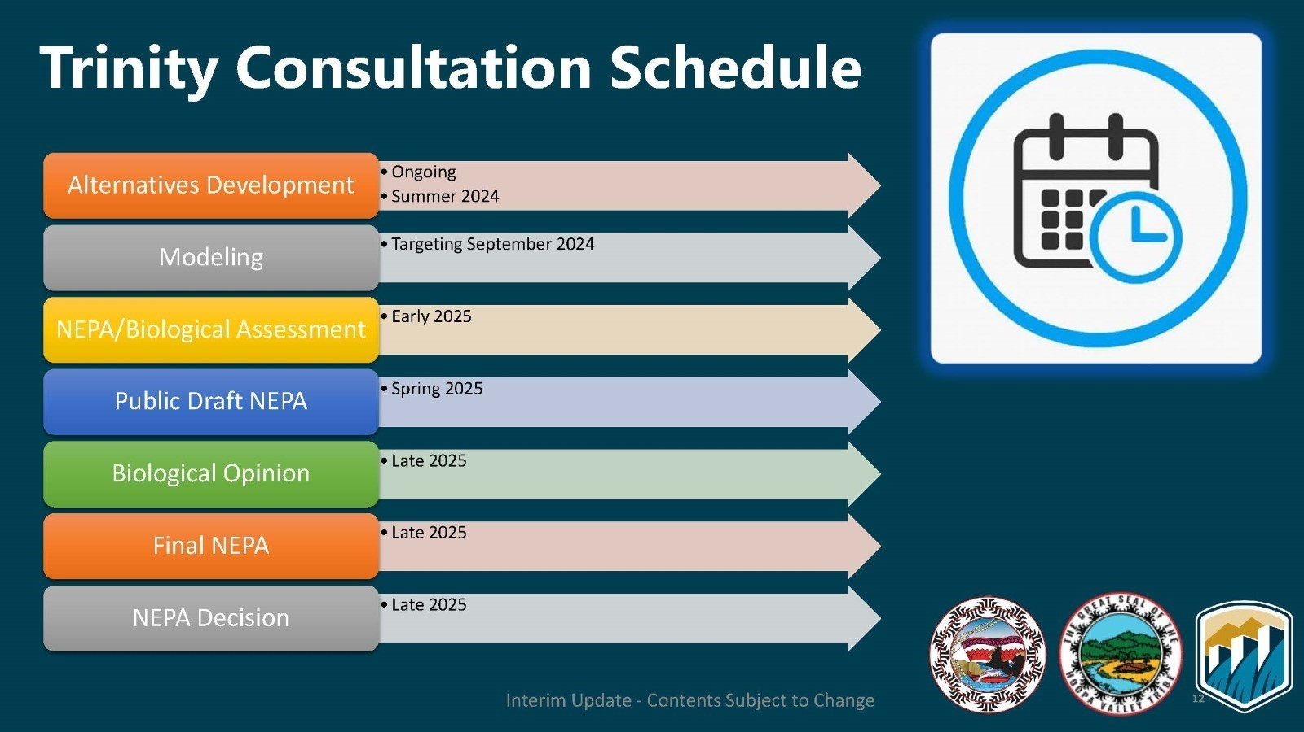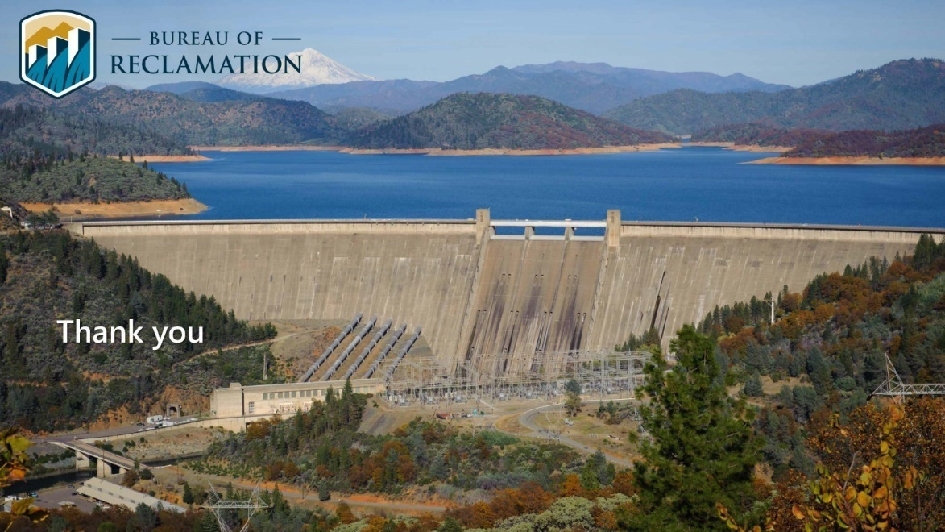
Public Comments
None given.

Reports and Comments of TRRP Entities
MO: For a year and a half we have been the co-lead on the Trinity River Division ROC reinitiation consultation. Long-term operations plan will not be completed until 2025. HVT and Yurok have requested in a letter to be co-leads and that the Trinity River be completed in advance of the CVP long-term operations plan. For a variety of reasons, that has not occurred. It remains a major concern and has been elevated to all levels of the federal government. Time frame and leaving behind Trinity River Basin is the big concern.
KH: Current structure is that 2000 ROD requirements for flows are incorporated into the EIS. Completion of process prior to Trinity does not preclude CVP and SWP. Trinity is part of the CVP and we will continue to work with HVT through the process. Your comments and concerns have been noted.
JLy: It would be helpful to know if important measures, such as minimum reservoir storage, proposed action alternatives presented to the Trinity River Division were acknowledged in the CVP to avoid redoing the NEPA. The Trinity should be ahead or concurrent.
KH: Acknowledged statement. It is not known what the requirements will be. Waiting for Trinity evaluation outcomes to see what the impacts are to determine the extent of necessary amendments. It is a step-wise process and may not be best for LTO process, but it is not possible to do the work in advance. There is not a fully agreed upon approach in Trinity which is

requiring the need to continue compliance in a non-optimal way. Justin’s comments will be carried back.
JLy: Regarding the NEPA for the Trinity reinitiation, is reclamation factoring in the Humboldt County 50,000 acre feet?
KH: Confirms that it is stored in the Trinity Reservoir and has been taken into account.
TMC Discussion

Limiting Factors Analysis Update (Eric Peterson)
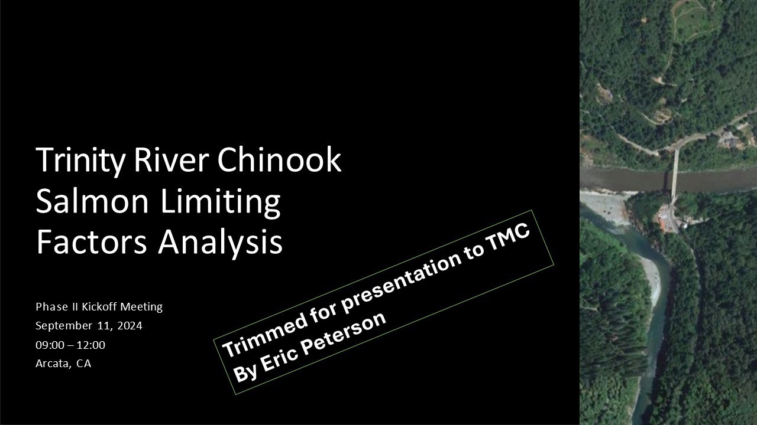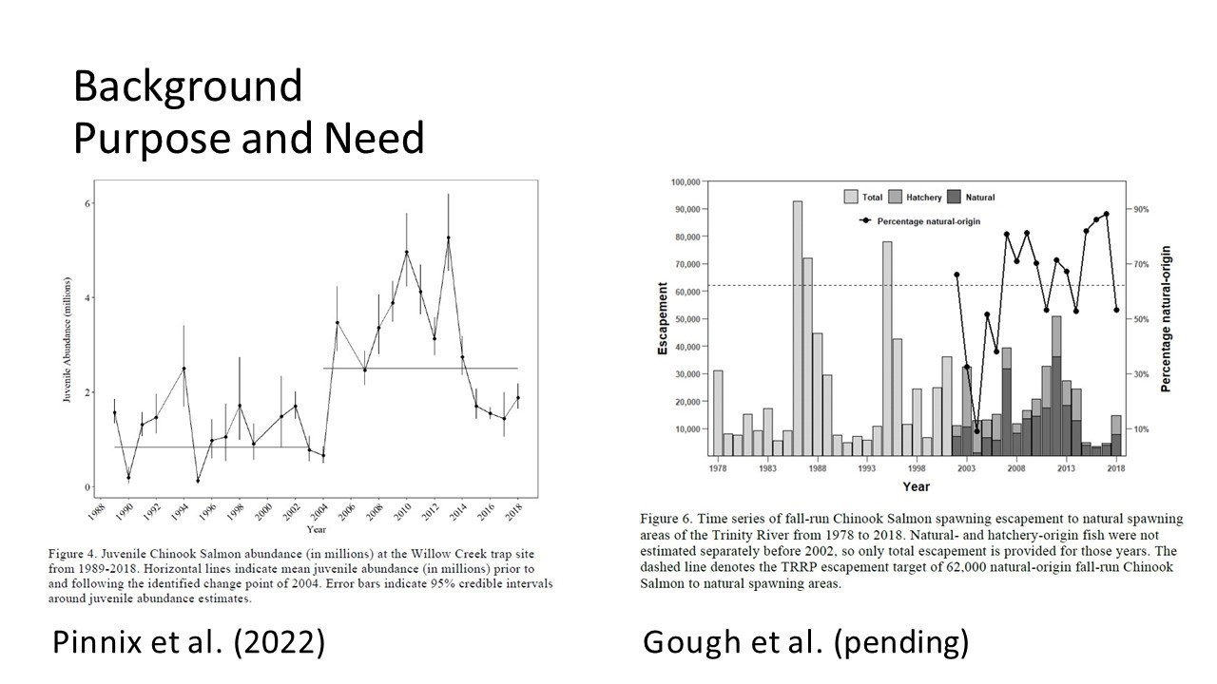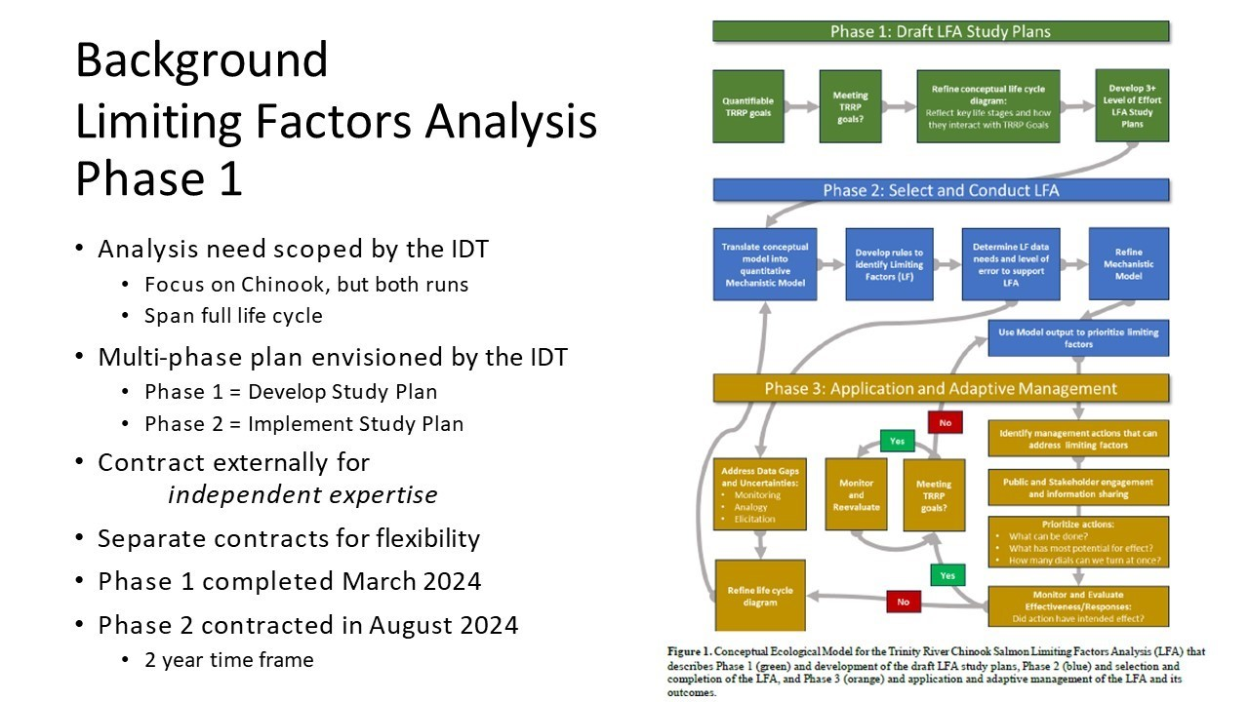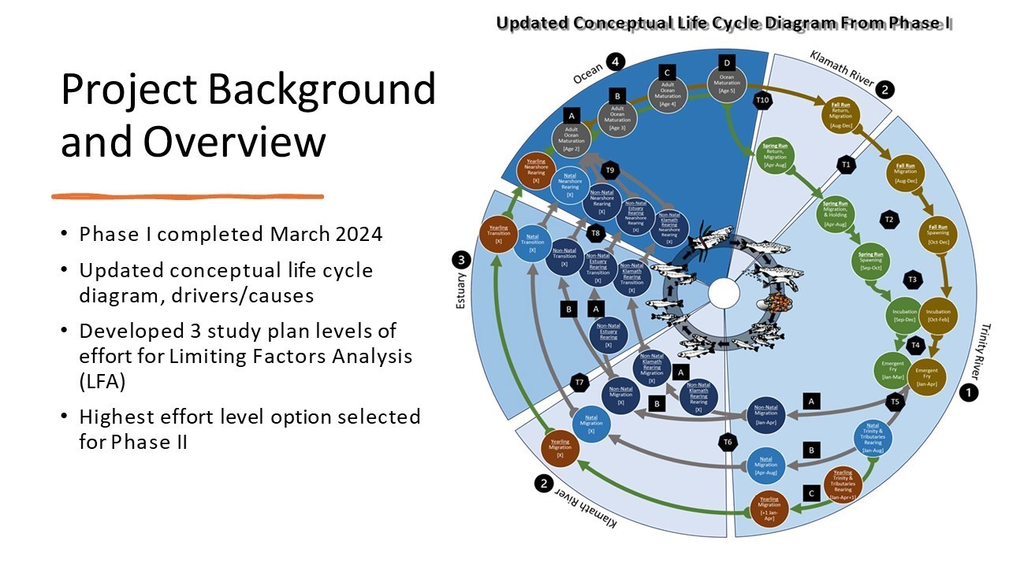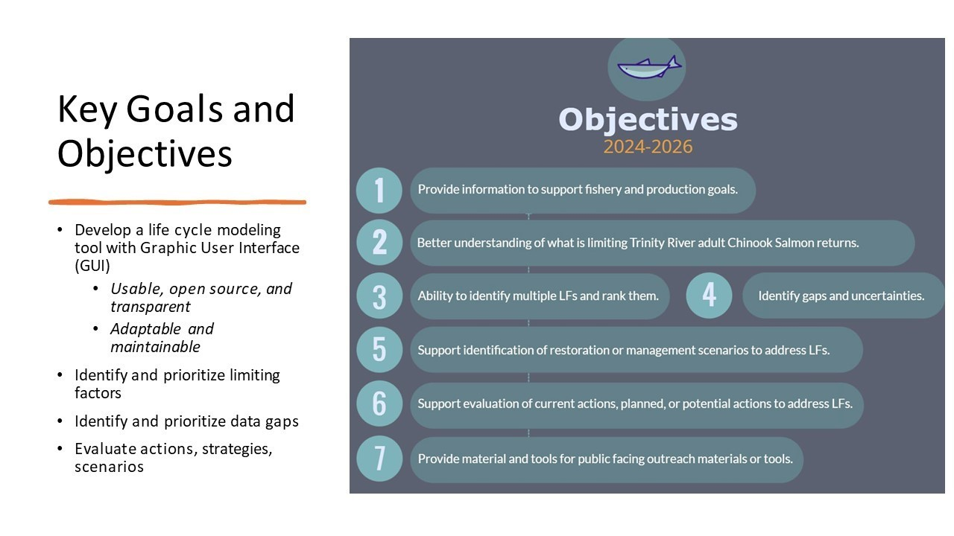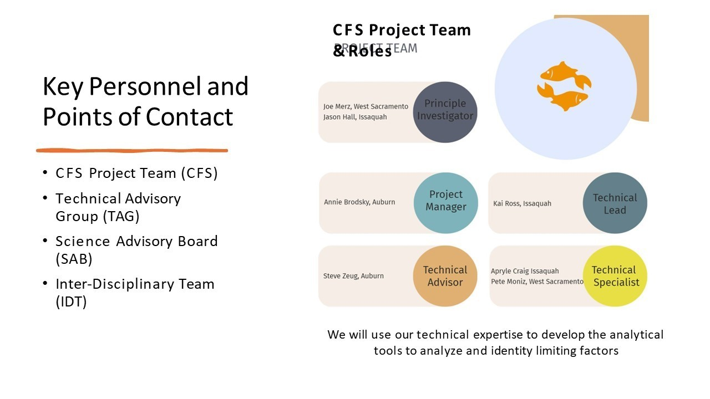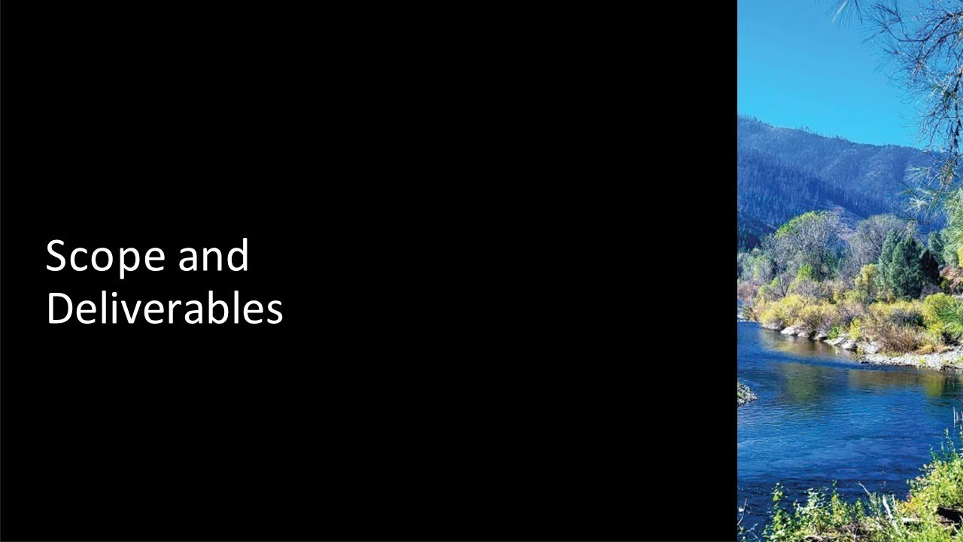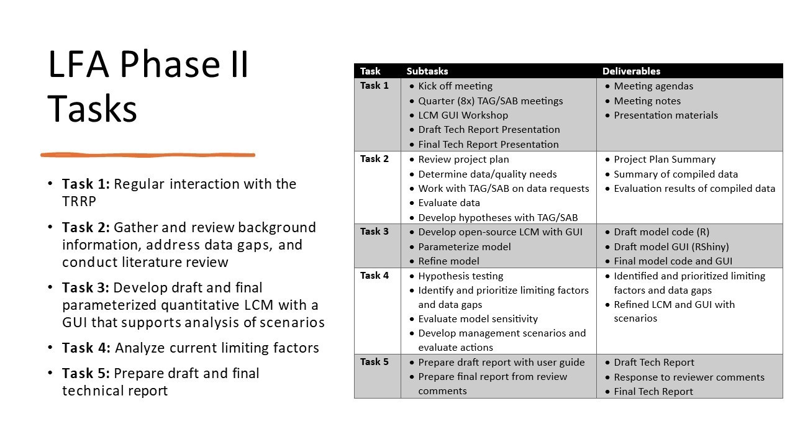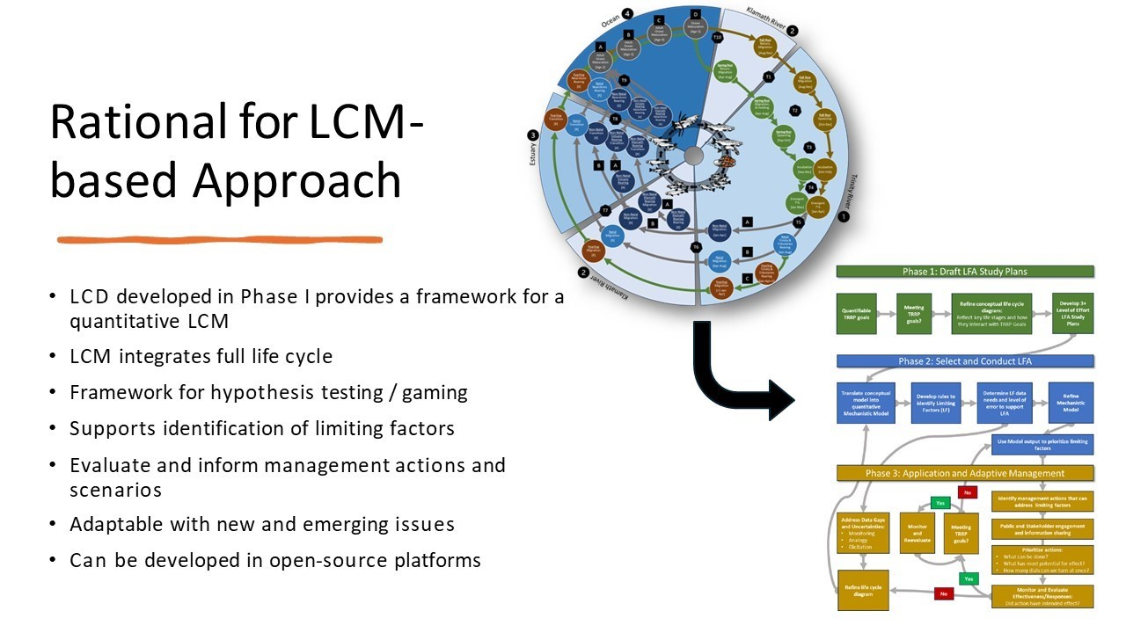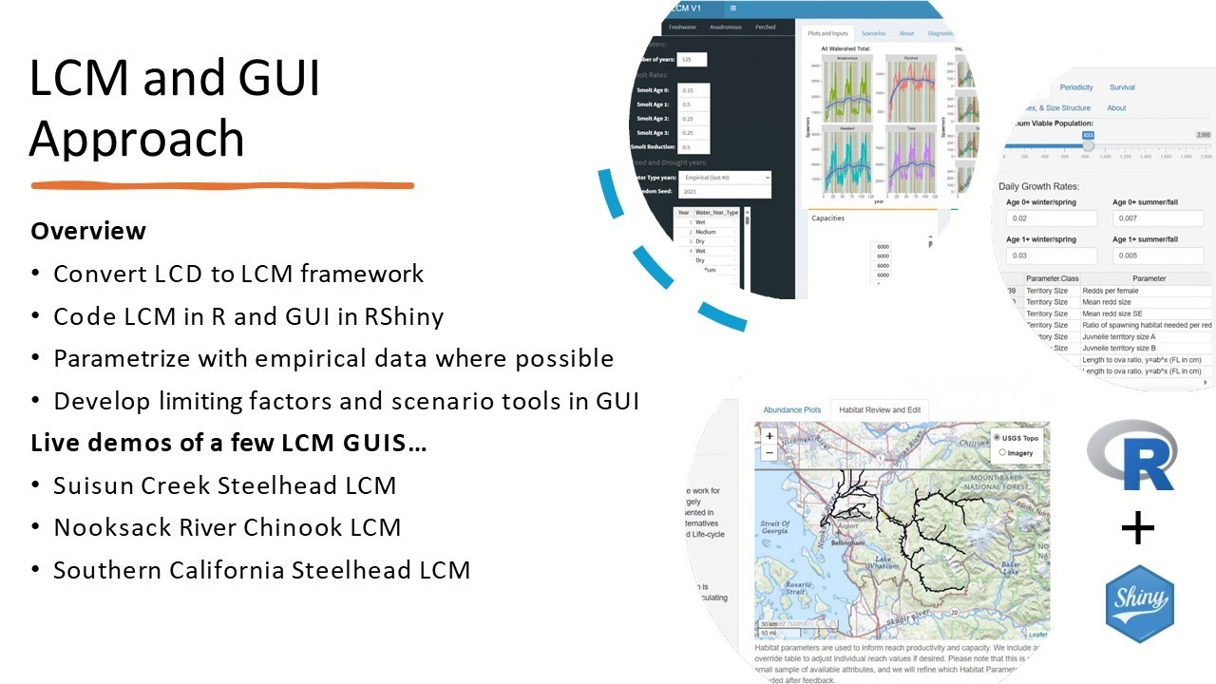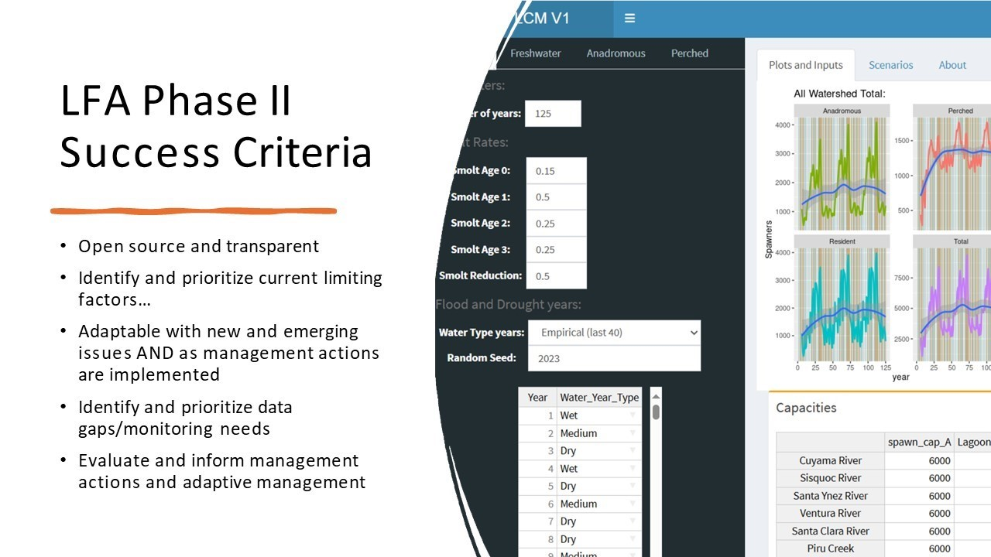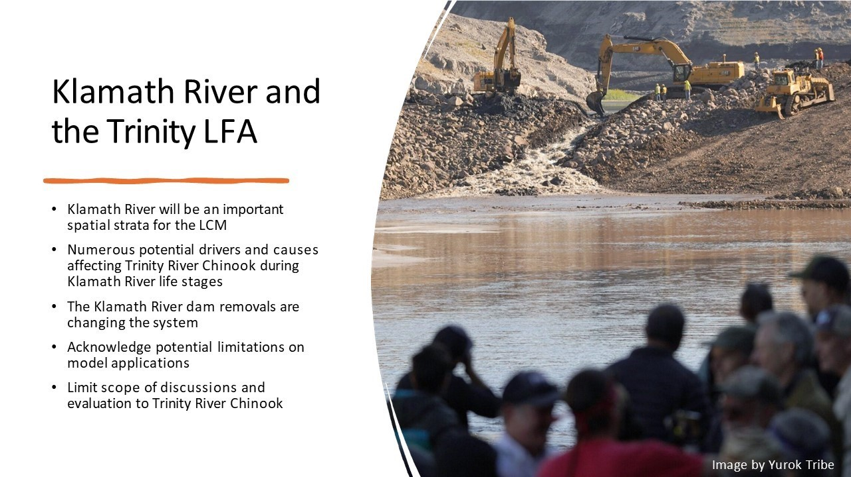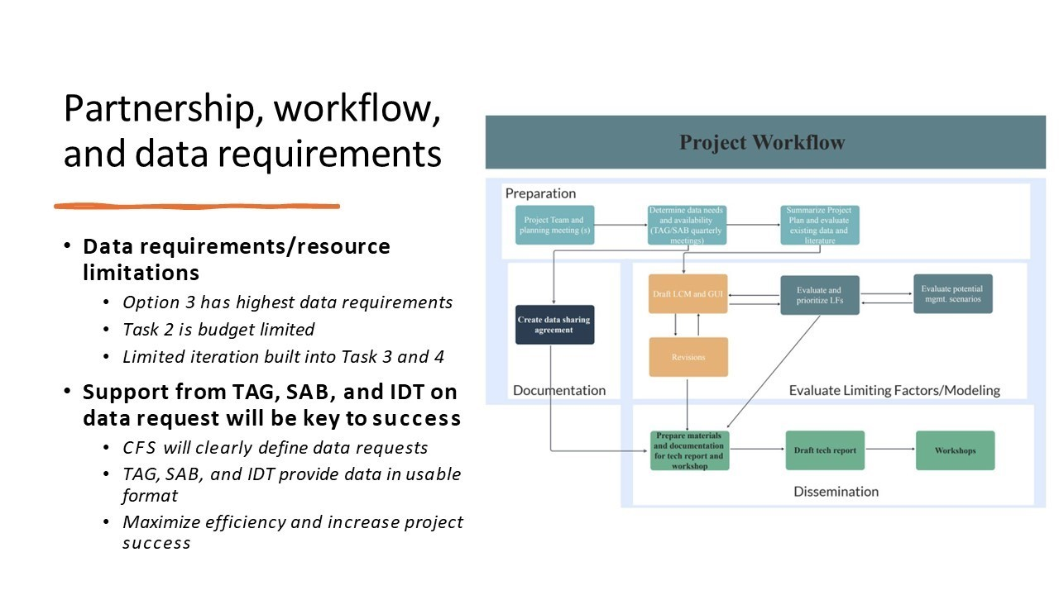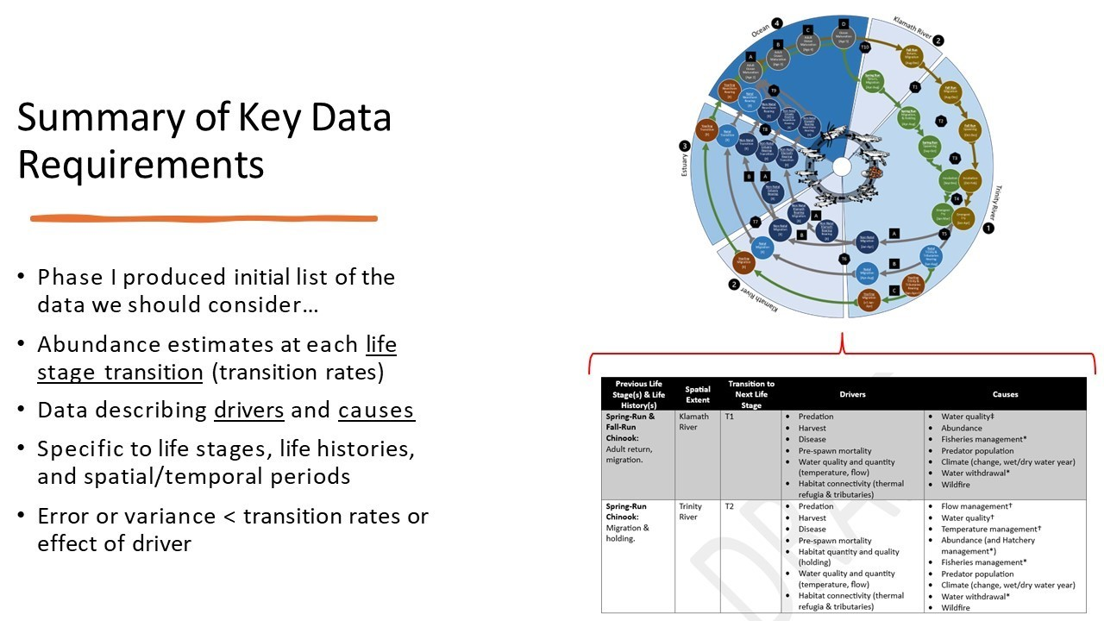
Public Comments
None given.

Reports and Comments of TRRP Entities
Questions Received During Slide Presentation
MO: [Regarding the disparity of juvenile return rate from the ocean] This is only fall Chinook, right?
EP: Yes, only fall Chinook.
MO : This doesn’t speak to spring Chinook?
EP: The juvenile numbers are fall and spring Chinook, they can’t be distinguished. The graph displayed is specific to fall Chinook.
MO : Regarding the statement of inability to see immediate response in return rates, to what is this being compared? Is it compared against the pre-dam levels?
EP: The shift in 2005 shows more juveniles on average, that shift is not shown here in a matter that is strong enough to be statistically detectable.
MO: How could you restate that in the context against the goals of the pre dam levels? Close to 50,000 in 2012?

EP: The goal would be to get the population to the line displayed on the graph on a regular basis.
MO: Is that 62,000?
EP: I’m not trying to make this relative to that. I’m simply stating the total populations are not responding the same way the juveniles have. Something in the lifecycle is affecting the number of returning adults. Identifying why this is happening has spurred the LFA.
Discussion of Presentation
MO: Regarding the life history model of Chinook specific to the Trinity, can we focus on different races and separate management goals for the spring and fall run? The debate seems to be on the winter flow variability for the last couple years. However, in the science symposium it was stated that most years are meeting the pre-dam level population for the spring run, and this is an issue to be discussed since juveniles are being overlayed with adults. With regards to life history model, there is a 40-mile reach limitation, and I would rather see focus on identifying problems in the life history evaluation rather than jumping to management options. The other large issue is in regards to climate, the difference in water quality is visible. Regarding Ocean Fishery Management, there are regulatory changes coming. Need a policy representative to guide IDT because multiple factors involved. Outreach needs to access other expertise, including the PFMC work discussed yesterday. The convert reconstruction and potential modification of the FMP need to allow for separation of the Trinity, how would you access the agencies, including the northwest region of the NOAA fisheries?
EP: [refers to LC diagram from presentation and explains that the model accounts for temporal differences for fall and spring runs] The population of the spring run appears to be hitting the targets, whereas the fall run hasn’t. How can we use models to influence and adjust transitions in LCM to create a larger number of fish that survive and return as adults? There is a disparity between young fish going out and mature fish returning due to difficulty in feeding and growing as they leave the system, leading to fish that are slightly smaller than prior to the ROD. The size of the fish entering ocean has strong correlation to fish size re-entering river. The program is currently working with a conceptual model to increase the fish size going out to increase size of return by adjusting flows, which will increase survival rates throughout the life cycle and result in larger population numbers. CFS has asked questions about life histories because the Trinity doesn’t see the same pathway of Chinook staying in the river for a year before departing to the ocean as they do in other river systems. Focusing on other factors, such as the differing pathways in river systems, could give a better understanding and ability to evaluate how to conceptually model and adjust factors in the river system that will lead to increase survival rates.

MO: This is a major reason why we need policy and personnel involved. Why was Chinook chosen? There are other species like Steelhead or Coho. Knowing the life history of the other species could give a more indicative path to understanding survival and growth in the area.
EP: Chinook is the focused because we have the most data on them, specifically fall Chinook. It is difficult to distinguish between fall and spring, and this is why they are viewed together.
MO: How are hatchery integrated management principles or mitigation functions built into this?
MD: We may be able to parameterize competition between hatchery fish in the river and the ocean. We can’t deny hatchery fish exist in the river, but we aren’t modeling what happens to hatchery fish as part of this.
MO: My point is that when there is a natural number in this table, it could be of hatchery fish. There is no genetic analysis to distinguish the fish, because what is being called natural is fish spawning outside of the hatchery and there is no differentiation between the natural population and fish originating from the hatchery.
EP: There may be ways to address the questions of hatchery fish, but this is a model focusing on the natural populations. To return to the discussion of life histories and other species, there may be some data to assist in parameterizing how things might change if we did have Chinook staying in the river for a year. Through the other species we may be able to gain some information on that.
MO: For Coho, there’s direct management implications in the ocean fishery management.
JLy: How much do you think it would be to model Coho and Steelhead?
EP: It is a similar process and in the realm of possibility. The greatest issue is limitations on data. We would need to gather literature and map patterns of the life cycle, similar to Chinook, and get the data of population numbers and transitions parameterized.
BP: Since the model is open source. I think we could transpose the pathway on this structure. We have a modeler, Chris Lascodi. We have the tools to transpose Coho and re-parameterize the different steps with the appropriate Coho information.
MD: It would be more difficult because of the lack of juvenile migration information on Coho.
BP: The data doesn’t drive the model. The model needs the data, therefore, once this is done we will be a lot closer to transposing the Coho data. Steelhead is more complicated due to the extended early rearing and freshwater rearing, which will require more steps. A contractor may be able to leverage off the Chinook model to develop a model at a much lower cost. We should keep future needs in mind as we develop each step.
EP: A significant number of scientists in the room are familiar programming in R.

MO: Can TMC members participate in model development?
EP: We need to make sure that the advisory group does not get too large, but we can incorporate individuals on specialized topics. The advisory group will largely be assisting Cramer by directing them to the scientists in the program that are familiar with the location of data.
JLy: Who is on the advisory group?
EP: The default is the primary members of the IDT and Scott McBain has been included.

TMC Discussion

Break

TRRP-Funded Projects in the Trinity R. Watershed, 2014-2024 (Lauren Alvares)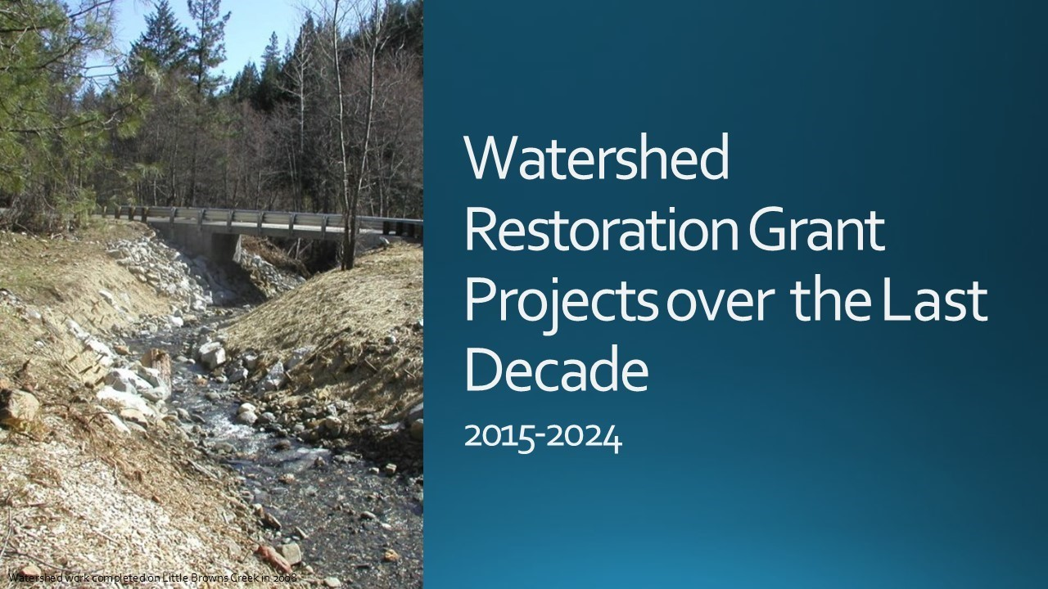
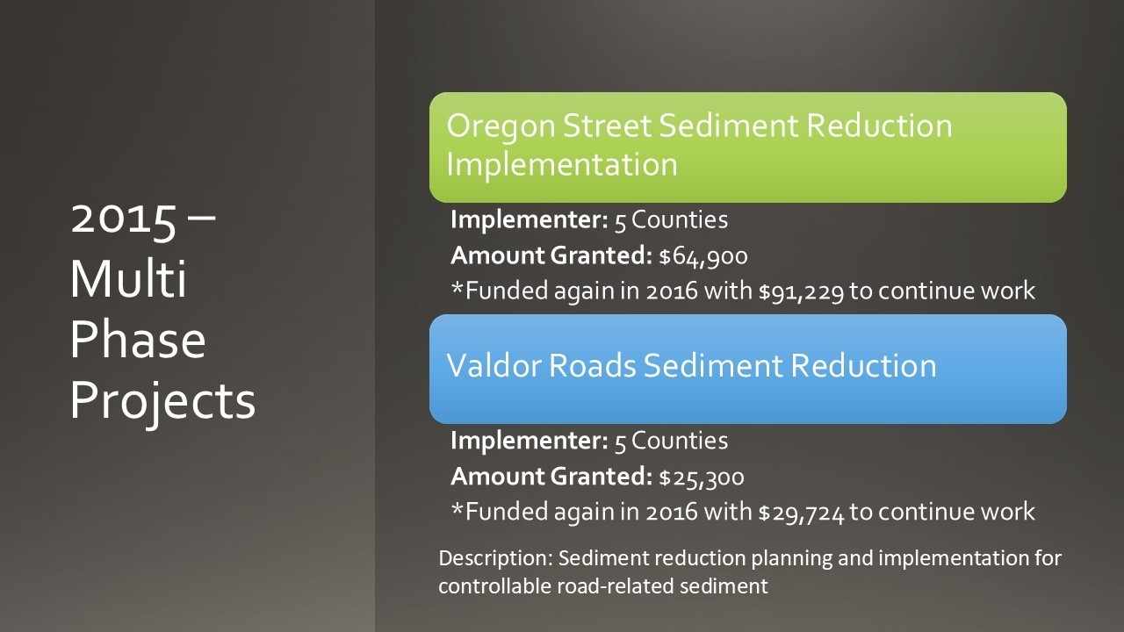
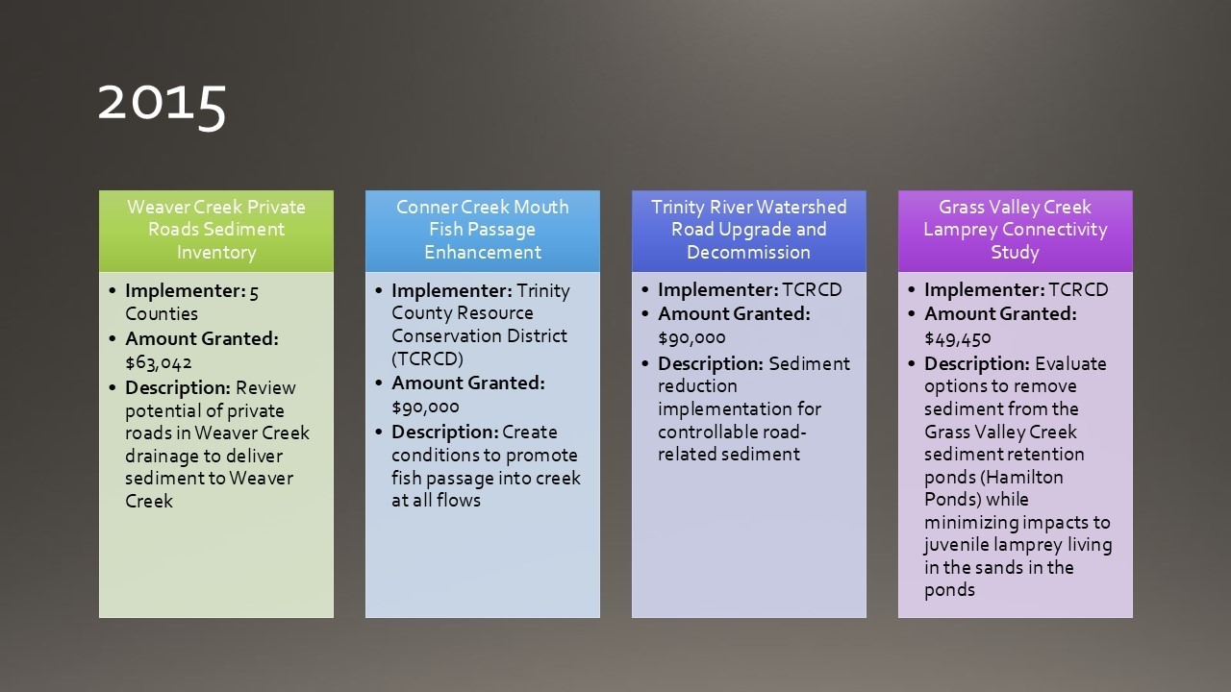
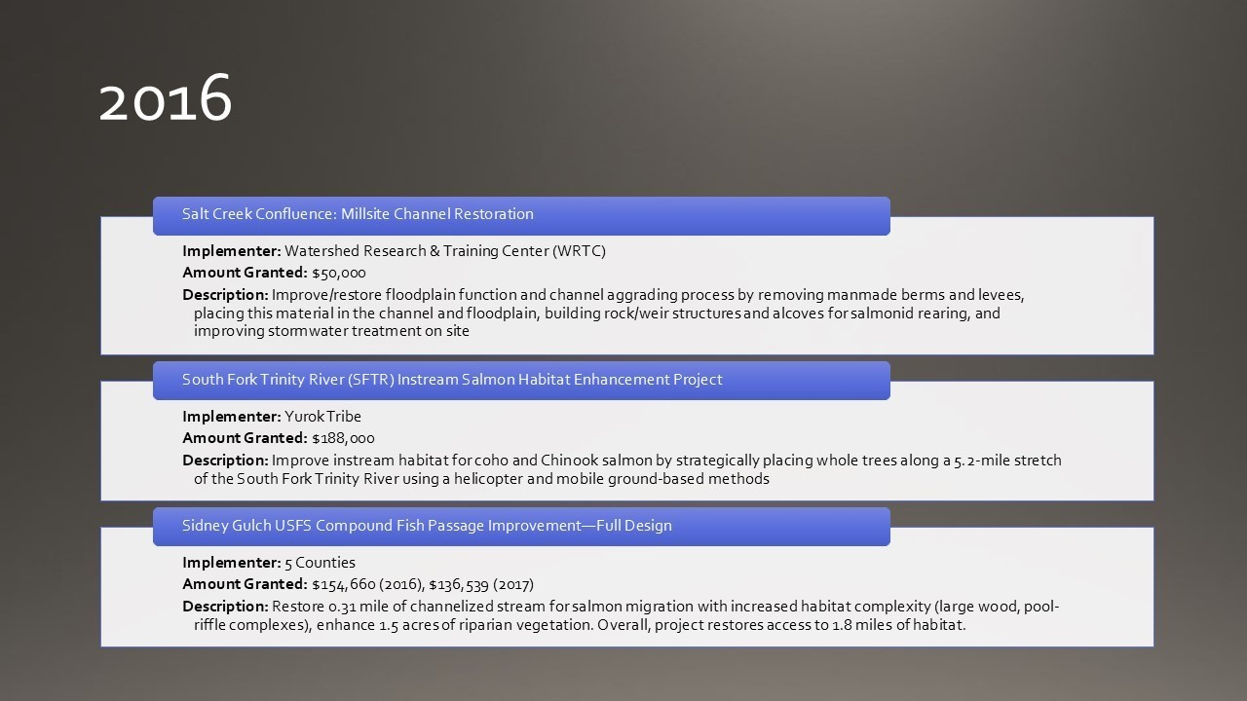
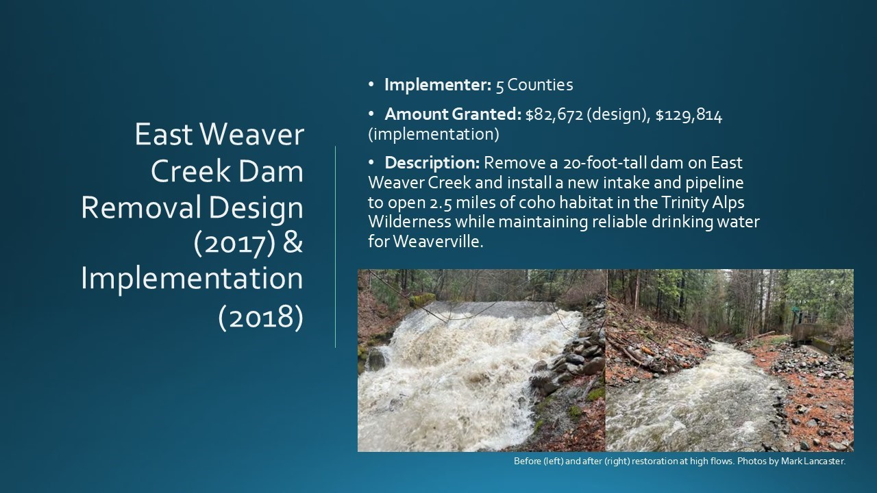
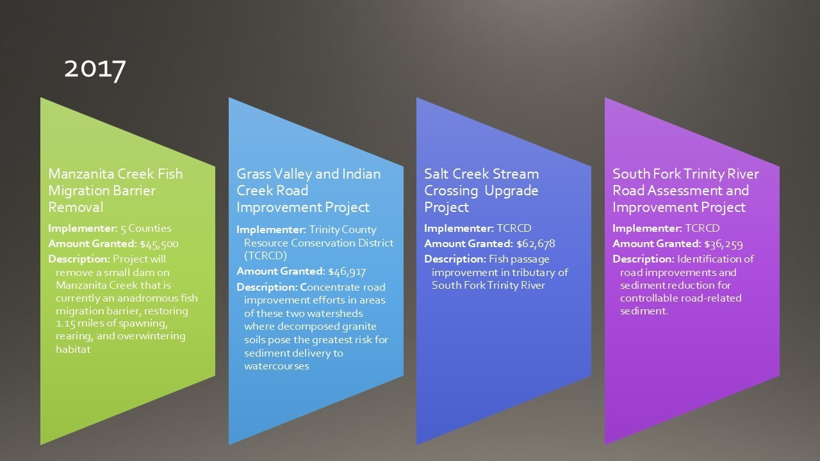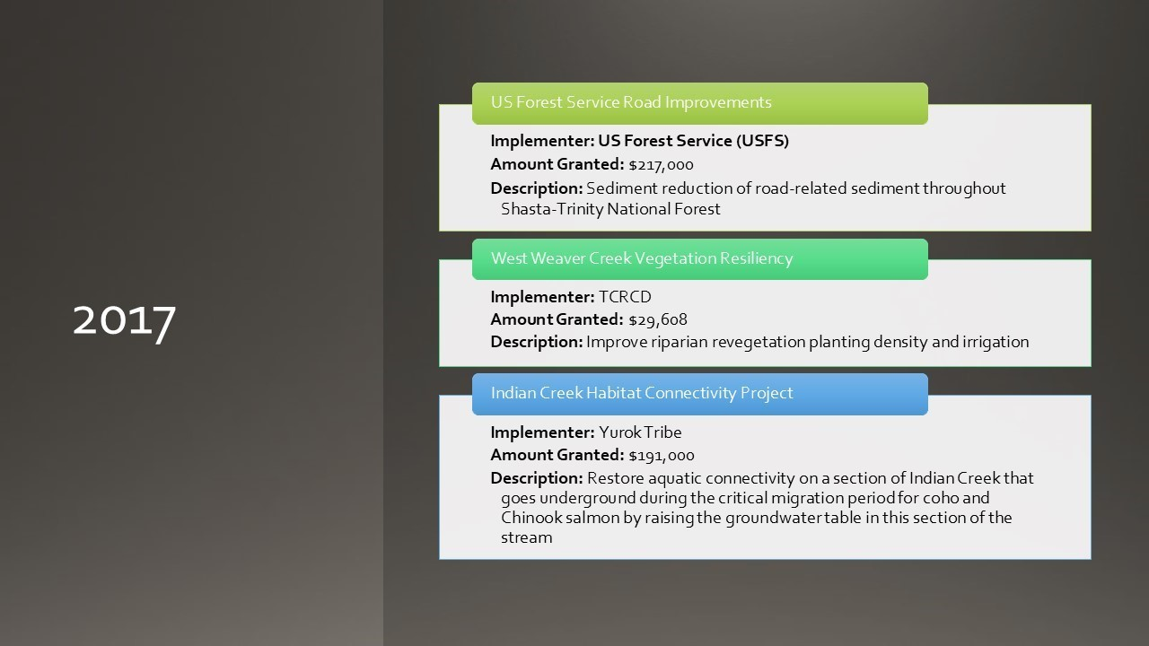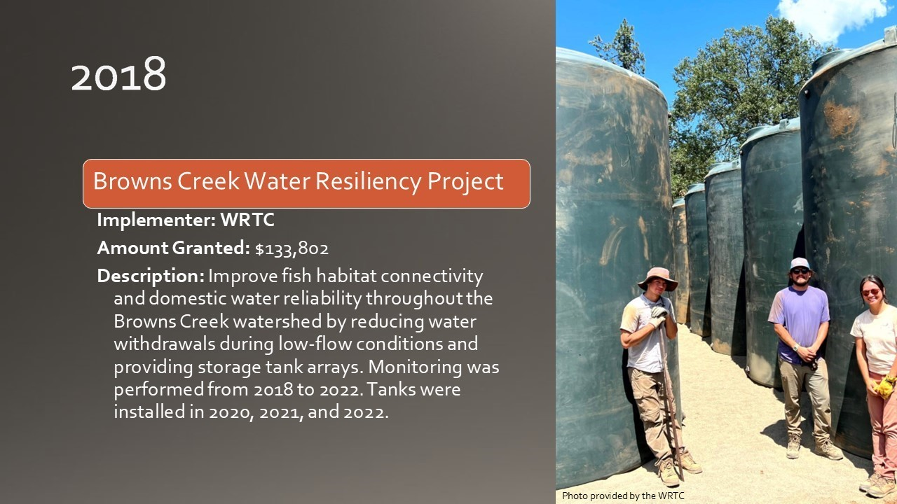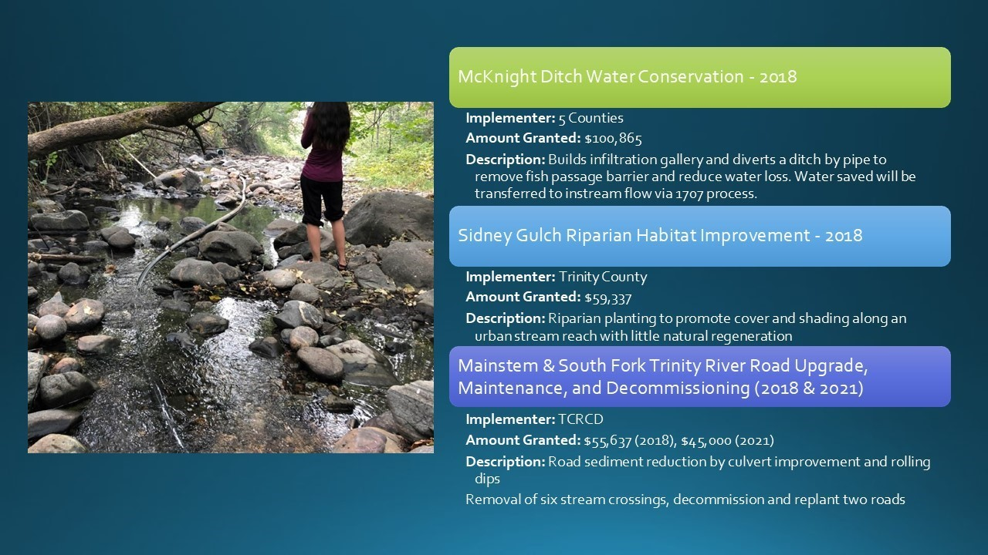

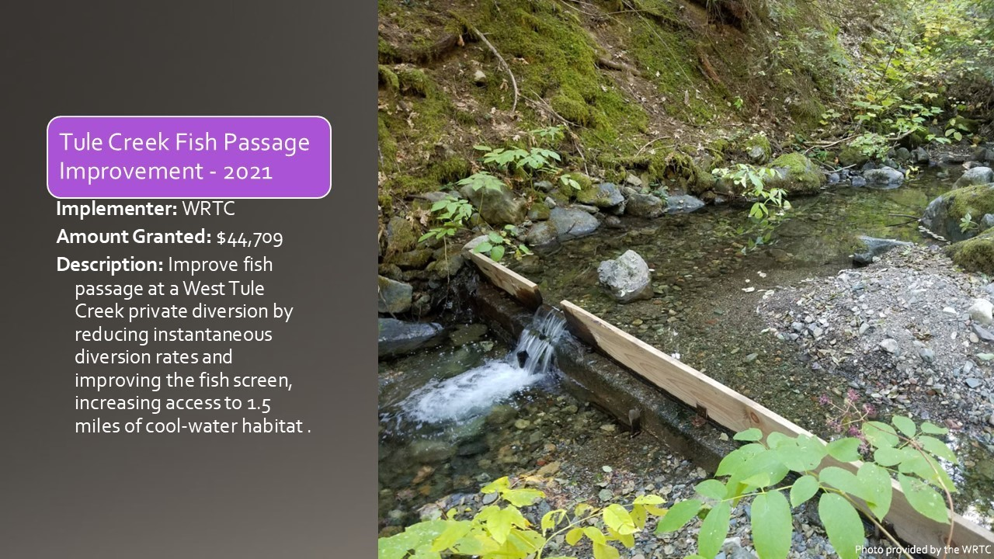
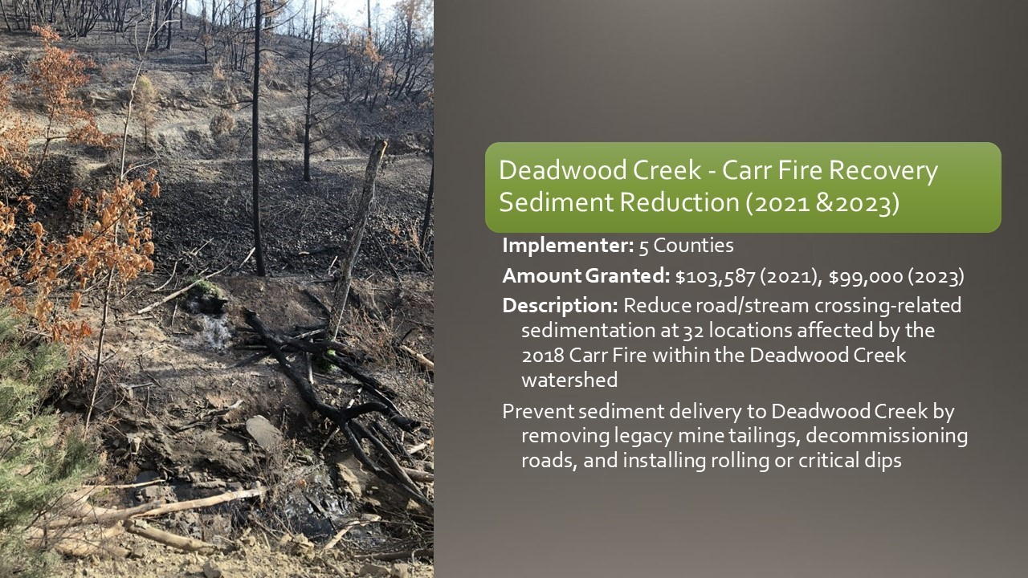
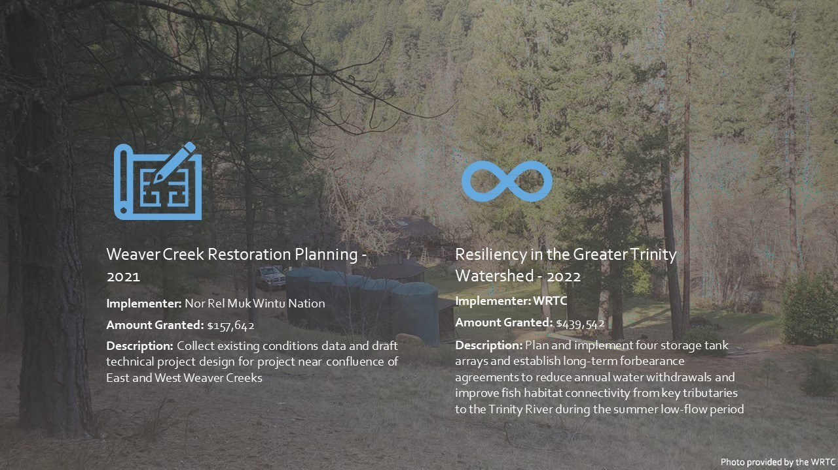
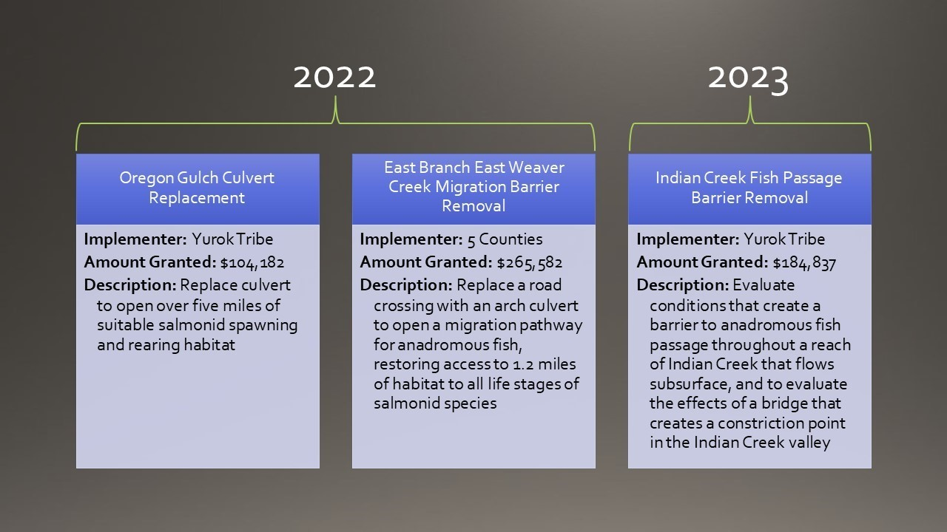
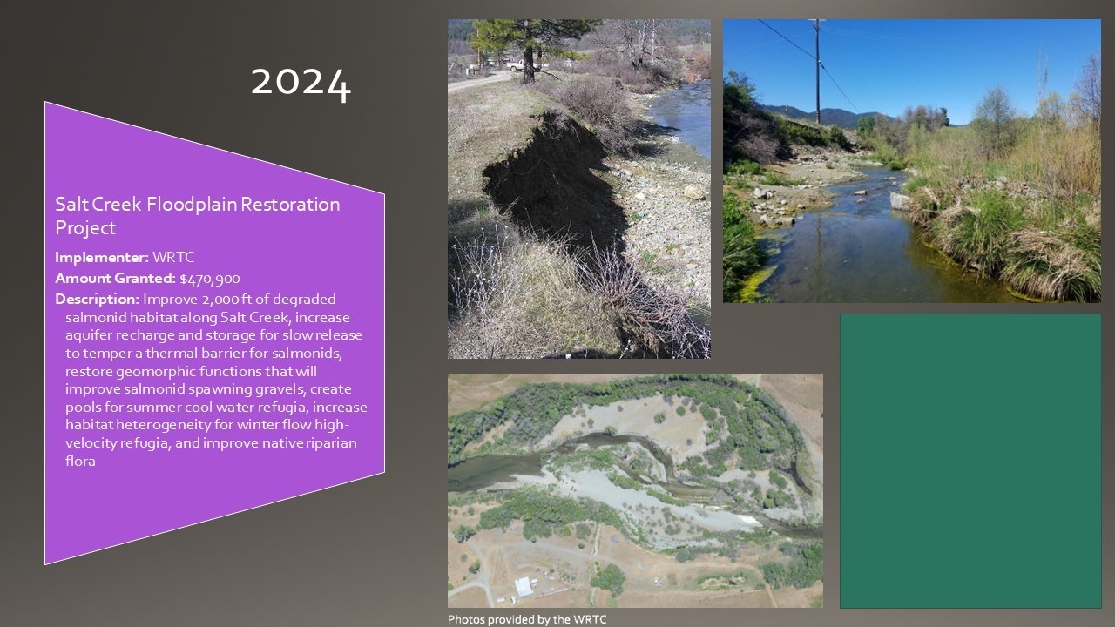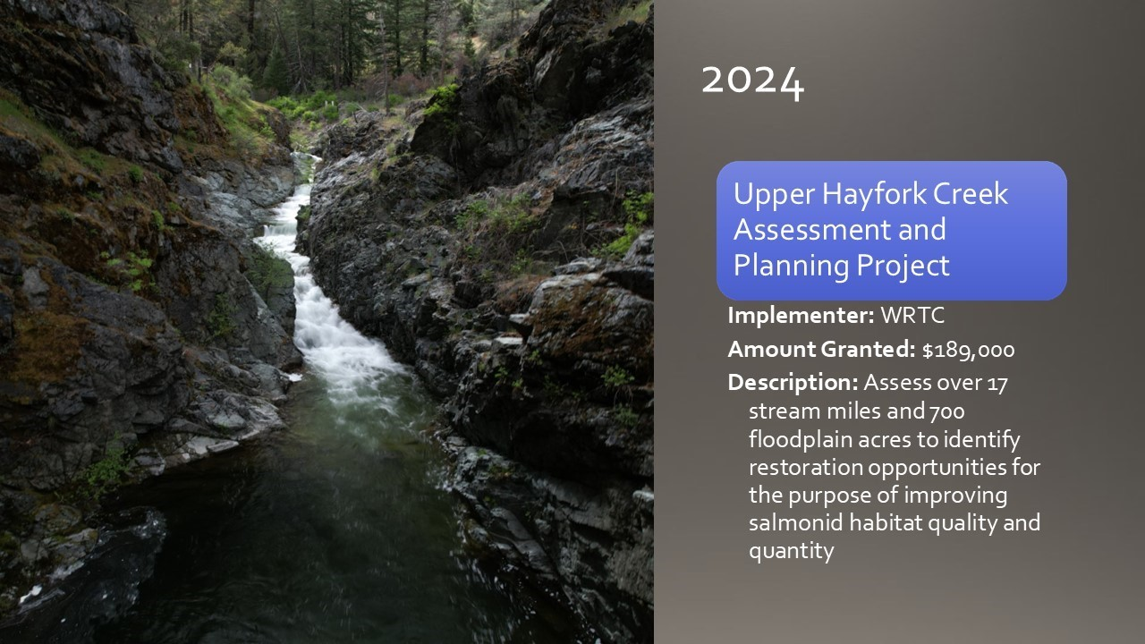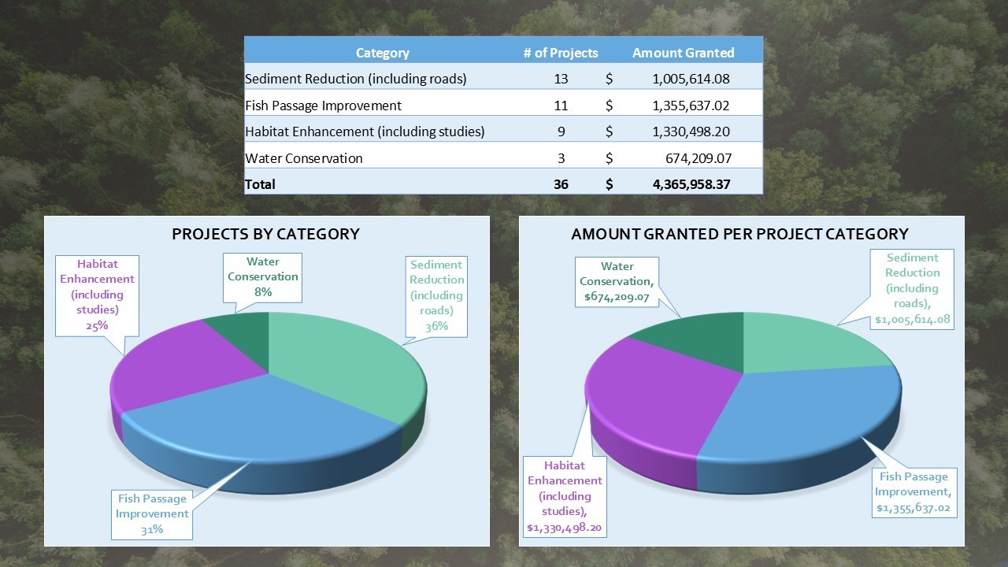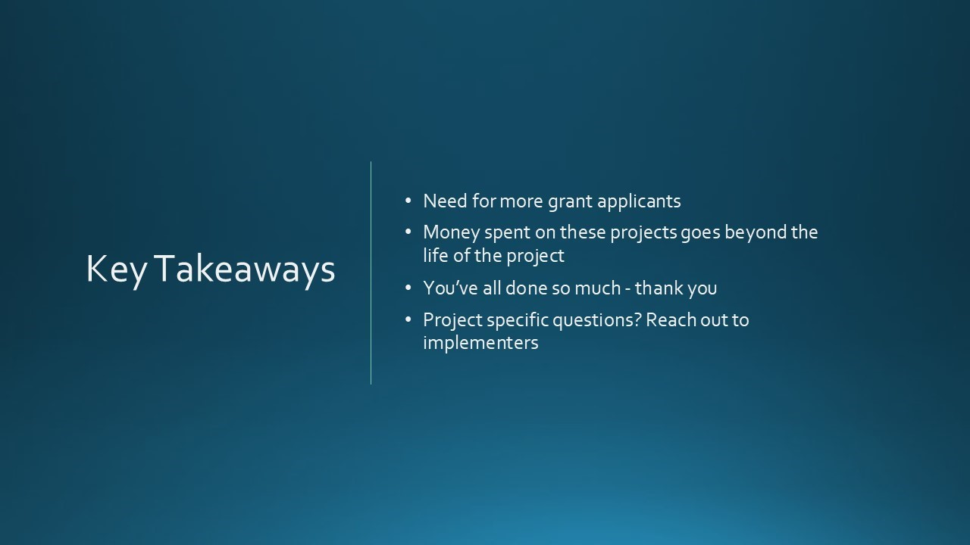

Public Comments
None given.
Reports and Comments of TRRP Entities
BP: Figures show the amount of funding provided by TRRP, but these funds have been leveraged with other funding sources in many cases.
JLee: Q – While researching, did you find as-built documents or reports provided to us? Or was this readily available information?
LA: No, I wasn’t looking for as-built documents. As-built documents are likely available, I think the 5 counties has most of their information on their website. If there is a project of interest, I can reach out to the implementer and get that information for you.
JLee: There’s a few I’m interested in. I will review your presentation and get back to you.
MD: A few years ago we tightened our post project reporting requirements because there was awhile where we were not getting information back.
EP: For a while, the agencies that work implementing these projects would simply send a final report to the contracting officer in Sacramento and we would not often receive that information. A couple years ago, Lindsey Walker and I worked to gather many of those documents from the past, and those are now more readily available through our data port. One of the reports I presented yesterday was the implementation report for the East Weaver dam removal. Acquiring available documents is on an improving trajectory.
RO: The last couple years there has been a lot of evaluations for potential projects and that information could be used for future solicitations or items to prioritize.
MO: Of the total projects funded, how much is for the South Fork relative to the overall percentage? It’s usually 500,000, right, for watersheds?
LA: I would have to look through the projects and see what was in the South Fork and get back to you with that number.
MD: There is the Upper Hayfork Creek assessment, Tule Creek fish passage, Salt Creek flood plain restoration, and a component of the second water resiliency grant is in Browns Creek and the other is in Hayfork Valley. The latter is the only project that applies to multiple locations, and it is not known at this time what proportion of funding went into the South Fork.
Unidentified speaker: Over the last 10 years, only one third of the projects were in the South Fork. That is just the number of projects, I am unsure of the dollar amount. The main project was the Forest Service maintenance funds, and the FS district spans to main stem and South Fork. You would have to make some assumptions there how much went to the South Fork.

MO: The purpose of my inquiry is there were barriers for a while based upon some legal opinion or personal opinion was precluded. Some of the bigger analysis of the South Fork, that I'm aware of, was that the legacy of the ‘64 flood in the routing of the sediments throughout the system is going to cost a lot. I’ve been concerned because it was previously precluded and would like to know how much of the budget entails where there is long term legacy items that have occurred from the analysis and watershed assessments in the basin. Getting necessary funding for the program has been an ongoing issue for years.
JLy: Previously the Trinity County RCD were outsourced and recently fewer projects were funded. Is this due to lack of applications or time?
LA: I’ve only been here for a year, maybe someone else can answer that. Mike?
MD: I spoke with Kelly Sheen, manager of the RCD, after they weren’t submitting proposals and discovered it was a lack of capacity to manage grants. They are doing large amounts of fuel treatment work across the Weaverville Community Forest and elsewhere. Another issue is a large turnover in their watershed program and the lack of continuity has caused a disruption in their applications for TRRP funding. Currently, it is only Mark and 2 other persons at the 5Cs.
MO: During a previous meeting, there was discussion of the Grass Valley Creek project. Is there a funding source available for watershed restoration work? Is there an allowable cost in the watershed restoration work to include seeding the habitat?
MD: It’s not a project type being solicited for NFWF grant.
MO: So, it was a statement at a meeting, but not criteria?
MD: Where the RSIs fit into the watershed discussion is that we are trying to get programmatic coverage for the NEPA work so our partners have an easier time implementing those projects. It is not that the TRRP wants to fund RSIs as a part of TRRP watershed management program. It is more of the programmatic NEPA work that brought that discussion up.
LA: We are still working on the programmatic EA, hoping to have the administrative draft available next month, and planning to have the NEPA coverage available to group next spring.
MO: Is it going smoother since we switched to NFWF
MD: It depends on who you ask. Our grantees would have a different answer. If you've applied for FRGP funding through CDFW, it's not dissimilar in the sense that working with NFWF to get the money and do the reporting is more onerous on the grantees’ side than they were used to when we were issuing grants directly from the restoration program. From our side, it's been seamless; it's been really helpful because the grant requires that NFWF set aside a portion of the grant funding (like 10%) to support environmental compliance. That makes it a lot easier for us to comply with our obligations under the law, which wasn’t happening before we were issuing grants. It was a federal action subject to NEPA, subject to the NHPA, and subject to the ESA. We weren't doing environmental compliance on any of that before and many of our grantees weren't doing any environmental compliance on that. But that problem has been mitigated by working through NFWF because they will not release funding until we have indicated that we are satisfied that they have met their environmental obligations.
MO: Which includes regulatory compliance?
MD: Yeah. In one project in particular, regulatory compliance has slowed down the pace of implementation due to issues with cultural resources. The East Branch of East Weaver culvert replacement was supposed to finish this summer, but Reclamation’s archeologists are demanding second field surveys to augment the previous work, and that project will not happen until next year now. We have obligations under the law, and we will meet them, even if it means waiting another year to replace the culvert.
JLy: Weaver Creek near Main St., it appears there could be restoration that would be visible to the community. Is there any thought incorporating that into the program?
MD: This has been done in an ad hoc manner and this has been discussed with a few different entities, because the Yurok Tribe and Nor Rel Muk project in Weaver Creek just below the east and west Weaver confluence. We funded the 5 counties for a project that has stalled out on the Sydney Gulch which flows through main parts of town. There are opportunities to highlight restoration within the community. There were roadblocks encountered with flood mapping. The RCD is doing work on West Weaver Creek and the 5 counties have a couple projects in east Weaver Creek watershed that have been completed. They have two more projects planned. In Sydney Gulch there is an opportunity to do restoration that will be very visible to the community. The Yurok Tribe project is on BLM land and there is an opportunity there to benefit the community and trails that could be made part of their trail network. There needs to be more discussion about a comprehensive approach to include these topics in the Weaver Basin.
BP: Would that be a role that TRRP can play?
MD: I think so. There has been focus on watersheds this year in the east and west Weaver Creek and Browns Creek that have large human populations and potential to focus more on Steelhead and Coho.
BP: Does our current NFWF agreement specify the project type balance?
MD: It just has to be in the Trinity River Watershed and has to meet one of the project types defined in the Klamath Basin IFRMP prioritization for that watershed.
SQ: We are planning on initiating an RSI project in East Weaver Creek this year. There was discussion of including some of Little Browns Creek, but there were some issues because Little Browns Creek is intermittent and runs out of water.

JLy: Will there be more than one RSI?
SQ: Eventually, this first year will just be the one site.
JLy: There was one on Grass Valley Creek.
SQ: Yeah, and we will continue that one and have plans to add.
MD: Regarding Mike’s discussion of the South Fork Trinity watershed, the scale of problems and legacy of clear cutting on erosive hillsides followed by the ‘64 flood will take a while to resolve. This is a problem for spring Chinook and Coho in the main stem of the South Fork. There are many other streams in the South Fork Trinity watershed, particularly many of the streams in the Hayfork Creek watershed, that could potentially prime steelhead habitats. We have the potential to aid important species in the program in the South Fork Trinity watershed, without solving South Fork Trinity watershed’s larger problems. Stream temperatures may never be conducive to Coho and the spring Chinook population may never return to previous population levels in the mainstem, but we have the ability to aid many of the streams to be better for the Steelhead population. Specifically in South Fork, the majority of the problems are removing barriers and getting more water into the streams. Maybe farmers go longer without diverting in the summer period. There is a lot of potential that we [TRRP] can contribute to.
MO: Does the Indian Creek watershed restoration that was approved yesterday fund through the Wildlife Federation?
MD: No, that will fund through the AFA.
MO: Is it watershed work?
MD: For that portion, because it is a project that was previously directly funded in 2018, right Lauren?
JLy: There is only a couple of days to obligate money.
MO: This is a really important area.
MD: We should do a field trip out there.
JLy: We should, can we put that into December?
MD: I was thinking in the March meeting that will be held in Weaverville, because it’s only a half hour away.
MD volunteers SQ to lead the field trip.
LA: Mike, the project you mentioned was in 2017.
TMC Discussion

Topics for Next Quarterly TMC Meeting in Redding (JLy)
- Bylaws
- Mechanism for funding watershed projects in FY26
- Elections for Chair and Vice Chair
- Discussion for other potential items included below

TMC Discussion
MD: Will be discussing the bylaws and mechanism of funding for watershed projects in 2026 because the NFWF grant will be expiring.
BP & RO: Maybe we can further discuss setting priorities for targeted projects or watersheds, as well as discussing timelines for the funding window and additional restoration work.
MO: We were on the cusp of doing a motion on the concept of reclamation being part of the PFMC work process. A way to approach this could be to make a request in the form of a letter to the regional directors. It’s vitally important to both tribal and nontribal fisheries in the Trinity Basin. The impacts are going on year 3, and we want to make the case for the Klamath side also. Since the regional directors oversee both Trinity and Klamath, sending a letter seems to be the way to advance that process. The letter would come from HVT and include multiple issues. TRRP can decide which ones apply to the work of the TMC.
JLy & MO agree that the letter would come from the tribes.
MD: We need to look at the solicitation for NFWF, get timelines and priorities, and decide if we are going to continue to work with NFWF before we get the solicitation out to the public. This is not a forgone conclusion, and it will be about 4-5 months to get a new agreement in place. TMC schedule is driven by NFWF schedule because it is a basin wide solicitation that includes funding opportunities for TRRP’s watershed funding, Reclamation’s Klamath Coho funding, and NRCS provided funding. Because it is a basin wide solicitation, it has various funding areas and amounts that can all be accessed by the grantees. (Jan-Feb).
MO: I would like to add to the list, the decision on winter flow variability and response from the regional directors, as well as an update on the FARS analysis.
MD: There is also the topic of the temperature control device at Trinity dam where a value planning study was being pursued. If Elizabeth can give an update on where that is?
EH: I will have to look into that, but I’m sure we can provide something. We can certainly get Paul Zedonis to discuss where we are with the FARS analysis.

RO: I would expect a regional director to give some indication on the winter flow variability prior to December, to allow the program time to inform locals, water users, and recreation about the plan. If we haven’t heard anything before December, we will reach out about that.
BP: It would be helpful to have a technical discussion with hatchery team about operations, goals and the potential for integrating TRRP goals the integrated fish population.
MO: Further, we could include an update on modernization.
MD: Since the USFS is hosting and that watersheds include the ridge top down to the active channel, could we get an update on priority landscapes (Wildfire Crisis Landscape - & infrastructure funding) for the funding that the USFS is putting into Shasta-Trinity resiliency.
KM: The location is not set due to office renovations. KM and EH will look for options.
EP: The IDT will have updates to the objectives and targets. We could also provide some annual work plans.
JLy: We have the synthesis report action tracker?
EP – Kyle provided a presentation to the Fish Work Group and other groups are beginning to take it on. If they take it on vigorously in the fall, we can also present that. Let’s wait and see where we’re at.
JL – Interested in synthesis report recommendations in list form from the different reports. Further, tracking what we are doing with them, whether passing, implementing, or on schedule. Is that the purpose of the action tracker?
EP – Yes, that can be computed in the action tracker. May not be a robust list by December due to the matter of how quickly they can go through all the reports while doing other topics as well.
EP will provide a list of recommendations of what is available at that time.
BP: Regarding the presentation yesterday and discussing the metrics used for assessing flow implementing the DSS. By December, will there be enough information to present to the group of what that looks like moving forward and some recommended changes?
EP: Can incorporate that information into a presentation on objectives and targets that includes objectives with multiple targets, targets related to monitoring, and modeling for decision support. It is important to get the report out on how implementation went prior to next cycle to be able to know the items needing assessment.
EP – Looking at a need similar to WY23’s partial implementation of the winter flow variability. Recommendations of workgroups in December would be very helpful to get ahead.

MO: Inclusive of the pre- and post-evaluation and implementations, it’s necessary to identify appropriate issues for LFA.
JLy: Is the S3 model still alive?
BP: Yes, it’s open-source and available. Some people trained up and are running it (Chris Lascodi, Seth Naman & Nick Som). The model is still around and relevant and generating results, which ties into the DSS and bench outputs. There has been some discussion about the differences between the model and outputs of S3 and how to include those in the future. We still need to come up with hydrographs for the spring period because the focus yesterday was pre-April 15th
EP: The issue with the slightly smaller fish suggests the food aspect of the habitat and temperature as it relates to food. The goal is to connect a food scape model to S3 model in FY2026. This should assist S3 in providing more contrast on the hydrograph options and improve its relevance to the DSS. As for the LFA, the S3 model is very relevant to the juvenile in river aspect of the life cycle model.
JLy: Elections will occur in December for Chair and Vice Chair. If there are additional agenda items, please send them to MD.
Adjourn 11:41

