Trinity River Restoration Program
P.O. Box 1300, 1313 South Main Street, Weaverville, California 96093
Telephone: 530-623-1800, Fax: 530-623-5944

NC-152

MEMORANDUM

To: Trinity Management Council
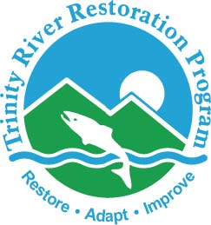

From: Mike Dixon, Executive Director
Trinity River Restoration Program

Subject: Director’s Report

Date: Sept 17, 2024

Major TRRP activities between June 2024 and September 2024 include:

Organizational Updates
- The solicitation for the Secretary position is closed and a cert was issued with applicants.
- The TRRP Data Steward remains vacant. Initial recruitment paperwork has been submitted and it is in queue for soliciting. It will be hired as a GS 7/9/11/12 Natural Resource Specialist.

Budget Updates/Adjustments:
The FY 2024 budget set aside about $345,000 for the environmental services contract, which expired and was re-solicited this year. The solicitation took longer than expected, and a contract won’t be secured until after the end of the fiscal year. To avoid a gap in environmental services, a six-month extension to the current contract was approved, and funded at ½ the typical annual rate instead of the $345,000 that was budgeted. This resulted in a budget surplus. There was already a surplus anticipated due to position vacancies. The combined surplus was approximately $450,000. With this surplus, I propose to supplement three tasks in the Annual Funding Agreement with the Yurok Tribe: as-builts for Upper Conner Creek, completing the Indian Creek watershed restoration project, and gravel processing at Sawmill. The rationale for this proposal will be presented as a decision item during this meeting.

Implementation Updates
Sky Ranch Channel Rehabilitation Site: Little change since last quarter. The design is at 60% and the VE study was completed; and a right-of-entry with the private landowner was established. The land transfer between USFS and BLM is expected to be completed this summer, after which TRRP can initiate NEPA. Depending on the availability of funding and the land transfer, the project may be constructed in 2025 or 2026. This project is the priority after Upper Conner Creek, although the land exchange must be completed before TRRP can move forward with planning.
Evans Bar Channel Rehabilitation Site: No change since last quarter. The design remains at the existing conditions report stage. A meeting between designers and neighboring landowners was planned for the week of September 16.
Sawmill Gravel Processing Site: A draft 90% design was prepared by the Yurok Tribe and State design group and is expected to be finalized in October. The EA for the project was completed in July 2024, so this project will be ready for implementation in 2025.
Upper Conner Creek Channel Rehabilitation Site: This project began in August 2024. The project was envisioned to be a one-year project, but delays in NEPA/NHPA postponed the start date enough that the project cannot be completed this year, and will continue through 2025.
EA Development
- Upper Conner Creek and Sawmill Environmental Assessment (EA)
The Upper Conner Creek and Sawmill EA was completed and a FONSI was signed in July.
- Sediment and Wood Augmentation Along the Trinity River Restoration Reach Project Environmental Assessment

The Sediment and Wood Augmentation EA was completed and a FONSI was signed in July.

- Watershed Programmatic EA
Work on the Watershed PEA continues, and is forecast to be completed in late 2024 or early 2025.

Public Outreach Update
Publications and Education Materials:
River Riffle – June, July and August
- Current Conditions: Flow, Temperature, Fish Health & Monitoring
- Program Updates
  - June: TMC Meeting Recap, July: Upper Conner Creek Update, August: Science Advisory Board, Sediment and Wood Environmental Assessment, Upper Conner Creek Rehabilitation
- Articles
  - July: Temperature Diversity in the Trinity River, a River System in a Mediterranean Climate (Lindke, Buxton, Lee). August: On Fish, and Fire (Peterson, Asarian)
- Spotlights: Common Wolly Sunflower, Milkweed, Grey/Ghost Pine
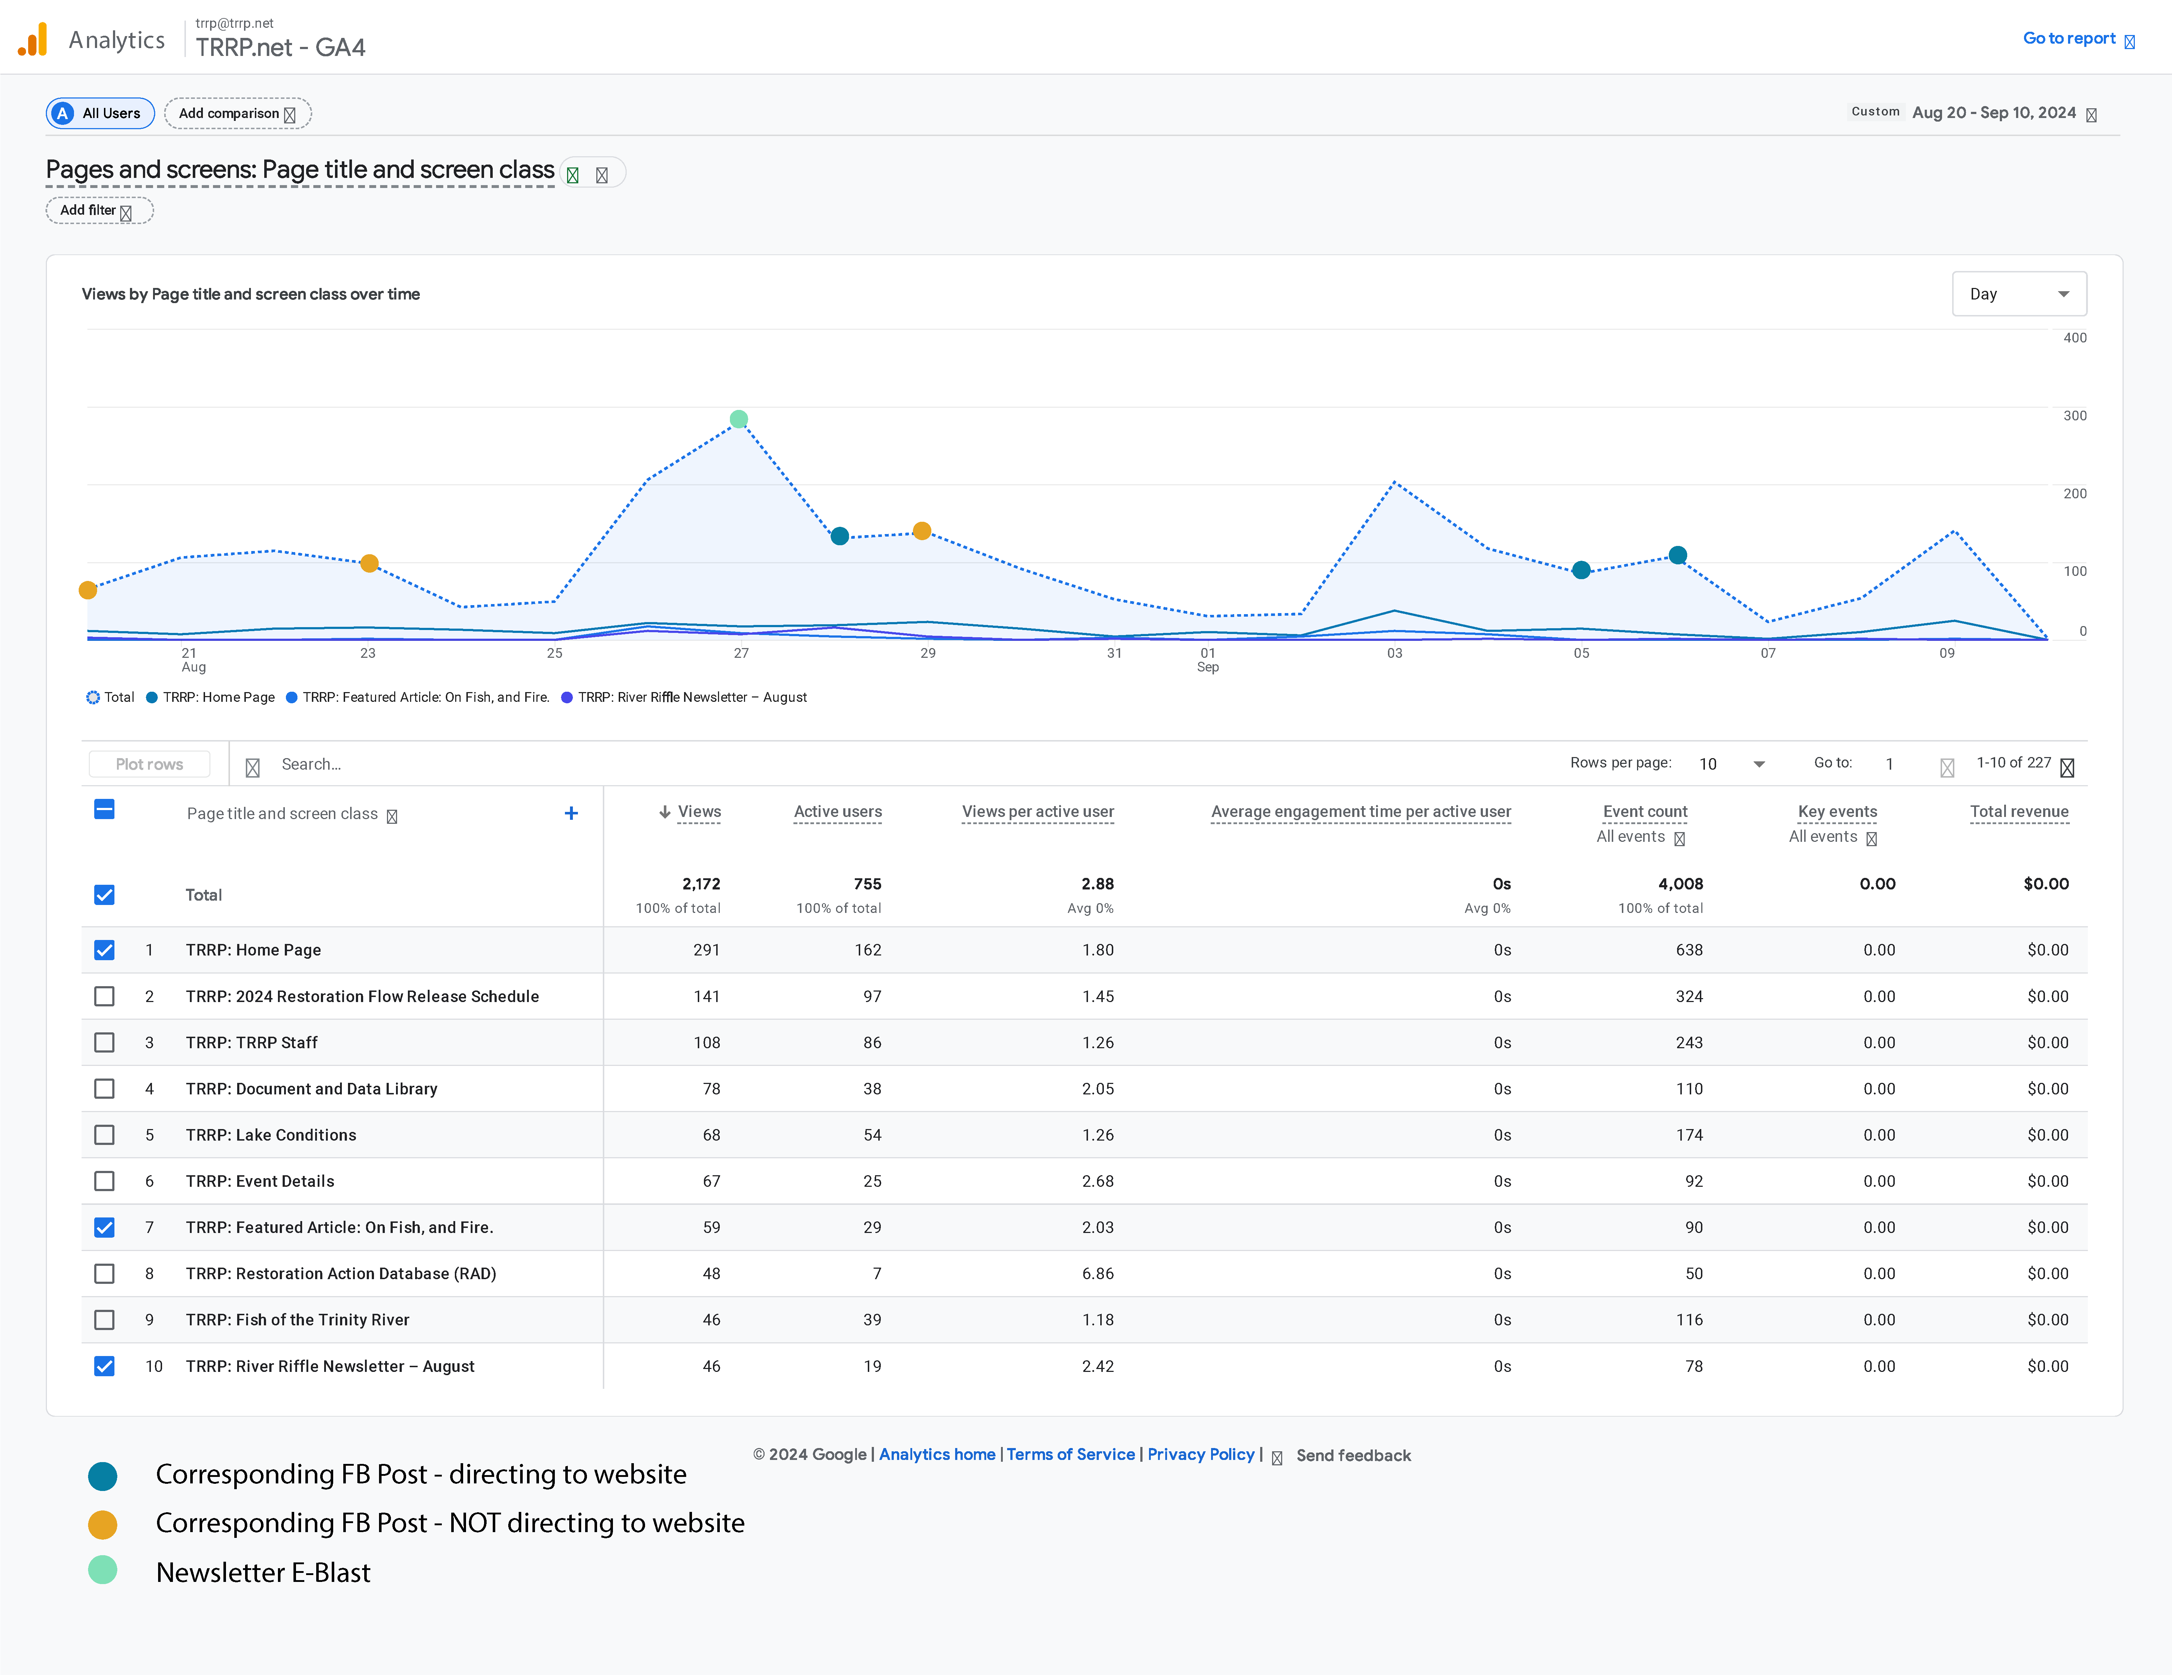
The TRRP Facebook Page is up 40 followers since our last meeting. We are currently at 1059 followers.
- Top post in the last 90 days was a post about Cal-Poly Humbolt, Klamath Basin Field Course River Tour.
- Impressions: 2196 | Reach: 1974 | Engagement: 351
- Reactions: 85 | Comments: 5 | Shares: 4
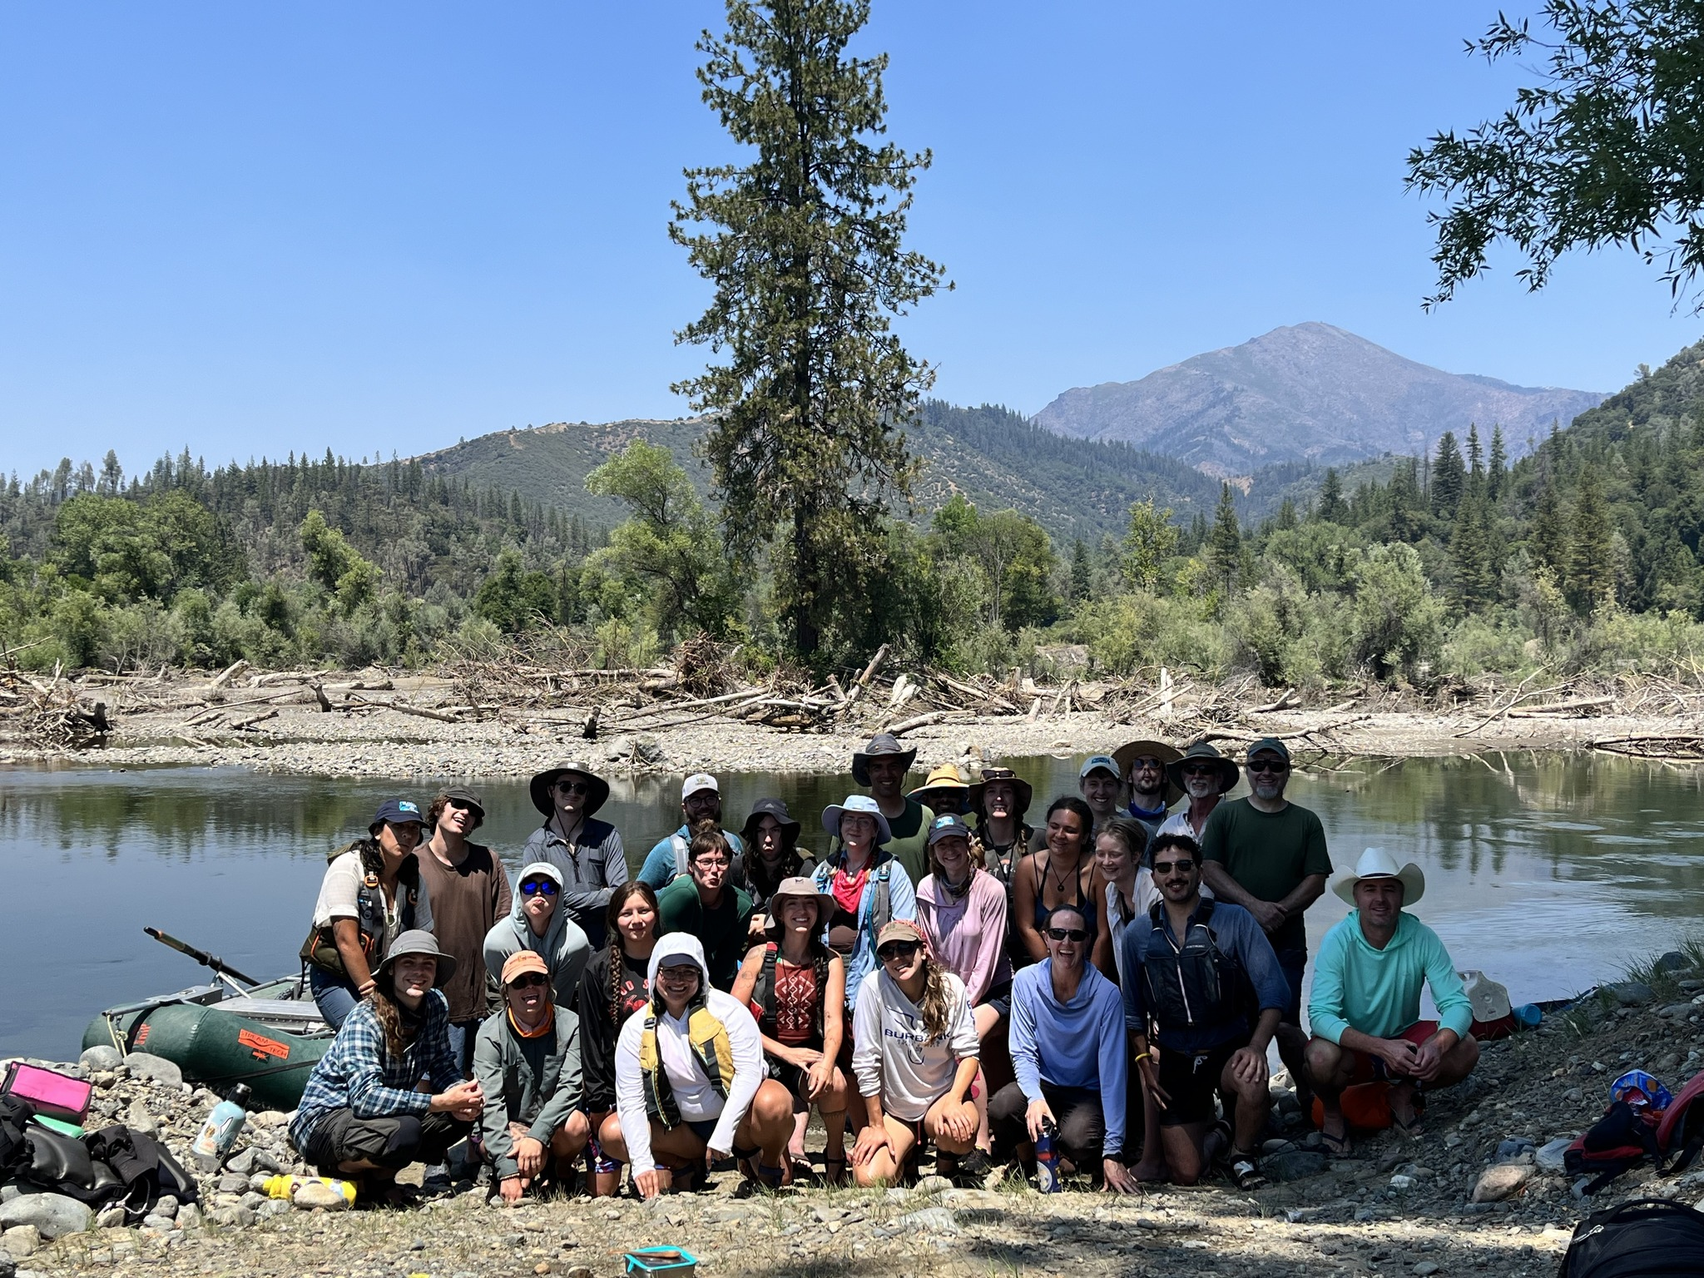

Public Events and Environmental Education
July 24: Science on the River (34 ppl)
- Derek Rupert, Fish Biologist with the Bureau of Reclamation – Northern California Area Office, “Lower Clear Creek Restoration – A Review of Habitat Restoration Efforts Occurring Over the Past 30 Years”
August 28: Science on the River (45 ppl)
- Todd Buxton, Hydrologist and Fish Biologist, Trinity River Restoration Program, “Stratification of water temperatures in pools on the Trinity River”
Educational Outreach
June 7: Hoopa Fish Fair – Fish and Fire Ecology Lesson
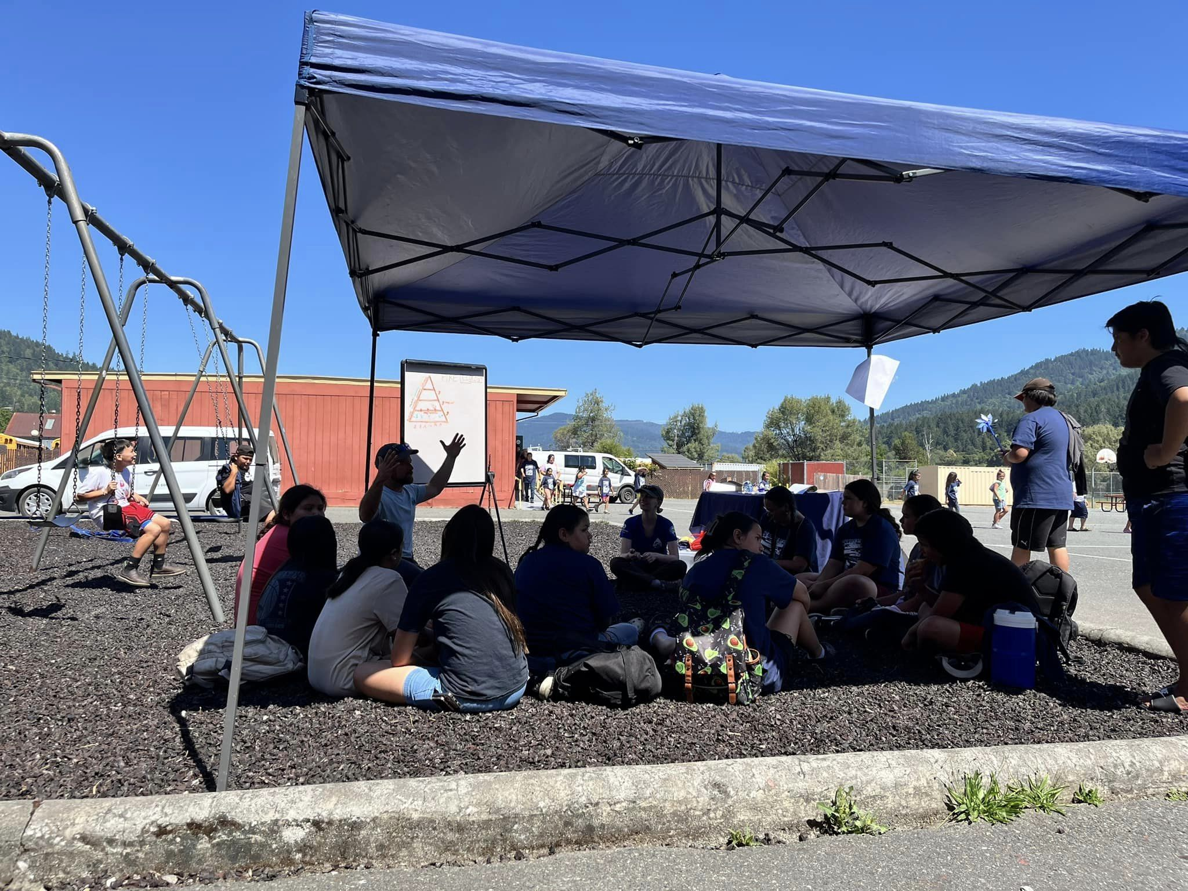
June 10: Douglas City 4th Grade Class at Oregon Gulch (4 stations – thank you Brian, Greg, Dave, Oliver and Elliot!)
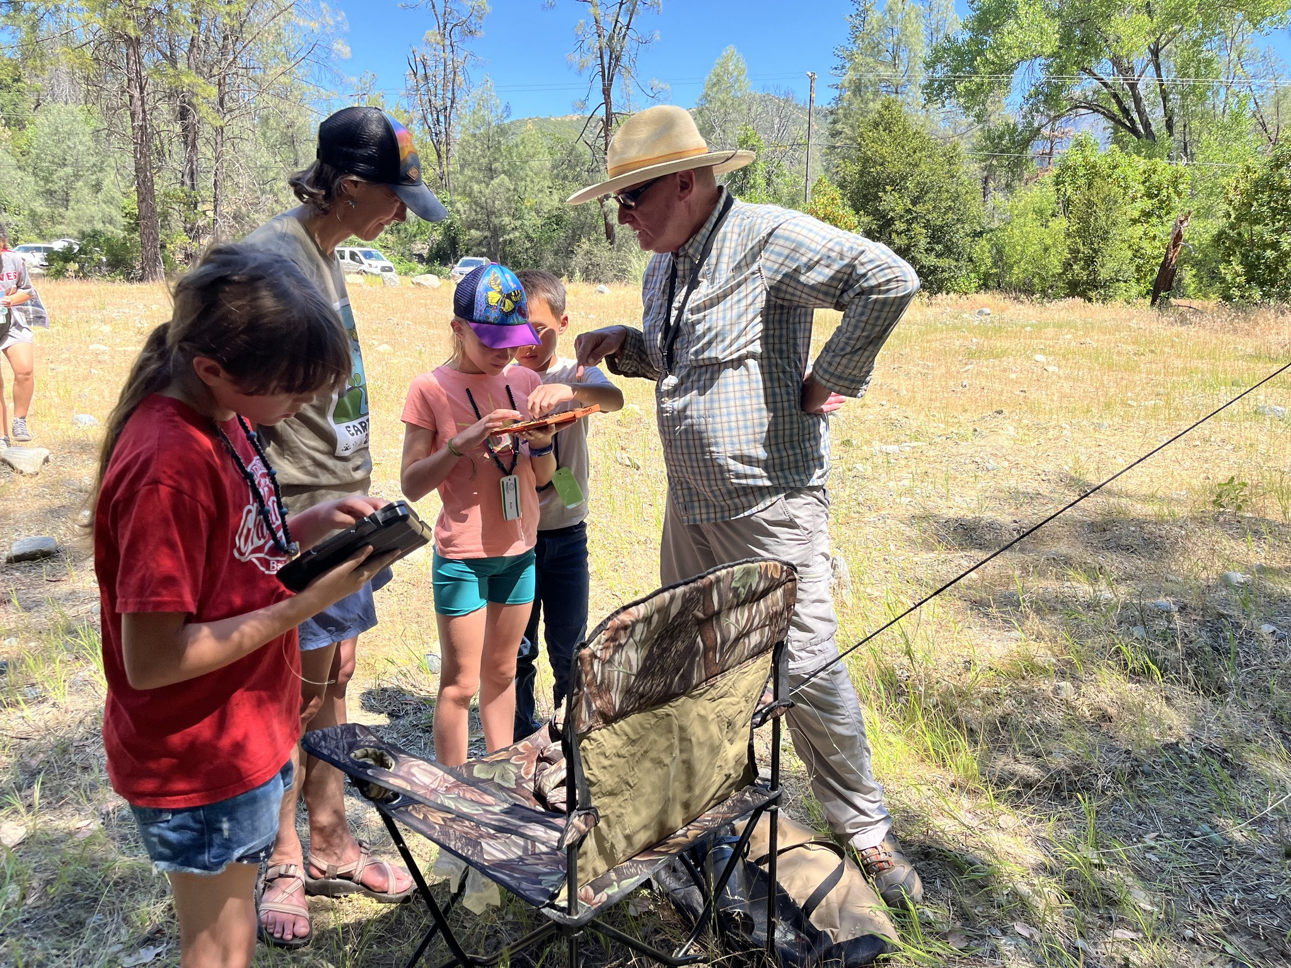
June 24: Ascend Wilderness Hatchery Tour (kinder group) – thank you Chris!
July 8-26: Weaverville Summer Day Camp
- 46 students (Grade levels: 1-6th) participated over three weeks
- 16 field trips and collaboration with 21 organizations, agencies, and community members who led 55 activities. The campers explored five different swimming holes, and they only had seven bee stings!
- In collaboration with the Fish and Wildlife Service, TRRP provided one of the educational outings. The activity was focused on riparian mapping.

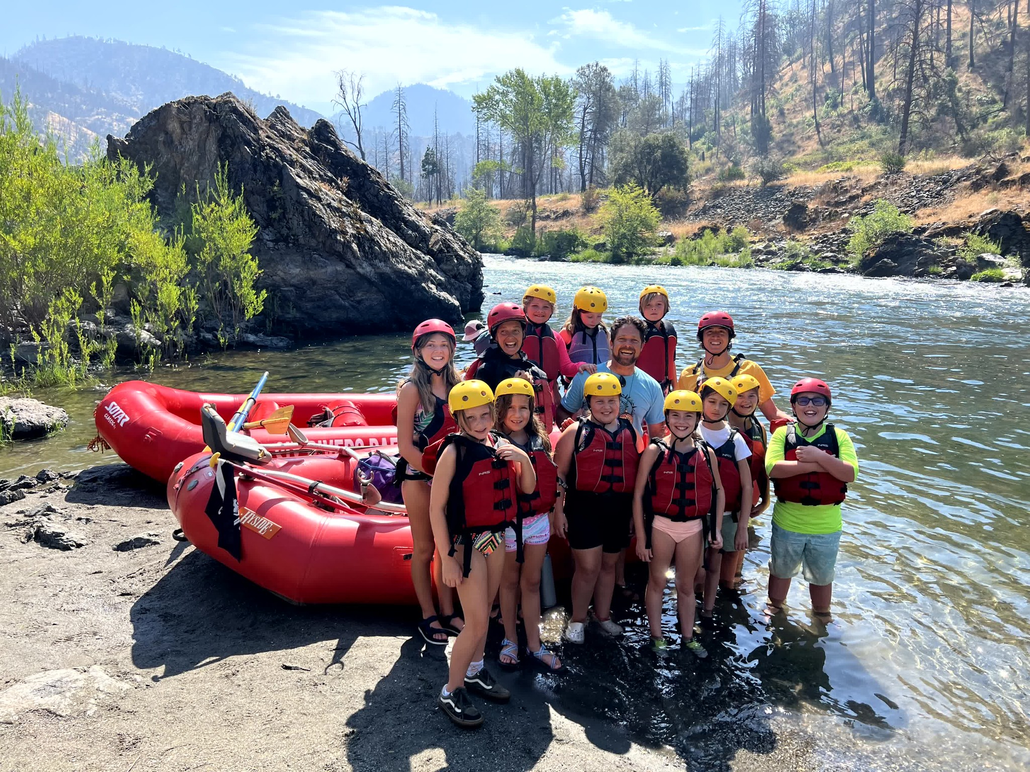
July 10: Cal-Poly Humboldt – Klamath Basin Field Course River Tour (Thank you: Seth, Ken, Patrick, Justin, Kyle D., and Greg!)
August 7: Ken Lindke met with Trinity County Supervisor Jill Cox at the JC Weir (Thank you Ken!)
August 9: Hoopa Sovereign Days (Thank you: Todd and Oliver!)
August 27: Float with Trinity County Representatives (Thank you: Seth, Ken, James, Patrick, Duncan, Justin, Kyle D., Kyle S., Chris, Greg and Wes!)

Landowner and Stakeholder Notifications
July 17: Neighborhood BBQ at Junction City Campground

Upcoming
September
- Sept 18-20: Bar 717 Environmental Camp
  - 6th Graders from 6 schools: Weaverville, Burnt Ranch, Hayfork, Lewiston, Trinity Center, Van Duzen/Ruth
- Sept 25: Science on Tap – Josh Smith and Bridger Cohen, The Watershed Research and Training Center, “Trinity Meadows – Lost and Found”
October
- Oct 5: Salmon meets Harvest Festival
  - Need Program Volunteers
- Oct 12: Trinity County Public Float – Evans Bar to Junction City Campground
  - Need Program Volunteers
- Oct 23: Mike Belchik – Klamath Dam Removal (unconfirmed)
- TBD Event 1: Environmental Flow Management Changes

November
- Nov 13: Darren Mierau from CalTrout, “Key Lessons Learned from the Klamath/Trinity programs that we’re applying to the Eel River”

Science Update
- Limiting Factors Analysis (LFA). Phase 2 (implementing the study plan) contract was awarded via NFWF to Cramer Fish Sciences (CFS). The IDT met with CFS on September 11 for a kick-off meeting. Numerous datasets were identified that TRRP partners will need to supply to CFS to ensure project success, and more are expected to be identified in the future. The project will include quarterly meetings with the IDT (at a minimum). Total project timeline is 2 years with final deliverables due August 2026. Further details will be provided in a presentation to the TMC.
- FY25 Science Priorities. In June, the TMC approved a request from the IDT to fund 3 projects for FY25, contingent upon IDT concurrence with project revisions. Revisions were made and concurrence was presented to the TMC during the July conference call. This enables monitoring of Benthic Macro-Invertebrates (BMI), initiating a model toward foodscape, and assessing riparian response to channel rehabilitation designs. Paperwork is underway for funding BMI work through USGS/CalPoly Humboldt. Other funding is expected to be provided through AFAs with tribes for calendar year 2025.
- FY26 Science Priorities. Per the Science Plan, the IDT began discussion of FY26 priorities in June. The focus is on 3 Key Uncertainties: nutrient flux, fish production, and temperature. Initially 5 questions were identified across these uncertainties, however one has been deferred until more information is available from the Limiting Factors Analysis. The IDT is requesting workgroups to write briefs on the remaining 4.
- Objectives, Targets, Monitoring and DSS. The IDT requested workgroups review Objectives and Targets in preparation for reviewing monitoring and modeling of Targets; thus far the groups have not identified any changes to Objectives, but found several refinements for Targets, plus a need to add one target to address Northwestern Pond Turtles. Objectives and Targets are then being used as a foundation for a review of monitoring (per the Science Plan) and DSS (per request by the Flow Workgroup). The IDT has listed activities needing review and parsed those reviews out to workgroups. Reviews should be completed in time to inform the TMC’s efforts next year on the FY26 budget.

In Review or Final Edits
- Gough, S. A., R. B. Smit, K. Lindke, K. De Juilio, C. Laskodi, G. Kautsky, and B. Matilton. 2024. Assessment of adult salmonid spawning in the Trinity River. Arcata Fisheries Technical Report TR 2024-71. [pending 508 compliance]
Final Publications and Reports
- Buxton, T. H. 2024. A method for scheduling Lewiston Dam releases to mimic diel variations in flow on unregulated streams. Report for the Trinity River Restoration Program (TRRP). TRRP, Weaverville, California. Available: https://www.trrp.net/library/document?id=2648.
- Buxton, T. H. and J. McSloy. 2024. Mapping active and exposed coarse bars and fine sediment deposits in the restoration reach of the Trinity River, California. Report for the Trinity River Restoration Program (TRRP). TRRP, Weaverville, California. Available: https://www.trrp.net/library/document?id=2656.
- Trinity River Restoration Program (TRRP). 2024. Trinity River Restoration Program Objectives and Targets Summary. TRRP, Weaverville, California. Available: https://www.trrp.net/library/document?id=2654.
Synthesis Reports – See Appendix II.
Incomplete:
- Cohort Reconstruction – coding nearly complete, analysis pending
- Large Wood Management – rebooted, annotated outline out for review
- Flow Synthesis – regaining momentum
- Channel Complexity

Design Reports- See Design Workgroup Report below
Environmental Reports and Findings
- U.S. bureau of Reclamation Trinity River Restoration Program (USBR-TRRP), North Coast Regional Water Quality Control Board, and U.S. Bureau of Land Management (USBLM). 2024. Sediment and Wood Augmentation along the Trinity River Restoration Reach Environmental Assessment and Initial Study. July, 2024. DOI-BLM-CA-2023-0033-EA, CGB-EA-2022-028, California State Clearinghouse No. 2008032110. USBR-TRRP, Weaverville, California. Available: https://www.trrp.net/library/document?id=2652.
Post-Implementation Reports
- Five Counties Salmonid Conservation Program (5Cs). 2024. East Weaver Creek Dam Intake Relocation & Dam Removal Project & McKnight Ditch Water Conservation Project. Report for the Trinity River Restoration Program (TRRP). 5Cs, Weaverville, California. Available: https://www.trrp.net/library/document?id=2649.
Final Data Packages
- Buxton, T. H. and J. McSloy. 2024. Active Gravel Bars 20231030 RM. Data Package for the Trinity River Restoration Program (TRRP). TRRP, Weaverville, California. Available: https://www.trrp.net/library/data?id=161.
Appendix I: Technical Workgroup Briefings
June 2024

Updates have been prepared for the Trinity Management Council by the Trinity River Restoration Program Technical Workgroup (WG) Coordinators.
Workgroup: Fish Coordinator: Chris Laskodi
The Fish Workgroup did not meet this quarter. Several topics came up during the recent IDT meeting that will be addressed in the next quarter including finalizing new targets/metrics to be incorporated into the DSS and objectives and targets. In addition, we plan on reviewing ongoing monitoring and modelling efforts.
Workgroup: Design Coordinator: Oliver Rogers
The Design Team met on August 15th, for a quarterly meeting and received updates from the State of California-Yurok Tribe Design Team, Hoopa Valley Tribe Design Group, and the Federal Design Team. Topics covered included an update on the Sawmill Gravel Processing Site Rehabilitation project. The 90% Project Report is drafted and under review and the designers are finalizing wood design calculations and updating design plans to 90%, anticipated to be complete by the end of September 2024. - The YT/State of California Design group for the Evans Bar project met on July 15th and are planning a meeting with landowners and representatives from TRRP in the coming months to address considerations/concerns with the goal of generating conceptual designs that can then be reviewed by the Design Team WG. - The Federal Design group provided an update on the land transfer that has delayed the Sky Ranch project, with an anticipated completion of 6-8 months per BLM. A meeting with landowners is being scheduled for late September 2024. - The DWR Design group provided their recommendation for the Steel Bridge channel rehabilitation site after reviewing Scott Kennedy’s (DWR) preliminary investigation from 2008 and conducting a site visit on August 9th. Due primarily to site constraints and existing habitat, the recommendation from the DWR Design group to the Design Team WG is to refrain from a large-scale channel rehabilitation project at this time and explore alternatives including large wood placement and gravel augmentation. The DWR Design group will generate a memo to describe project possibilities. - Additionally, the Design Team WG was provided with a Draft Existing Conditions Preliminary Scoping for Remaining Channel Rehabilitation Site Template. The various Design groups are continuing the scoping process upon further clarification from TRRP’s Implementation Branch.
ASCE released 2023 project award winners: Water Project – Oregon Gulch – Trinity River Channel Rehabilitation Project.
Workgroup: Flow Coordinator: Patrick Flynn
The Flow Work Group met on 22 July, 9 August, and 19 August to review flow proposals for the period between 01 Oct and 15 April, as directed by the TMC at the June TMC meeting. The group was successful in reaching consensus on a proposal submitted by Trinity County that includes implementation of the Winter Flow Variability project. The Flow Work Group briefly discussed FY26 Science Planning during its 19 August meeting. The workgroup’s proposal for Water Year 2025 will be presented during the TMC meeting.
Workgroup: Watershed Coordinator: Justin Alvarez
The Watershed Workgroup has not had need for a meeting this quarter.

Workgroup: Physical Coordinator: Smokey Pittman
One of the sub-groups formed in the May 2024 meeting (the bar area subgroup) met to discuss assignments and next steps. The bar area sub-group identified potential tools and considerations for developing gravel storage targets. At least one member of the Physical Workgroup provided peer review for TRRP’s June 2024 report, “Active and exposed coarse bars and fine sediment deposits in the restoration reach of the Trinity River, California.” Workgroup coordinator Pittman met with TRRP’s Lauren Alvares to discuss the Sediment and Wood Augmentation EA and developed a plan for her to present the EA at the next workgroup meeting, as the physical workgroup will be responsible for developing sediment augmentation plans.
Workgroup: Riparian and Aquatic Ecology Coordinator: Brad Nissen
The Riparian and Aquatic Ecology Workgroup (RAEWG) met on Sept. 3 to discuss the current proposed list of key uncertainties for FY26, reviewed and revised the Objectives and Targets relevant to our workgroup, updated the action tracker spreadsheet, and discussed the status of the Wood management plan synthesis report, as well as the RAEWG’s role in the upcoming Limiting Factor Analysis (LFA). Discussion on key uncertainties included interest in bringing in modeling suitable turtle temperatures. The workgroup is drafting language for a target specifically related to maintaining suitable temperatures for turtles and revising two other targets, intending to finalize these revisions before the November IDT and December TMC meetings. Our next meeting will be at the end of October to continue finalizing the Objectives and Targets relevant to RAEWG.
Workgroup: Interdisciplinary Team Coordinator: Ty Wallin / Eric Peterson
The IDT has been busy! The team had two full day meetings (June 25th and Sept 11th) plus one brief meeting (July 17th). For the most part, activity has focused on the items listed at the beginning of the Science Update (Limiting Factors Analysis, completion of the FY25 Science Priorities, initiation of the FY26 Science Priorities, and the Objectives-Targets-Monitoring-DSS Review). Additionally, the group has addressed tracking of recommendations from synthesis reports and mapping out future work load (which will be presented during the TMC meeting).

Appendix II: Synthesis Reports Tracking and Estimated Completion Dates
Synthesis Reports
Project No. | Brief Title | Involved Entities | Proposed  Due |  | Status
TRRP-2018-002 | Tributary Delta | Program Office (POC: Todd Buxton, TRRP) | March 2019 |  | Published in Ecohydrology 2022;e2463
TRRP-2018-003 | Fish Habitat | HVT, USFWS, YT, USBR TSC (POC: Damon Goodman, USFWS) | 2nd Q 2019 |  | USFWS portion Posted; YT portion Posted
TRRP-2018-007 | Juvenile Chinook Production | USFWS, YT, HVT (POC: Bill Pinnix, USFWS) | July 2017 |  | FINAL POSTED
TRRP-2018-009 | Cohort Reconstruction | HVT, USFWS, CDFW (POC: Ken Lindke, CDFW) | 2nd Q 2019  Cur.ETA mid-2024 |  | In progress
TRRP-2018-011 | Adult Salmon Spawning | USFWS, HVT, YT, CDFW (POC: Steve Gough, USFWS) | 2nd Q 2019 |  | Report complete; awaiting 508 compliance.
TRRP-2018-018 | Bed Mobility and Scour | HVT, USFWS (POC: Geoff Hales & Scott McBain, McBain Associates) | 2nd Q 2018 |  | FINAL POSTED
TRRP-2018-019 | Cottonwood Seed Dispersal | HVT (POC: John Bair, McBain Associates) | 3rd Q 2018 |  | FINAL POSTED
TRRP-2018-021 | Riparian Encroachment | HVT (POC: John Bair, McBain Associates) | 4th Q 2018 |  | FINAL POSTED
TRRP-2018-022 | Sediment Storage | HVT, USFWS (POC: Geoff Hales & Scott McBain, McBain Associates) | 4th Q 2018 |  | FINAL Posted
TRRP-2018-025 | Channel Complexity | HVT, USFWS (POC: Smokey Pittman & Scott McBain, McBain Associates) | August 2019  Cur ETA ? |  | Delayed- uncertain timeline
TRRP-2018-027 | Fine Sediment | Program Office, NMFS, HVT (POC: Todd Buxton, TRRP) | July 2020 |  | FINAL POSTED
TRRP-2018-032 | Water Temperature | YT, USFWS, HVT, USBR, NMFS (POC: Eli Asarian, Riverbend Sciences) | May 2019 |  | FINAL POSTED
TRRP-2018-033 | Large Wood Management | NMFS, YT, HVT (POC: Scott McBain) | April 2018  Cur.ETA 2024 |  | In progress
NA | Flow Synthesis | HVT et al. (POC: Justin Alvarez) | Mid FY 22  Cur.ETA: July 2024 |  | In Progress

Completed reports at https://www.trrp.net/restoration/adaptive-management/synthesis-reports/.

