Meeting Summary
Flow WORK GROUP
Monday July 22, 2024
TRRP Office/MS Teams

July 22, 2024: 2:00 PM

Participants
Ty Wallin (USFWS), Patrick Flynn (TC, Workgroup Coordinator), Eric Peterson (TRRP/USBR), Justin LaNier (CDWR), Todd Buxton (TRRP/USBR), Ken Lindke (CDFW), Reuben Smit (USFWS), Chris Laskodi (YT), John Bair (ARS/HVT), James Lee (TRRP/USBR), Justin Alvarez (HVT), Seth Naman (NMFS), Don Bader (USBR, meeting intro only), Kiana Abel (TRRP/USBR), Lauren Alvares (TRRP/USBR), Galen Anderson (USFS), Kyle De Juilio (YT)

Action Items Derived During the Meeting
- Patrick to return to County with some clarifications and questions
  - Risk tolerance: what propotion of time must these be met?
  - Is there flexibility of even one day for Jan, Feb maxes?
  - Is a 10-20% chance of missing acceptable?
  - Confirm if Oct-Dec is flexible
  - Can we ignoring average impacts for sync period? … it either happens or not.
  - Table shows 0 impact for December because there were no syn events in the analyzed history for EA in Dec. But they could happen, so the max loss numbers should be applied to December too.
  - But consider Dec-Jan-Feb all one period with one instance of days lost… if total of 6 days lost across the period, makes it easier to do a sync flow
- De Juilio, Lindke, and Laskodi to be a subcommittee working with the County on ca. weekly basis to improve understanding and refine proposal.
- Workgroup to have one more full meeting prior to August deadline.

Summary of Meeting
Bader joined meeting briefly to make sure the group was in full understanding of the task at-hand. Bader has been in contact with regional leadership. Have EA from a couple years ago ready and being reviewed. Karl Stock will hold off on signing until proposal at TMC in September. Don’t want competing proposals, need Flow WG to bring a consensus proposal to TMC, can be scaled down within the EA. TMC needs a chance to vote on a workgroup proposal. In the future, flow management will be governed by a new EIS/ROD. For WY25, need an interim proposal.
Lindke asked for clarification on what fits within the EA… could volumes shifted be changed (reduced)?
Bader said yes, just could not exceed.
De Juilio: noted County letter this morning requested elevated flows Oct 1 to Dec 1 … are those outside the EA? Bader: haven’t’ seen letter yet, but sounds like it.
Peterson: is correct to characterize as bookends with 2000 ROD as low end, new EA as high end? Bader: that is appropriate.
Able: is there a plan for consensus at TMC level? Bader: will work on pre-meeting outreach.
Bader: reconsultation on track for CY2025 and will bring winter flows. Reclamation is committed to doing the right thing for the fish.
Bader left the meeting.
Patrick: agenda review and check.
Prior WFV proposal
Lindke: reviewed, general patterns. Sync event Dec 15-Feb.14. Elevated baseflow with 2 check-in points per B120s Feb 15-Apr15 and Mar15 to Apr15. Additional flows per B120 forecasts. Same proposal was advanced for WY22.
De Juilio: designed to provide benefit found in natural hydrographs and volumes are scaled to natural hydrograph patterns.
Lindke: yes, lots of benefits, covered in prior reports. Trying to not expend time on what we already know and save it for County proposal.
Flynn: Will present county proposal. Wearing multiple hats and has been trying to help county get a proposal together. Lindke as outgoing coordinator offered to help review and suggest on making an actionable proposal.
New proposal not based on volumes, but on fishable days. Stipulations: 1. Used table from EA and roughly cut numbers of lost fishable days in half (though averages were raised a little). 2. Flow sync supported for just one sync and minimize descending limbs. 3. Consider sync in Oct – Dec 1 timeframe to shift more water.
Flynn continued: Review/discussion with Lindke has shown that this fits the proposal that the county voted against last year. However, the stipulations were arrived at from a different perspective. Thanked Lindke for digging in for this recognition.
Discussion
De Juilio: does include winter sync, but with maximum rampdowns. Looking at fishable days, would fit up to a Wet Year with Sync Flow.
Flynn: no restriction based on water year type or volume, purely can the fishable days criteria be met.
Laskodi: analysis suggests that January/February days lost are either zero or a lot, not many scenarios that can be in between.
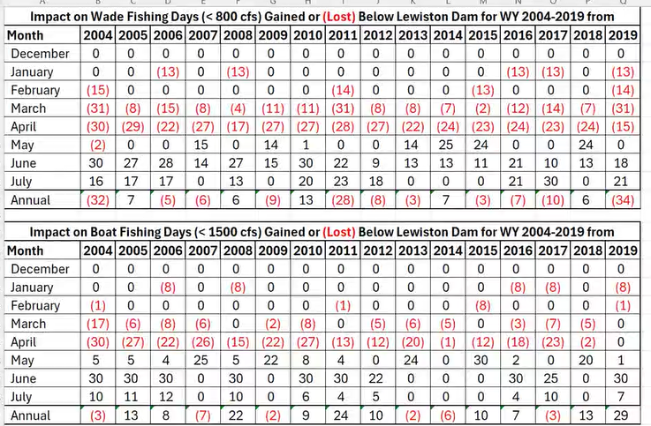
If we get a sync, then will not be able to meet the county’s numbers using the synchronized flow schedule developed thus far. Number of days impacted can be reduced by reshaping the synchronized flow schedule, but it still an all or nothing impact.
Laskodi question to Flynn: are those numbers at all flexible?
De Juilio: Jan/Feb, meets except when syn flow happens. March mostly meets. April is the problem.
Naman: we have a process for bringing proposals forward that was developed through the refinements process and development of the program document, science plan, and objectives/targets document. These documents and the processes described in them were agreed upon by all parties, including the County. Goals: restore river, restore fishery. Obj./Targ. Give Objectives to meet those goals. Objectives do not include fishable days. County is bringing a new Objective outside of that agreed upon process that may be opposed to goals/objectives of restoration.
Peterson: Last year, kept asking for constraints, TMC motion specified time for constraints. So TMC has effectively legitimized hearing those constraints in addition to Obj/Targ. Question now is can we pull something forward within those constraints.
Abel: just what are fishable days?
De Juilio: It was clearly defined in the 2000 EIS, but the definition is imperfect. (definition is copied to chat, >1,500 cfs is unfishable for boating, and >800 cfs is unfishable for wade fishing). Did not consider other weather conditions that might complicate fishing anyway or any number of additional factors.
Buxton: we have in front of us the County starting a process that this group should accommodate in collaboration… it is the only way we can move forward with something. Difficult without the fully county personnel with power to decide within the room. Also, county would look better if it updated definitions of fishable days, considering flow, turbidity, etc. Move forward together without just pointing out what is wrong.
De Juilio: fishable days will always be subjective based on individual perspectives. Also, county may be discounting value of May/June fishing. We have had people come into the office asking when the river will come down enough for fishing. This proposal doesn’t give consideration to gains in fishing toward summer. We need real socioeconomic data to make decisions on real information rather than making decisions based on individuals worrying.
Buxton: we don’t have the luxury of more data at the moment. Need to move forward. Hearing ideas that seem to reject County proposal, rather than how to maybe work with it. Can we accept in draft and work forward?
Laskodi: County comes close to something functional. Of course can meet if we use less water but point is to move a significant amount of water. Not sure we can do both moving the water and meeting County.
De Juilio: We want to hold to the volumes and actions (i.e., synch flows to 6,500 cfs and elevated baseflows) described in the EA. How to meet County? Sync flow mechanics with ramp down rates if we hit 6500, then will take 4 days to return to baseflow.
Lindke: just a little flexibility might go a long way to fitting sync events (January). And not the entire 4-5 days are lost from flows… 2-3 of those may be lost anyway because of turbidity because the synchronized trigger is large enough that natural flows everywhere will be high.
Lindke: with full implementation of WVF and modification of the synchronized flow schedule, 90+ % chance that will meet County stipulations. Small chance would not. If County is willing to accept that small chance, then will be much easier to move on. On other hand, if everything is hard yes or no, then stipulation 3 already misses the EA (fall flows).
De Juilio: regarding the County’s request for elevated flows Oct-Dec, if we had elevated flows during peak spawning, we would need to keep them up until fish hatch (as late as March) or we would dewater redds. Also, fully maximizing ramp-up and ramp-down rates and maintaining the sync volume would force 600 cfs or so through remainder of sync period.
Flynn: Oct-Dec period has been a discussion with Trent for a while. He included it in the memo to see if it is feasible or not. Understands the numbers need to be checked with County for flexibility, particularly the hard number 4 for Jan, Feb max boat day loss.
De Juilio: yes 4 is very difficult, 5 more reasonable. Wade fishing days in March are impossible under WFV in wetter years (120+ TAF).
Laskodi: might be useful to go through the decision tree to see when numbers are violated. Already calculated probabilities for the different pathways (for a fly fishing club presentation).
De Juilio: Jan 7 days loss to wade is also very difficult, ramping rates pretty much require 8.
Laskodi: showed chart with probabilities from the record. 38% of years have a sync event. Feb forecast 72% Crit dry or Dry (uses 90% forecast). Laskodi continued to describe the diagram below. Explained why numbers don’t quite add up… had to do with high probability of staying within Crit Dry by the 90% forecasts.
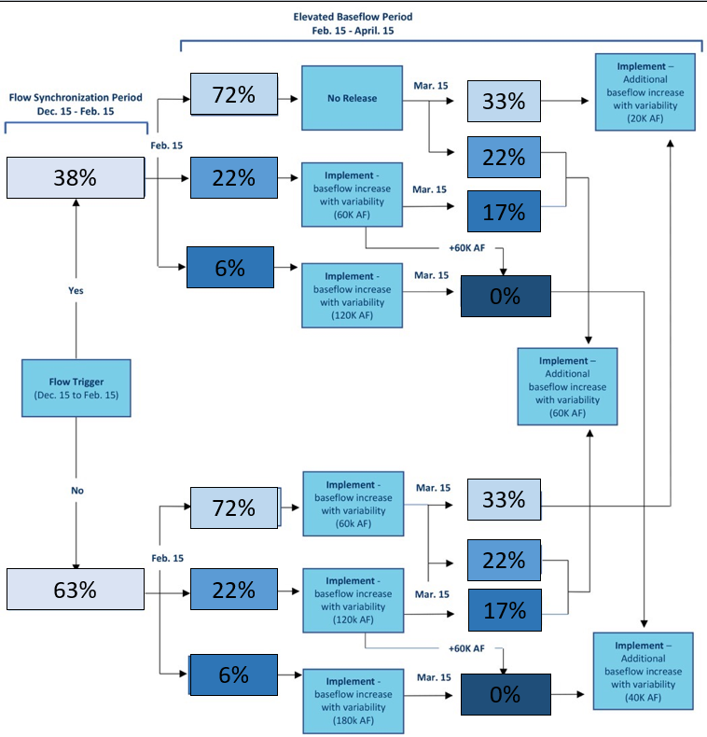De Juilio: calc’ed earlier, about 20% not meeting the March days criteria with WFV as is. What is the County’s tolerance for risk.
Lindke: if max ramp up and down rates, just go to sub-daily peak of 6500, end up with 4.25 days over 1500 cfs.
Flynn: specifically what can he take to County leadership to continue conversation?
- De Juilio: risk tolerance: what proportion of time must these be met?
- De Juilio: is there flexibility of even one day for Jan, Feb maxes?
- De Juilio: is a 20?% chance of missing acceptable? Keep in mind these are all based on historic record, always some chance of something else going down.
- Flynn: confirm if Oct-Dec is flexible.
De Juilio: showed hydrographs for sharp sync peaks
Buxton: those sharp peaks may cause more problems with sediment sorting on the bed.
Peterson: asked for clarification because ramping rates are not as sharp as natural storm events.
Buxton: rapid flow drop will cause sediments to drop rapidly.
De Juilio: if volume of sync period is reduced, then volume gets spread into elevated baseflows, thus causing more March impact.
Lindke adds to list:
- Ignoring impacts of averages for sync period? … it either happens or not.
  - If no sync, then 0 loss
  - If sync, then max loss.
  - No in-between.
- Table shows 0 impact for December because there were no syn events in the analyzed history for EA in Dec. But they could happen, so the max loss numbers should be applied to the whole synch period, not calendar months. Also important to note that the transition between synch period and elevated baseflows is mid-February, so calendar month impacts get wonky there too.
Lindke repeated, when synch flow impacts happen we can get close to the County’s request (5-days)
De Juilio: points out never will have multiple impacts across Dec-Jan-Feb if only have one sync. So if you look at average impact across those 3 months, then the average does fit County proposal.
- Flynn/ De Juilio: consider Dec-Jan-Feb all one period with one instance of days lost… if total of 6 days lost across the period, makes it easier to do a sync flow.
Buxton: if tributary accretion is keeping flows high downstream, does that count against us? De Juilio: no, EA (and 2000 EIS) limited the lost days to the Lewiston area only for this reason.
Flynn: upcoming meetings? One more before the Aug deadline?
De Juilio: would be glad to help with County
Peterson: suggest some sort of interaction at least weekly, and at least one full WG meeting before next deadline.
Lindke: would also be glad to help;
Peterson: is WG comfortable with De Juilio/Lindke working (subcommittee) with the County on WG behalf with 1 full WG meeting before next deadline. Group had consensus for it.
De Juilio: added Laskodi into the subcommittee.
Adjourned 4:10pm

