

Trinity River Restoration Program

January 11, 2024

VIA ELECTRONIC MAIL ONLY

Memorandum

To: Don Bader, Chair, Trinity Management Council

From: Ken Lindke, Flow Work Group Coordinator

Subject: Water Year 2024 Revised Winter Flow Variability Recommendation

The Flow Work Group (FWG) presented its technical recommendation on flow management for Water Year 2024 (WY24) to the Trinity Management Council (TMC) at their quarterly meeting in Weitchpec on September 19th, 2023. The recommendation was to implement winter variable flows (WVF) using the same methods and flow schedules approved by the TMC for WY23, as described in a memo from the FWG to TMC and TMC quarterly meeting minutes from the September and December of 2022 and 2023. A motion to implement WVF in WY24 failed, and a second motion to implement 300 cfs baseflow from October 14, 2023 to April 15, 2024 also failed. I, as the FWG coordinator, after conferring with colleagues, could not identify a path forward for WY24 flow planning that would not conflict with the will of TMC. WVF was not recommended and proceeding with spring releases after April 15th would require implementation of 300 cfs baseflow until mid-April, which TMC also did not support.

The FWG returned to TMC at their quarterly meeting in Redding on December 5th, 2023, to seek further guidance as described in meeting minutes. In the days prior to the December meeting, Trinity County provided a letter to the TMC requesting consideration of an alternative set of flow recommendations developed by Joe Polos, a former TRRP scientist and a retired USFWS employee. Following a presentation and discussion, Trinity County requested that the FWG work with County technical staff to evaluate their alternative proposal, make adjustments as needed, and return a revised technical recommendation for WVF implementation to the TMC by January 11th. This memo is provided to fulfill that request and should be considered the FWG technical recommendation for WY24 flow management through 14 April, 2024. The following specific guidance was also provided from representative Gogan or from the letter provided by the County to meet the County’s objectives for recreation.

- From February 15th to March 14th, do not exceed 1,200 cfs release from Lewiston Dam
- Preferred releases are closer to 800 cfs (1,200 and particularly 800 cfs are intended to reduce impacts to fishing opportunity)
- Releases from March 15th to April 14th can exceed 1,200 cfs (an upper limit was not specified)
- WVF release volumes should be scaled to water year type
- No elevated flows should be proposed prior to February 15th
- Any proposal should be accompanied by Decision Support System results
- Address concerns regarding protecting carryover storage in Trinity Reservoir

The FWG met on December 20th, 2023, to consider the County’s alternative flow proposal and develop a recommendation that would meet the above guidelines. Initial conversation centered around Joe Polos’ proposed hydrographs, which were ultimately not advanced as part of this recommendation. That proposal was incomplete in not providing a mechanism to determine which hydrograph to select in February, was not developed to meet specific biological or physical objectives, and it was unclear if it would be covered by the Environmental Assessment (EA) developed for the WVF project.

The revised recommendation from the FWG is shown in Figure 1, which follows the decision tree shown in Figure 2. This recommendation preserves a limited set of components from the WY23 and WY24 recommendations with modification to one component to reduce impacts to fishing opportunity in March and April. A 60k acre-feet (AF) release from February 15th to April 14th would occur regardless of the water year type forecast in February, then releases from March 15th to April 14th would be determined by the B120 forecast. If the March B120 forecasts a Critically Dry water year, no changes to the schedule would be made. A Dry water year forecast would result in an additional 20k AF release, and a Normal or wetter forecast would result in an additional 60k AF release. This revised recommendation is intended to strike a balance between the FWG consideration of the best available science (i.e., previous recommendations for WY23 and WY24), the desires of Trinity County provided in the bulleted list above, and to ensure that the action would be covered under the draft EA developed in 2022. Specifically:

- By keeping volumes and partial implementation of the decision tree from the EA, this action would be considered analyzed and would be covered under a signed Finding of no Significant Impacts (FONSI)
- It scales to water year type by considering the March B120, ranging from 60k AF (Critically Dry) to 120k AF (Normal or wetter)
- Based on historic record (2004-2019), the full volume proposed to be moved into winter in WVF project would be achieved in 50% of years
- As was well documented in the WVF report, protecting carryover storage in Trinity Reservoir is guaranteed by using the conservative B120 forecast (90% exceedance)
- The predetermined 60k AF release Feb-April would provide certainty now to anglers and river users on flows through mid-March, with only two possible alternative increases in March
- Releases remains below 1,200 cfs and almost entirely below 800 cfs through February 15th
- Critically Dry March B120 forecast would provide 28 days less than 1,200 cfs (3 days above)
- Dry March B120 (+20k AF) forecast would provide 16 days less than 1,200 cfs
- Normal or wetter March B120 forecast would provide more fishing opportunity (11 days less than 1,200 cfs vs. zero) compared to previous WVF proposal.
- Releases would be 872 or 1,169 cfs on April 1st for the fly water opener (would have been up to 1,764 cfs).
- Peaks are scheduled to occur on weekdays to reduce impacts to angling (assuming more angling occurs on weekends).

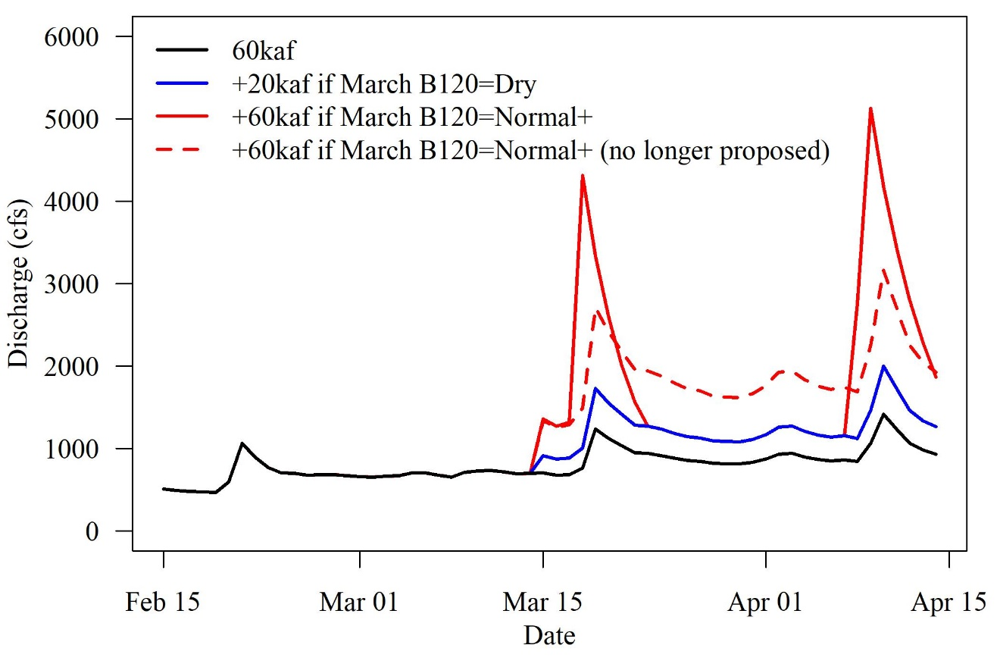
Figure 1. Proposed hydrograph components for releases from Lewiston Dam from February 15th to April 14th, 2024. The solid black line depicts a 60k acre-feet release that would occur regardless of water year forecast, and the solid blue and red lines depict 20k and 60k acre-feet releases that would occur if the March B120 forecast is for a Dry or Normal (or wetter) water year. The dashed red line depicts a 60k acre-feet release that was included in the original FWG recommendation that is no longer under consideration.

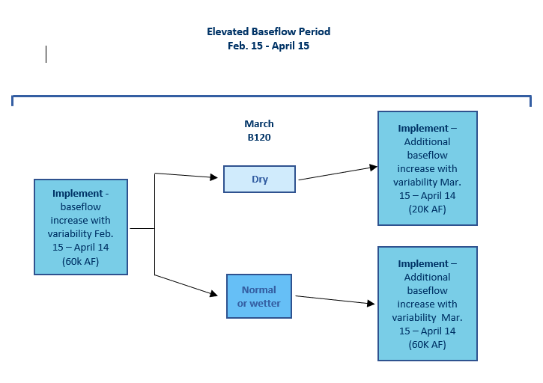
Figure 2. Decision tree for implementing winter variable flows from February 15th to April 14th, 2024. Hydrographs for each component are shown in Figure 1.

While this revised recommendation preserves some portion of the original WVF proposal, it is important to recognize that as a reduced action it can only be expected to meet objectives of the WVF proposal under limited conditions. Specifically, we should only expect to meet objectives and have potential for measurable results if there is no trigger event during the synchronized flow period, the February B120 90% forecast is for a Dry or Critically Dry WY, and the March B120 90% forecast is for a Normal or drier WY. One of the most important parts of the original WVF proposal is the volume of water moved out of the spring release to reduce temperature suppression of growth for juvenile salmonids. By limiting the volume, this benefit is substantially compromised in Wet and Extremely Wet WYs as detailed in the WVF report. These are also the water year types in which temperature suppression is greatest, and thus the benefit of moving water is the greatest of all water year types. In addition, excluding the possibility of a synchronized flow event removes the benefit of scouring flows to food web development and routing of sediment from tributaries in the upper river.

Analyses of recommended flow schedules

Trinity County requested that any new flow recommendation be evaluated with the Decision Support System (DSS) used to make annual flow management decisions for the spring release. The FWG decided to present alternative analyses for a few reasons. The current DSS is focused on and has only been used for flow management decisions for the spring release period, starting mid-April. Consequently, it includes several analyses that are not relevant to flow management earlier in the year (e.g., riparian and Foothill Yellow-legged Frog recruitment) or objectives that are not possible to meet with a limited WVF implementation (i.e., geomorphic bedload transport). However, results of analyses that are relevant to winter releases are presented here. The original WVF proposal and the reduced action recommended here preserve sufficient water volume for the spring release to meet objectives for that flow management period (Abel et al. 2022). The FWG will develop and recommend flow schedules for the period starting April 15th in the coming months.

Before presenting modelling results for the reduced recommendation, it is important to note that a key objective of the original WVF recommendation was increased food production from scour and inundation, but it was not analyzed directly in WVF report (or here) due to lack of models or empirical data. However, monitoring was in place for the WY23 implementation and sample collection is planned for WY24 if elevated winter baseflows are implemented. Funding would need to be provided to process samples and analyze data. In addition, the modification made to the 60k AF component for March 15th to April 14th to reduce impacts to anglers and other river users (i.e., reducing baseflow between peaks) also reduces the area of sustained inundation, which in turn is expected to reduce food web productivity relative to the original recommendation.

Analyses and some language presented here were taken directly from the WVF report (Abel et al. 2022) for years in which observed hydrologic conditions and B120 forecasts would have resulted in the same volumes of water moved into the winter period. Specifically, years in which no trigger event occurred during the flow synchronization period, the February B120 forecasted a Critically Dry or Dry water year, and the March B120 forecasted a Normal or drier water year. These conditions occurred in eight of the sixteen years (50%) analyzed. Detailed methods and additional information can be found in Abel et al. (2022). Here we present results and interpretations relevant to the limited set of years. Citation for Abel et al. (2022) should be considered implicit throughout and some language was used verbatim without quoting.

Adult holding and juvenile rearing temperature targets
Under ROD flow management and the proposed WVF, adult holding targets are met in most years and exceedances are small when they occur (Figure 3, Table 1). Larger exceedances of the July 1st to September 14th 15.6° C target at Douglas City were estimated to have occurred under the WVF scenario in a few years but were of a similar magnitude to observed exceedances under current ROD flow management. The largest differences occurred in 2005 and 2010, when degree day exceedances for WVF were 6.5 degree days in both years at Douglas City. In 2005, the largest 1-day exceedance was 1.2° C (modeled temperature of 18.8° C) and exceedances were more than 1° C for only five days. In 2010, the largest 1-day exceedance was 0.6° C. Temperatures in this range do not pose a threat to holding spring Chinook Salmon and only occur for a short time, thus the recommended WVF scenario is not expected to have a significant impact on adult salmonids. Observed and estimated exceedances for the two later targets are identical between WVF and ROD because flows are always returned to summer baseflow prior to September 15, so temperatures are the same between the two scenarios.

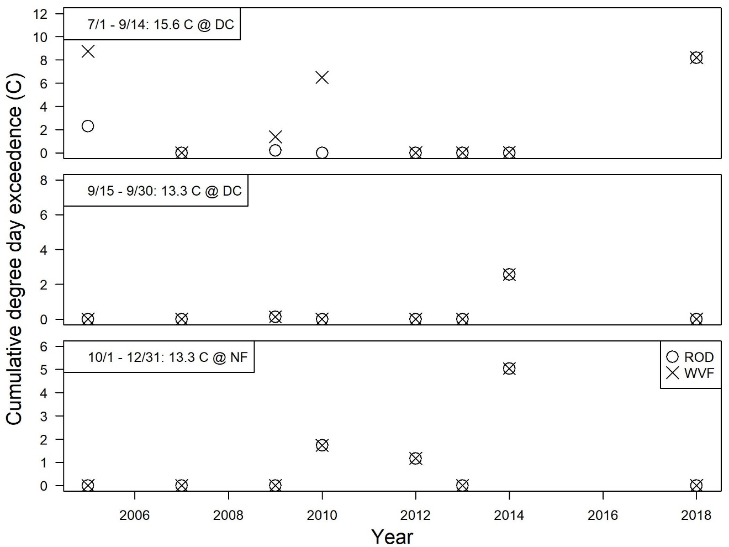
Figure 3. Timeseries of degree day exceedances of adult spring Chinook Salmon holding temperature targets for the Trinity River at Douglas City (DC) and the North Fork Trinity River (NF) for revised winter variable flow (WVF) recommendation and ROD flows.

Table 1. Annual degree day exceedances of adult spring Chinook holding and deviations of juvenile rearing targets based on RBM10 temperature modelling of the mainstem Trinity River for the revised winter variable flow (WVF) recommendation and ROD flows.

Moving water volume out of the spring releases is expected to result in warmer temperatures earlier in the year, which is an intentional outcome of the WVF recommendation to reduce temperatures suppression of growth. Negative deviations are less under the WVF scenario, meaning the river is warmer and spends less time in the suboptimal cold temperature range (Figure 4, Table 1). Positive deviations are greater under the WVF scenario (Figure 4, Table 1), which is an expected result of returning to summer baseflow earlier. Closer examination of daily modeled temperatures (available upon request) indicates that exceedances are almost entirely attributed to temperatures in July and rarely exceed 20° C. Nearly all juvenile Chinook Salmon have emigrated out of the restoration reach by July and maximum temperatures that would have the most detrimental effect on juvenile salmonids that are present year-round occur later in the year when there is no difference between the WVF scenario and ROD flows. Consequently, the increased positive deviations from the juvenile rearing temperature target from implementing the WVF scenario are not expected to have a substantive negative impact on rearing juvenile salmonids as compared to ROD flow management.

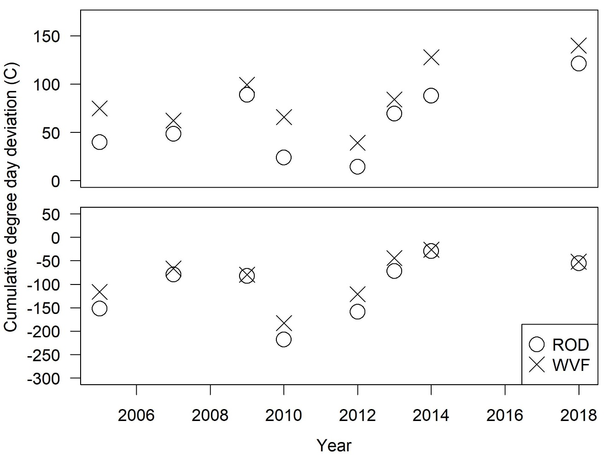
Figure 4: Timeseries of degree day deviations of juvenile rearing temperature targets for the Trinity River at the North Fork Trinity River, April 1st to July 31st, for revised winter variable flow (WVF) recommendation and ROD flows. The upper panel shows cumulative exceedances above the upper target of 16.5° C, and the lower panel shows cumulative deviations below the lower target of 13.0° C.

Salmonid growth, biomass and abundance
Abel et al. (2022) evaluated the difference in biomass and abundance of juvenile Chinook Salmon using the Stream Salmonid Simulator (S3), which requires water temperature and streamflow as physical inputs. The model outputs the number of fry (≤50 mm fork length), parr (50 < fork length ≤ 90 mm) and smolts (fork length > 90 mm) emigrating downstream of Pear Tree and Weitchpec. Smolt abundance results are included in the total abundance and biomass for Tables 2 and 3, but not reported here because the small numbers of smolts produced in the S3 model runs result in large differences by percent that are not readily interpreted (e.g., a difference between 5 and 10 smolts would be a 100% difference). Differences in smolt abundance were positive across years on average (the revised WVF recommendation would result in more smolts). Water year 2005 was not evaluated because the first water year in the S3 input files is 2006.

Overall, the revised WVF recommendation was estimated to increase total biomass with little change to total abundance at both Pear Tree and Weitchpec (Table 2 and 3). This can be interpreted such that WVF results in overall larger Chinook Salmon outmigrants in the Trinity River, which is a desired effect and expected to result in higher survival (Pearcy 1992; Beamish and Mahnken 2001). Results at Pear Tree show a decrease in fry and an increase in parr, which reflects improved growth conditions because more fish are moved into the larger size category (parr vs. fry). At Weitchpec, the percent decrease in fry was equal to the increase in parr, so the higher total biomass likely reflects an increase in smolts.

Table 2. Differences in S3 modelled abundance (%) and biomass (%) of juvenile Chinook Salmon fry and parr between the revised WVF recommendation and ROD conditions at Pear Tree upstream of the North Fork Trinity River. Differences in smolt abundance and biomass are included in totals, but not shown separately.
Water Year | Fry Abundance | Parr Abundance | Total Abundance | Total Biomass
2005 | NA | NA | NA | NA
2007 | 2.0% | 2.3% | 2.2% | 6.9%
2009 | 0.7% | -0.9% | -0.1% | -0.8%
2010 | -6.6% | 8.5% | -2.5% | 2.8%
2012 | -6.1% | 9.0% | -0.6% | 4.3%
2013 | -2.7% | 2.0% | -0.7% | 3.1%
2014 | -1.4% | 0.9% | -0.7% | -1.2%
2018 | -4.2% | 5.5% | -1.4% | 1.6%
Average | -2.6% | 3.9% | -0.5% | 2.4%

Table 3. Differences in S3 modelled abundance (%) and biomass (%) of juvenile Chinook Salmon fry and parr between the revised WVF recommendation and ROD conditions at Weitchpec. Differences in smolt abundance and biomass are included in totals, but not shown separately.
Water Year | Fry Abundance | Parr Abundance | Total Abundance | Total Biomass
2005 | NA | NA | NA | NA
2007 | 4.1% | -1.5% | 1.1% | 6.1%
2009 | 5.4% | -2.0% | 1.2% | 2.3%
2010 | -1.0% | 2.0% | 0.1% | 2.2%
2012 | -4.2% | 4.4% | -0.1% | 4.0%
2013 | 2.5% | 0.4% | 1.4% | 3.8%
2014 | -5.1% | -0.6% | -2.7% | -2.8%
2018 | -6.5% | 2.2% | -2.2% | -0.5%
Average | -0.7% | 0.7% | -0.2% | 2.2%

Fish growth integrates many factors, including food consumption, temperature, metabolic and physical demand, fish density, competition, and other factors. Reducing temperature suppression of growth in the spring due to elevated dam releases is a primary objective of the WVF. While the S3 model incorporates the effects of temperature on growth, among several other factors, Abel et al. (2022) isolated the effects of temperature by combining modeled water temperatures from RBM10 with a fish growth model, assuming a constant food ration of two-thirds of the maximum consumption rate. The result is the average mass of an individual fish at the end of June if it had reared near the lower extent of the restoration reach prior.

The WVF project would result in greater end-of-June Chinook Salmon mass than baseline conditions (Table 4). Increases in mass ranged from 1.1 g to 1.7 g (average 1.5 g). The resulting differences in mass as a percentage of end-of-June Chinook Salmon size ranged from 6.6% to 11.8% (average 9.3%) over the eight years evaluated. These results also align with the S3 model results, in general showing larger Chinook Salmon resulting from shifting water into the winter months, because not doing so results in unnaturally cold water that does not warm in a typical seasonal pattern in the spring months.

Table 4. End-of-June mass (g), and difference between the proposed Trinity County compromise and the baseline conditions (Abel et al. 2022).
Water Year | Mass (g)  Proposed Compromise | Mass (g)  baseline | Difference (g) | Difference (%)
2005 | 14.7 | 13.1 | 1.6 | 11.1
2007 | 17.2 | 15.5 | 1.7 | 10.0
2009 | 15.9 | 14.8 | 1.1 | 6.8
2010 | 12.6 | 11.1 | 1.5 | 11.8
2012 | 12.5 | 11.2 | 1.3 | 10.5
2013 | 17.3 | 15.6 | 1.7 | 9.7
2014 | 20.9 | 19.5 | 1.4 | 6.6
2018 | 17.7 | 16.3 | 1.4 | 8.1
Average | 16.1 | 14.6 | 1.5 | 9.3

Habitat availability
The first thing to recognize regarding habitat availability is that increasing physical habitat (i.e., suitable depths, velocities, and distance to escape cover) is not an explicit objective of the WVF project or the revised WVF recommendation for WY24, and the analysis results presented below only considers physical habitat. The primary habitat benefit in winter from elevated winter flows is to food production, for which we do not currently have explicit models. These habitat results are provided here for completeness and transparency. While the original WVF proposal resulted in an average increase of physical habitat availability of ~8%, the compromised proposal shows increase of less than 1%.

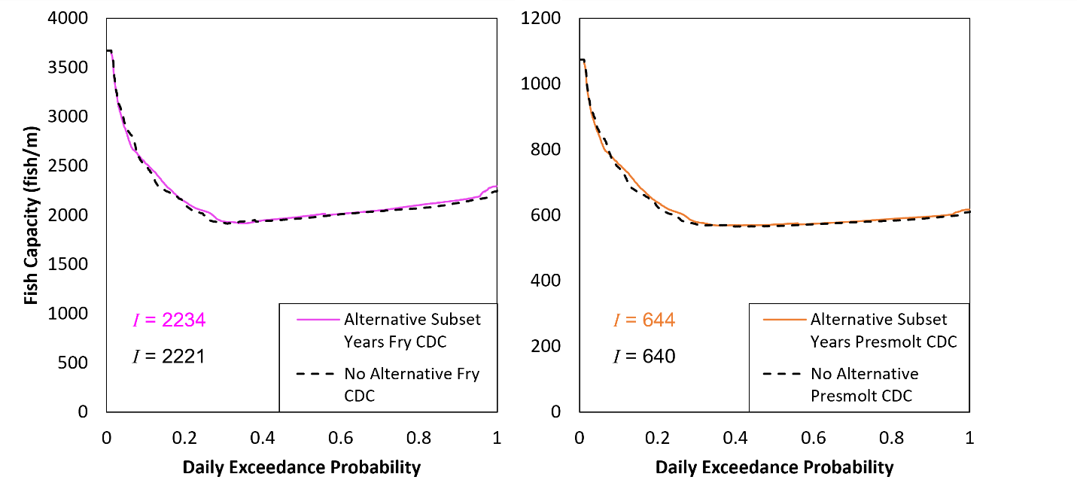
Figure 5. Capacity of fry (left) and presmolt (right) Chinook Salmon as it relates to flow duration for revised winter variable flow recommendation (“Alternative Subset Years”) and ROD flows (“No Alternative”) over the entire Trinity River restoration reach.

Planned Monitoring

Much of the monitoring that is needed to evaluate the effects of implementing WVFs this year, or any year, has been in place for many years, and additional monitoring that was added in WY23 specifically to measure the effects of WVF is planned for WY24. These monitoring activities include:

- Temperature monitoring at various locations throughout the mainstem river (e.g., Lewiston, Douglas City, the North Fork, and Hoopa), and the RBM10 model can be updated and calibrated with observed temperatures, flows, and meteorology to provide fine-scale estimates of temperatures. Water temperature is critical to understanding the effects of WVF on both physical processes (e.g., reduced flows in spring) and biological processes (e.g., fish growth, larval frog growth and development). Temperature data is also needed to evaluate compliance with regulatory temperature targets.
- Juvenile outmigrant monitoring at Pear Tree and Willow Creek provide empirical data on fish size, abundance, and the timing of outmigration. The effects of WVF on juvenile fish are extensive and well documented in Abel et al. (2022), and the effects of fish size on survival is well documented throughout extensive literature on the subject spanning decades.
- The SRH-2D model is regularly used by the Program and was updated last year. This can be used to quantify the amount of additional habitat that would be inundated from implementation of WVF, thus providing physical habitat and increased food production. This model is also used for S3.
- The S3 model can be ran with observed flows, temperatures, and fish abundance inputs such that an accurate picture of the effects of WVF on the growth and movement of juvenile Chinook Salmon resulting from a WVF implementation can be modeled. Importantly, however, S3 does not incorporate increased food production that may result from WVF implementation.
- Adult harvest and escapement monitoring has been in place for more than 40 years and will continue for the foreseeable future. These data will be critical in the future to quantify the effects of WVF on juvenile productivity (juveniles or biomass per spawner) and juvenile survival downstream of the Trinity River, ultimately resulting in adult returns.
- Benthic macroinvertebrate samples were taken and analyzed in inundated floodplains during WY23 WVF implementation to directly measure the effects of WVF on food web development. The analysis is ongoing, and sample collection is planned for WY24 if elevated winter baseflows are implemented again. Sample processing and analysis would need additional funding, and a solicitation for that additional work is currently in development.

Literature Cited

Abel, C. E., K. De Juilio, K. T. Lindke, S. Naman, and E. E. Thorn. 2022. Trinity River Flow Project. Final Report, August. Prepared for Trinity River Restoration Program. https://www.trrp.net/library/document/?id=2566.

Beamish, R. J. and C. Mahnken. 2001. A critical size and period hypothesis to explain natural regulation of salmon abundance and the linkage to climate and climate change. Progress in Oceanography 49: 423-437.

Pearcy. W. G. 1992. Ocean ecology of the North Pacific salmonids. University of Washington Press, Seattle: Washington Sea Grant Program.

