Meeting Summary
Interdisciplinary Team (IDT)
Thursday, October 18, 2023,1pm
Via Microsoft Teams and at TRRP Office, Weaverville, CA

Participants
Eric Peterson (TRRP/USBR), Patrick Flynn (TC), Ken Lindke (CDFW), Kiana Abel* (TRRP/USBR), Galen Anderson (USFS), John Buffington (SAB), Andy Paul (SAB), Chris Laskodi (TRRP/YT), Karl Seitz (HVT), Kyle DeJuilio (YT), Todd Buxton (TRRP/USBR), Karl Seitz (HVT), Bill Pinnix (USFWS).
* = note takers

Action Items Derived during the Meeting
Next meeting is November 28 – expect everyone to put thought into the list of questions for the LFA and circulate ahead of the next meeting. Cover objectives and targets table, with an additional column on what monitoring is being done currently. Please edit the template.

See also attached bullets captured by Peterson during the meeting.

Summary of Meeting by Agenda Items

- Introductions / Agenda Review and Finalization, IDT Notetaker, brief program updates (Peterson)

Agenda review. No changes needed from the group. Eric’s no longer detailing as Science Coordinator, trying to limit his participation. IDT has a lot of work to do based on the science plan, Mike, Eric and IDT will need to take these changes on as a workgroup. Ken is curious if there is a plan for IDT, and who is supposed to lead the workgroup. Peterson, notes in the program document, each TMC entity will appoint 1 member and 1 alternate to the IDT. The coordinator is defined in three different ways showing that the Program Document has some glitches that need working out. Reclamation and the Service will jointly coordinate the IDT. Pinnix: thinks we’ll have an FACA coordinator set in at FWS by December 4th. The program document is in Legal review, hopefully the document can be cleaned up prior to posting and finalization. Pinnix: is there supposed to be a distinct chair and a coordinator? Other groups he works in have that framework. Peterson: is unsure of the final outcome, will need to be defined more clearly.

Lee provides an update on Oregon gulch. Project is done with the construction, revegetation is under way, almost done with willow and cottonwood planting. May be done by the end of the month, but maybe the end of the week. YTCC will do some road repair, informational sign, and project clean up.
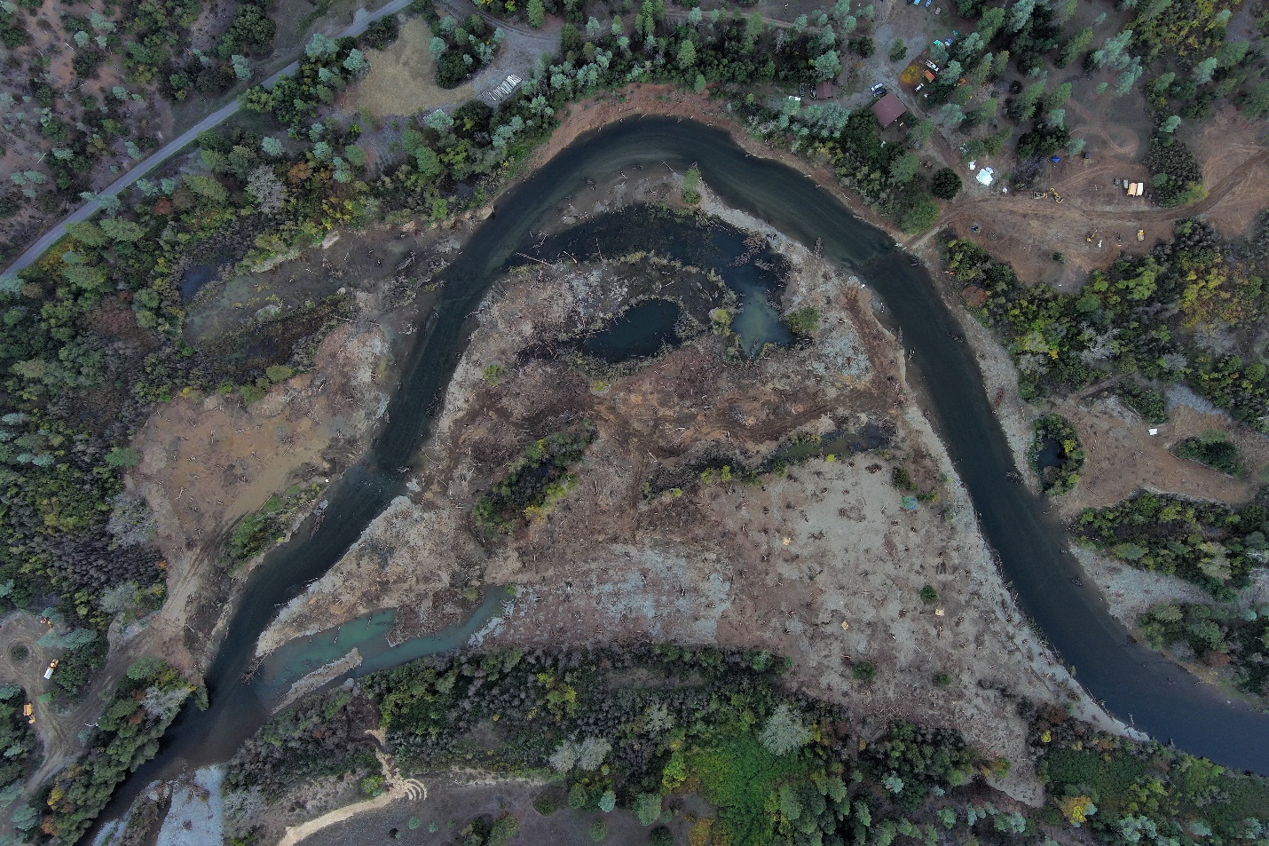
Aerial photo of Oregon Gulch from October 13, 2023. [Max Ramos, Yurok Tribal Fisheries Department]

Wide range of flows increase habitat. From Lewiston to NFT confluence, 64 acres are now wet at 1000 that weren’t wet at 300, this adds 32 acres in the amount of low flood plain habitat – 50% increase. Elevation plug from water surface? 12 ft or more – tops at around 13 or 14,000 cfs. The plug is not obvious, there is a gradual increase from the rivers edge and then it taperes on the backside. Important from the design team’s perspective because “if” the river put it there it should be able to be wet within the range of observable flows.

SAB new members on the threshold of contracting paperwork. Hoping to be done by the end of the calendar year.

Cramer Fish Sciences and the initial LFA kick off meeting will be in Weaverville tomorrow (10/19), if anyone wants to tag along to Oregon Gulch they are welcome.

- Strategizing reviews of core monitoring and flow DSS

Figure 6 of the Science Plan: Timelines. Review of long-term monitoring activities for ’23-’24. Hoping to tackle core monitoring over the next year. Gauge data, aerial imagery, topography models, as-built surveys, fisheries monitoring. Let’s take a hard look at how monitoring fits with what we need and identify gaps and trimming unnecessary items. How should we go about the monitoring review?

Discussion: Pinnix thinks we should consider adding monitoring and scaling back on other monitoring, vs removing monitoring. Let’s remain open to the idea of limitations and budget constraints. How can we be more efficient and what are the affects of the action. Regular and recuring meetings are important for moving things forward. Can IDT sketch out the scope of the review? Do we need a sub-committee? It will be helpful to have coordinators once they are on board and prior to that can we keep the process moving in the right direction. Peterson sent out a template to document each activity’s purpose and how it relates to key uncertainties and objectives and targets, which could be a foundation. Let’s create a method for the review so we’re approaching them the same way. Form was sent out on September 19. Pinnix likes the form for the core monitoring – how do we expand a schedule for the remaining items. De Juilio: who is intended to fill out the draft form (likes the idea) geared toward work group coordinator, PI on the project? Peterson: thinks PI on project (Ken with weirs, example) then processed through the IDT to ensure coverage and then compiled for priority to fit the budget. One to lead the review, but multiple people back and forth. Why was this included? What projects do we want to do during phase 3? Came to the conclusion that we need to review the core monitoring and second was key uncertainties. Two tasks, review the things you do, then come up with the items that can fit within or help identify the key uncertainties. Buffington: Key Uncertainties in the Science Plan address good topics, but they need fleshing out in terms of what will be done and how monitoring activities will inform them. Offers Large wood as an example – is wood monitoring a new effort or an existing one that needs to be evaluated? Which monitoring activities are providing critical knowledge? De Juilio agrees, yes, we need to look at current monitoring and evaluate effectiveness and purpose. Lindke: key uncertainties was not intended to be comprehensive, recognize the authors are a subgroup of the program wanted to make it more like a task and guided by objectives and targets. Intended to provide context and information toward reconfiguring what the science program should look like going forward. Most interested in starting toward how we’re going to get this task done. IDT Task? Subcommittee to bring it back to IDT? What is the process, so we can start moving forward. PI level by the science coordinator and whomever represents Reclamation and FWS – as the organizers and managers of the process, and IDT doing the work.
- Fill out the table with a third column to objective and targets
- review template sheets give feedback on the template
- send to PI’s then review as a group
- Prior to the next November meeting?
DeJuilio: Apply key uncertainties to see where we are already covered and where we are not. More intended for new project ideas. Lindke: potential for overlap with core monitoring but key uncertainties could be used to fill in shorter term questions – not necessarily longer-term monitoring.

Please send edits to Eric on the review template.

- FY25 science priorities (Peterson)

Table 3 - annual science prioritization process to address key uncertainties. Funding is not guaranteed, but the hope is that we’ll have a set of projects for FY25. FY24 is limiting factors analysis. Considering FY25 key uncertainties – July discussion identified the groups priorities:
- Nutrient Flux
- Wetted Width (take advantage of Oregon Gulch)
Research questions, develop RFP posting in February 2024. Need to develop a list of specific research questions and develop a workflow. Target November meeting to have the list of questions and ranked as a team. Buffington: procedural question, SAB change in role included in the question development, especially if they are involved in the evaluation in the end. Peterson: does that disturb the independence of the SAB? Andy Paul: independence is important, but not having the insight into why the questions were what they were has put the SAB at a disadvantage. Buffington: resource independent of development. Peterson: isn’t it appropriate for the SAB to redirect the group? Andy Paul: yes, participation may show oversight and it’s important to not remain silent. Somehow, staying in the bounds are important. De Juilio: SAB engagement has been less in the past, reviews have had a lot of connectivity questions. Want to get really specific with RFP’s – respondents provide methodology. Important to get the questions right. Buffington: seems like involvement will be useful, just need to make sure to remain advisory.
How to move forward next steps
Lindke: List of questions for November meeting, let ‘s spend some time brainstorming today and have people bring forward specifics to the November meeting regarding the key uncertainties. De Juilio: invertebrate monitoring has been of the one-off variety, but annually performed since 2018. Propose periphyton & invertebrate monitoring in the future for consideration. Ben King’s inundation study is looking informative, but replication is important in different water years. Peterson: propose BMI study for long term monitoring, would back that idea. Lindke: also supports. Incorporate long term food scape monitoring, current work are critical components that need to be folded into a systems long term monitoring. Where do we have levers to maximize that opportunity, specifics are a heavy lift to on the ground information to inform management. Broad scale study project. Short term, we should be focusing our energy on how we are making food for fish with timing and temperature. Peterson: targeted FY25 could be the start of a long-term monitoring to put it together and get off the ground. Pinnix: agree with that recommendation – let’s design the project in FY25. Funding is a key consideration and needs to be incorporated as well. Likely going to need to give and take to add something large like this. Can we scale back outmigrant monitoring to shift resources? Resources are not unlimited. De Juilio: need a proposal and developing the cost estimate and that can be weighed against current expenses. Invertebrate colonization – still more to learn, conduct another round of the same monitoring. Peak projection can vary from one site to another – not necessarily seasonal. Only a year of data that corresponded with the flows well, but we had critically dry years prior and it seems like we still have a lot to learn. Lindke: we don’t have anything in the docket for this type of monitoring in FY24, and that is a concern. Inundation component would be difficult in the absence of winter variable flows, but also could provide a contrast to winter flow. What does the bug community look like at winter baseflow (300cfs)? Likely to provide insight on foodweb development in the perennial channel, which we don’t currently have a great grasp on. Don’t have data for that scenario, if LFA doesn’t consume the science budget, lets at least get the samples. Need to understand this topic, let’s elevate it! Peterson: geomorphic flows are happening at the wrong time but may still have food in bedrock areas. De Juilio: Hyporheic flow study, will that collect samples? Buxton: no, we’ll monitor in (May, September, October FY24), not the right time of year.
Nutrient flux: Buxton, suggests to reach out to Danile Tonina who has a lot of experience in this area. Peterson: would this conflict with his start date on SAB? Andy Paul: Here’s someone that knows something, can he give advice? Seems like a good idea he could help inform and advise. Until they are on contract need to be careful about their time, but the question seems fair. Lindke: if we didn’t leverage their expertise, seems foolish. Expect their level of professionalism to give honest critique or to recuse themselves, even if they help to develop or advise the path of a question.

Wetted width ideas
De Juilio – how will riparian vegetation repopulate? Monitoring over a few years, may want to start in three years. Need to hear from the riparian ecologists on how to move forward with monitoring. How does natural revegetation occur on a large floodplain like Oregon Gulch? Peterson: how does the surface evolve over time? Does it remain low, aggrade, how does the vegetation participate? De Juilio: as built survey of the surface with FY24 dollars. Lindke: recent tools, fitted curve between flow magnitude and fish capacity, percent of the bed that is disturbed based on shield stress thresholds. Acreage of wetted area, 300cfs baseflow – 3000 (most common flows seen in the restoration reach). What is an acreage example of wetted area relating it to food productivity. De Juilio: FY23 evolution of stream morphology – using hydrodynamic model from 2016, which may be a good place to establish the relationships that Ken is referring to. Project hasn’t started due to availability of the model, but it may address some of the wetted width questions. Peterson: photo at pear tree, used to have a gradual topography, photo taken in July, the willow collected a huge row of gravel behind it. Flow study seems to think gravel was evacuated, but where did it go? He’s thinking 1974 flood may have sent a lot of the gravels behind vegetation and created larger banks.

Create specific questions out of this brainstorming session and ranking them for the November meeting.

- Science Symposium: committee

James
Kiana
Kyle
USFWS person TBD
Ken if they need help

Let’s look at dates vs February (weather, presenter availability)

- LFA: Plan who will participate on the planning team

Phase 1 develop the plan (group of TRRP scientist participation) bring in outside experts on how to proceed. Put a RFQ together, and Cramer Fisheries will be in Weaverville tomorrow. Need 3 internal people involved, who will that be? Lindke: plan for tomorrow? Meet and greet brainstorm, bringing their edits to lifecycle. Pulling program information together will be the responsibility of this planning team.
- Ken Lindke
- Chris Laskodi
- Justin Alvares or Karl Seitz
- Seth Naman (if he has time, if someone reaches out to him, if he requests to be part)
- Bill can be penciled in, wants to check with his management and his roll on the TMC.
Lindke: first phase funding has been decided, but not the second phase. Can Bill and Karl/Justin figure out their participation prior to the 9am meeting tomorrow?
Next meeting is November 28 – expect everyone to put thought into questions and circulate ahead of the meeting. Cover objectives and targets table, with an additional column on what monitoring is being done currently. Please edit the template.

Adjourned 3:55pm

Attachment:
Bullets captured by Peterson during the meeting:

Core Monitoring Review
- Fill out new column for Objectives and Targets, (plus Key Uncertainties?)
- Edit/Alternatives for Review Template
- Both for late Nov meeting

Science Priority Questions brainstorming
- Nutrient Flux
  - Design and initialize a (potential) long term BMI/primary production activity?
  - If FY24 not entirely consumed with LFA, maybe get some BMI sampling?
    - Already have a small amount to support the Hyporheic study
  - Spatial aspects of BMI?
  - Relating BMI more to Fish Growth
  - Reach out to new SAB members?
- Wetted Width
  - How does natural reveg occur on a large low floodplain (Oregon Gulch)
  - Wetted Acreage vs Flow and a way to relate food production (food per acre inundation)
FY21 project will do a lot of habitat capacity work with 2022 model
Science Symposium Subcommittee
- James Lee
- Kiana Abel
- Kyle De Juilio
- Maybe USFWS person TBD (onboarding December)
- Ken can help if the committee is short on people

LFA Participants
- Ken Lindke
- Chris Laskodi
- Justin or Karl?
- [Bill depending on time and FWS perspective]

