TRRP Physical Workgroup Meeting Notes
Virtual meeting
Thursday, February 10, 2022

Participants
Todd Buxton (workgroup coordinator), Brandt Gutermuth, Chad Able, Oliver Rogers, James Lee (USBR); Kyle De Juilio, Dave Gaeuman (YT); Conor Shea, Josh Boyce (USFWS); Smokey Pittman (McBain Assoc.); Karl Seitz (HVT); Scott Kennedy (DWR); Roman Pittman (NOAA); Maya Williams (Trinity County).

Note takers: Chad Abel, Todd Buxton

New Actions Items
- The physical workgroup prioritized delineating the province where fluvial geomorphic processes may occur or be restored in the modern Trinity River valley this calendar year.
Workgroup recommendations/decisions
- Physical metrics were finalized for presentation to the Science Coordinator.

Meeting agenda
Agenda
Time | Topic | Presenter
1300-1310 | Agenda Review / Announcements | Todd
1310-1430 | Update on development of gravel augmentation sites | Chad
1430-1600 | Finalize metrics | All
1600 | Adjourn

Notes
1310-1430 | Update on development of gravel augmentation sites | Chad
The workgroup discussed new sediment augmentation locations proposed by Dave Gaeuman, Smokey Pittman, and Todd Buxton on the Trinity River. The new locations are intended to give more options for adding sediment to the channel where it may be needed for a variety of restoration purposes. The notes that follow were speaking points used by the Implementation Branch to facilitate discussion on this topic. The notes for this topic are in blue font.
2022 Gravel Introduction proposals: Implementation Input Feb 2022
All Proposals: This is an opportunity to address the size distribution and method for placement at each location. Should we be assuring a smaller proportion of 4”+ material for better mobility? If the WG could provide a size distribution of material to place at each location, that would help.
Vitzum Gulch had specific recommendation. Chop off distribution of Todd’s recommendation to disallow the fines in his recommendation for proportion of material sizes. Would be hard in functionality to actually composing the mixtures of specific sizes. Dave said the upper size used to be 6”, then 5” became better top end, now 4”. Last processing was 4”max sieve size at Sawmill. But leave flexibility of grain sizes to be placed in EA. Concerning grain size dist, we typically just run through with max size and smaller ½” falling out, but we just get what passes the screens. No “designer grain size” methods considered as it would be costly. Could accomplish the same simply by preferring certain parts of the pile based on visual observation that are to be processed
TRRP is presently permitted to place clean gravel 3/8 to 5 inch diameter. Present TRRP gravel permit allows high flow placement or summer placement. Ability to place material during winter low flows would require permit amendment. Are fines only needed in the Lewiston reach well upstream? Introduction of fines was not included in the Trinity River Mainstem fishery restoration program EIS or the Master EIR. Reclamation needs to determine whether it authorized to add fines based on adaptive management.
Our intent is to analyze all these proposed gravel intro sites in an EA so public can see the process of consideration and exclusion to arrive at sites that we’d seek long-term permitting for. We plan to begin scoping (mailings to all riverfront owners upstream of Douglas City, and other outreach) March 1. After the scoping period, EA drafting would likely begin in May.
Dark Gulch/Gold Bar – Implementation Input:
Physical WG were concerned about the potential impact of placing gravel upstream of the Brown’s Mountain RD bridge (aka the Bucktail bridge). There is potential to rack rocks up at the bridge and to increase flood elevations as rock does not route under the bridge.
Options: We can 1) place rock on right bank well upstream (RM 106.7 as recommended) so that it does not route to the bridge quickly – but it will get there, 2) place the rock downstream of the bridge, or 3) Determine that replacement of the bridge is a high priority activity for TRRP work. There is a CH2MHill design for a bridge replacement there that includes habitat on the floodplain. Here is a little more detail on these options:
- RM 106.7 Dark Gulch/Gold Bar (right bank)
Options are to either: a) Bring gravel via Salt Flat bridge, if we have support of owner(s) with driving access (e.g., property 1 or 3 across river); or b) Process on-site. Processing on-site will require time for approvals as Reclamation would need to appraise the value of the material and purchase it. We might be able to bring a processor across the river (via #3 or across Bucktail site area).
Hesitant to place in highlighted property 1, because of side channel. Todd thinks placing at BLM land would be a good spot. Doesn’t believe the gravel would be a slug that far downstream to bridge. We could talk about prioritizing the replacement of the bridge, but Mike thinks its unlikely TRRP budget could afford $2million+ project. Josh thinks entrance into side channel at Bucktail Ponds could be impacted by the gravel. Conversely, Todd thinks that might not be good justification to prevent action. Believes the river would benefit from the additions. But you could also say the area has correct amount of gravel here, per Dave.

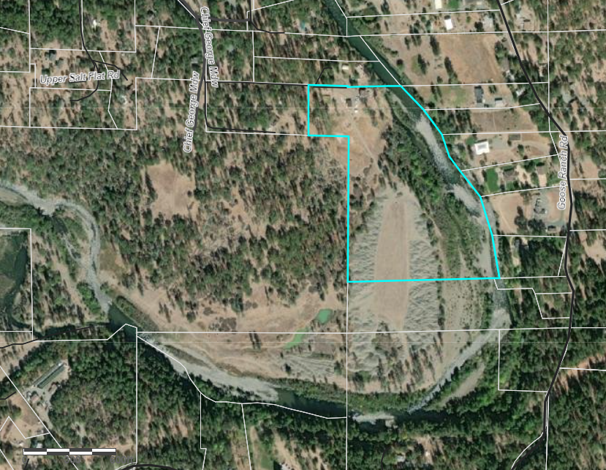
3
2
1
BLMM
Figure – Showing private parcels at Dark Gulch area with gravel for processing. #1 has driving access road, built in 2008 Dark Gulch project, to the Gold Bar tailings.

- RM 105.9 Bucktail (downstream wetland side-channel or at Boat Ramp). Problem is bridge constriction downstream.
- RM 105.4 Downstream Bucktail bridge- addition downstream bridge is likely with less lead time. WG thoughts about the appropriateness of gravel additions here?
- River left: clear some vegetation and drop rock down steep slope into Bucktail hole area at high flows. Chad believes that placing in this popular swim/fish hole would be a PR nightmare. Need BLM approval.
- River right: Add gravel from Bucktail subdivision – at what location? Much flatter grade but more inside of bend “like.” Locals have not been supportive at this location in the past. Need BLM approval.
What do we think the gravel is going to do to make things better in that reach? Not that far to Lowden Ranch, and a lot of gravel is there. Not a lot of distance to benefit here. Wouldn’t be worth the negative aspects of placing here.

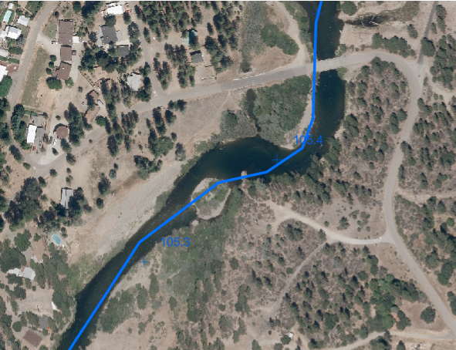
Figure- Downstream Bucktail bridge (RM 105.3-105.4):

Two gates block access from Browns Mountain Road to this site on the right bank. First gate is Perry’s and then B. Wellock’s. Need access via both gates to fix/rebuild and extend the 2010 Trinity House Gulch access road to the spoils. Some potential that a new road could be created exclusively on B. Wellock’s property, but have yet to discuss with landowner. This was not supported in 2010 project. Can place on road on Perry’s, per conversation with him, but would need to enhance old road (this is a different road, not 2010 access road) to river and would need to bring material in (no access to THG spoils). Preliminary talks with the landowner to cross Perry’s to access B. Wellock’s are not promising, however, another option for private access on river right (Browns Mt RD) may be available. We will visit soon.
Access from river left may be possible. Based on field observations, Oliver suggested taking advantage of the existing hydraulic control and placing (oversize) upstream at Trinity House Gulch just downstream and opposite the side channel entrance (~RM 104.25-104.3 in figure). Placement of gravel and oversize here might force more water into the inlet of the side channel and inundate at lower flows. Does WG support this?

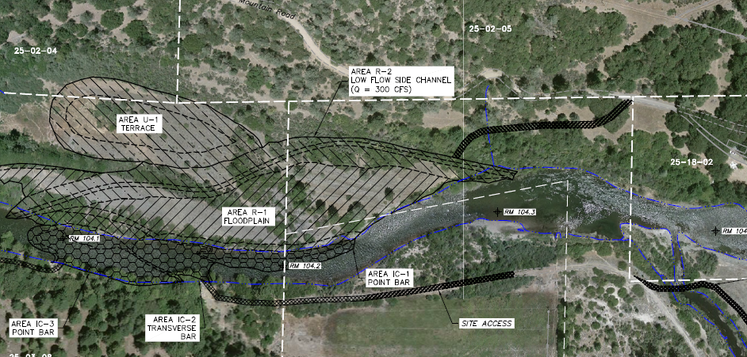
BLM
BLM
Perry
B. Wellock
Figure – 2010 THG access from design sheets. Access was made across properties shown in red

Was it proposed to use the spoils area (U1 terrace)? Smokey drafted this proposal. This is head of most impaired reach in bar mapping project. Get as far downstream as we can on Wellock’s property would be better. Reports: Bar Area Mapping Report 2014 and Sediment Synthesis Report 2021
The idea of processing the old THG spoils pile to create gravel makes sense but requires substantial access (e.g., road or shallow & quality river crossing) to bring gravel processor into the location. We are looking at access options. If we can’t use the old THG as source material, does it make sense to develop an augmentation location on river right with the Lowden fence line permitted augmentation site immediately across on river left?
China Gulch (looks to be in Limekiln Gulch drainage at RM 101-101.6):
There is access potential on river right via SPI to BLM managed lands. We walked the 1.4-mile road from Brown Mt Rd access to the river over SPI (~0.9 mile) and BLM (~0.5 mile). SPI would support the effort but note that proposed road improvement is in Watershed and Lake Protection Zone (WLPZ) and that about 1200 ft of the road is very steep (between 20-45% slopes) and not likely to be used by SPI. SPI guestimates cost of road upgrade at $150K not including surfacing of any portions of the road or backhauling any excavated material. Road access places rock delivery at the Montana historic cabin on BLM by the river. We found no steep bank to push rock over into the river. Project would require cultural surveys (the access is historic) and reporting. Location has potential but requires time and funding to work out details. Stockpile u/s or d/s cabin.
River left China Gulch (via narrow private road) has potential if willing landowners support truck access. Will learn more during scoping.
Encouraging that a path to the river has been discovered. Cultural evaluations could take time, but seem to have SPI support. Could drive through neighborhood on river left, but we haven’t approached landowners there and it’s probably unlikely. Also, Oliver and Brandt walked in from Limekiln old project. It’s wide and shallow there, but good offsite locations for stockpiling. So potentially 3 access locations to analyze in EA for China Gulch. Three miles into 13 mile reach of having lowest sediment storage.

Steel Bridge Day Use (RM 98.5):
This site was included in the 2009 Gravel Replenishment Study (Sherer, 2009) which estimated a composition of 60% spawning gravel (or ~4,500 CY at 100% processing efficiency). Should we consider processing here or on the abutment bar? Due the relatively low yields (lowest of the studied sites), processing materials in-situ is likely infeasible. (Note: The 2009 study included the area upstream at RM 99.0 in the ESL, but no results for that upstream area were included in the study). The proposed gravel placement location access is via narrow county (Steel Bridge) road. The recommended BLM day use gravel placement holds a mining claim. The Swanny Mine claim (#265834) appears to be a valid current claim. We will need to work with the miner to determine options. The site would otherwise take very little effort to prepare.
Proposal recommends adding gravel prior to spring release. This is not permitted, presently. There is potential to add clean gravel in winter if needed. Is there a summer option? Is there potential to place gravel upstream at the large boat ramp downstream of Steel Bridge campsite - the one with abutments? Does WG support this?
Because of the nature of Steel Bridge road (very narrow, with residences right along the road), the approach we’ve considered most feasible for public support would be to haul in material in winter, during weekday hours when most people are at work/school. Also less pets and livestock in road during that time, and no one with windows open. Doesn’t mean placement would need to coincide with hauling, but the ability to retain a stockpile on site under that scenario would be important (mine claim issue?).
At steel bridge day use, or consider the abutment area as well? Dave thinks downstream of the hole, but there is USGS gage we could screw up. That was also a sediment monitoring location just 50-100 yards downstream of abutment. Smokey agrees we shouldn’t mess up the monitoring location. Reach downstream of the day use area is super bony; perhaps the worst in the whole focal reach (Jack Hood playground). Can’t interfere with mine claim; need to notify.
Vitzhum Gulch (RM 96.5-96.6):
Not really to supply sediment but to blow up the bend. Put in coarser material to make river do something. Can likely add boulders for complexity, unlike the restrictions against fine sediment. Todd thinks the result would be local but it is a large-scale problem “in a sea of crappy habitat”. Mobile gravel would likely end up in side channel downstream. Value in trying new things – how much will right bank respond to steering by the oversized material. Dave prefers slope at staging area – just the dump it over the edge approach.
Place material (3/8 up to 14 inch diameter material) at high or low flows to cause erosion on the right bank. Does the WG agree with the prescription of oversized material at this location? Will additional removal of veg on right bank or placement of large wood be needed to ensure erosion of the bank on inside bend? If so, access to right bank with equipment may be necessary. We would need to determine right bank (BLM) access options.
Several alternatives for placing material from the Left bank came to mind when we looked at the site. How do these sound to the WG?
- Original WG recommendation - Dump gravel directly down slope from SR 299 pullout. Additional mechanical equipment may be required to push gravel materials down existing slope and into river channel.
- Construct chute/slide, potentially supplied with water to motivate gravels, to deliver gravels from SR 299 pullout to river
- Excavator constructs a new access road to reach existing terrace ~20 ft below guardrail there looks to be a flat place. This site is within the Caltrans Right-of-Way (though Brandt believes that we will also need permission from BLM – who manage the land), design access road for excavator will likely require Caltrans standards. Excavator places gravel and larger rock into the river from flat spot. If engineering plans are required, Oliver could likely design the access that conforms to any Caltrans standards.
Concerns have been raised about erosion on downstream private property (at Marinchak on river Left just >1 mile downstream, beyond the Indian Ck delta). Would this project increase erosion on downstream private property? The pullout where placement would occur is a popular parking spot for fishing the downstream riffle, meaning it would be important to place material shortly after the rock is hauled in. A long-term stockpile would exclude/inhibit fishers from parking there.

1430-1600 | Finalize metrics | All
A table of physical metrics proposed by Dave Gaeuman, Smokey Pittman, and Todd Buxton was presented to the group. The table summarize writeups of the metrics provided by their authors and gives a final summary of the metrics for evaluation on the Trinity River. A few changes to information in the table were made and the group agreed to consider its revised content final. The table is pasted below.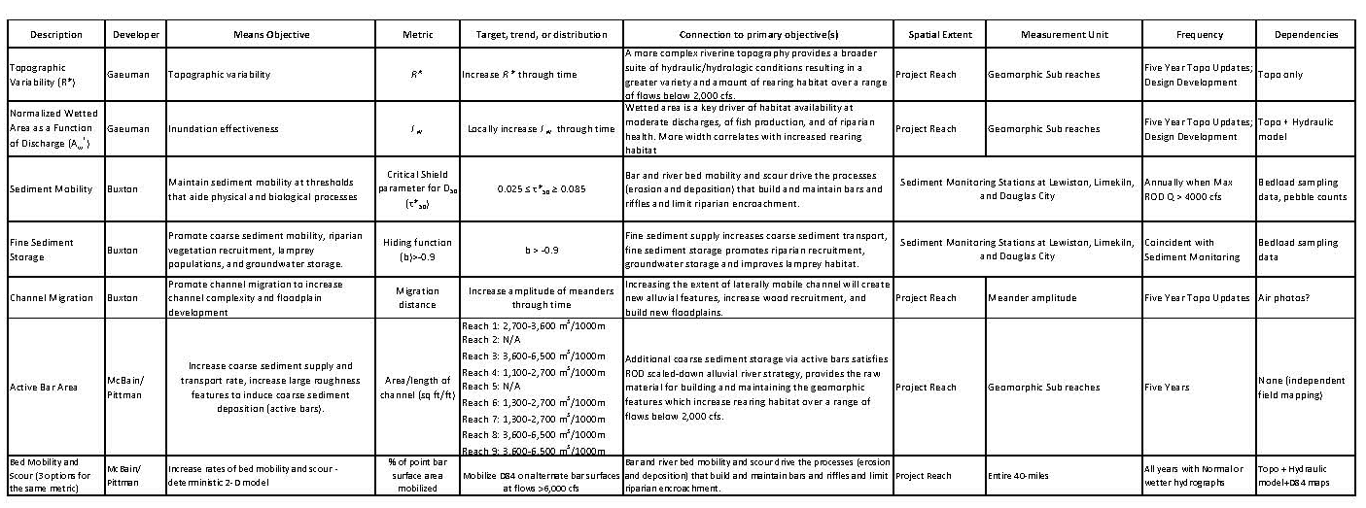
The meeting concluded with a discussion of potential undertakings by the workgroup this year. An idea that was raised is to delineate the province where fluvial geomorphic processes may occur or be restored in the modern Trinity River valley. This issue will be discussed in the next workgroup meeting.

